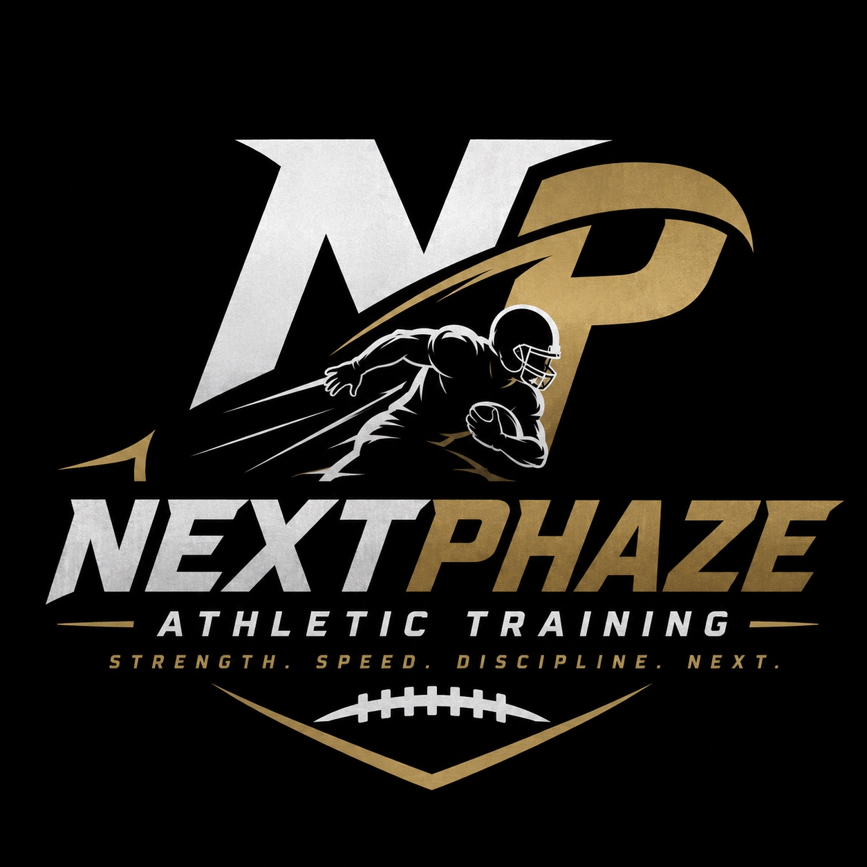
NEXTPHAZE ATHLETIC TRAINING
Extensive Website Content, Athletic Career Research & Media Plan
Carrington Thompson | Western Michigan #15 | Wide Receiver
Prepared August 2026

PURPOSE OF THIS DOCUMENT
This is the source-of-truth content brief for rebuilding the NextPhaze website. It combines the original client-provided business information with verified public athletic records, a media/source inventory, recommended page copy, SEO direction, and implementation guardrails for the frontend design agent.

Strength. Speed. Discipline. Next.

STRATEGY

Executive Summary
NextPhaze Athletic Training should be positioned as an athlete-development brand led by a coach whose own career reflects progression through multiple competitive levels. Carrington Thompson’s verified playing history gives the site a stronger credibility foundation than the original content document communicated.
The most defensible public story is: Lamar High School in Houston → Northwood University → Western Michigan University #15 → 2016 MAC Championship and Cotton Bowl → West Michigan Ironmen → 2018 professional indoor championship and MPIF Offensive Rookie of the Year → NextPhaze Athletic Training.
1,936  COLLEGIATE RECEIVING YARDS | 139  COLLEGIATE RECEPTIONS | 18  COLLEGIATE RECEIVING TDS | 8 / 177 / 2  CAREER GAME VS. EMU

CORE BRAND IDEA
YOUR CURRENT LEVEL IS NOT YOUR FINAL LEVEL. Development happens one phase at a time. Carrington’s own progression provides authentic proof of the NextPhaze concept.

Critical Accuracy Update
The original document lists “AFL experience” and “IFL experience.” Public research verifies professional indoor/arena football with the West Michigan Ironmen, including the MPIF in 2018 and arena/indoor competition in 2019. A 2019 FOX 17 feature reports interest from the Arena Football League and Canadian Football League, but that is not the same as verified AFL playing experience.
- Publish now: “Professional indoor and arena football experience with the West Michigan Ironmen.”
- Publish now: “2018 MPIF Champion” and “2018 MPIF Offensive Rookie of the Year.”
- Do not publish specific AFL or IFL playing claims until Carrington confirms the club, season, and league.
- Do not invent training certifications, client results, testimonials, locations, or athlete counts.
EXISTING SOURCE MATERIAL

Business Information from the Original Client Document

Coach & Contact
Item | Current Information
Coach | Carrington Thompson
Email | carrington.j.Thompson15@gmail.com
Phone | 810-869-8554
Role | Athletic trainer / former collegiate and professional indoor wide receiver

Training Services
- Speed development
- Wide receiver training and position-specific development
- Footwork
- Agility and quickness
- Acceleration and change of direction
- Strength and athletic movement
- Sport-specific skill development
- Overall athletic performance and conditioning

Sports Served
Football, basketball, soccer, baseball, track & field, and other sports where speed, agility, movement quality, conditioning, and athletic development are relevant.

Pricing
$30  GROUP SESSION / ATHLETE | $60  1-ON-1 SESSION / ATHLETE

Availability
- Monday–Friday: flexible / open availability
- Saturday: 9:00 AM–12:00 PM
- Scheduling is based on current availability and confirmed bookings.

Cancellation Policy
Bookings may be cancelled up to 12 hours before the scheduled session.
NEEDS CLIENT INPUT BEFORE LAUNCH
Training location(s), service radius, age ranges, session duration, group capacity, late/no-show policy, weather policy for outdoor sessions, refund policy, waivers/parental consent requirements, and whether taxes/processing fees are included.

CARRINGTON THOMPSON

Verified Athletic Career Profile

Western Michigan University
Carrington Thompson wore #15 at Western Michigan University and played wide receiver. WMU lists him at 6'2", 176 pounds, as a redshirt senior from Houston, Texas. He played 26 games across the 2015 and 2016 seasons for Western Michigan.
Season | Games | Rec. | Yards | Avg. | TD | Yards/Game
2015 | 12 | 8 | 89 | 11.1 | 2 | 7.4
2016 | 14 | 42 | 637 | 15.2 | 6 | 45.5
WMU career | 26 | 50 | 726 | 14.5 | 8 | 27.9

His 2016 senior season was the breakout: 42 receptions, 637 yards and six touchdowns. The final 2016 totals include the Cotton Bowl. Some pre-bowl WMU documents show 38 receptions and 605 yards because those materials were published before the bowl game.

Historic 2016 WMU Team Context
- 13–1 overall record
- 8–0 Mid-American Conference record
- MAC Championship
- Cotton Bowl berth vs. Wisconsin
- No. 15 in the final AP poll
- Coached by P.J. Fleck
- Receiving corps included Corey Davis, Michael Henry, Carrington Thompson, and emerging younger players
This context is useful because Carrington was not simply on a college roster. He contributed to one of the most significant seasons in Western Michigan football history.

Career Performance: Eastern Michigan
8  RECEPTIONS | 177  RECEIVING YARDS | 2  TOUCHDOWNS | 51  LONG RECEPTION

On October 22, 2016, Thompson produced career highs with eight receptions, 177 receiving yards and two touchdowns against Eastern Michigan as No. 20 Western Michigan preserved its unbeaten record. WMU’s later media guides continued to list the 177-yard performance among notable single-game receiving marks.

Championship-Stage Production
In the 2016 MAC Championship Game against Ohio, Thompson caught six passes for 72 yards and a touchdown. This is a strong website credibility point because it demonstrates production in a championship setting, not only regular-season volume.

Spring 2016 Emergence
WMU’s spring coverage identified Thompson as a receiver making a name for himself entering his senior year. In the spring game, he opened with a 53-yard reception and finished with three catches for 85 yards while being described as a threat opposite Corey Davis.

EARLIER COLLEGIATE PHASE

Northwood University
Before Western Michigan, Carrington played two seasons at Northwood University. WMU’s official bio credits him with the following production across 20 games:
89  RECEPTIONS | 1,210  RECEIVING YARDS | 10  RECEIVING TDS | 13.6  YARDS PER CATCH

WMU also lists a 60.5 receiving-yards-per-game average over those Northwood seasons. Public game records support individual performances such as eight catches for 98 yards against Walsh in 2013 and four catches for 86 yards against Quincy.

Combined Collegiate Totals
139  RECEPTIONS | 1,936  RECEIVING YARDS | 18  RECEIVING TDS | 4  DOCUMENTED COLLEGE SEASONS

PUBLISHING LABEL
These figures combine Northwood and Western Michigan. On the website, label them “collegiate career totals” and never present 1,936 yards / 139 receptions / 18 TDs as Western Michigan-only statistics.

Lamar High School, Houston
Western Michigan’s official player bio says Carrington starred at Lamar High School in Houston and helped the program to district championships in 2011 and 2012 and a regional championship in 2012. This can appear briefly in the career timeline but should not dominate the site because the college and professional accomplishments provide stronger current credibility.
WEST MICHIGAN IRONMEN

Professional Indoor / Arena Football
After Western Michigan, Carrington continued playing with the West Michigan Ironmen. Public reporting documents significant production, a league title, an individual award, and continued interest from higher professional levels.

2018 MPIF Championship
The Ironmen completed a 5–0 2018 season and won the Midwest Professional Indoor Football championship. In the title game, Carrington caught five touchdown passes and also returned a kickoff 44 yards for a touchdown during the decisive fourth-quarter surge.
5  TD RECEPTIONS IN TITLE GAME | 1  KICK-RETURN TD IN TITLE GAME | 68–44  CHAMPIONSHIP SCORE | 5–0  IRONMEN SEASON RECORD

2018 Offensive Rookie of the Year
A 2019 Ironmen season preview identifies Carrington Thompson Sr. as the 2018 MPIF Offensive Rookie of the Year. This is a specific, attributable individual honor and should be featured prominently once Carrington confirms the preferred wording of his name on the site.

Selected Ironmen Performances
Game / Context | Performance | Why it matters
2018 MPIF Championship | 5 receiving TDs + 44-yard kick-return TD | Championship-stage production
2018 vs. Chicago Blitz | 7 catches, 55 yards, 3 receiving TDs + 50-yard kick-return TD | Multi-phase scoring impact
2018 league semifinal | 4 catches, 48 yards, 1 receiving TD + rushing TD | Playoff production
2019 vs. Indianapolis | 2 first-quarter receiving TDs | Fast start in league opener
2019 vs. Muskegon Mustangs | Game-winning touchdown catch with 3 seconds left | Clutch performance captured in video/photo coverage
2019 vs. Indianapolis | Two touchdown catches in regular-season finale | Late-season production before playoffs

FOX 17 Profile & Character Context
FOX 17 profiled Carrington in May 2019 while he was playing for the Ironmen. The piece documents Arena Football League and Canadian Football League interest and includes praise from Ironmen head coach Nate Smith, who described Thompson as the league’s best receiver in his opinion and emphasized his leadership, character, relationship with fans, and interest in working with kids.
This provides a useful bridge from “player” to “trainer.” The website should use the underlying theme without over-quoting: Carrington’s history includes both competitive performance and a documented interest in positively impacting younger athletes.
NEXTPHAZE STORY

Recommended Brand Positioning

Primary Positioning Statement
RECOMMENDED
NextPhaze Athletic Training develops athletes through focused speed, movement, discipline, position-specific skill work, and competitive preparation, led by former Western Michigan #15 Carrington Thompson, a MAC Champion and professional indoor football champion.

Brand Narrative
The strongest narrative is not “former athlete starts training business.” It is “development is a progression.” Carrington moved through high school, Northwood, Western Michigan, a breakout senior season, championship football, professional indoor football, and now athlete development. That progression makes “NextPhaze” meaningful rather than decorative branding.

Messaging Pillars
- Development: athletes are not defined by their current level.
- Details: speed, footwork, movement quality, route mechanics, body control and repeatable technique.
- Discipline: consistent work and preparation are part of performance.
- Competition: training should transfer to game situations and pressure.
- Confidence: improved skill and preparation create more confident athletes.
- Progression: each training phase should prepare the athlete for the next.

Recommended Tagline Options
- Strength. Speed. Discipline. Next.
- Your Current Level Is Not Your Final Level.
- Train for the Next Phase.
- Built for What Comes Next.
- Development Happens One Phase at a Time.
RECOMMENDATION
Keep “Strength. Speed. Discipline. Next.” as the formal tagline because it already exists in the brand, and use “Your Current Level Is Not Your Final Level” as a recurring campaign / homepage message.

INFORMATION ARCHITECTURE

Recommended Website Architecture
The original content can support a focused conversion website. A one-page site is possible, but a small multi-page structure gives Carrington’s story, services, booking, and SEO content enough room without turning the homepage into a résumé.
Route | Purpose | Primary content | Primary CTA
/ | Establish credibility and drive booking | Hero, coach intro, proof stats, programs, training method, pricing preview, media, CTA | Book a Session
/about | Tell Carrington’s development story | Bio, career timeline, stats, championship moments, philosophy | Train with Coach Carrington
/training | Explain services and fit | Speed, agility, WR, sport-specific, 1-on-1 vs group, expectations | Choose Training
/booking | Convert visitor to appointment | Availability, pricing, intake fields, payment/cash option, cancellation policy | Confirm Booking
/media | Optional proof/archive page | Selected verified press, game video links, photos with rights cleared | See the Journey
/contact | Low-friction contact | Email, phone, booking CTA, service-area note | Contact / Book

Homepage Section Order
- Hero: athlete-focused value proposition + authentic Carrington action image + Book a Session CTA.
- Credibility strip: Western Michigan #15 · 2016 MAC Champion · Cotton Bowl · 2018 MPIF Champion · 2018 Offensive Rookie of the Year.
- What We Develop: speed, movement, footwork, agility, position-specific skills, confidence and discipline.
- Meet Coach Carrington: concise bio with a link to the full athletic journey.
- Career Numbers: 1,936 collegiate receiving yards, 139 receptions, 18 touchdowns, with clear “combined Northwood + WMU” labeling.
- Programs: group sessions and 1-on-1 training, including current pricing.
- Your Current Level Is Not Your Final Level: development philosophy / progression section.
- Career Performance Feature: 8 catches / 177 yards / 2 TD vs. Eastern Michigan.
- Media / Journey: FOX 17 profile, verified WMU and Ironmen coverage, video links where embedding is permitted.
- Availability + Booking CTA.
- Contact / footer with policies and verified contact information.
READY-TO-USE DRAFT

Website Copy: Homepage

Hero
H1
ATHLETE DEVELOPMENT FOR WHAT COMES NEXT.

NextPhaze Athletic Training helps athletes build speed, footwork, agility, movement quality, position-specific skill, discipline, and confidence through focused training led by former Western Michigan wide receiver Carrington Thompson.
Primary CTA: Book a Session | Secondary CTA: Meet Coach Carrington

Credibility Line
WESTERN MICHIGAN #15 • 2016 MAC CHAMPION • COTTON BOWL • 2018 MPIF CHAMPION • 2018 OFFENSIVE ROOKIE OF THE YEAR

Section: Build the Athlete, Not Just the Drill
Training is designed around the athlete in front of us. Sessions can be adapted to age, sport, skill level, and goals while emphasizing the movement, technique, discipline, and confidence that transfer to competition.
- Speed & acceleration
- Footwork & change of direction
- Agility & quickness
- Wide receiver development
- Sport-specific movement
- Strength & athletic conditioning

Section: Meet Coach Carrington
Carrington Thompson’s path through football is a story of development. After productive seasons at Northwood University, he transferred to Western Michigan and developed into a starting wide receiver on the Broncos’ historic 2016 MAC Championship and Cotton Bowl team. His senior season produced 42 catches, 637 yards and six touchdowns, including a career-best 177-yard, two-touchdown performance against Eastern Michigan.
Carrington continued competing with the West Michigan Ironmen, helping the team win the 2018 MPIF championship with five touchdown catches in the title game and earning 2018 MPIF Offensive Rookie of the Year recognition. Today, he brings that experience into NextPhaze to help athletes prepare for their own next level.

Section: The Numbers
COLLEGIATE CAREER TOTALS — NORTHWOOD + WESTERN MICHIGAN
139  RECEPTIONS | 1,936  RECEIVING YARDS | 18  RECEIVING TOUCHDOWNS | 14.5  WMU CAREER YARDS/CATCH

Section: Your Current Level Is Not Your Final Level
Development is a process. Carrington went from eight receptions and 89 yards in his first playing season at Western Michigan to 42 receptions, 637 yards and six touchdowns as a senior. NextPhaze applies that same progression mindset to training: identify the next area to improve, train it with purpose, and keep moving forward.

Section: Training Options
GROUP TRAINING — $30 per athlete. Train alongside other athletes in a competitive environment focused on movement, speed, footwork, conditioning, and skill development.
ONE-ON-ONE TRAINING — $60 per athlete. Individualized attention around the athlete’s current ability, sport, position, mechanics, and development goals.
[NEEDS CLIENT INPUT: session length, group size, age limits, exact training location, included equipment, and whether pricing varies for specialty sessions.]

Closing CTA
READY FOR YOUR NEXTPHAZE?
Book your training session and start working toward what comes next.

READY-TO-USE DRAFT

Website Copy: About Coach Carrington

Page H1: Experience the Game. Understand the Work.
NextPhaze Athletic Training is led by Carrington Thompson, a former Western Michigan University wide receiver who wore #15 for the Broncos and competed on the program’s historic 2016 MAC Championship and Cotton Bowl team.
Carrington’s path was built through development, persistence and taking advantage of each opportunity. Before arriving at Western Michigan, he played at Northwood University, where WMU records credit him with 89 receptions for 1,210 yards and 10 touchdowns across two seasons.
After transferring to Western Michigan, Carrington developed into a starting receiver. In 2016 he recorded 42 receptions for 637 yards and six touchdowns while helping the Broncos complete an undefeated regular season, win the MAC Championship and reach the Cotton Bowl. His senior season included a career-high eight receptions for 177 yards and two touchdowns against Eastern Michigan and six catches for 72 yards and a touchdown in the MAC Championship Game.
Carrington continued his playing career with the West Michigan Ironmen. In 2018, he helped the Ironmen win the MPIF championship, catching five touchdown passes in the championship game, and was later identified as the league’s Offensive Rookie of the Year. A 2019 FOX 17 profile also highlighted his leadership, relationship with fans, and interest in working with young people.
NextPhaze is the next phase of that journey. Carrington now uses the experience earned through college championship football and professional indoor competition to help athletes develop speed, footwork, movement, skill, confidence and discipline.

Career Timeline Copy
LAMAR HIGH SCHOOL | HOUSTON — Helped Lamar to district championships in 2011 and 2012 and a regional championship in 2012.
NORTHWOOD UNIVERSITY — 89 receptions · 1,210 yards · 10 touchdowns across two documented seasons.
WESTERN MICHIGAN | #15 — 50 receptions · 726 yards · 8 touchdowns across 2015–2016.
2016 MAC CHAMPIONS — 42 catches · 637 yards · 6 touchdowns in a 13–1 season that ended in the Cotton Bowl.
WEST MICHIGAN IRONMEN — 2018 MPIF Champion · five touchdown catches in the championship game · 2018 MPIF Offensive Rookie of the Year.
NEXTPHAZE ATHLETIC TRAINING — Turning experience into focused athlete development for the next generation.
READY-TO-USE DRAFT

Website Copy: Training

Page H1: Train With Purpose
Every athlete has a different starting point. NextPhaze training is designed to identify what the athlete needs next and build sessions around movement quality, speed, footwork, skill, discipline and competition.

Speed Development
Acceleration mechanics, efficient movement, controlled sprint work and the ability to create usable speed for sport.

Footwork & Agility
Change of direction, balance, body control, reaction, quickness and movement patterns that transfer to competitive situations.

Wide Receiver Development
Position-specific work centered on releases, route mechanics, footwork, body control, catching and competitive receiving skills.

Sport-Specific Development
Training adapted to the movement and athletic demands of football, basketball, soccer, baseball, track & field and other sports.

Athletic Conditioning
Work capacity and repeatable movement intended to help athletes maintain quality as intensity increases.
SCOPE NOTE
Avoid medical, rehabilitation, injury-prevention guarantees, nutrition prescriptions, or strength claims that imply licensed healthcare or credentialed performance services unless those qualifications are confirmed.

FUNCTIONAL SCOPE

Booking & Business Requirements

Required Booking Fields
- Parent / guardian name
- Athlete name
- Athlete age
- Parent / guardian contact information
- Preferred date and time
- Training type: Group or One-on-One
- Payment choice: pay online or pay cash
- Optional athlete goals / sport / position field recommended

Business Dashboard Requirements
- Calendar view of upcoming bookings
- Client names and contact details
- Booked service and payment status
- Instant booking notifications
- Cancellation / reschedule notifications
- Appointment reminders
- Availability management and blocked dates
- Double-booking prevention
- Past and upcoming appointment history
- Google Calendar sync if feasible
- Usable from phone and desktop

Booking UX Recommendations
- Show price and session type before collecting personal information.
- Show available time slots instead of asking the visitor to type an arbitrary time.
- Keep group and one-on-one flows distinct.
- Display the 12-hour cancellation policy before confirmation.
- Use a clear payment-status label: Paid Online / Cash Due at Session.
- Send confirmation with date, time, location, coach contact, cancellation policy and preparation instructions.
TECHNICAL + ON-PAGE

SEO & Search Content Direction

Recommended Search Themes
- athletic training + city / service area [NEEDS CLIENT INPUT]
- speed and agility training + city
- football training + city
- wide receiver training + city
- youth athletic training + city
- sports performance training + city

Homepage Metadata Draft
Title: NextPhaze Athletic Training | Speed, Agility & WR Training
Meta description: Build speed, footwork, agility, confidence and position-specific skill with NextPhaze Athletic Training, led by former Western Michigan WR Carrington Thompson.
Once the service city is confirmed, localize the title and description without keyword stuffing.

Structured Data Guidance
Use Organization / LocalBusiness structured data only for facts that are confirmed. Do not fabricate ratings, reviews, price ranges beyond the listed services, service areas, opening hours, or athlete results. Person structured data for Carrington can include his verified role and public bio, but should not claim unverified professional league affiliations.
PHOTOGRAPHY AND VIDEO

Media Plan: Existing Client Assets + Online Research

Existing Assets in the Original Document
The original Word document contains three embedded assets. They should remain priority media because they were supplied as project assets and appear to be directly connected to the NextPhaze/Carrington brand.
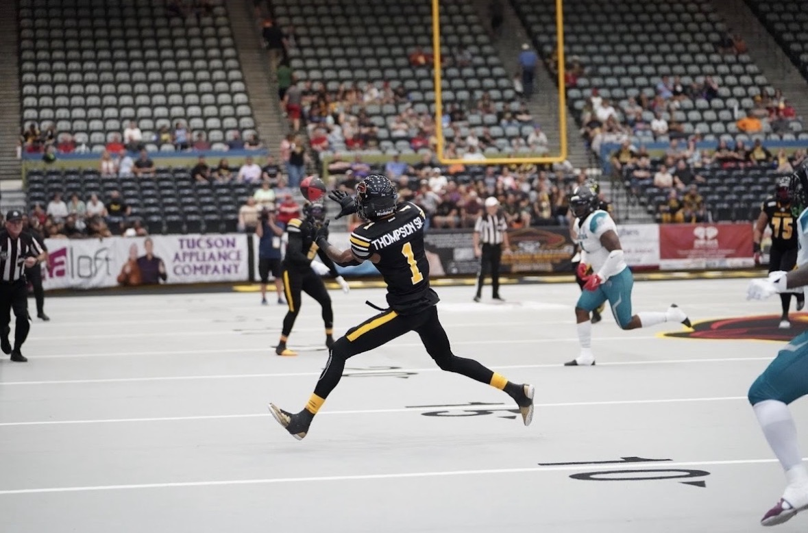  Existing Carrington athletic / community image from source document | 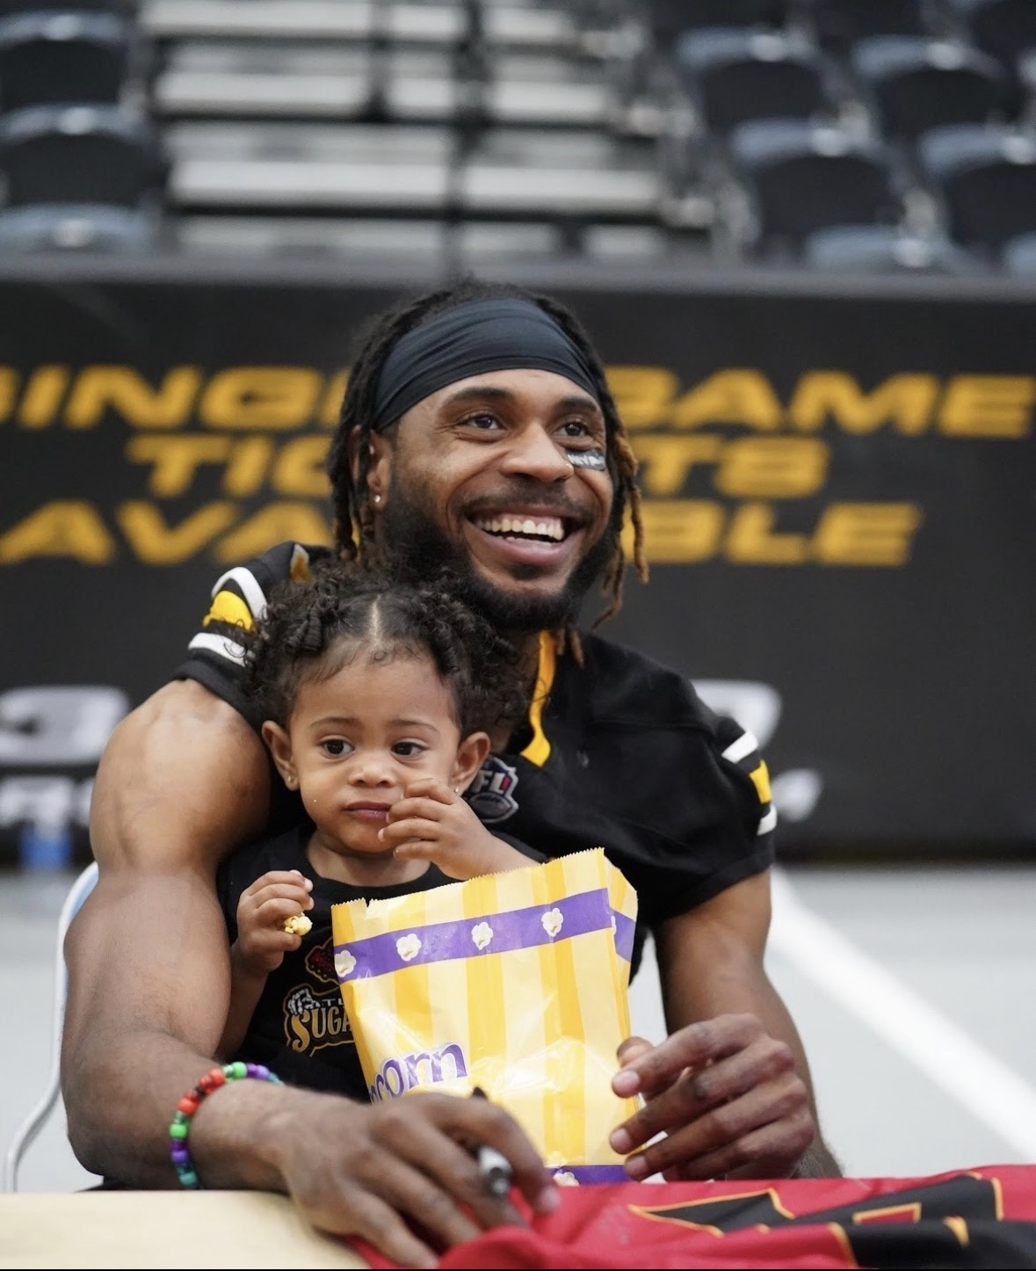  Existing Carrington athletic / community image from source document

Online Media Shortlist
The sources below contain Carrington-specific images and/or video that are useful for design research. They are not automatically cleared for republication. The site should link/embed only where the publisher provides an embed mechanism or where Carrington/the photographer confirms usage rights.
Source | Media available | Recommended use | URL
Western Michigan official roster/profile | Official roster image and player profile | Strong candidate for historical career section; obtain permission or use a Carrington-owned original if available | Open source
WMU vs. Eastern Michigan recap | Official story around 177-yard, 2-TD career game | Use as citation/link; check page media rights separately | Open source
FOX 17 feature | Video profile: “Carrington Thompson chases football dream with Ironmen” | Excellent “In the Media” link; embed only if publisher player/embed permits | Open source
Local Sports Journal: Muskegon Mustangs | Video + photos, including game-winning catch | Strong visual evidence; request photographer/publisher permission for stills | Open source
Local Sports Journal: 2018 championship | Championship coverage + photos; five TD catches | Use for story/citation; permission required for photos | Open source
Local Sports Journal: 2019 Indianapolis | Video + photo of Carrington carrying the ball | Potential media page link / video embed if supported | Open source

Media Rights Workflow for Codex
- Prefer images already supplied by Carrington / client in the project files.
- For every online photo, record source URL, photographer if shown, publisher, and proposed placement.
- Do not hotlink third-party images into production.
- Do not download and publish a news/sports photo simply because it is publicly viewable.
- Where a video platform/publisher provides a supported embed, use the official embed and preserve attribution. Otherwise link to the source page.
- If rights are unclear, create a polished placeholder and mark it [NEEDS CLIENT MEDIA / USAGE PERMISSION].
- Ask Carrington for original WMU, Ironmen, training-session, and athlete-action files. Those will produce the strongest and safest finished site.
FOR THE DESIGN AGENT

Visual Direction Guidance
The site should feel competitive, precise and athletic without falling into generic “sports template” patterns. The existing NextPhaze logo establishes black, metallic gold and white as the core visual palette.
- Use black / near-black as structural grounding, not as a constant flat background for every section.
- Use gold as a controlled performance accent for numbers, rules, focus states and key CTAs.
- Use authentic Carrington photography as the visual anchor. Avoid generic stock athletes when a real image can serve the same purpose.
- Use the #15 and receiving stat language as subtle editorial motifs, not oversized decorative gimmicks.
- Let performance data behave like sports editorial graphics: concise numbers, strong hierarchy, restrained labels.
- Favor directional crop, motion, field markings, split layouts and strong typography over glass cards and gradient blobs.
- On mobile, preserve narrative rhythm: credibility → training value → coach proof → programs → booking. Do not merely stack desktop modules.

Three Art-Direction Starting Territories
A. Championship Editorial — Sports-magazine energy: dramatic authentic photography, strong typographic grid, stat callouts, newspaper/editorial sequencing, minimal containers.
B. Training Lab — Performance-development aesthetic: dark technical surfaces, timing/measurement motifs, linework, motion diagrams, precise spacing, controlled gold accents.
C. Journey / Next Phase — Narrative-forward composition built around progression: Lamar → Northwood → WMU → Ironmen → NextPhaze, with asymmetric milestones and athlete-development messaging.
The design agent should generate all three as genuinely different concepts, then choose one only after evaluating business goals, media quality, mobile behavior, and conversion clarity.
BEFORE PUBLISHING

Client Verification Checklist
- Confirm preferred public name: Carrington Thompson vs. Carrington Thompson Sr.
- Confirm whether Carrington actually played in the AFL and/or IFL. If yes, provide team names, seasons, and any supporting roster/media links.
- Confirm training location(s), city, service radius, indoor/outdoor setting, and parking/access instructions.
- Confirm athlete age range and whether younger children require a parent/guardian to remain on site.
- Confirm session duration, group maximum, and whether $30/$60 prices apply to all session lengths.
- Confirm cancellation, reschedule, no-show, refund, weather and late-arrival policies.
- Confirm business payment processor and whether cash payment remains available.
- Confirm waiver / release requirements and who supplies the legal language.
- Confirm current certifications, CPR/AED status, coaching roles or training credentials, if any, before adding them.
- Confirm media ownership / permissions for the three existing images and provide original high-resolution versions when possible.
- Request original WMU #15 photos, Ironmen photos, personal highlight video files, current training photos/videos, and any parent/athlete testimonials with written permission.
BUILD CONSTRAINTS

Implementation Requirements for the Frontend Design Agent
- Treat this document as the content source of truth. Do not fabricate facts or “improve” statistics.
- Follow the repository AGENTS.md non-negotiable sequence before coding: project brief → three art directions → selected direction/rationale → information architecture → page specification → implementation.
- Use the design-discovery, industry-design-research, art-direction-generator, information-architecture, page-content-planner and frontend-ui-builder skills in sequence.
- After implementation, run visual-design-review, responsive-design-review, accessibility-audit, technical-seo-audit, performance-review, anti-template-review and website-qa.
- Target WCAG 2.2 AA, semantic HTML, keyboard support, visible focus, 320px no-overflow and strong contrast.
- Test at 375, 390, 768, 1024 and 1440 pixels.
- Keep exactly one descriptive H1 per normal content page and provide unique title/meta descriptions.
- Do not claim online images are licensed. Keep a media provenance file in the repo.
- Do not use synthetic athlete imagery in a way that could imply the person is Carrington or an actual NextPhaze client.
- Optimize images (responsive srcset / modern formats), lazy-load non-critical media, and avoid autoplay video with sound.
- The primary conversion is “Book a Session.” Keep that path visible without turning every section into a CTA.
VERIFIED PUBLIC SOURCES

Research References
These references support the athletic-history additions in this document. Publication dates and pre-bowl statistics explain why some official 2016 documents show incomplete season totals. Final season totals should use completed-season statistical sources.
Western Michigan official player profile — Roster identity, 2015 summary, Northwood totals, high school background. https://wmubroncos.com/sports/football/roster/carrington-thompson/4346
Sports-Reference: Carrington Thompson — Final WMU 2015 and 2016 season totals. https://www.sports-reference.com/cfb/players/carrington-thompson-1.html
Sports-Reference: 2016 Western Michigan — 13–1 season, final ranking and team context. https://www.sports-reference.com/cfb/schools/western-michigan/2016.html
WMU 2016 Cotton Bowl guide — Pre-bowl player profile, Eastern Michigan career game and MAC Championship production. https://s3.us-east-2.amazonaws.com/sidearm.nextgen.sites/wmich.sidearmsports.com/documents/2016/12/19/Western_Michigan_Complete_Bowl_Guide.pdf
WMU vs. Eastern Michigan recap — Eight catches, 177 yards, two touchdowns. https://wmubroncos.com/news/2016/10/22/football-no-20-wmu-keeps-perfect-record-in-tact-fights-past-emu.aspx
WMU spring game — 53-yard spring-game reception; 3 catches, 85 yards; threat opposite Corey Davis. https://wmubroncos.com/news/2016/4/16/210894098.aspx
WMU spring scrimmage — Two highlight touchdowns and senior-season emergence. https://wmubroncos.com/news/2016/3/31/210850329.aspx
Local Sports Journal: 2018 championship — MPIF title, five touchdown catches, kickoff-return TD. https://localsportsjournal.com/2018/04/ironmen-hold-off-late-midway-rally-win-mpif-championship-game-68-44/
Local Sports Journal: 2019 season preview — 2018 MPIF Offensive Rookie of the Year. https://localsportsjournal.com/2019/03/new-league-same-goal-ironmen-open-on-saturday-prepared-to-push-for-another-title/
FOX 17: Carrington Thompson chases football dream with Ironmen — Ironmen profile, AFL/CFL interest, coach comments and youth/community context. https://www.fox17online.com/2019/05/28/carrington-thompson-chases-football-dream-with-ironmen
Local Sports Journal: Chicago Blitz — 7 catches, 55 yards, 3 receiving TDs, 50-yard kick return. https://localsportsjournal.com/2018/03/ironmen-build-a-big-early-lead-claim-a-68-41-victory-over-the-chicago-blitz/
Local Sports Journal: Muskegon Mustangs — Game-winning touchdown with three seconds left; video and photos. https://localsportsjournal.com/2019/05/video-west-michigan-ironmen-hold-on-in-qb-shootout-with-the-muskegon-mustangs/
Local Sports Journal: Indianapolis finale — Two touchdown catches; video/photo source. https://localsportsjournal.com/2019/06/ironmen-warm-up-for-the-playoffs-with-a-62-12-victory-over-indianapolis-enforcers/
Wisconsin Badgers Cotton Bowl matchup article — Independent opponent preview noting Thompson’s impact and 177-yard game. https://uwbadgers.com/news/2017/1/2/football-matchups-to-watch-wisconsin-vs-western-michigan
SOURCE OF TRUTH

Final Publication Rules
SAFE TO PUBLISH AS VERIFIED
Western Michigan #15; wide receiver; 2015/2016 WMU stats; Northwood totals reported by WMU; combined collegiate totals when properly labeled; 2016 MAC Championship; Cotton Bowl team; Eastern Michigan 8/177/2 career game; 2018 MPIF championship; five TD catches in the championship game; 2018 MPIF Offensive Rookie of the Year; West Michigan Ironmen experience.

NEEDS CARRINGTON CONFIRMATION
Specific AFL playing experience; specific IFL playing experience; current certifications; current coaching affiliations; current training location; age limits; session duration; athlete/client results; testimonials; legal waiver language; rights to third-party photos and video.

Once these client-input items are confirmed, update this document and the website together so the site remains factually aligned with the source of truth.

