# CSD-325 – Module 7 Assignment

Jadon Argo  
Assignment 7: Test Cases – city_functions.py and test_cities.py

## Screenshots and Results

1. 1. 1. Initial Output: city_country(city, country)

Executed city_functions_v1.py with three function calls using only city and country.  
  
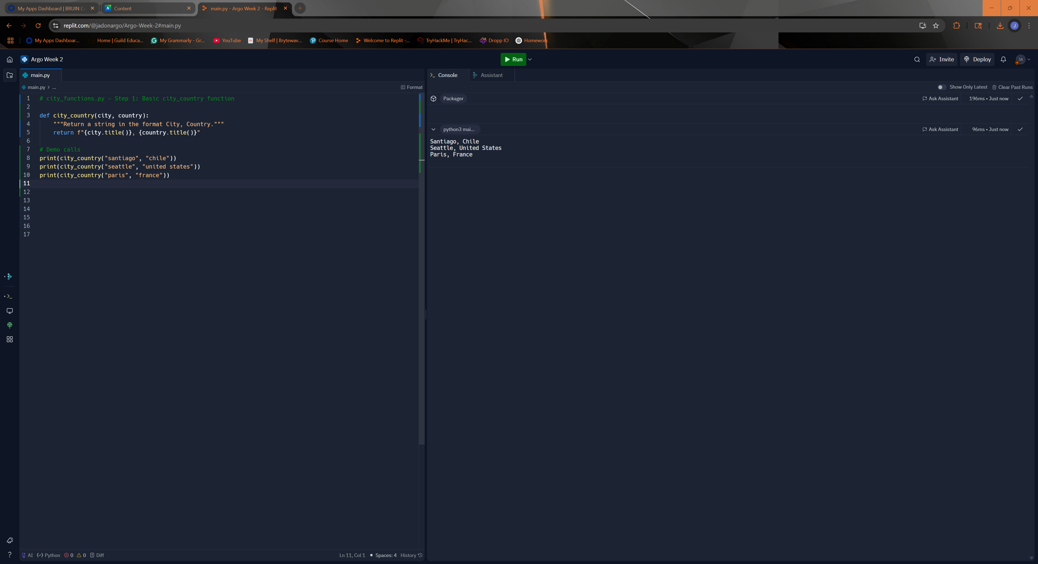

1. 2. 2. Unit Test: test_city_country() passes

Ran test_cities.py with city_country() from version 1. Test passed successfully.  
  
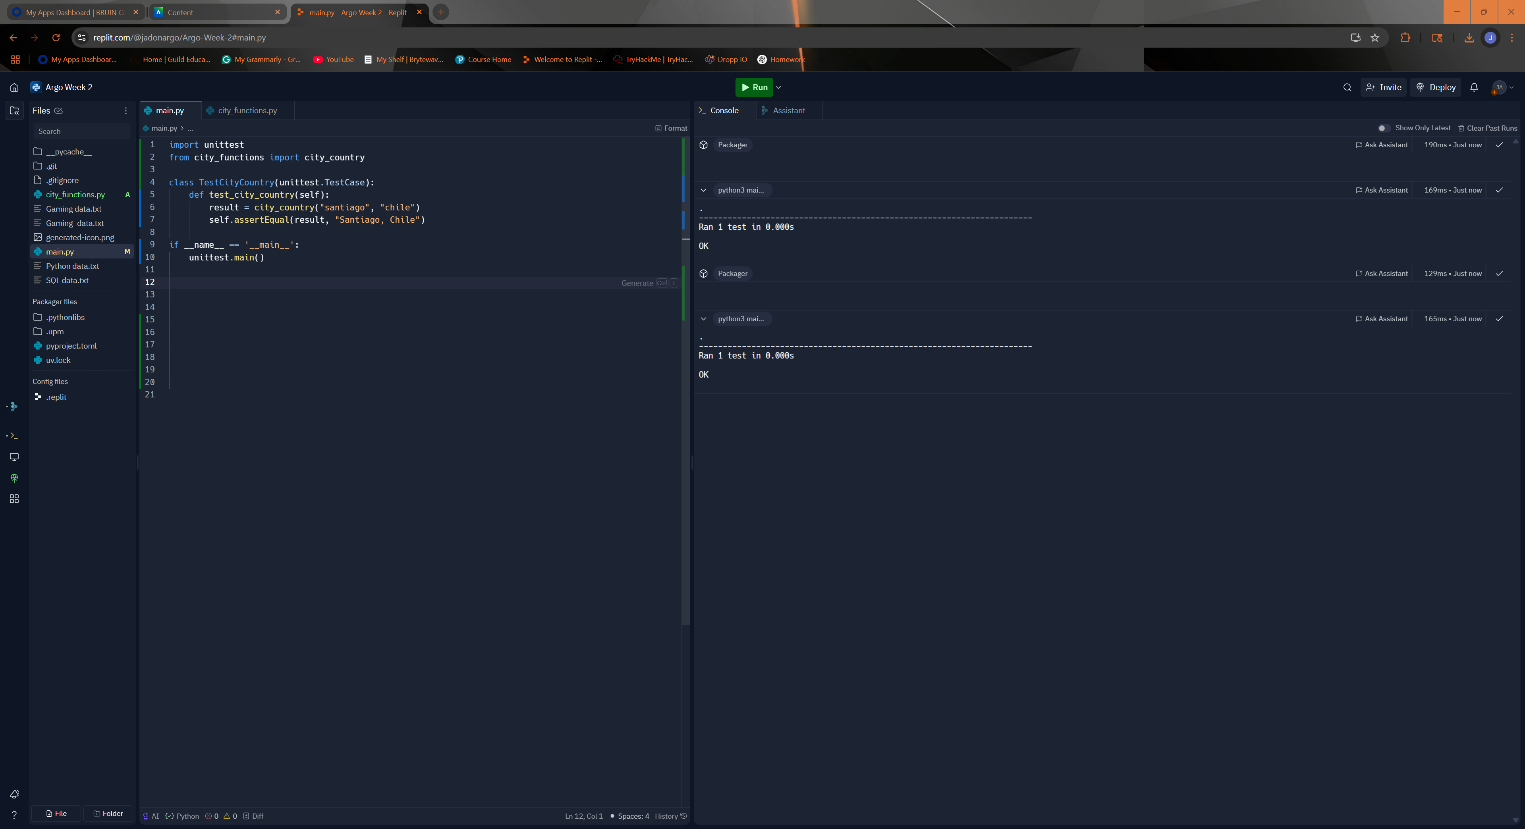

1. 3. 3. After Adding Required Population Param (Expect Failure)

Modified city_country() to require population. Ran test_cities.py and test failed as expected.  
  
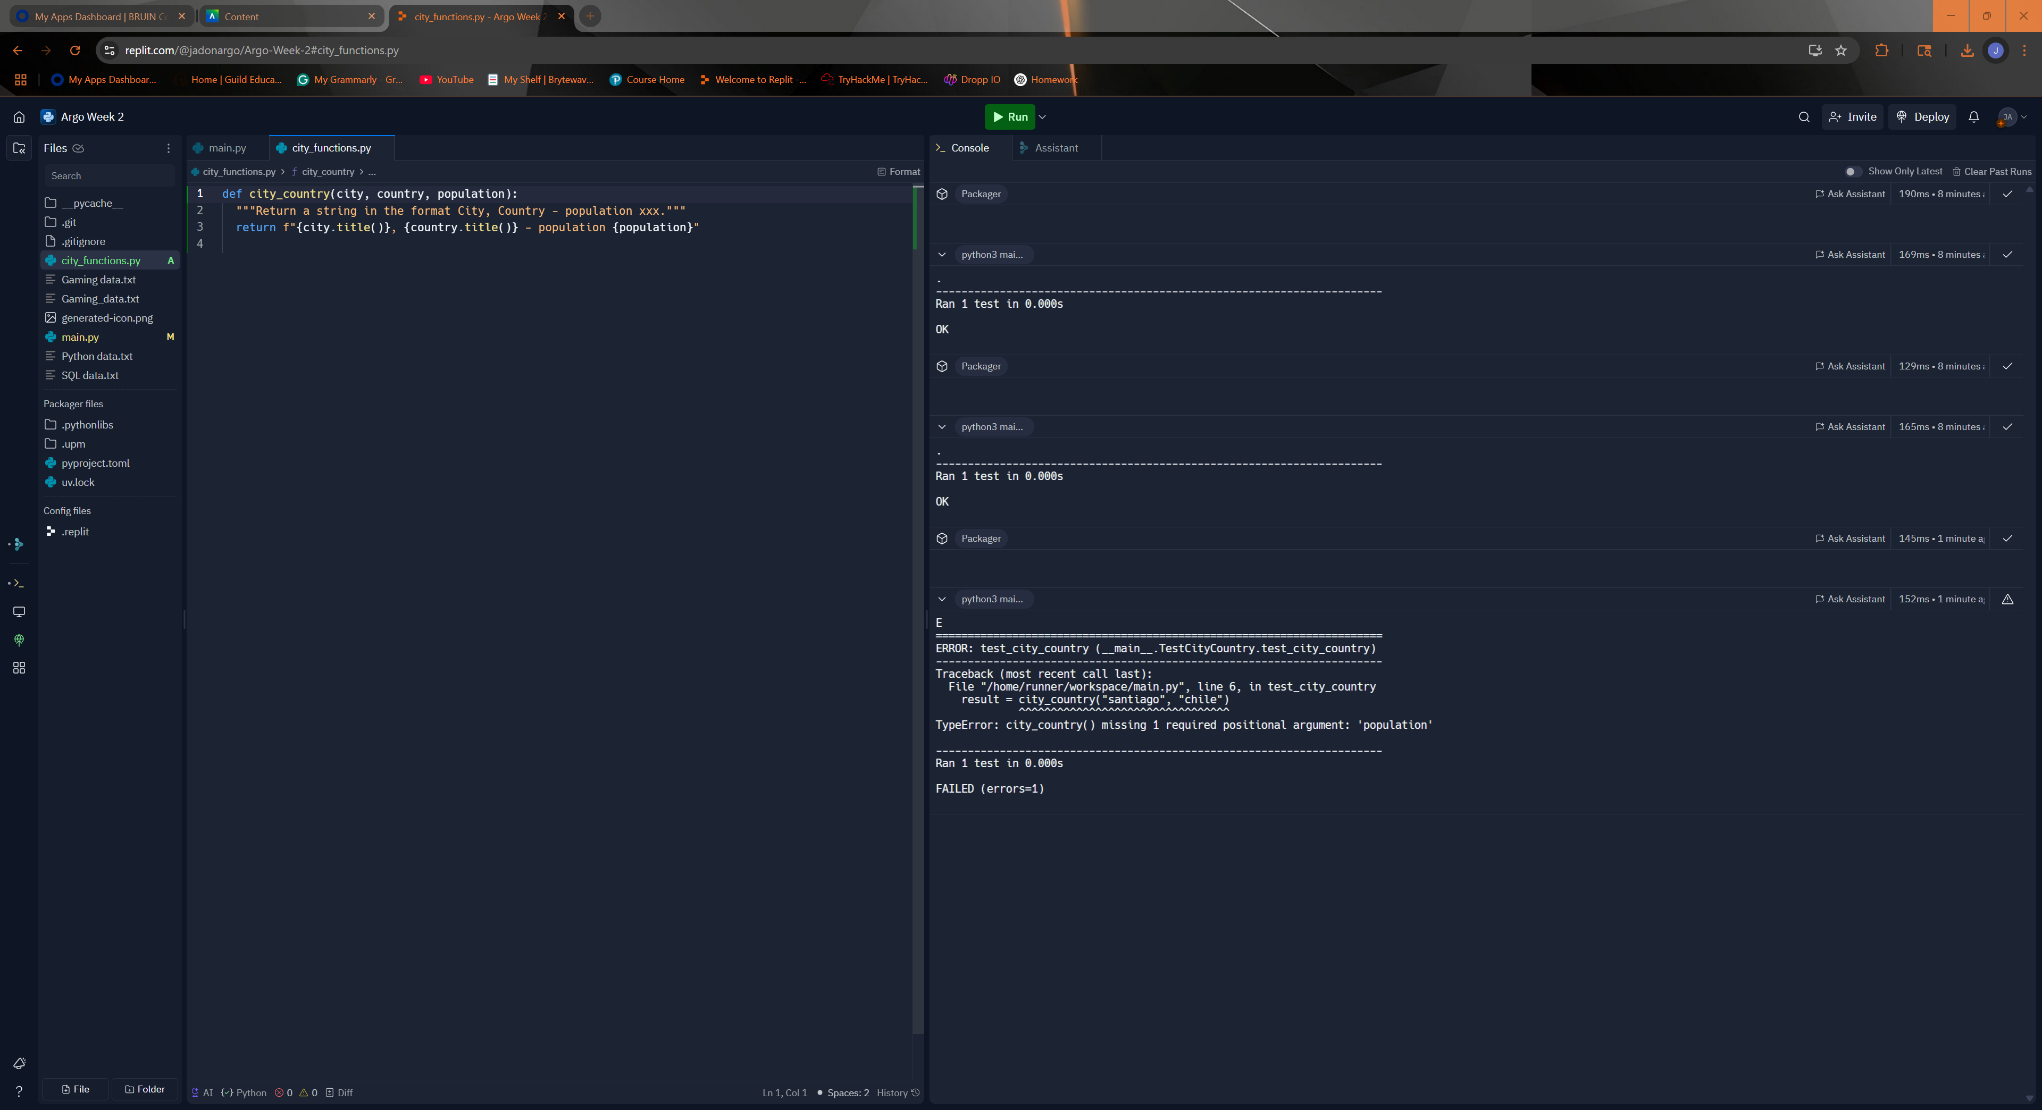

1. After Making Population Optional (Expect Pass)

Updated city_country() so population is optional. Reran test_cities.py and it passed.  
  
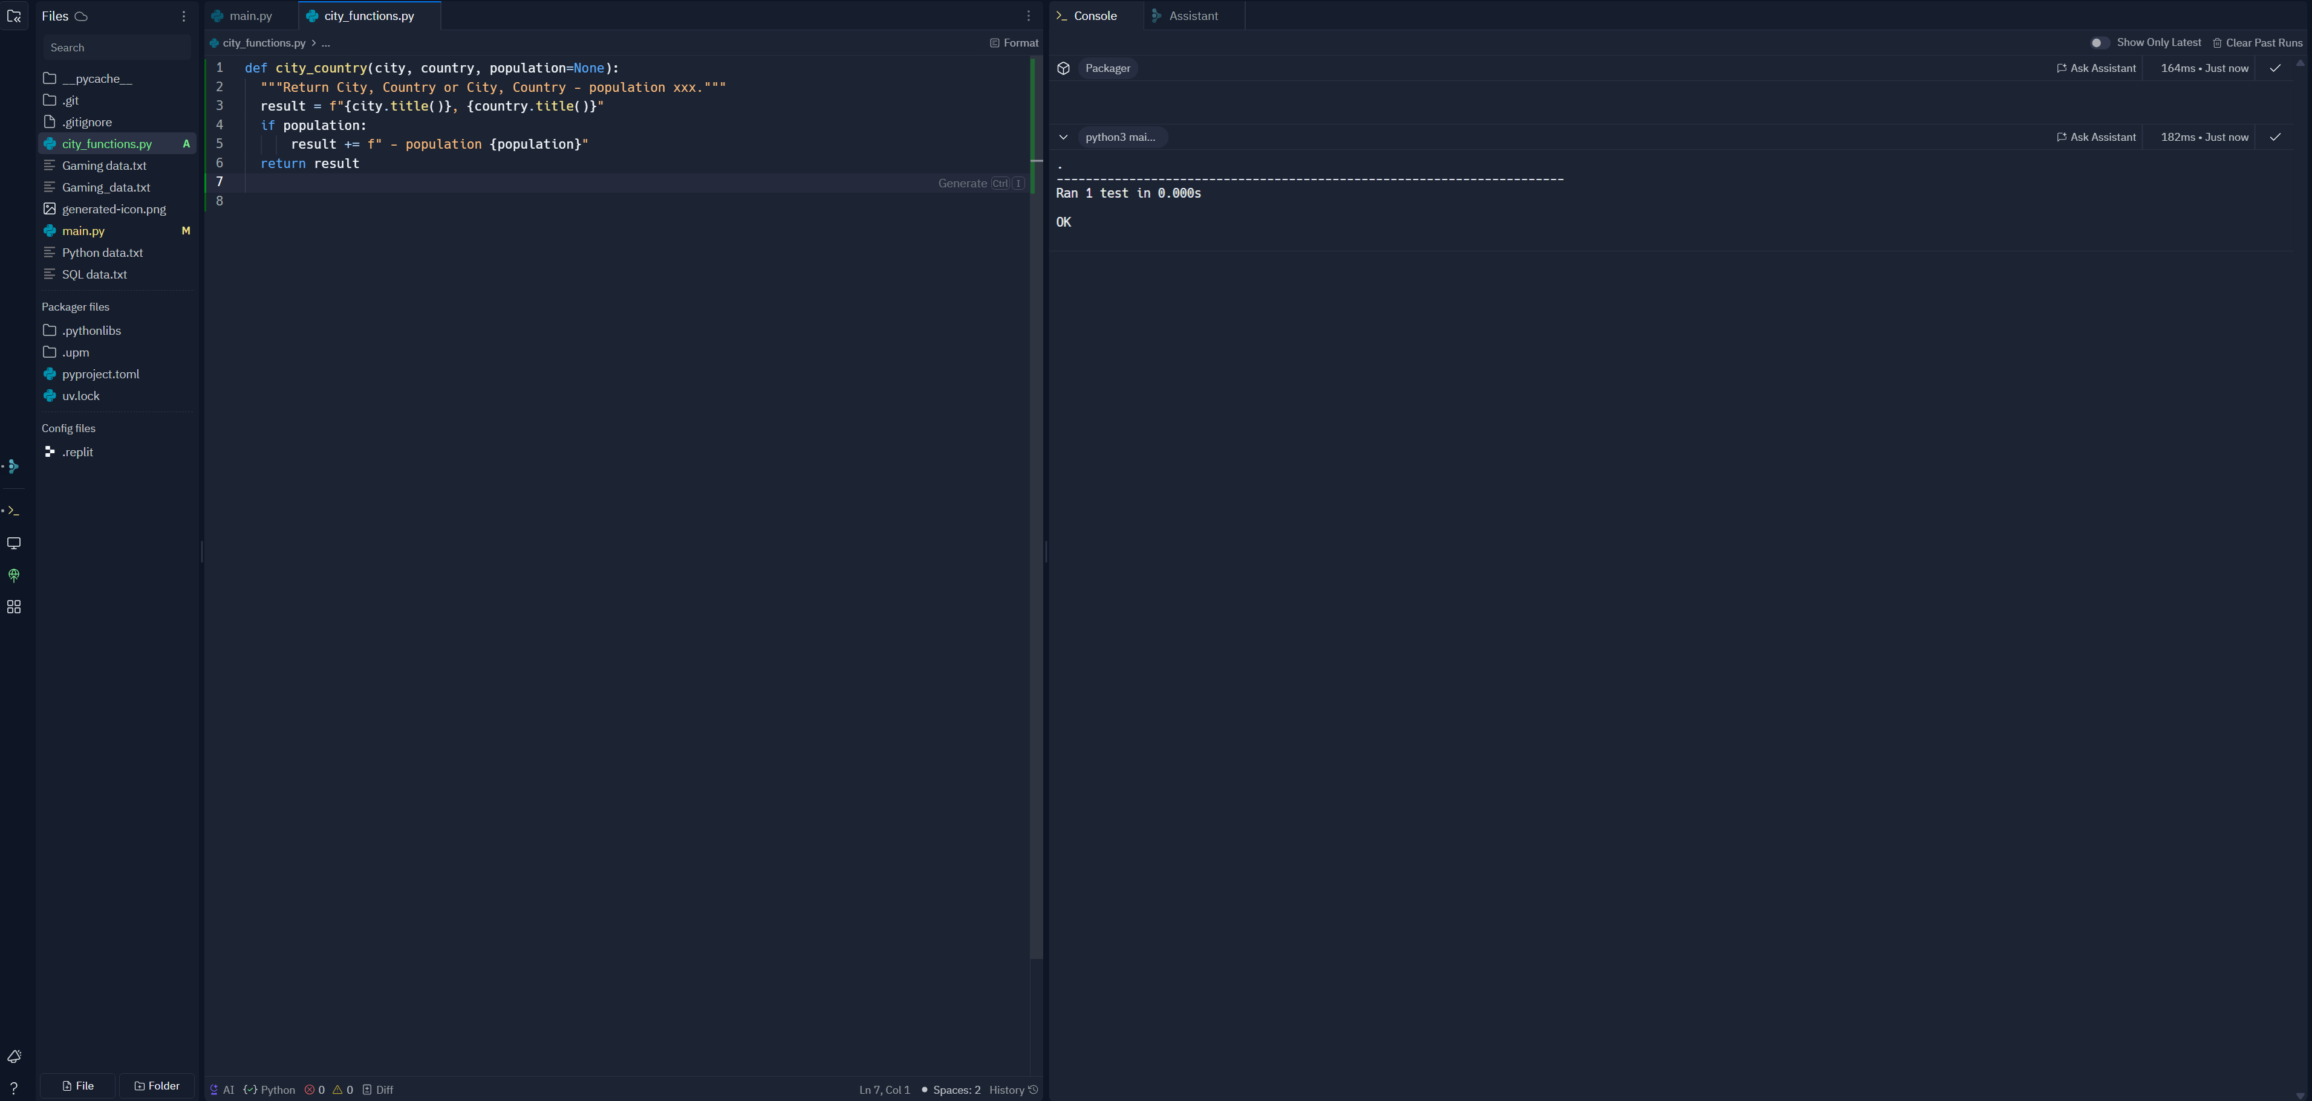

1. 5. 5. After Adding Required Language Param (Expect Failure)

Modified city_country() to require a fourth parameter, language. test_cities.py failed again.  
  
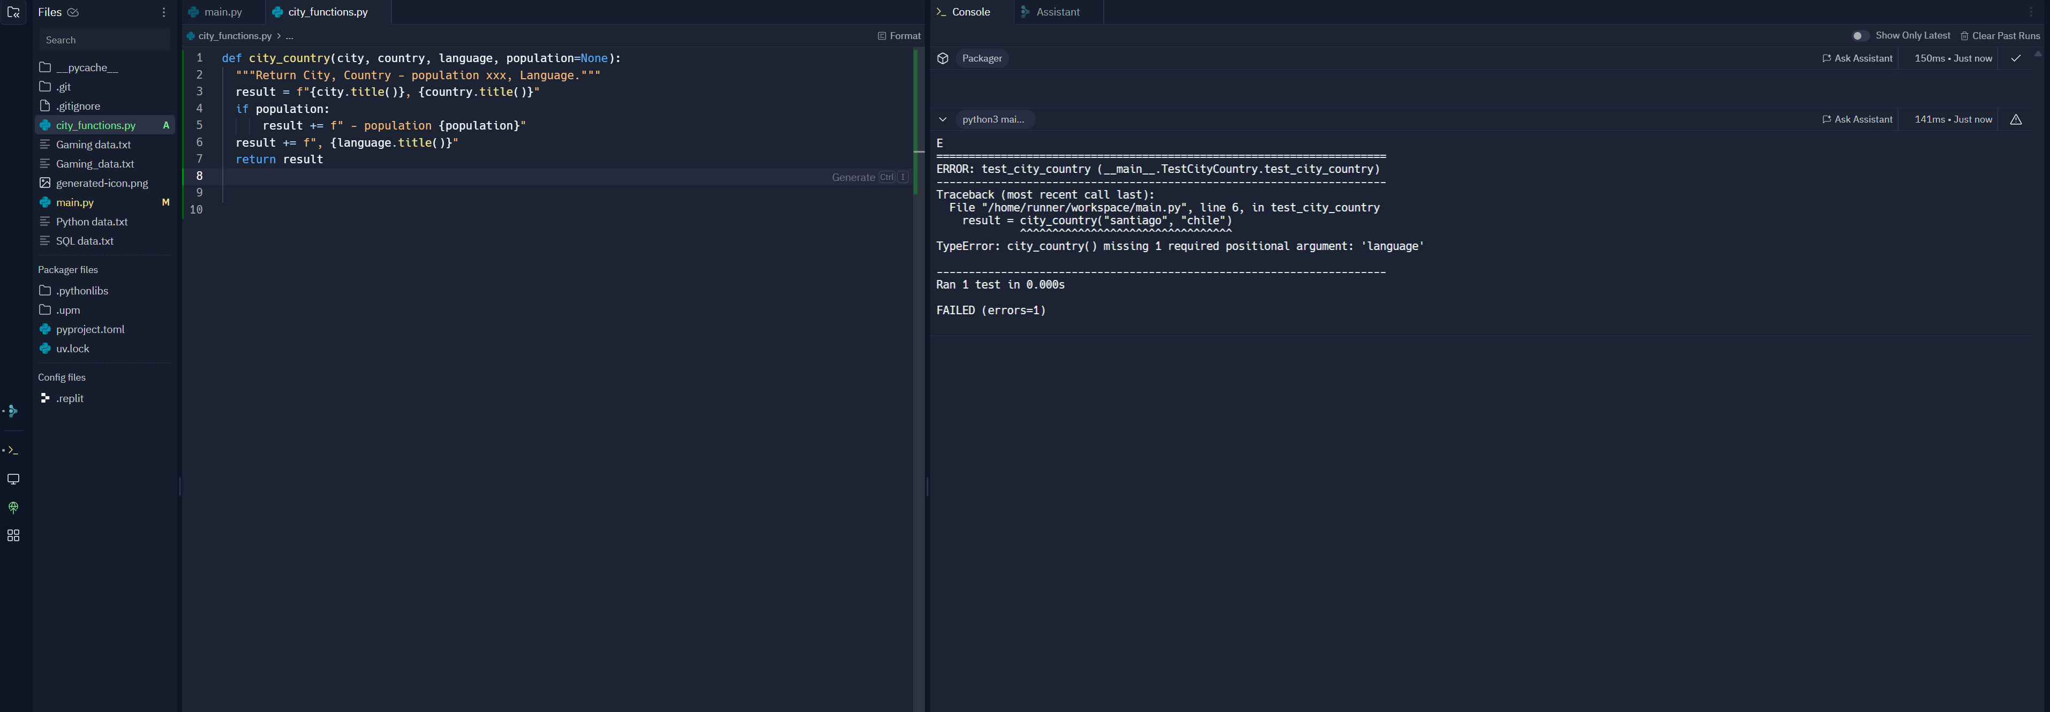

1. 6. 6. After Making Language Optional (Expect Pass)

Made language optional in city_country(). test_cities.py passed after this update.  
  
1. 7. 7. Final Output Using All Param Types

Ran city_functions_final.py calling city_country() with:  
 • City, Country  
 • City, Country, Population  
 • City, Country, Population, Language  
All outputs rendered correctly.  
  
