CSD 402 - Java for Programmers
Assignment 6 - Fan Class
Jadon Argo
October 18, 2026
Assignment Overview
This program creates a Fan class that demonstrates object-oriented programming through private fields, constants, overloaded constructors, accessor and mutator methods, and a toString() method. The main method tests two Fan instances and displays their states before and after changing field values.
GitHub Repository
https://github.com/FliporFlop1/csd-402
Program Location
C:\csd\csd-402\module-6\Fan.java
Required Class Features
• Speed constants: STOPPED = 0, SLOW = 1, MEDIUM = 2, FAST = 3.
• Private fields: speed, on, radius, and color.
• Default constructor: speed 0, off, radius 6.0, white.
• Parameterized constructor: sets the four fields from supplied arguments.
• Getters and setters for all four fields, plus a toString() description.
• Test code: creates two Fan objects and exercises constructors, setters, getters, and toString().

Figure 1 - Module 6 Directory Verification
The directory listing confirms Fan.java was saved in the correct module-6 folder. After testing, the compiled Fan.class file was removed so only the Java source remains.
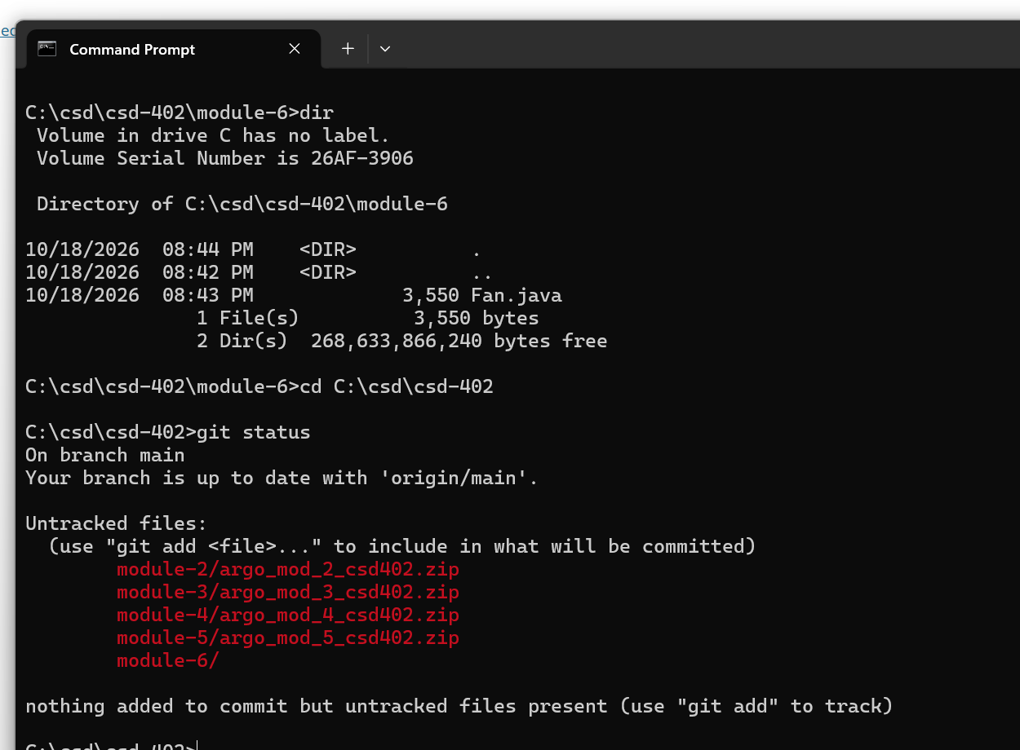

Figure 2 - Compilation and Program Testing
The program ran successfully in Command Prompt. The default fan begins stopped and off with a radius of 6.0 and a white color. The second fan uses the parameterized constructor. The subsequent output demonstrates changing attributes through setters and reading values through getters.
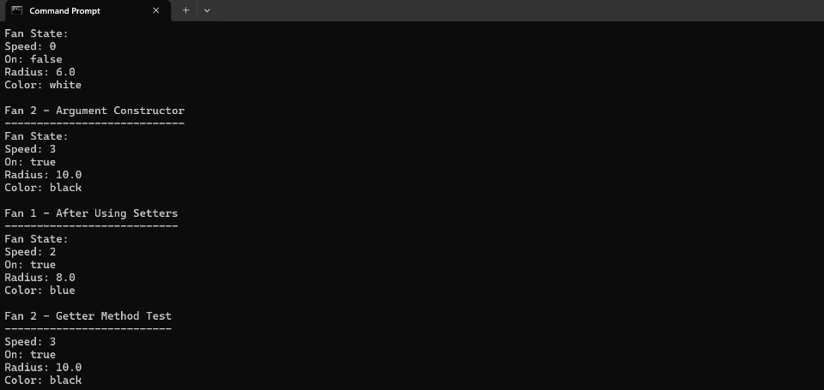
Test Results
• Fan 1 default: speed 0; on false; radius 6.0; color white.
• Fan 2 argument constructor: speed 3; on true; radius 10.0; color black.
• Fan 1 after setters: speed 2; on true; radius 8.0; color blue.
• Fan 2 getters: speed 3; on true; radius 10.0; color black.

Figure 3 - GitHub Source Code Verification
The GitHub screenshot confirms Fan.java was committed to the module-6 folder. The visible source shows the class name, speed constants, private attributes, and constructors.
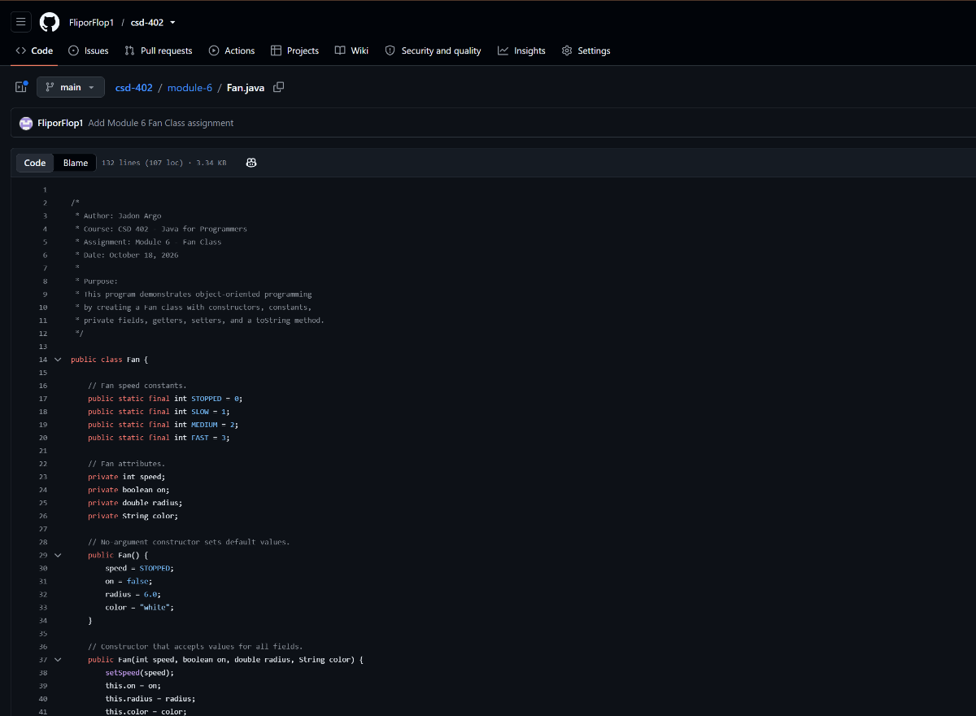
Submission Verification
The Java test demonstrates both constructor types and the functionality of the Fan class methods. The final submission ZIP should contain Fan.java and Jadon_Argo_Module_6_Assignment.docx. The GitHub repository URL will be included in the Blackboard assignment comments.

