CSD 402 – Java for Programmers
Module 9 Programming Assignment: Exception Handling and Text I/O
Jadon Argo
November 8, 2026
Assignment Overview
This assignment consists of two Java programs. Program 1 uses an ArrayList of ten strings, a for-each loop, user input, autoboxing and auto-unboxing, and exception handling for invalid selections. Program 2 creates or appends to a file named data.file, writes ten randomly generated integers separated by spaces, and reopens the file to display its contents.
Program 1: StringArrayList.java
The first program stores ten vehicle manufacturers in an ArrayList<String> and displays them using a for-each loop. The user enters a selection as a String, which is converted to an Integer. The program demonstrates boxing into an Integer object and unboxing to a primitive int before using the selected value as a zero-based list index. A try/catch block handles an out-of-range selection by displaying “Exception has been thrown: Out of Bounds”; a separate catch handles nonnumeric input.
Program 1 Testing and Results
The program compiled using javac StringArrayList.java and ran using java StringArrayList. Entering 3 returned “Selected vehicle: Honda.” Running the program again and entering 15 produced the expected out-of-bounds exception message. Figure 1 documents both test cases.
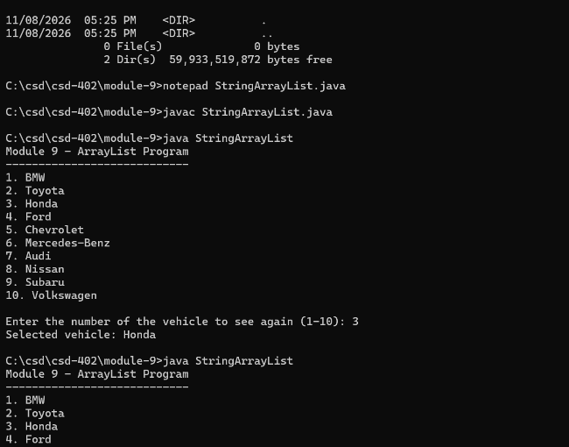
Figure 1. ArrayList valid selection and out-of-bounds exception tests.
Program 2: RandomNumberFile.java
The second program uses Path and Files to check whether data.file exists and contains data. FileWriter opens the file in append mode, creating it if necessary. A loop generates ten random integers from 1 through 100, separated by spaces. A try-with-resources statement closes the writer automatically. The program then reopens the file using Scanner, reads its contents, and displays the saved integers. IOException is handled with a catch block.
Program 2 Testing and Results
The program compiled using javac RandomNumberFile.java. On its first run, it created data.file and wrote ten integers. On its second run, it appended ten more integers without deleting the original values. The type data.file command independently confirmed that the file contained all twenty space-separated numbers. Figure 2 records the file creation, append operation, and verification.
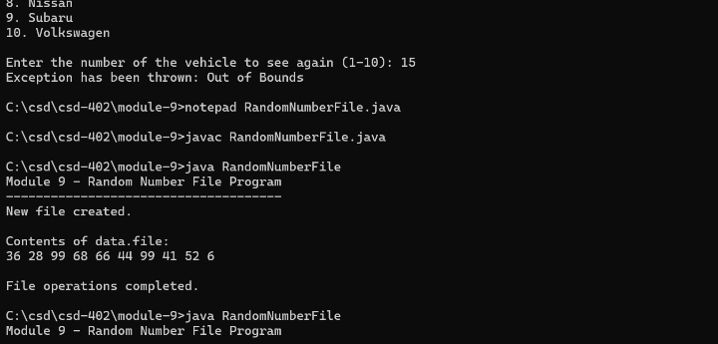
Figure 2. Random-number file creation, append, and contents verification.
GitHub Repository Verification
Both Java source files and data.file were staged, committed, and pushed to the main branch of the CSD402 GitHub repository. Figure 3 confirms the three assignment files appear in the module-9 folder.
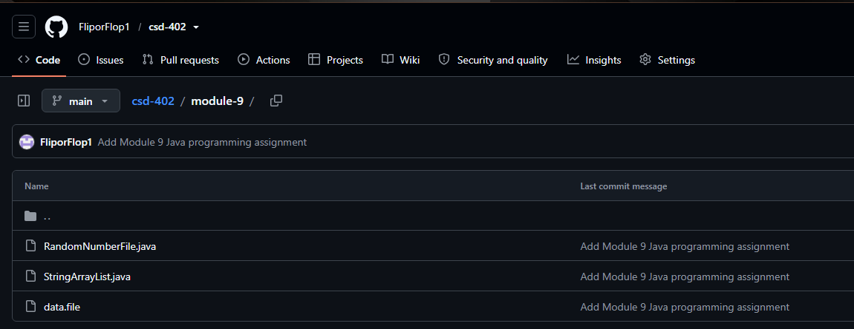
Figure 3. GitHub module-9 directory showing both source files and data.file.
Submission and Conclusion
Repository: https://github.com/FliporFlop1/csd-402/tree/main/module-9
The observed tests confirm that Program 1 displays the ArrayList and handles an invalid index, while Program 2 creates, appends to, closes, reopens, and reads data.file. The Java source files, data.file, and this documentation are intended for inclusion in argo_mod_9_csd402.zip for Blackboard submission.

