CSD 402 – Java for Programmers
GitHub Repository Setup
Jadon Argo

Repository | csd-402
Visibility | Public
Local directory | C:\csd\csd-402
Repository URL | https://github.com/FliporFlop1/csd-402

Setup Verification
The GitHub repository was created as a public repository with a README.md file and the required Python .gitignore file. The repository was then cloned to the local C:\csd directory using Git. The local repository is on the main branch, is synchronized with origin/main, and reports a clean working tree.

GitHub Repository
The screenshot below shows the public csd-402 repository on GitHub, including the repository description, .gitignore, and README.md.
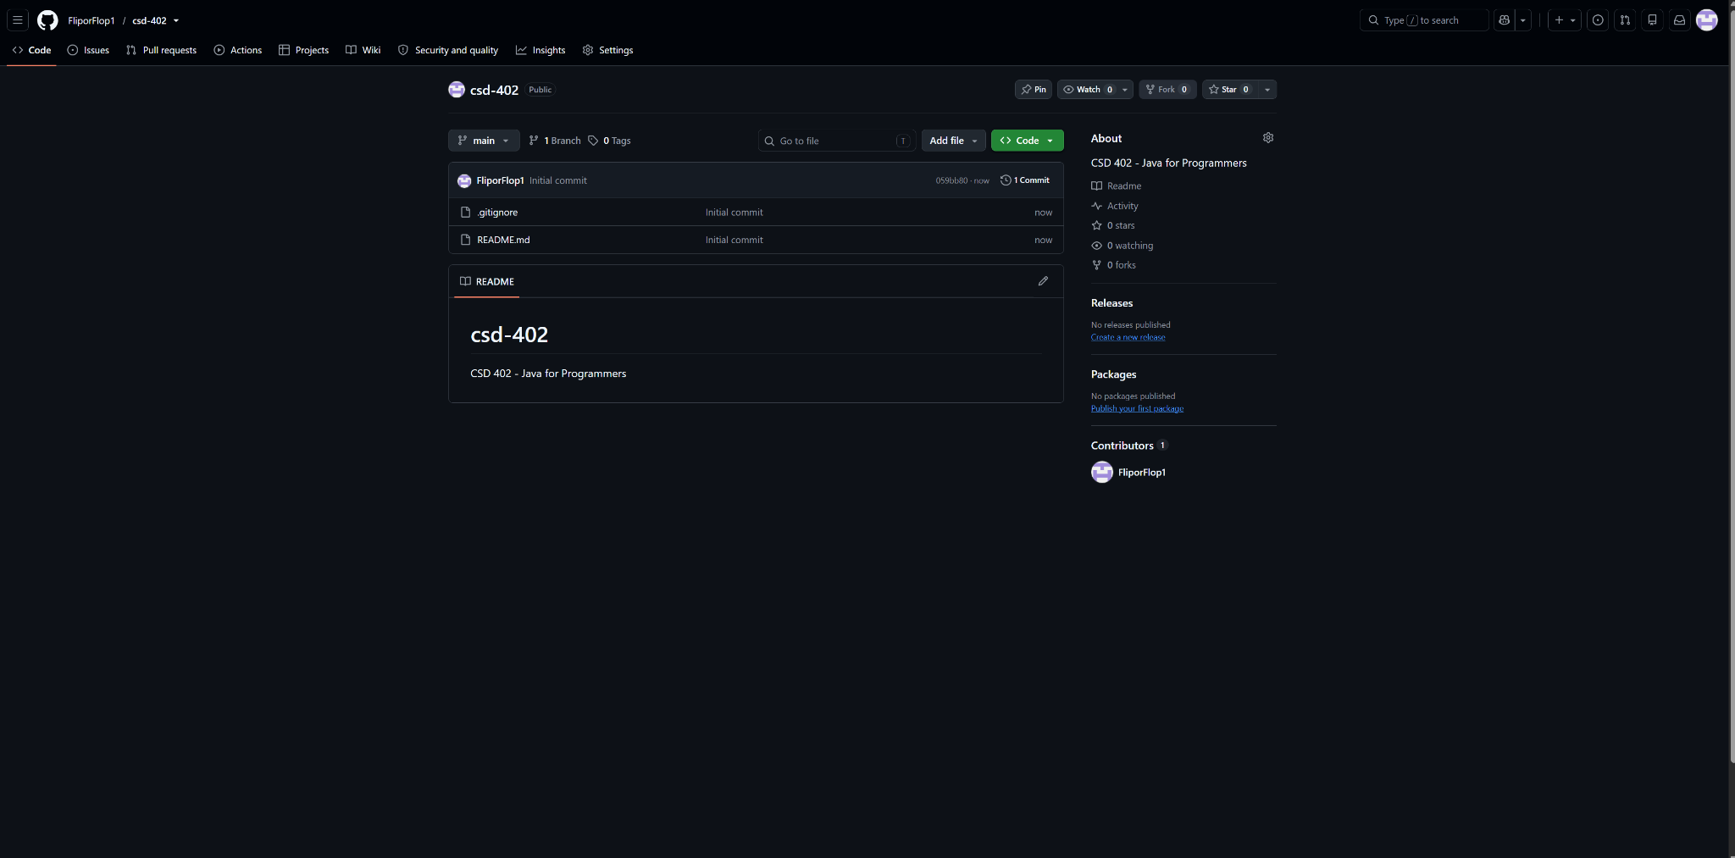
Figure 1. GitHub csd-402 repository.

Local Repository Verification
The screenshot below verifies the required local directory structure. It shows C:\csd\csd-402, the .gitignore and README.md files, and the Git status confirming that the main branch is up to date with origin/main and that the working tree is clean.
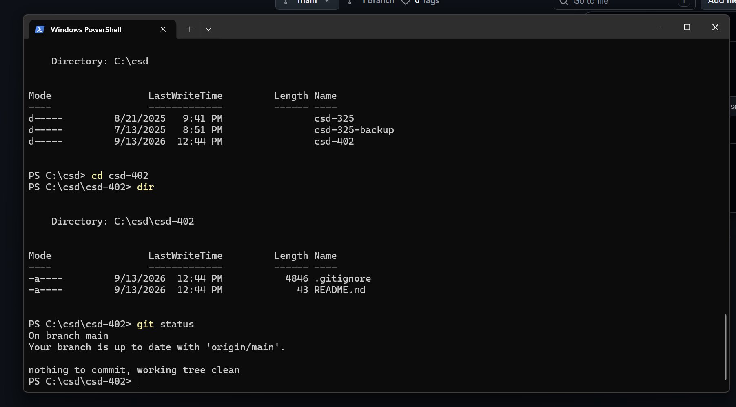
Figure 2. Local csd-402 directory and Git status verification.

Submission Note:
For the assignment link: https://github.com/FliporFlop1/csd-402

