CSD 402 - Java for Programmers
Assignment 5 - Locating Largest and Smallest Array Elements
Jadon Argo
October 11, 2026
Assignment Overview
This program demonstrates overloaded Java methods that locate the largest and smallest elements in two-dimensional arrays. Two methods accept double[][] arrays and two accept int[][] arrays. Each method returns an int[] containing the zero-based row and column indexes of the located element. The main method displays both original arrays and tests all four methods.
GitHub Repository
https://github.com/FliporFlop1/csd-402
Program Location
C:\csd\csd-402\module-5\LocateArrayElements.java
Required Methods
public static int[] locateLargest(double[][] arrayParam)
public static int[] locateLargest(int[][] arrayParam)
public static int[] locateSmallest(double[][] arrayParam)
public static int[] locateSmallest(int[][] arrayParam)

Figure 1 - Module 5 Directory and Source File
The Command Prompt directory listing verifies that LocateArrayElements.java was saved in the correct module-5 folder before compilation.
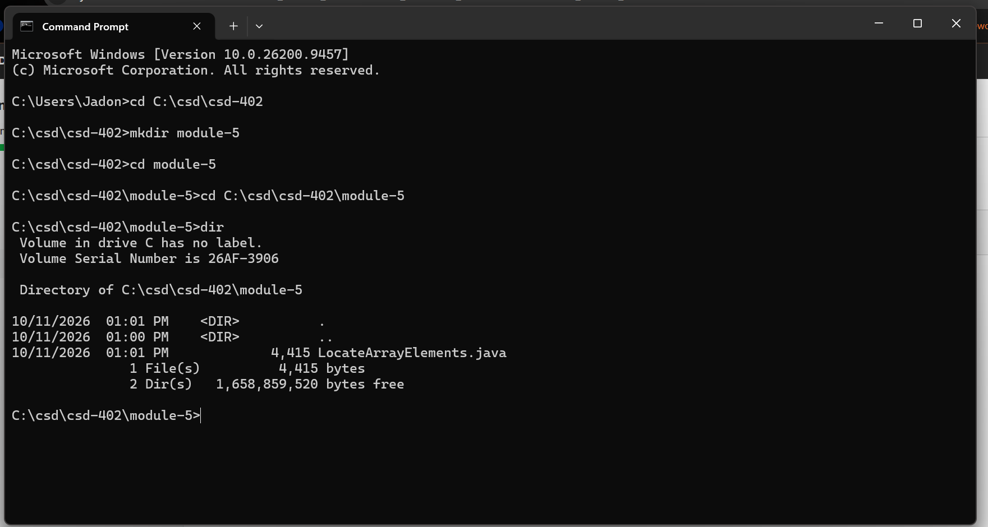

Figure 2 - Compilation and Program Testing
The source compiled successfully using javac and ran using java LocateArrayElements. The displayed results verify the correct zero-based locations for the largest and smallest values in both arrays.
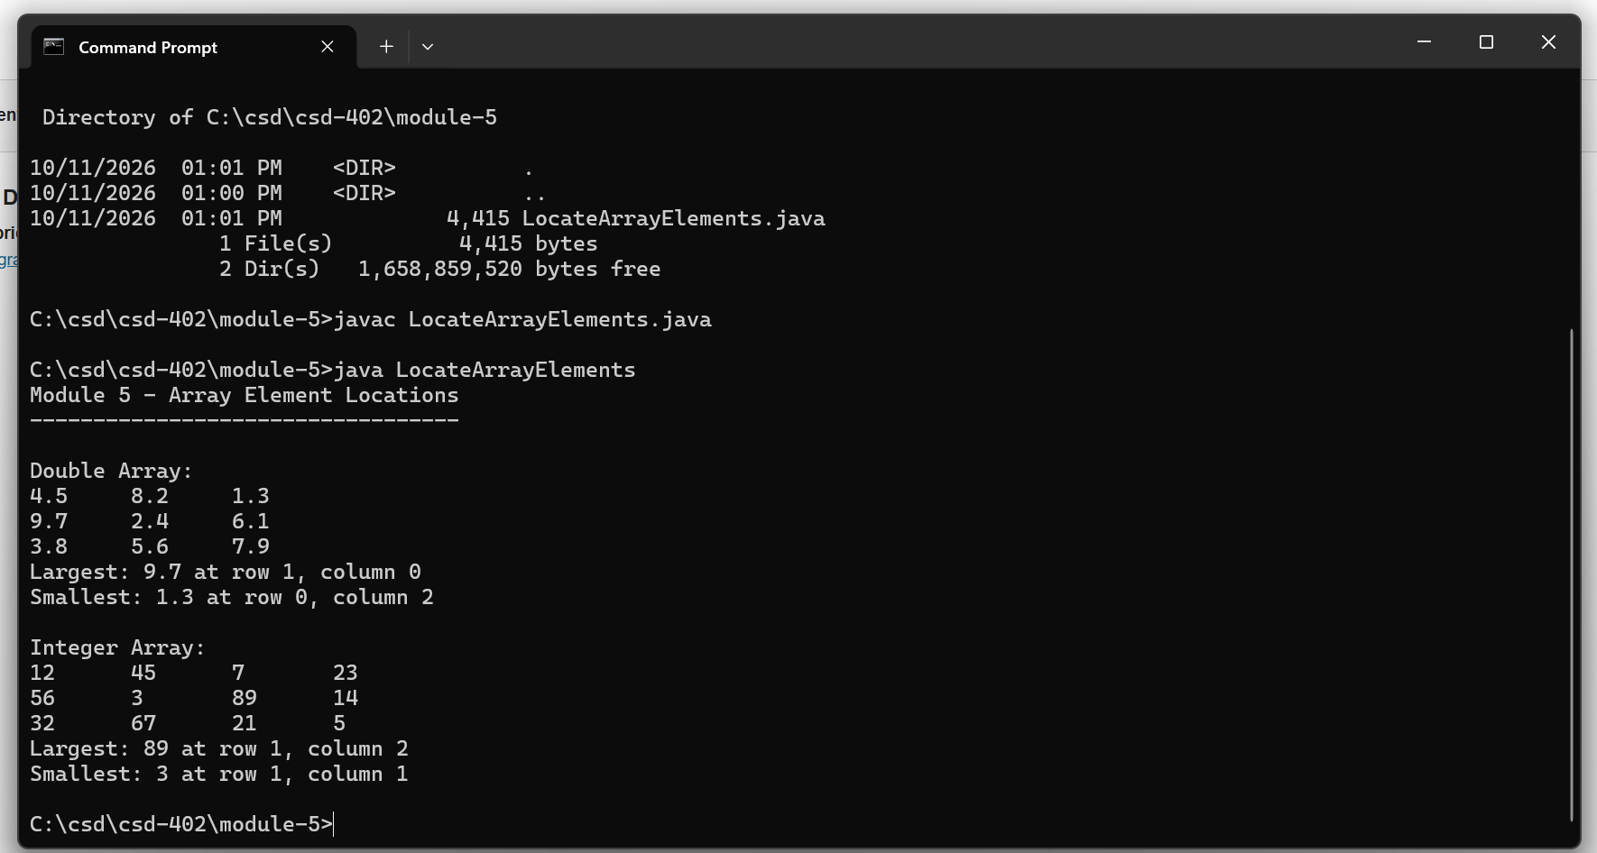

Figure 3 - GitHub Folder Verification
This screenshot confirms that LocateArrayElements.java was committed and pushed to the module-5 directory in the csd-402 GitHub repository.
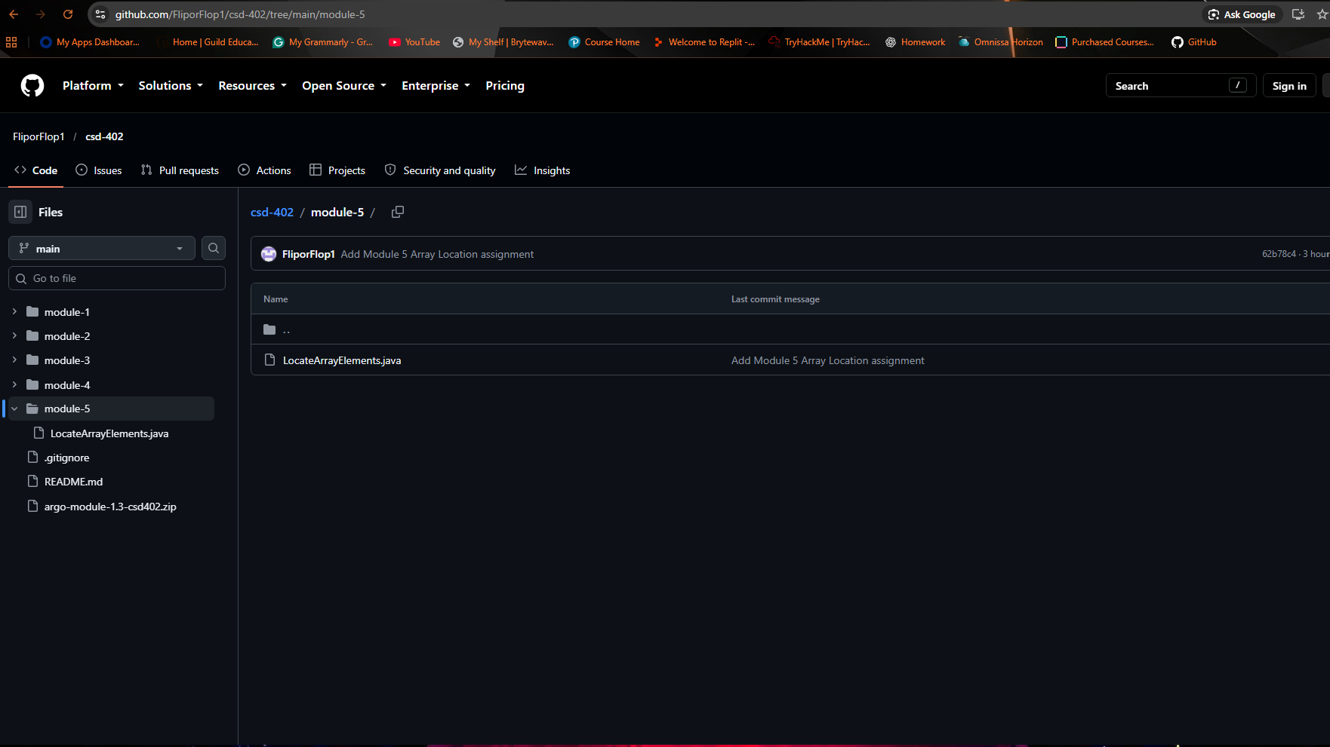

Figure 4 - Source Code and Method Verification
GitHub displays the public class LocateArrayElements and identifies the four overloaded locateLargest and locateSmallest methods, along with the main method used for testing.
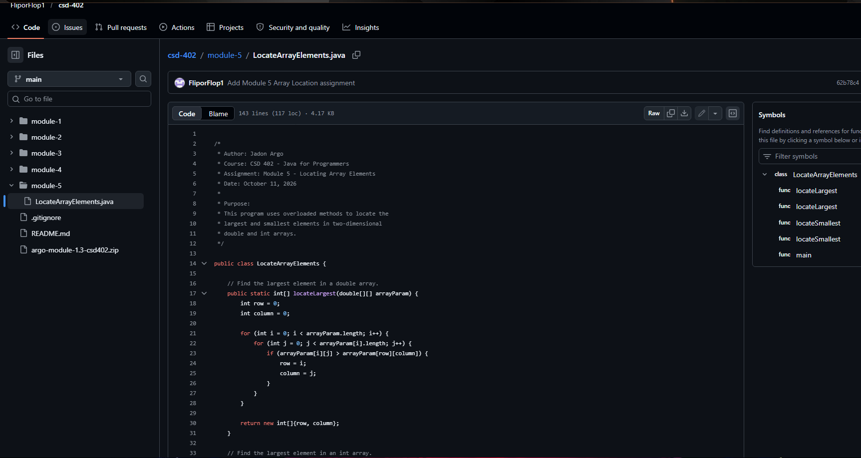

Submission Verification
The test program successfully located the largest and smallest elements in both two-dimensional arrays. Java uses zero-based indexes, so row 0 and column 0 identify the first element in an array.
Double array: largest 9.7 at row 1, column 0; smallest 1.3 at row 0, column 2.
Integer array: largest 89 at row 1, column 2; smallest 3 at row 1, column 1.
Final Submission
The final ZIP will include LocateArrayElements.java and Jadon_Argo_Module_5_Assignment.docx. The GitHub repository URL will be included in the assignment submission comments. The ZIP is for the course submission and does not need to be pushed to GitHub.

