CSD 402 - Java for Programmers
Assignment 2.2 - Rock-Paper-Scissors
Jadon Argo
September 20, 2026

Assignment Overview
This program simulates Rock-Paper-Scissors. The computer randomly generates a value from 1 through 3, where 1 represents Rock, 2 represents Paper, and 3 represents Scissors. The user enters a value from 1 through 3. The program displays both selections and determines whether the user wins, the computer wins, or the game is a tie.
GitHub Repository
https://github.com/FliporFlop1/csd-402
Program File
module-2/RockPaperScissors.java
Figure 1 - Source Code and Documentation
The first portion of RockPaperScissors.java shows the required program documentation, Scanner setup, random computer selection using Math.random(), user instructions, input validation, and the beginning of the switch logic.
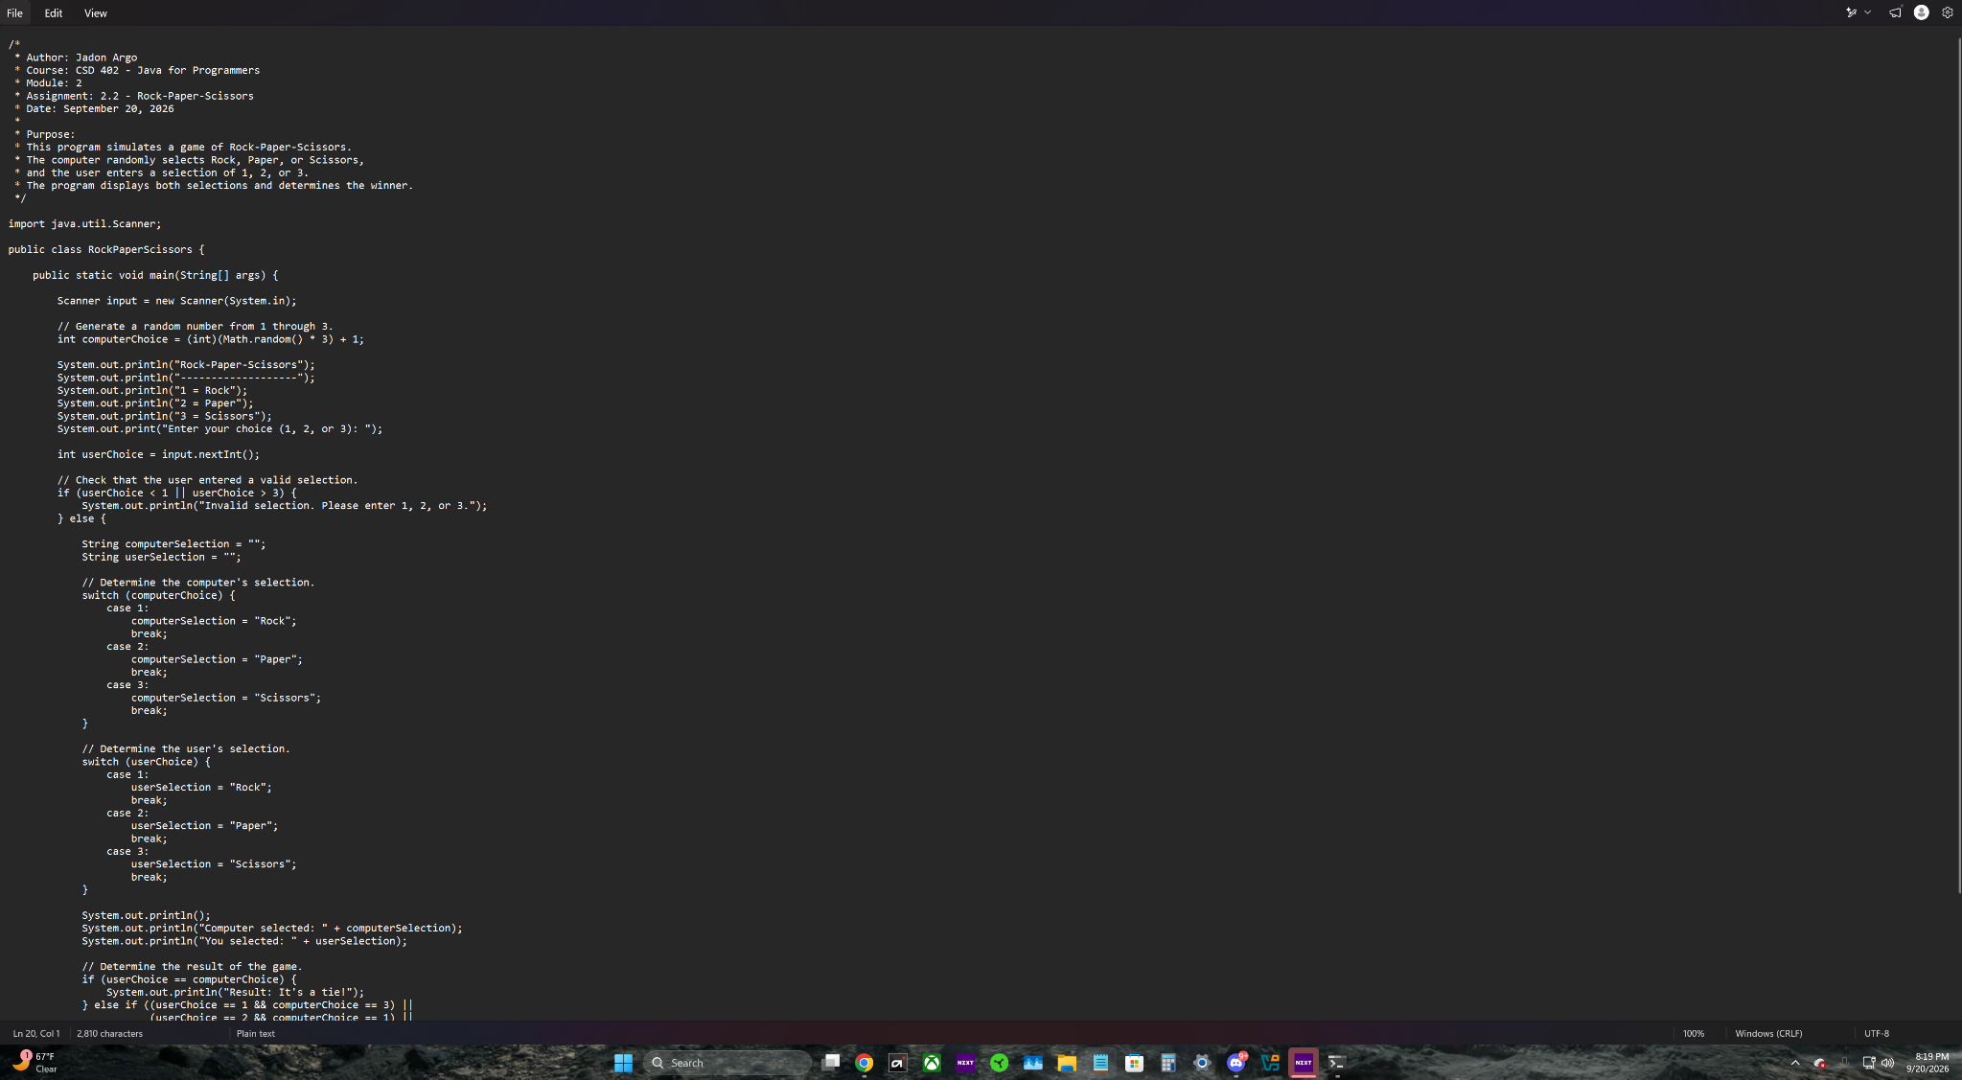
Figure 2 - Game Logic
The remaining source code shows the switch statements used to translate numeric selections into Rock, Paper, or Scissors and the if/else logic used to determine a tie, user win, or computer win.
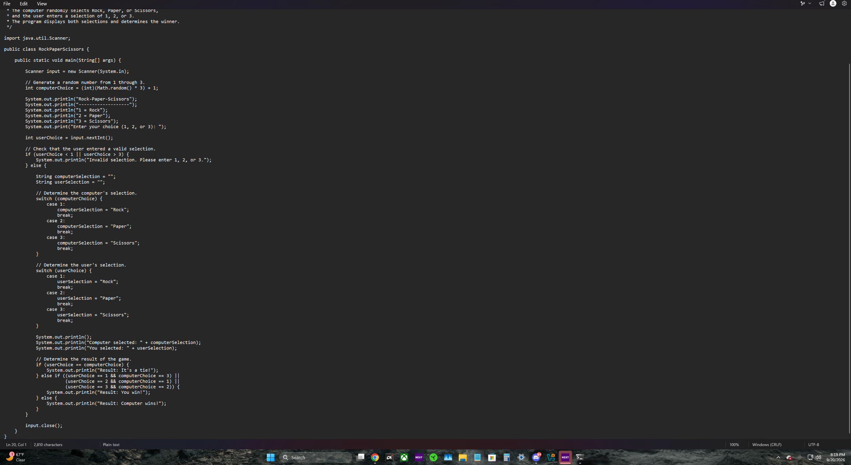
Figure 3 - Compilation and Program Testing
The program compiles successfully with javac. A normal test shows the computer selecting Scissors and the user selecting Paper, producing the correct result that the computer wins. A second test enters 4 and demonstrates the program's invalid-selection message.
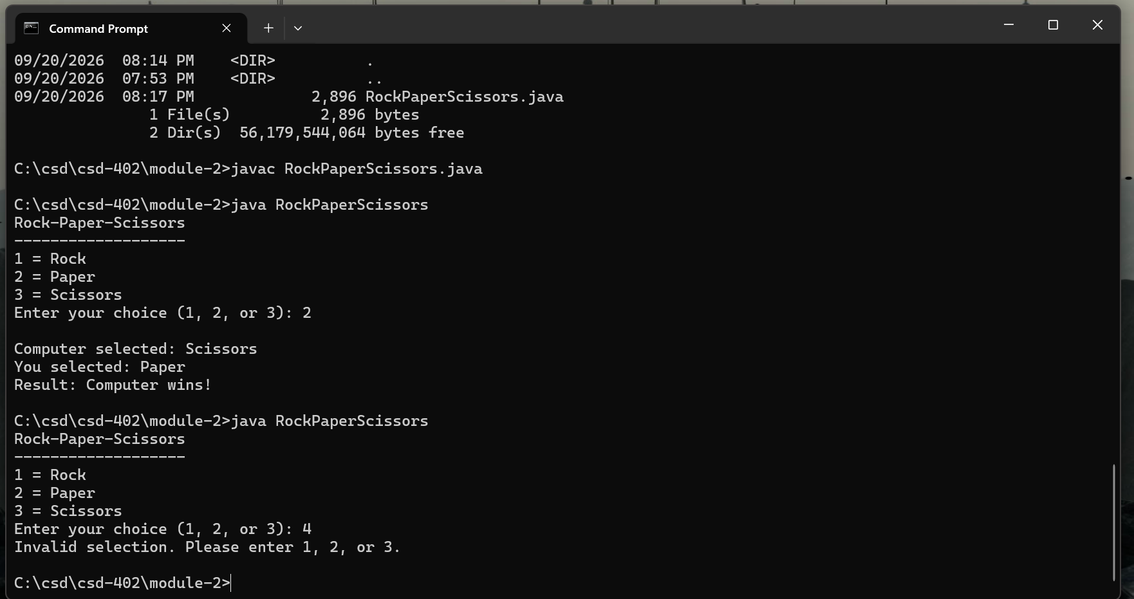
Figure 4 - GitHub Push Verification
After the source file was staged, committed, and pushed, RockPaperScissors.java appears in the remote GitHub repository under csd-402 / module-2. The screenshot also shows the Assignment 2.2 documentation at the top of the source file.
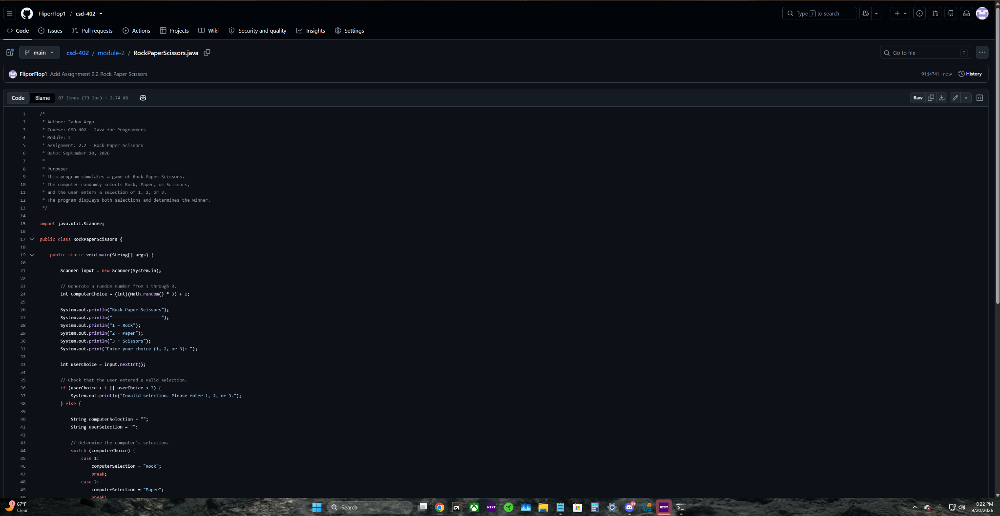
Submission Verification
RockPaperScissors.java was compiled and tested successfully. The program generates the computer's selection, accepts the user's selection, displays both choices, determines the result, and rejects values outside the required range of 1 through 3.
The source file has been committed and pushed to the GitHub repository in the module-2 directory.
Repository URL: https://github.com/FliporFlop1/csd-402

