CSD 402 – Java for Programmers
Module 1.3 Programming Assignment
Water Heating Energy Calculator
Jadon Argo
September 13, 2026

Assignment Overview
This submission documents the installation and configuration of Java and JavaFX and demonstrates the completed Module 1 water-heating energy calculator. The Java program prompts for the amount of water in kilograms and the initial and final temperatures in Celsius, then calculates the required energy in joules using Q = waterMass × (finalTemperature − initialTemperature) × 4184.
Repository
GitHub repository: https://github.com/FliporFlop1/csd-402

Java Installation Verification
The screenshot below verifies that Java is installed and available from PowerShell. The java --version command reports OpenJDK 21.0.12.1 LTS using the Eclipse Temurin runtime.
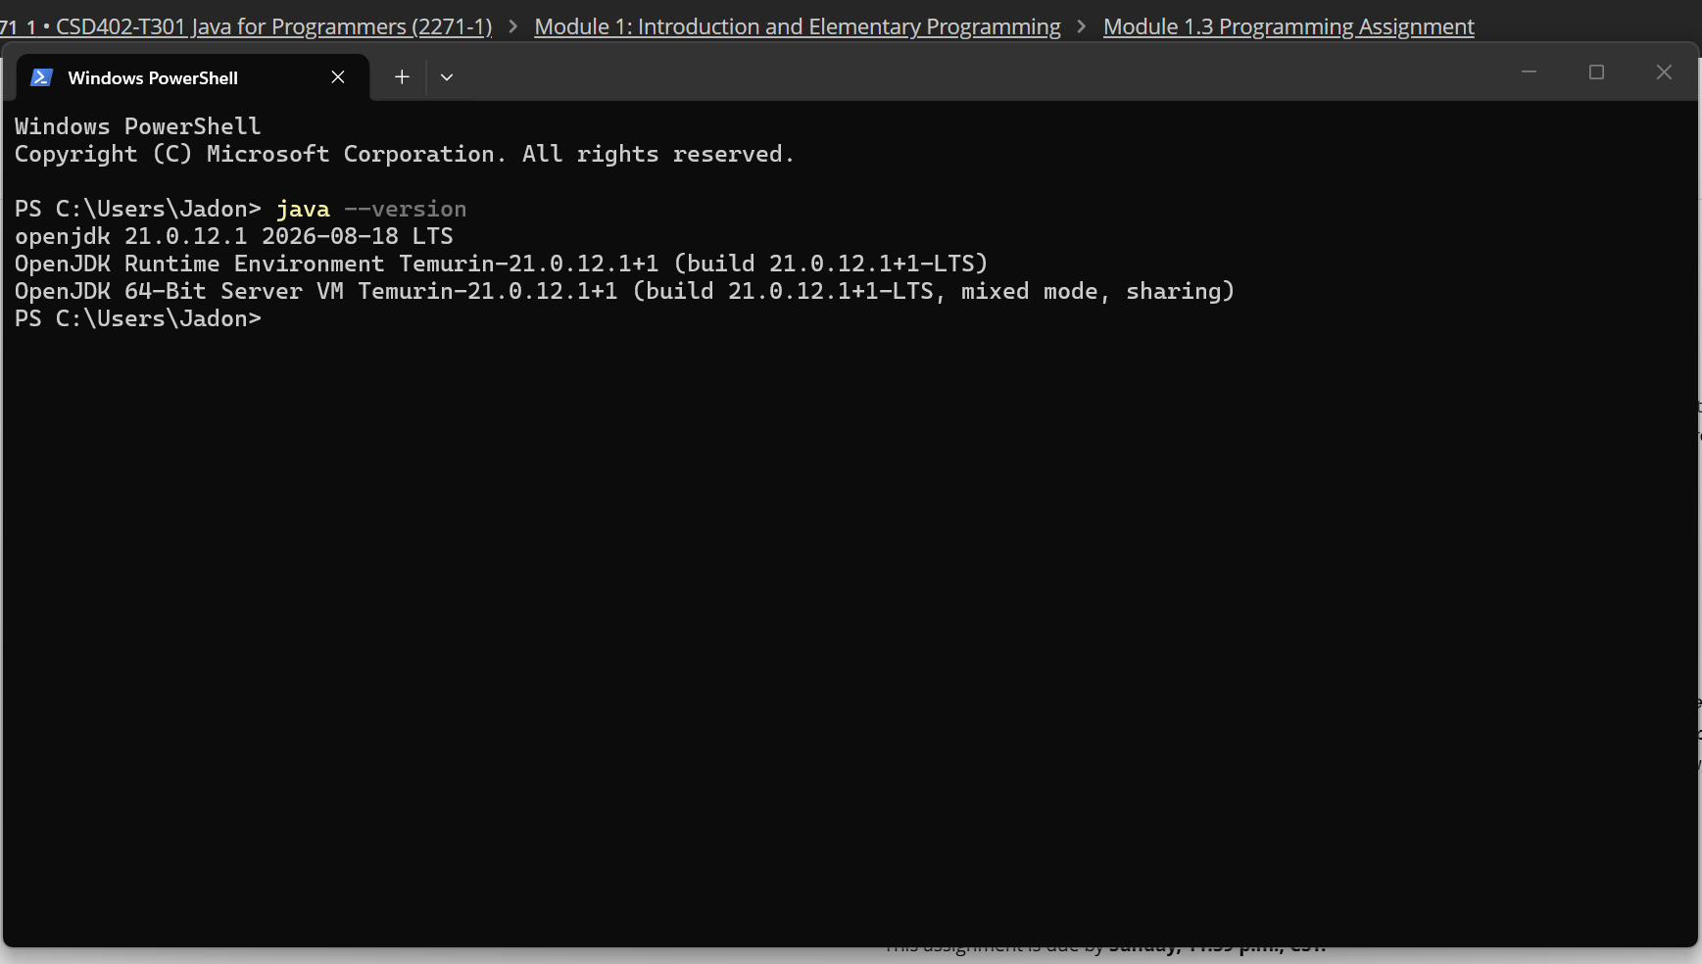
Figure 1. Java 21 installation verified in Windows PowerShell.

JavaFX Installation and Configuration Verification
JavaFX SDK 21.0.11 was extracted to C:\javafx-sdk-21.0.11. The JavaFX library path was configured and the test application compiled and launched successfully, displaying “JavaFX 21 is working!”
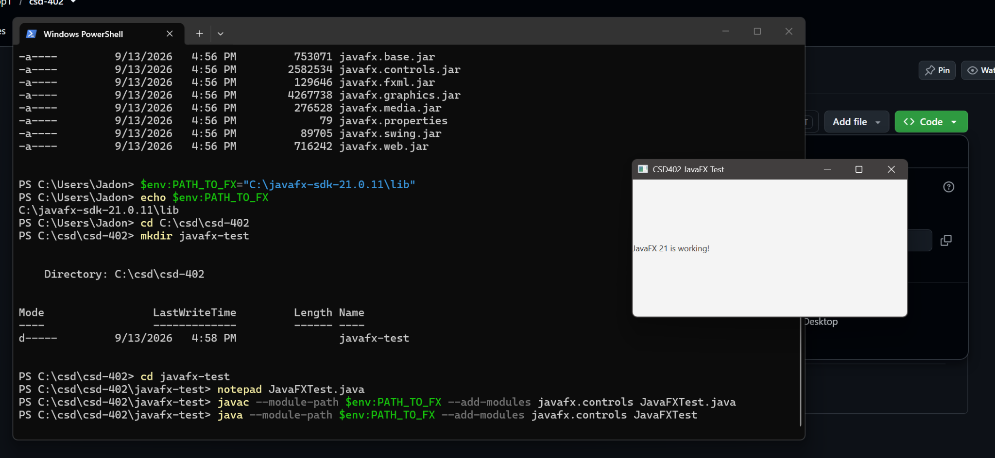
Figure 2. JavaFX 21.0.11 successfully configured, compiled, and launched.

Program Execution – Valid Input
The completed WaterHeating program was compiled with javac and executed successfully. Using 2 kilograms of water, an initial temperature of 20°C, and a final temperature of 80°C, the program correctly calculated 502080.00 joules.
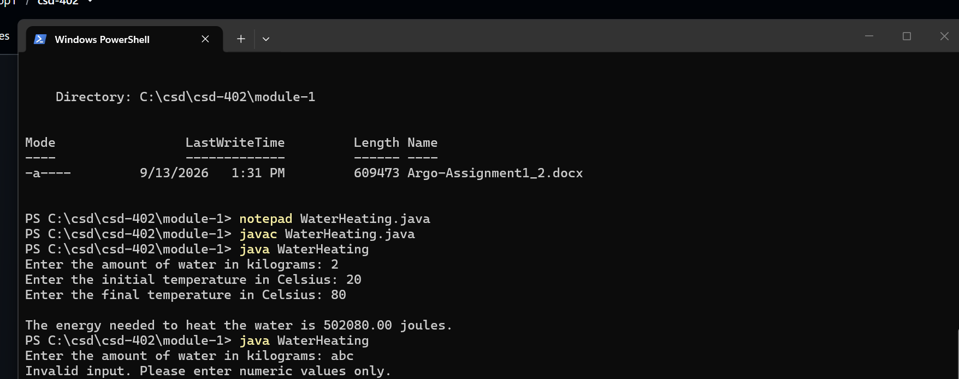
Figure 3. Successful program execution and correct energy calculation.

Program Error Handling
The program also handles nonnumeric input. Entering “abc” for the water mass produces a clear console message instructing the user to enter numeric values only instead of allowing the program to terminate with an unhandled exception.
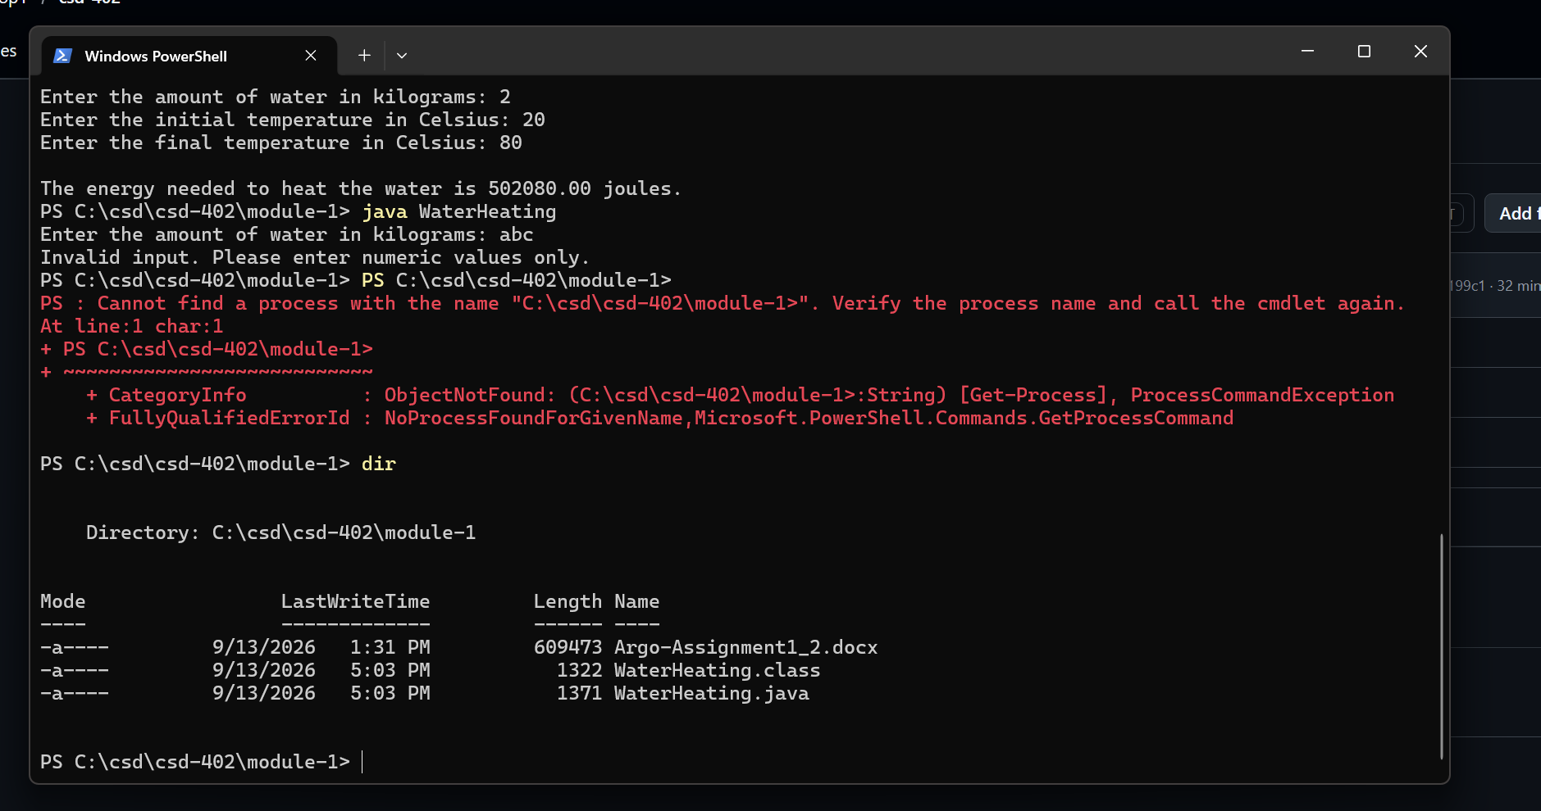
Figure 4. Error handling for invalid nonnumeric input.

GitHub Source Code Verification
The completed WaterHeating.java source file was added to the existing module-1 folder in the csd-402 GitHub repository. The source includes authorship and assignment documentation, the required energy formula, formatted output, and exception handling.
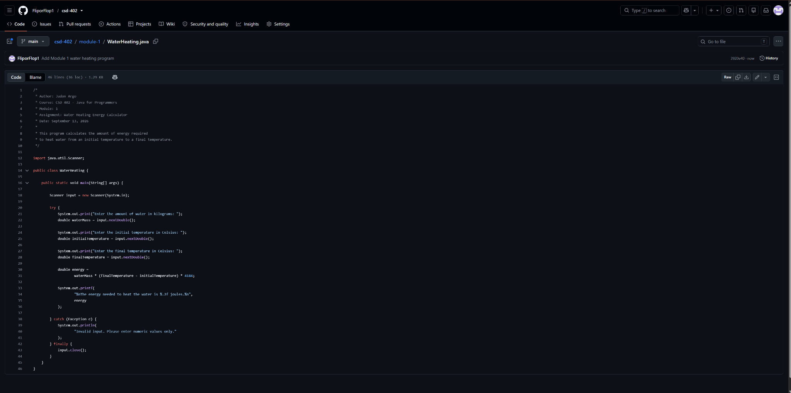
Figure 5. WaterHeating.java stored in the module-1 folder on GitHub.

GitHub Push Verification
The final source file was committed and pushed to origin/main. The final Git status confirms that the local main branch is up to date with origin/main and that the working tree is clean.
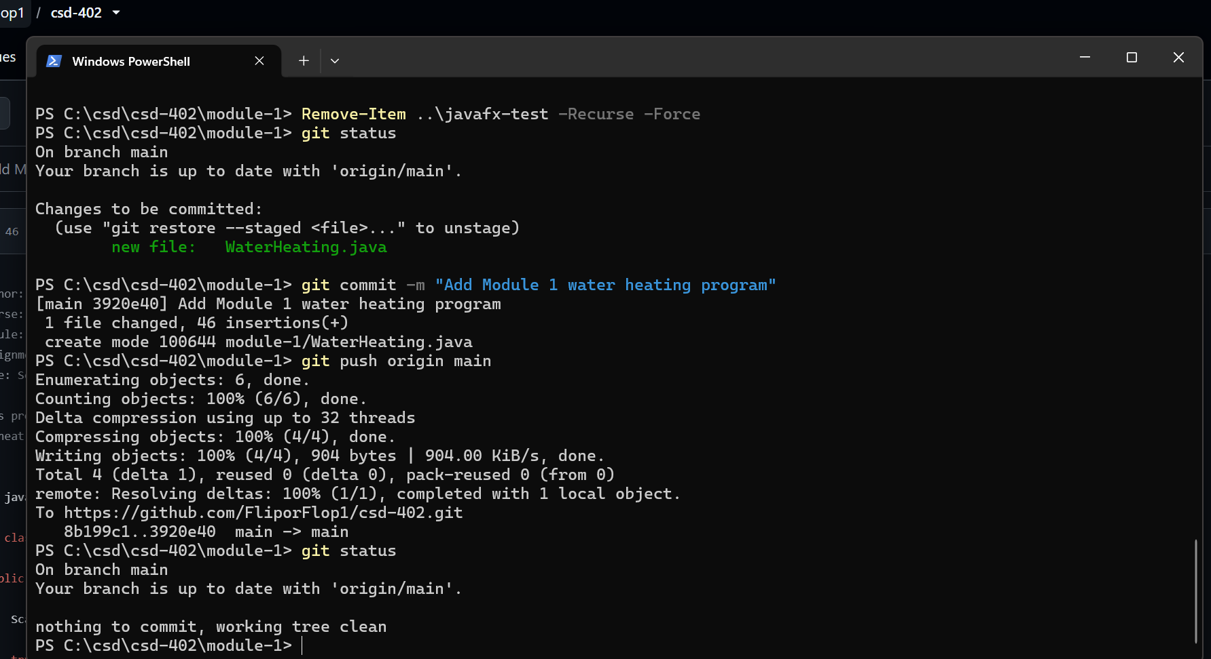
Figure 6. Successful Git commit, push, and clean working tree verification.
Submission Note
https://github.com/FliporFlop1/csd-402

