CSD 402 – Java for Programmers
Module 7 Programming Assignment: UseFans
Jadon Argo
October 25, 2026
Assignment Overview
This assignment extends the Module 6 Fan class by adding a UseFans class that creates a collection of Fan objects and displays their properties. The program demonstrates object-oriented programming, constructors, encapsulation, collections, and method-based output.
Fan Class and Module 6 Functionality
The Fan class retains the four speed constants (STOPPED, SLOW, MEDIUM, and FAST), private attributes for speed, power state, radius, and color, two constructors, getter and setter methods, a toString() method, and the original Module 6 testing routine. The Module 7 version uses the this reference for instance attributes and method calls where appropriate, including constructor chaining in the default constructor.
UseFans Class Implementation
UseFans creates an ArrayList-based Collection<Fan> containing four Fan instances with different settings. The displayFans(Collection<Fan>) method loops through the collection and calls displayFan(Fan) for each object. The displayFan(Fan) method uses getter methods to print the speed, power state, radius, and color directly, without invoking toString().
Test Procedure
Both Java files were compiled from the module-7 directory using javac Fan.java UseFans.java. The program was then executed using java UseFans. The Command Prompt output showed no compilation errors and displayed all four fan objects and the updated first fan.

Program Execution and Results
Figure 1 shows the successful execution of UseFans in Command Prompt, including the four initial Fan objects and the updated Fan 1 after its setters were called.
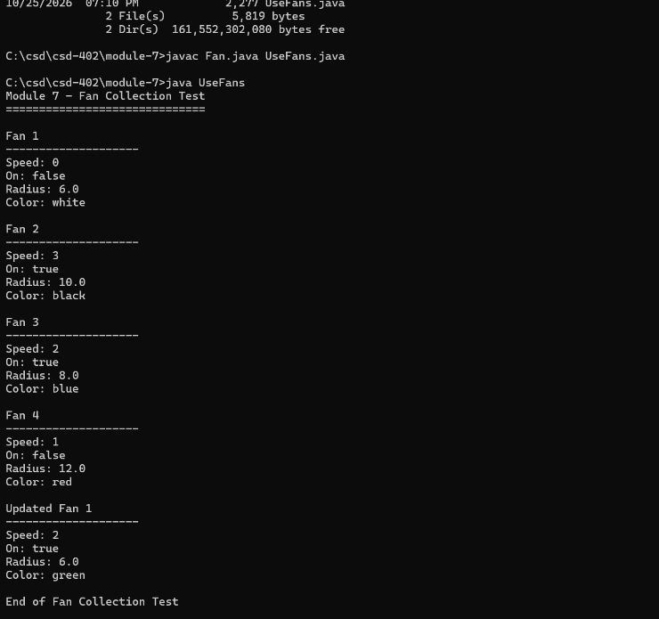
Figure 1. Command Prompt compilation and UseFans program output.
Observed Results
• Fan 1: speed 0, off, radius 6.0, white.
• Fan 2: speed 3, on, radius 10.0, black.
• Fan 3: speed 2, on, radius 8.0, blue.
• Fan 4: speed 1, off, radius 12.0, red.
• Updated Fan 1: speed 2, on, radius 6.0, green.

GitHub Repository Verification
The two Java source files were committed and pushed to the main branch of the CSD402 GitHub repository. Figure 2 shows both Fan.java and UseFans.java inside the module-7 folder.
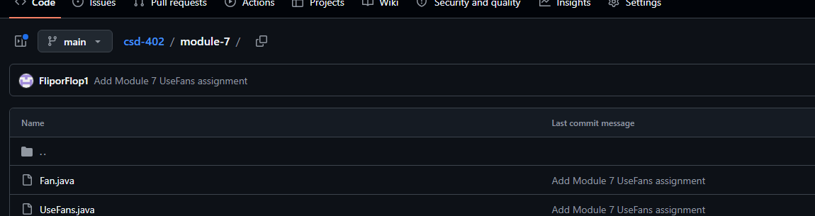
Figure 2. GitHub module-7 folder showing both Java source files.
Repository: https://github.com/FliporFlop1/csd-402
Module 7 folder: https://github.com/FliporFlop1/csd-402/tree/main/module-7
Requirements Verification
• A collection of Fan instances was created and populated.
• A method accepts a collection of Fan instances and displays each object.
• A separate method accepts one Fan instance and displays its properties.
• The new display methods do not use toString().
• The Fan class uses this where appropriate and retains Module 6 functionality.
• Test code demonstrates collection display and changes to an individual fan.
Conclusion
The Module 7 UseFans assignment compiled and executed successfully. The output confirms that the collection and single-object display methods function as intended, and the source files were uploaded to the course GitHub repository.

