CSD 402 - Java for Programmers
Assignment 3 - Nested For Loops
Jadon Argo
September 27, 2026

Assignment Overview
This program uses nested for loops to display seven rows of powers of 2 in the required pyramid format. Each row increases from 1 to its highest value and then decreases back to 1. Every line ends with the required @ symbol.
GitHub Repository
https://github.com/FliporFlop1/csd-402
Program File
module-3/NestedLoops.java

Figure 1 - Source Code and Documentation
The first portion of NestedLoops.java shows the required program documentation, the main method, the outer loop that controls the seven rows, and the nested loops used for spacing and increasing powers of 2.
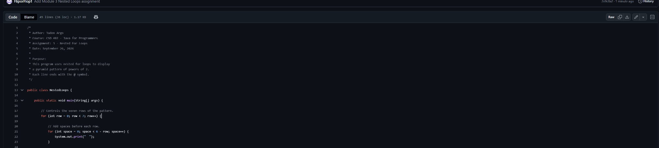

Figure 2 - Nested Loop Logic
The remaining source code shows the nested loop used to move back down through the powers of 2 and the statement that prints the required @ symbol at the end of every row.
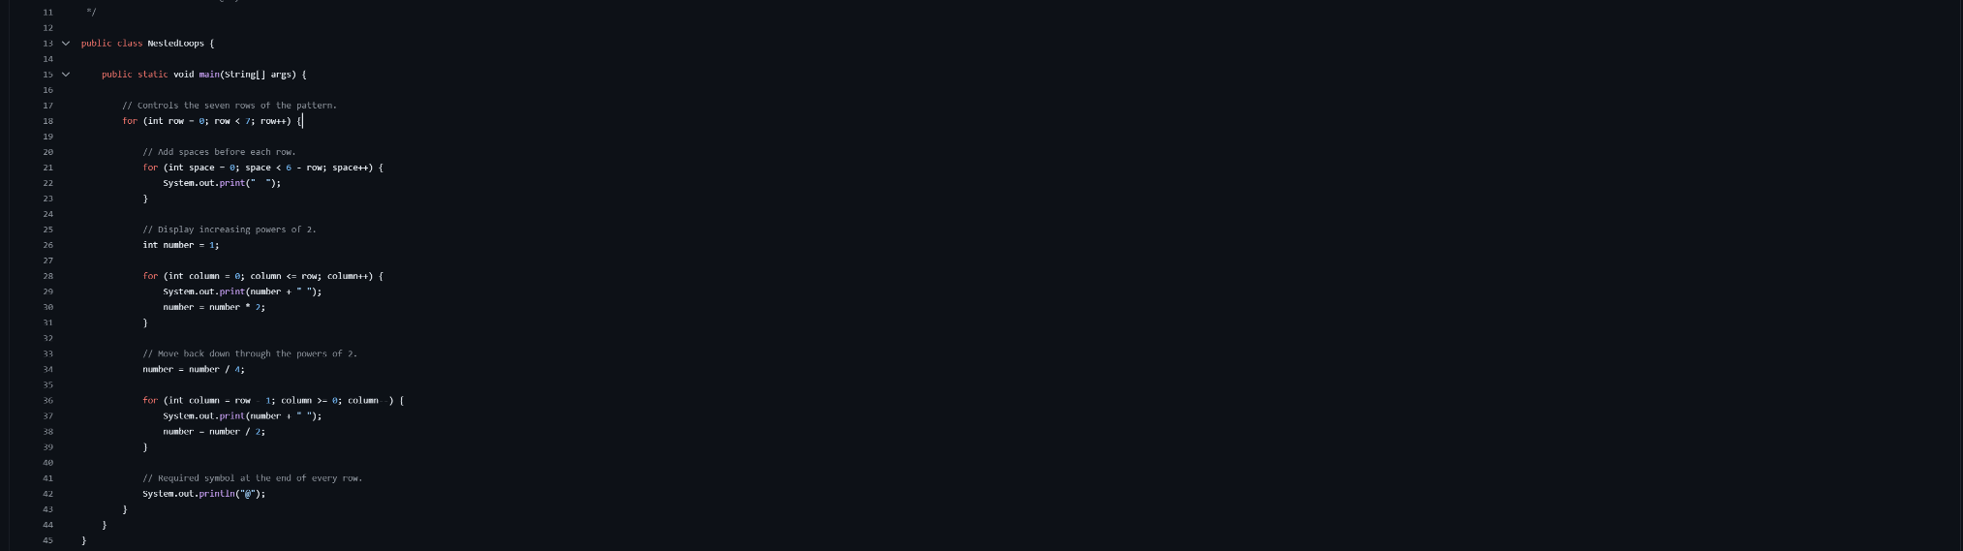

Figure 3 - Compilation and Program Testing
The program compiles successfully with javac and runs with java NestedLoops. The output displays all seven required rows with the correct powers of 2 and an @ symbol at the end of each line. The directory listing also verifies that NestedLoops.java is stored in the module-3 directory.
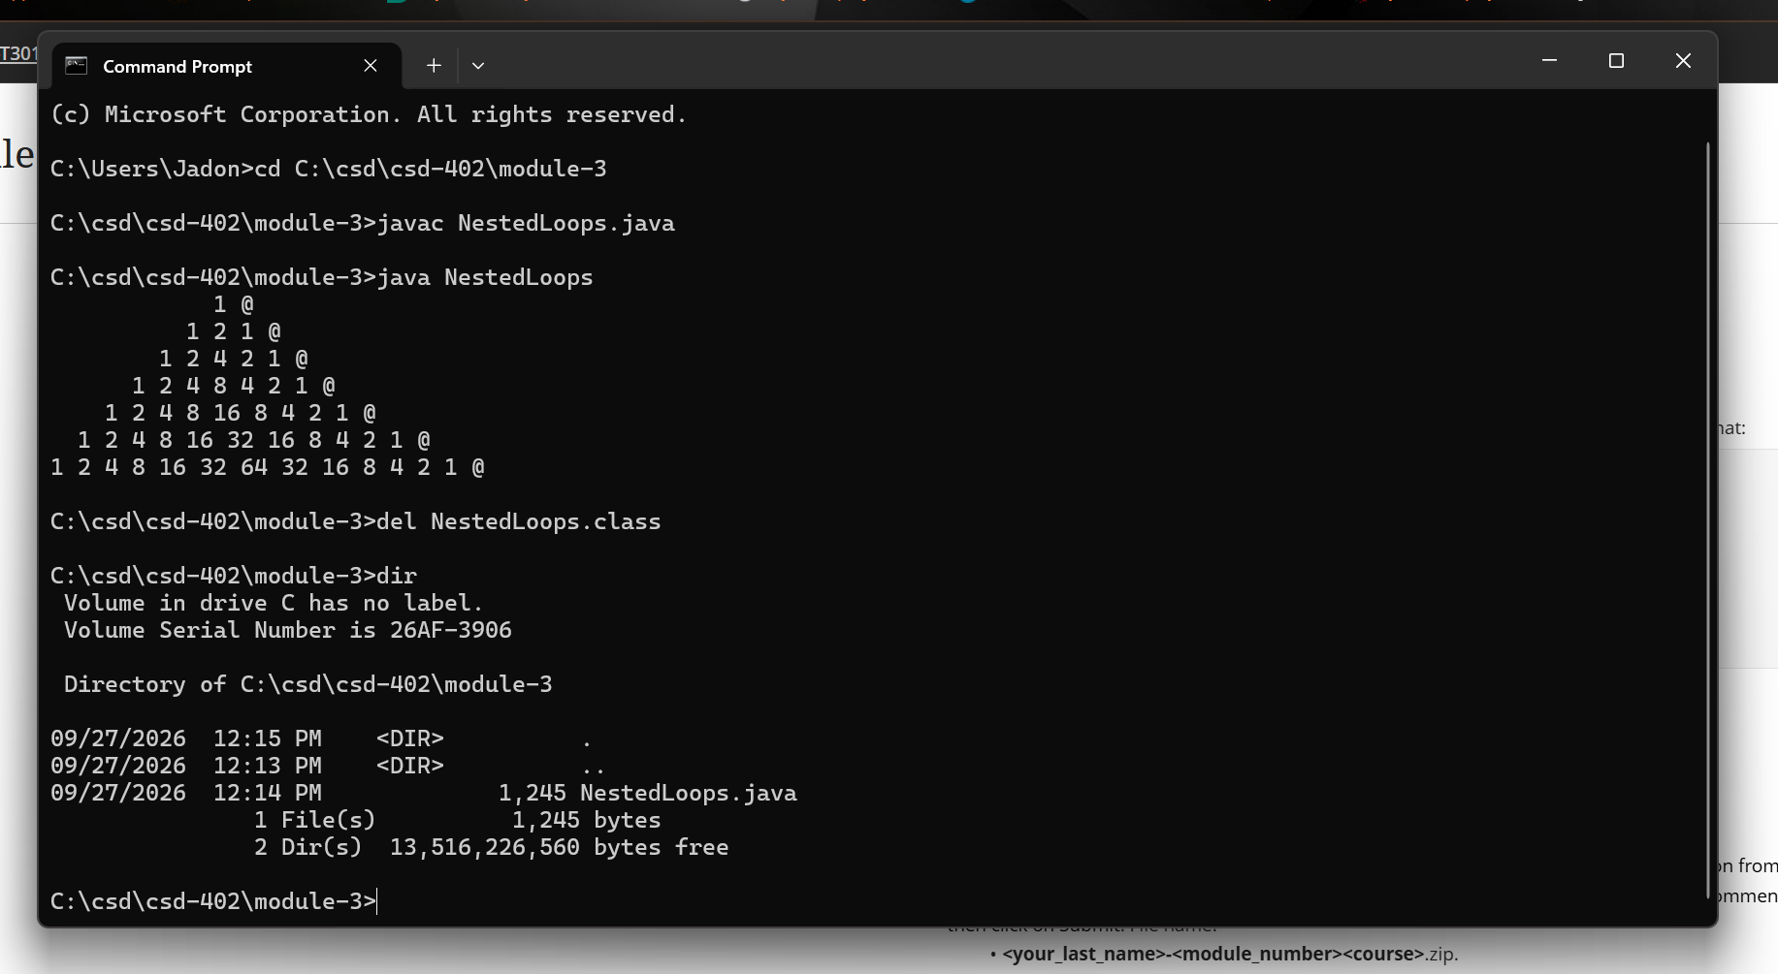

Figure 4 - GitHub Push Verification
After the source file was staged, committed, and pushed, NestedLoops.java appears in the remote GitHub repository under csd-402 / module-3. The screenshot also shows the Assignment 3 documentation at the top of the source file.
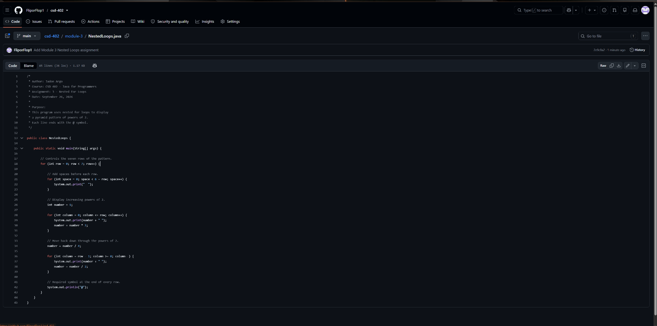

Submission Verification
NestedLoops.java was compiled and tested successfully. The program uses nested for loops to generate the required pyramid-style pattern of powers of 2 and includes the @ symbol at the end of each line.
The source file has been committed and pushed to the GitHub repository in the module-3 directory.
Repository URL: https://github.com/FliporFlop1/csd-402

