CSD 402 – Java for Programmers
GitHub Repository Setup
Jadon Argo

Repository | csd-402
Visibility | Public
Local directory | C:\csd\csd-402
Repository URL | https://github.com/FliporFlop1/csd-402

Setup Verification
The GitHub repository was created as a public repository with a README.md file and the required Python .gitignore file. The repository was then cloned to the local C:\csd directory using Git. The local repository is on the main branch, is synchronized with origin/main, and reports a clean working tree.

GitHub Repository
The screenshot below shows the public csd-402 repository on GitHub, including the repository description, .gitignore, and README.md.
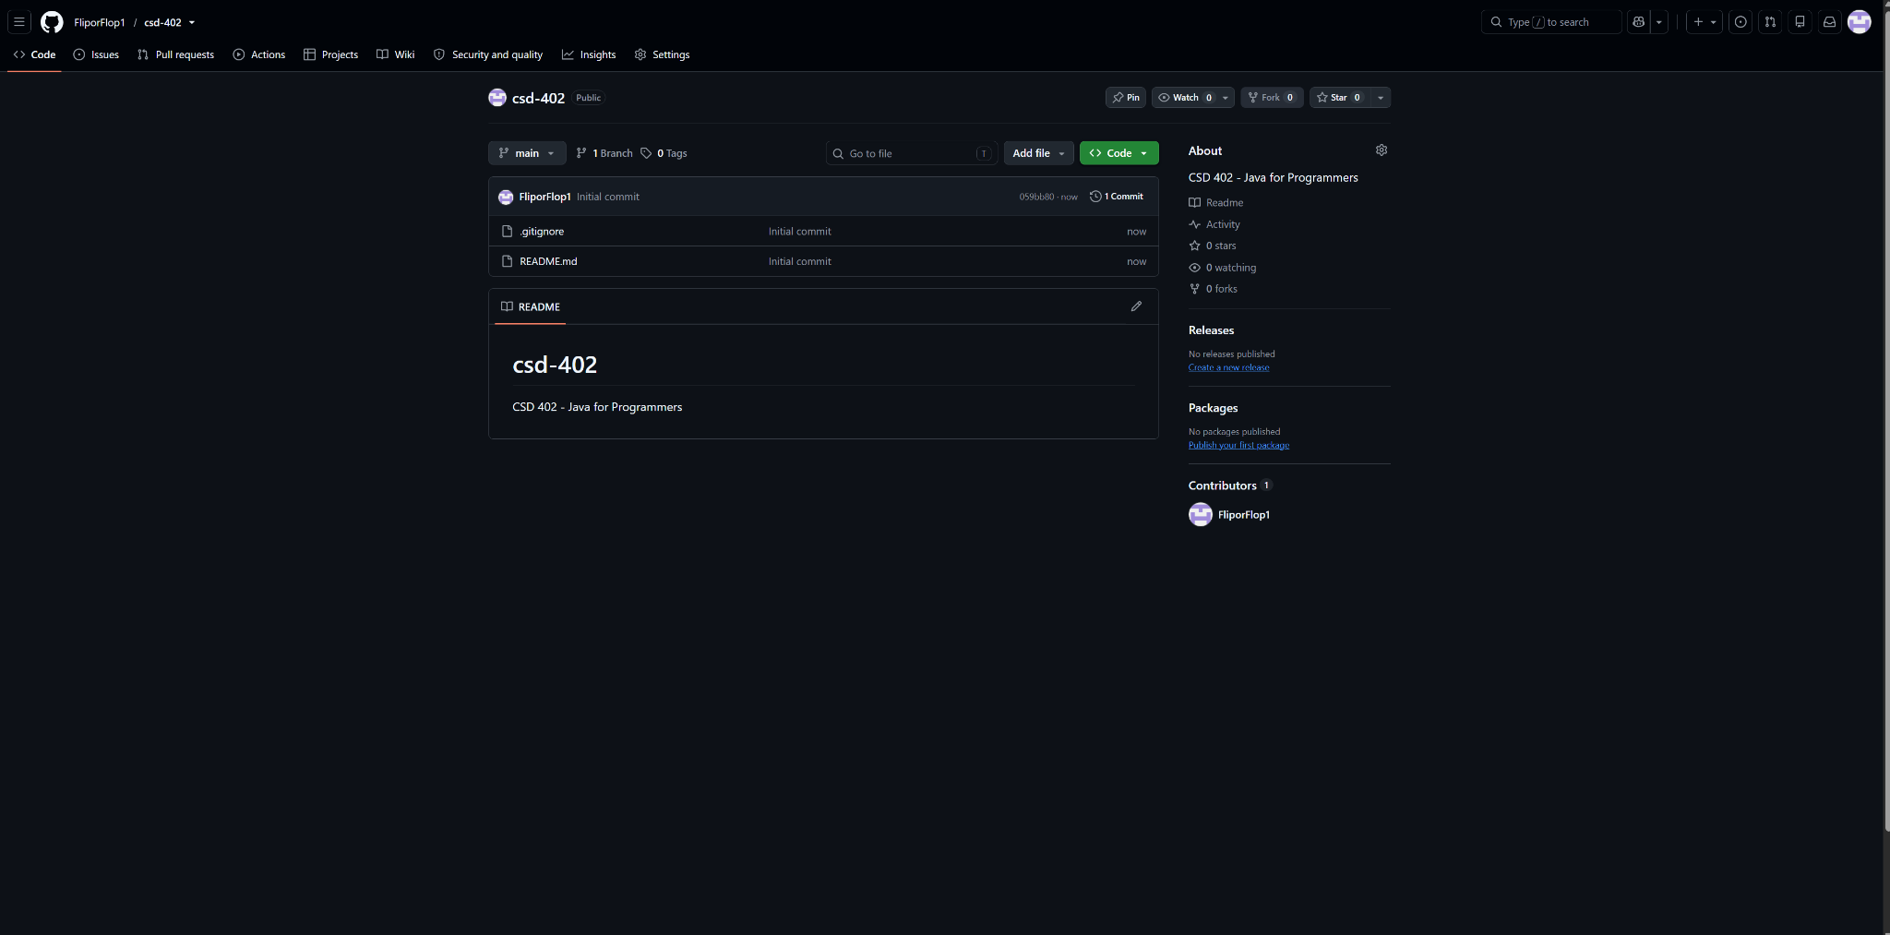
Figure 1. GitHub csd-402 repository.

Local Repository Verification
The screenshot below verifies the required local directory structure. It shows C:\csd\csd-402, the .gitignore and README.md files, and the Git status confirming that the main branch is up to date with origin/main and that the working tree is clean.
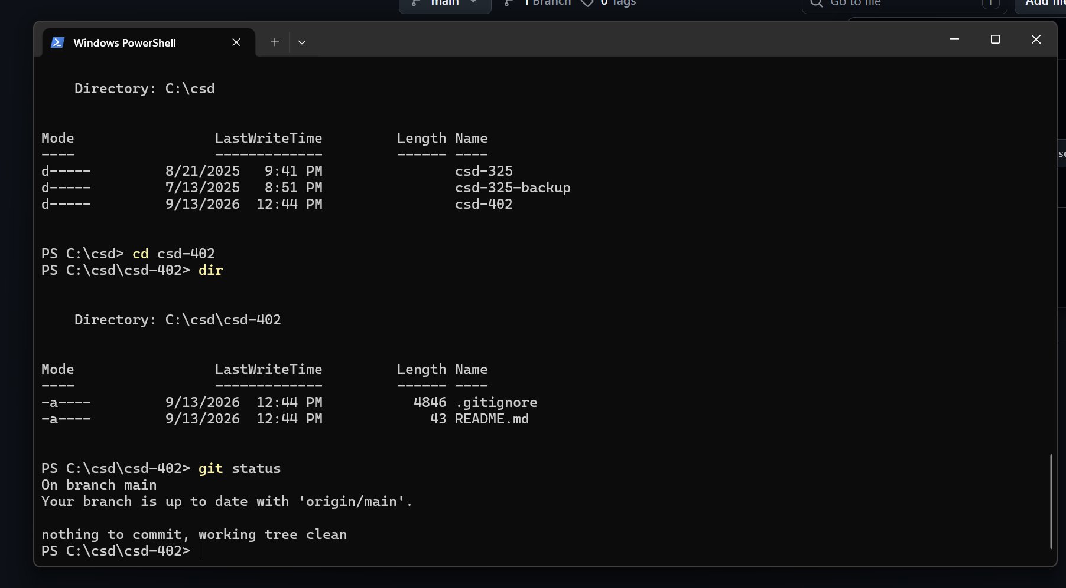
Figure 2. Local csd-402 directory and Git status verification.

Submission Note:
For the assignment link: https://github.com/FliporFlop1/csd-402
Module 1 Directory Creation
The screenshot below verifies that the required module-1 directory was created in C:\csd\csd-402. The directory listing shows module-1 alongside the existing .gitignore and README.md files.
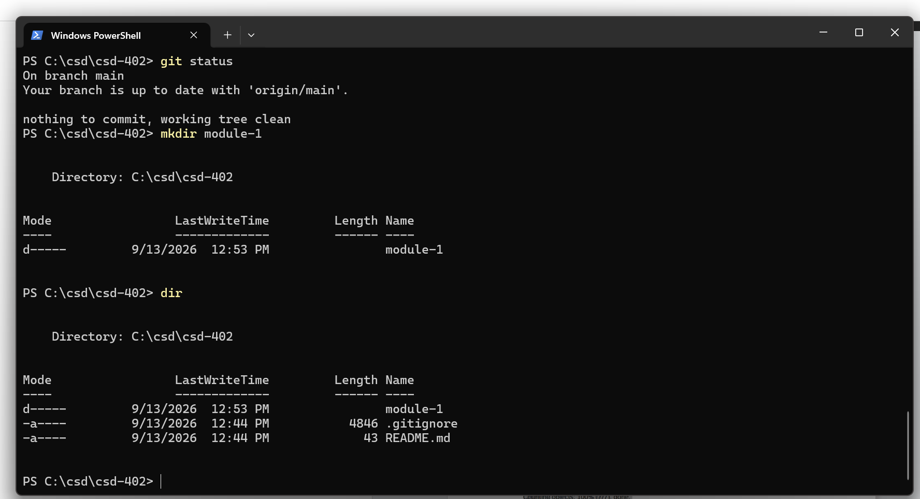
Figure 3. Creation and verification of the module-1 directory.
Git Stage Verification
After the Word document was placed in module-1, git add --all was used to stage the changes. The git status output below confirms that the assignment document was staged and ready to be committed.
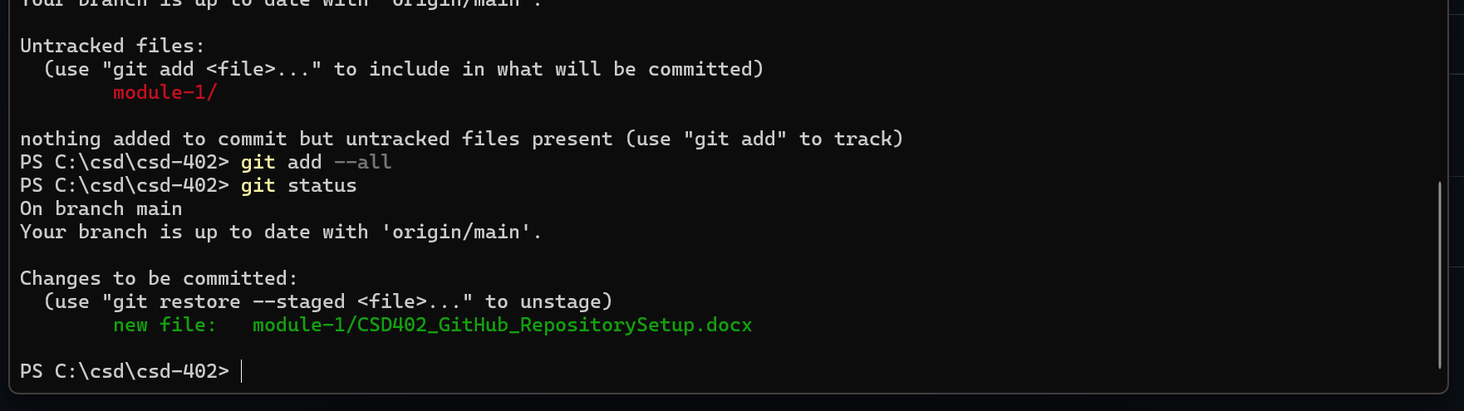
Figure 4. Git status showing the Module 1 Word document staged for commit.

Git Commit Verification
The staged assignment document was committed to the local repository with the message "Add module 1 assignment." The output confirms that the new Word document was successfully included in the commit.
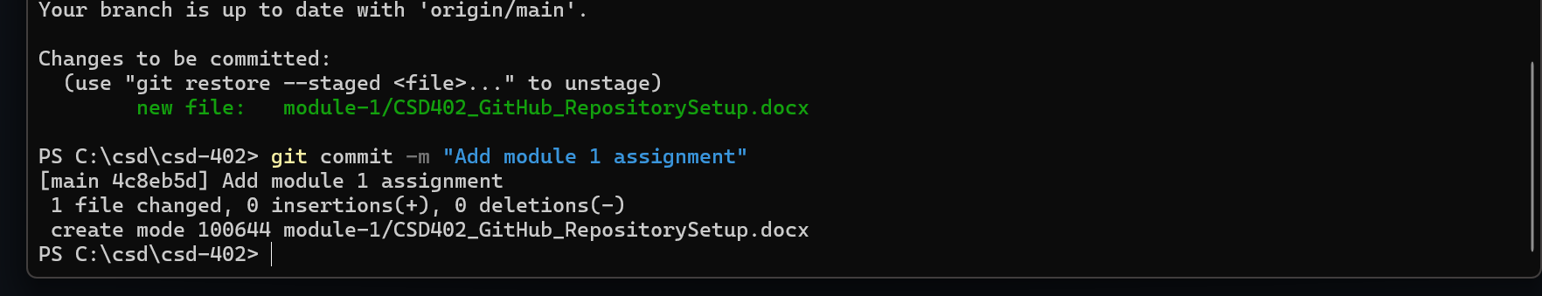
Figure 5. Successful Git commit of the Module 1 assignment document.
GitHub Push Verification
After the commit was pushed to GitHub, the assignment document appeared in the remote repository under module-1. The screenshot below shows the repository path csd-402 / module-1 / CSD402_GitHub_RepositorySetup.docx.
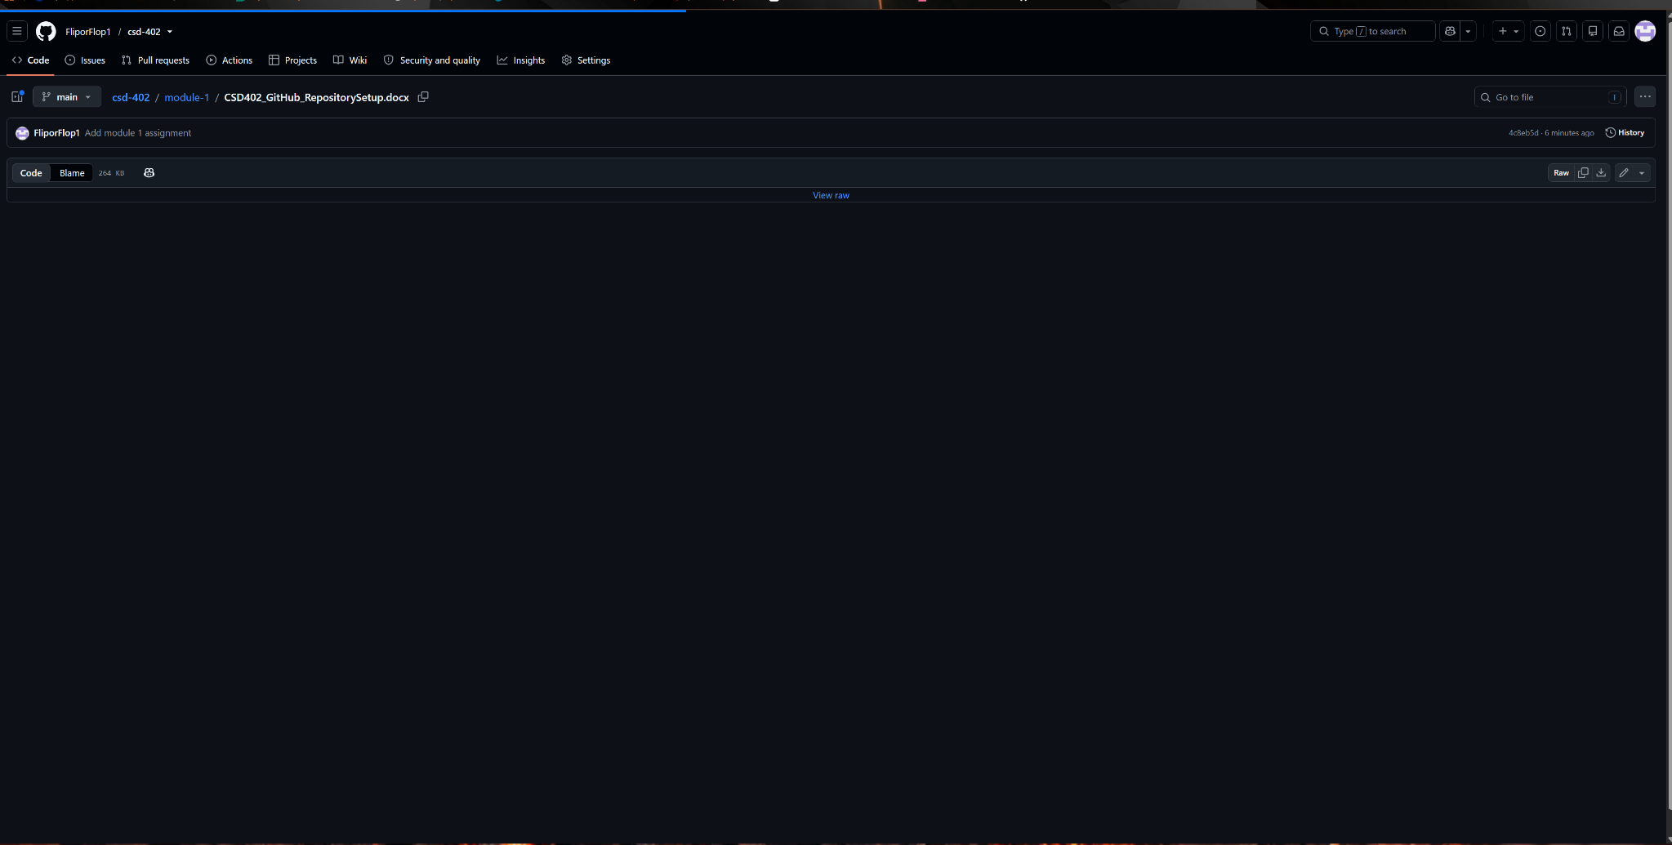
Figure 6. Assignment document successfully uploaded to the module-1 directory on GitHub.

