CSD 402 - Java for Programmers
Assignment 4 - Overloaded Average Methods
Jadon Argo
October 4, 2026
Assignment Overview
This assignment demonstrates Java method overloading by creating four methods named average. Each method accepts a different array data type: short, int, long, or double. The test program uses arrays of different sizes, displays the original array elements, invokes the matching overloaded method, and displays the average returned by that method.
GitHub Repository
https://github.com/FliporFlop1/csd-402
Program Location
C:\csd\csd-402\module-4\ArrayAverage.java

Figure 1 - Module 4 Directory and Source File
The Module 4 directory contains ArrayAverage.java. The class name begins with an uppercase character and matches the Java source filename.
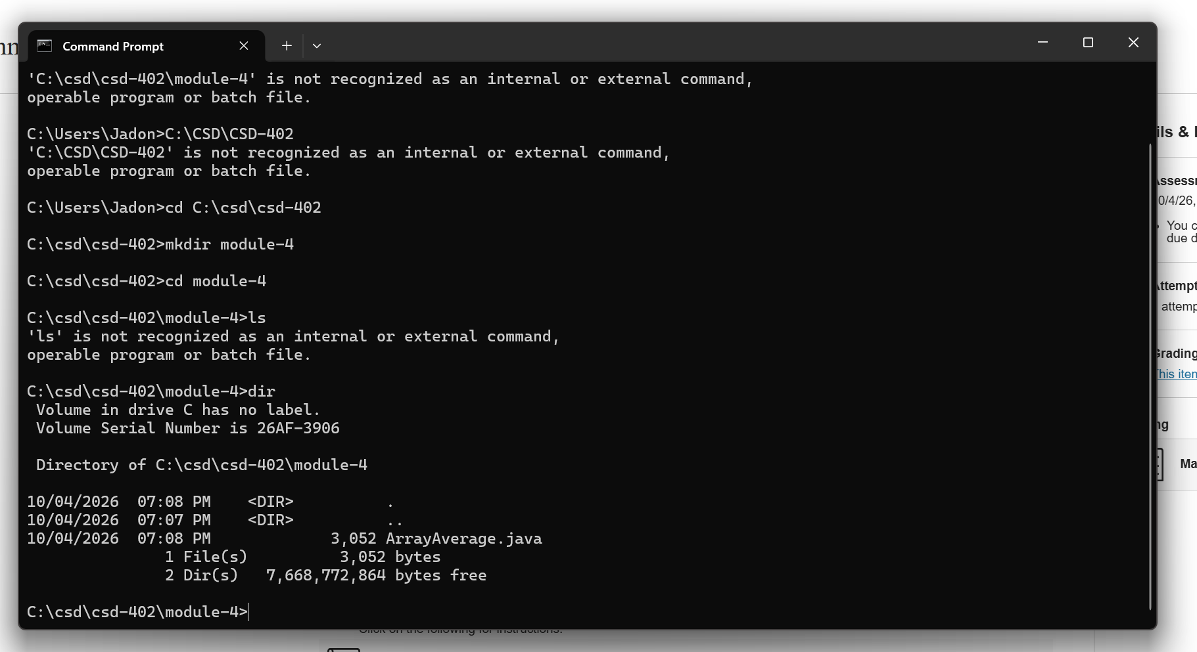

Figure 2 - Compilation and Program Testing
The program compiled successfully with javac and ran with java ArrayAverage. The output displays each original array followed by its calculated average. The short, int, long, and double arrays contain 3, 4, 5, and 6 elements respectively, satisfying the requirement that the arrays be different sizes.
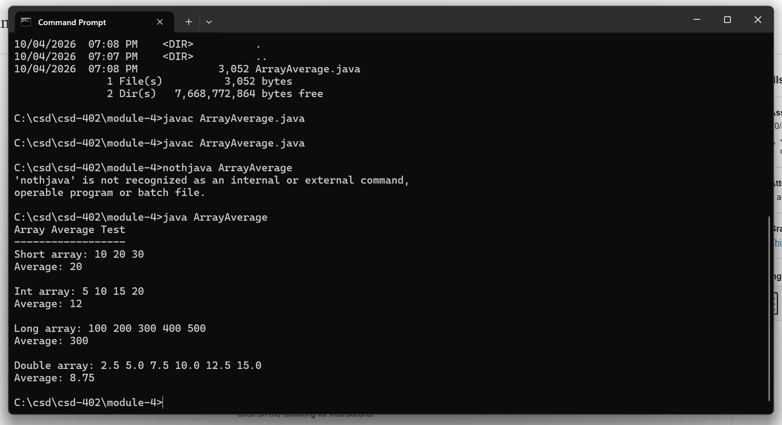

Figure 3 - GitHub Push Verification
After testing, ArrayAverage.java was staged, committed, and pushed to the csd-402 GitHub repository. The screenshot below verifies that the source file is present in the module-4 folder.
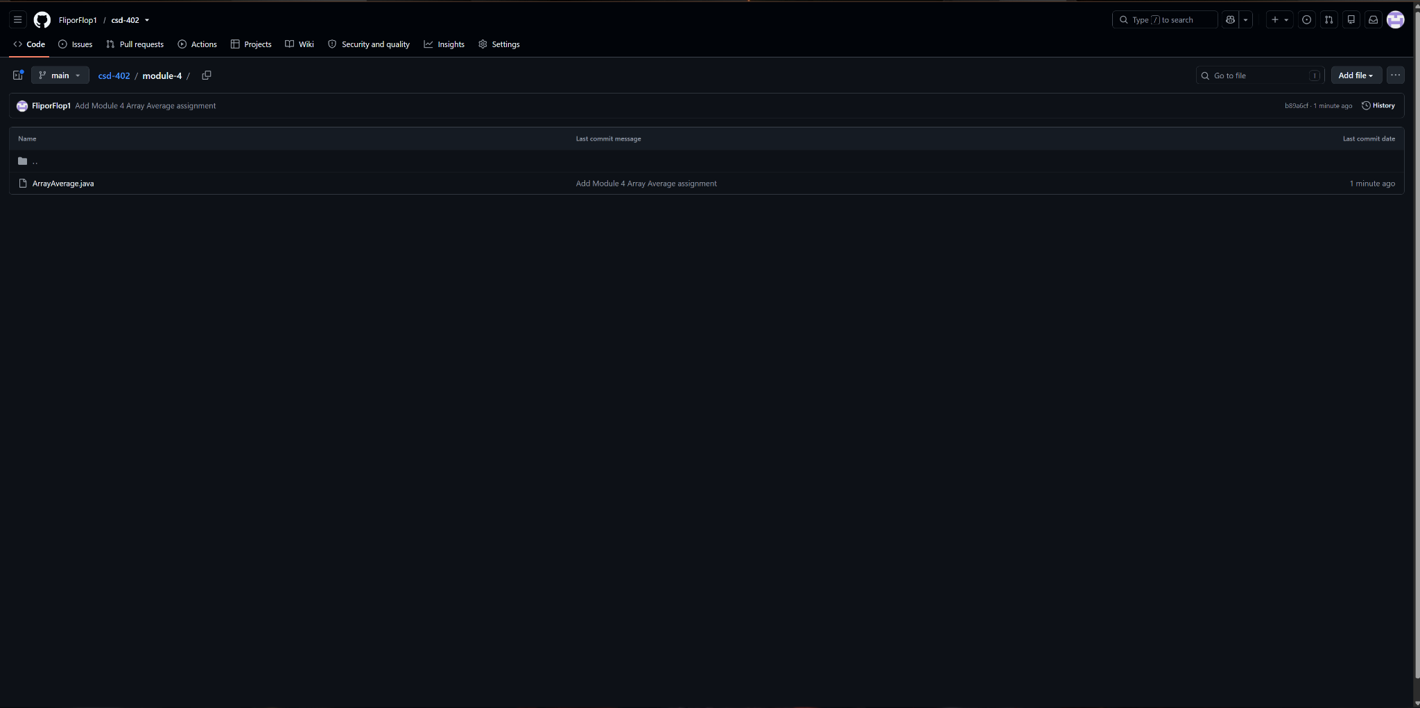

Submission Verification
The completed Module 4 submission includes the Java source file and this documentation. The final ZIP file will contain ArrayAverage.java and Jadon_Argo_Module_4_Assignment.docx. The GitHub repository URL will be entered in the assignment comments area when the ZIP file is submitted.
Required overloaded methods:
public static short average(short[] array)
public static int average(int[] array)
public static long average(long[] array)
public static double average(double[] array)

