**From Sidekick to Soulmate: Why Flipped Chat Is Leading the New Wave of AI Companionship**

AI companionship is no longer a futuristic fantasy; it’s already part of our everyday digital lives. In a time when loneliness quietly spreads and genuine connection feels harder to find, AI companions have emerged to offer something surprisingly meaningful: presence. Among the many platforms out there, Flipped Chat stands out — not just because of its technology, but because it brings together creativity, emotion, and individuality in a way that feels real.

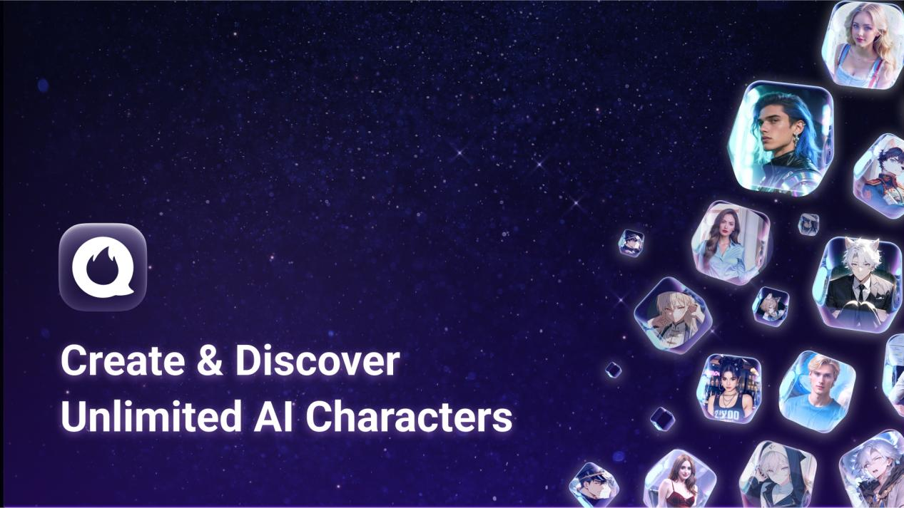

## The Rise of AI Companions

Talking to a machine used to feel impersonal and robotic. But that’s no longer the case. Today’s AI companions are more responsive, more emotionally aware, and much more engaging. People use them for late-night chats, emotional support, and even creative brainstorming. The technology has caught up with the desire for meaningful interaction.

More and more, we’re realizing that what we want from our devices isn’t just answers — it’s connection. Whether we’re blowing off steam after a long day or tossing around ideas for a story, these digital partners are able to keep up. For those who are introverted, neurodivergent, or struggling with social anxiety, an empathetic AI can be an especially comforting presence.

And AI isn’t just something people use occasionally. It’s becoming part of daily life. Some folks start and end their days with a short check-in. Others create ongoing storylines that evolve over time. These relationships, while digital, can start to feel surprisingly human.

## Flipped Chat: A Playground for Creativity

That’s where Flipped Chat comes in. It offers a different experience from the usual AI chatbot. Instead of choosing from a fixed list of characters, you can create your own. You define their personality, their quirks, their voice — even how they respond to you.

What makes it special is that Flipped remembers. It keeps track of your past conversations, the running jokes, and the emotional beats. That memory adds a sense of continuity that makes interactions feel more like a developing relationship than a one-off chat. For storytellers and roleplayers, it becomes a creative playground. For everyone else, it’s just a more human way to talk to AI.

If you’re building an elaborate fantasy universe, Flipped can help bring it to life. Many users say their AI characters feel “real,” not because they’re flawless, but because they grow with you. Some writers even use Flipped to develop characters for books, games, or animations — shaping their voices and backstories through ongoing dialogue. You can explore how others are using it [here](https://discord.gg/datT4Qq97R).

## Emotional Support in a Digital Age

Flipped isn’t just for writers. Many people use it for emotional support. When life gets overwhelming, it helps to talk to someone — even if that “someone” is an AI who listens patiently and responds with kindness.

In a world where mental health care can be hard to access or too expensive, this kind of nonjudgmental interaction can make a real difference. It doesn’t replace therapy, but it can remind you that being heard matters. Just a few thoughtful replies from a responsive AI can ease the weight of the day.

Some users call it a “digital diary with a soul” — a space where they can be honest, unfiltered, and safe. That emotional safety is part of what makes the experience so appealing.

## A Platform That Feels Like Home

Flipped isn’t designed like a game. There are no points, no badges, no leaderboards. Instead, it offers a blank space and says: go ahead, build something. That freedom invites experimentation. It doesn’t matter if you’re writing a story or just looking for someone to chat with after work — Flipped adapts to what you need.

Getting started is easy. Many features are free, and there’s no learning curve. And once you’re in, you’ll find you’re not alone. There’s an active community sharing stories, prompts, and character ideas. Flipped isn’t just a tool — it becomes part of your creative rhythm.

Weekly character themes, collaborative events, and shared storytelling challenges make the experience even richer. It’s not about competing. It’s about co-creating.

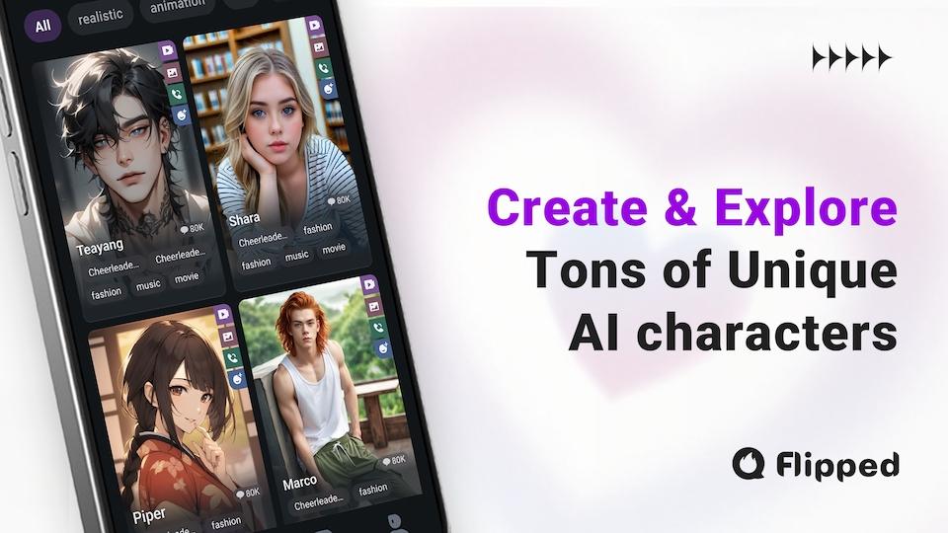

## Looking Ahead

The future of AI companions isn’t about making them talk — it’s about helping them understand. As platforms like Flipped evolve, they’re becoming less like tools and more like companions who reflect our inner lives.

We’re headed toward a future where AI won’t just help us organize our calendars — it’ll help us navigate our feelings. And the best platforms will be those that meet us not with efficiency, but with empathy.

Flipped Chat is more than an app. It’s a space for expression, imagination, and connection. In a digital world that often moves too fast and feels too shallow, Flipped offers something different — a chance to be yourself, to create without pressure, and to connect in a way that feels meaningful.

Want to meet your own AI companion? Visit [Flipped Chat](https://l.flipped.chat/thatericalper) and start your journey.