Пр1

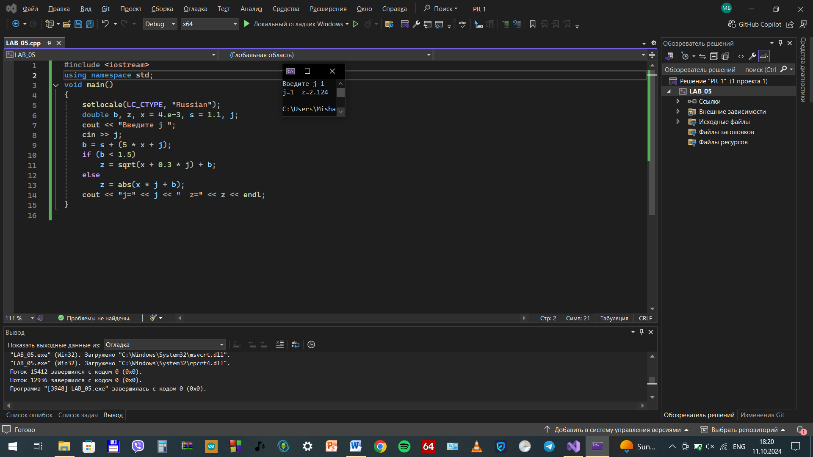

Пр2

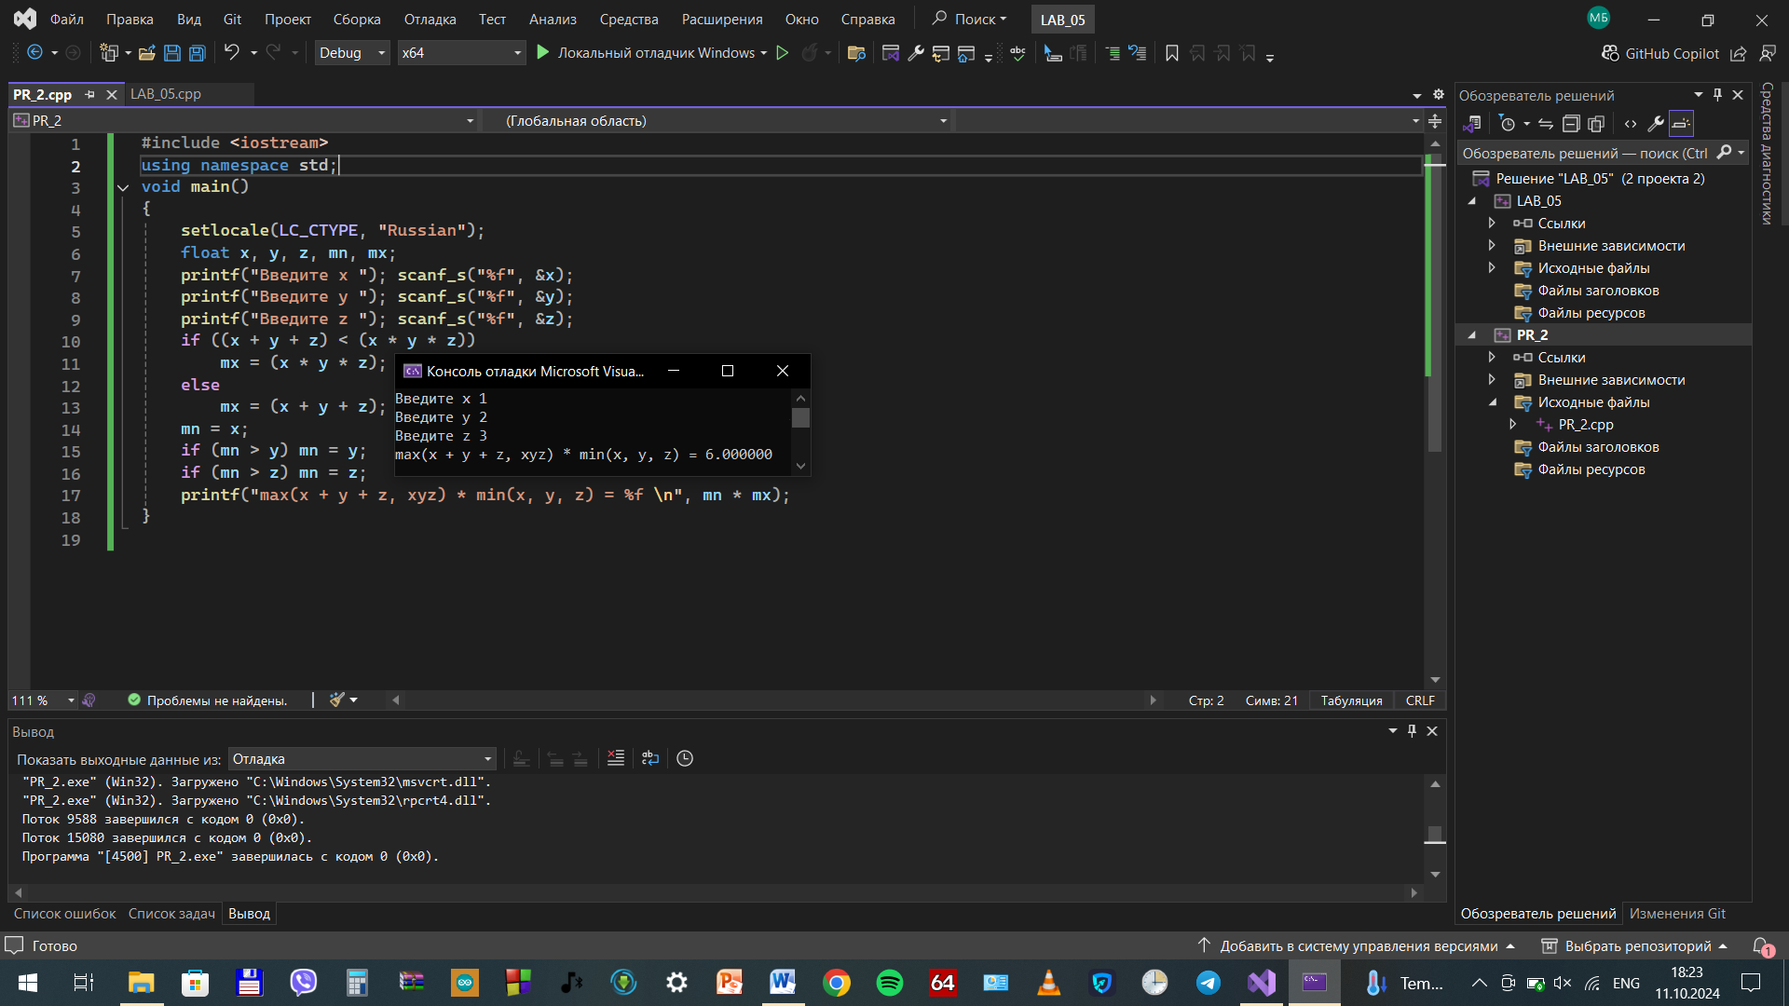

Пр3

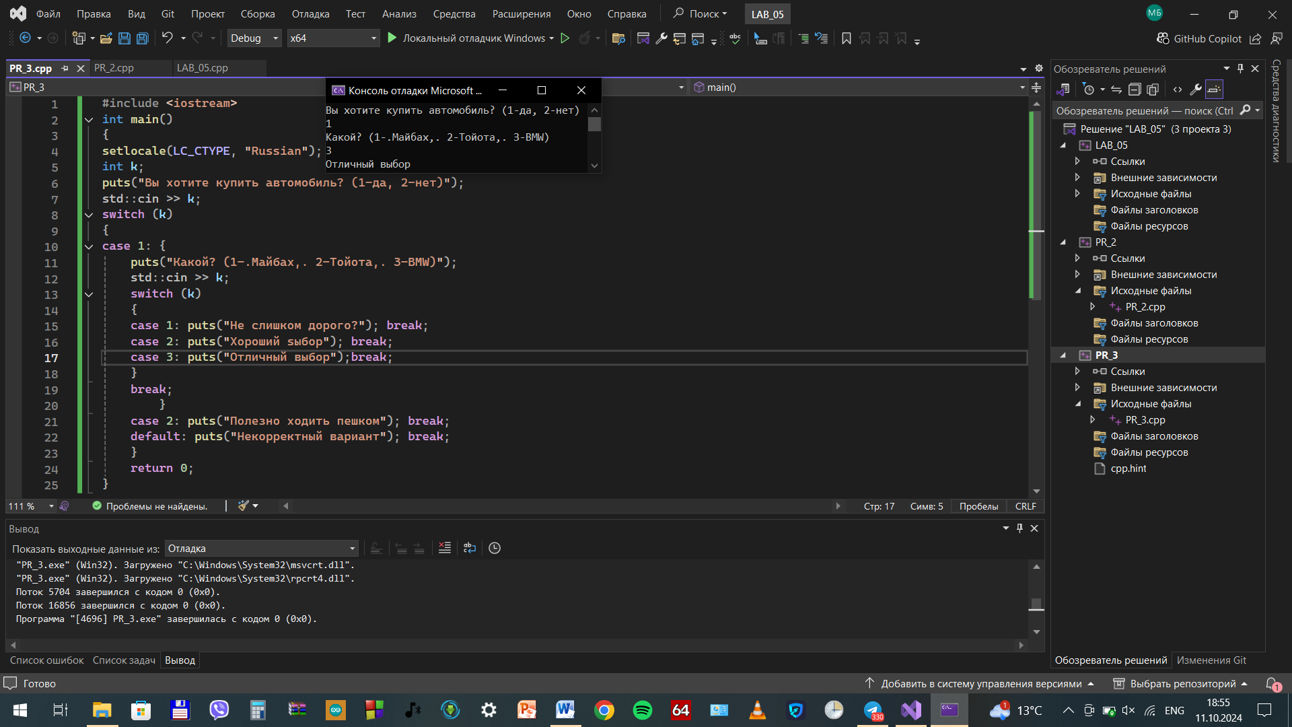

Упр4

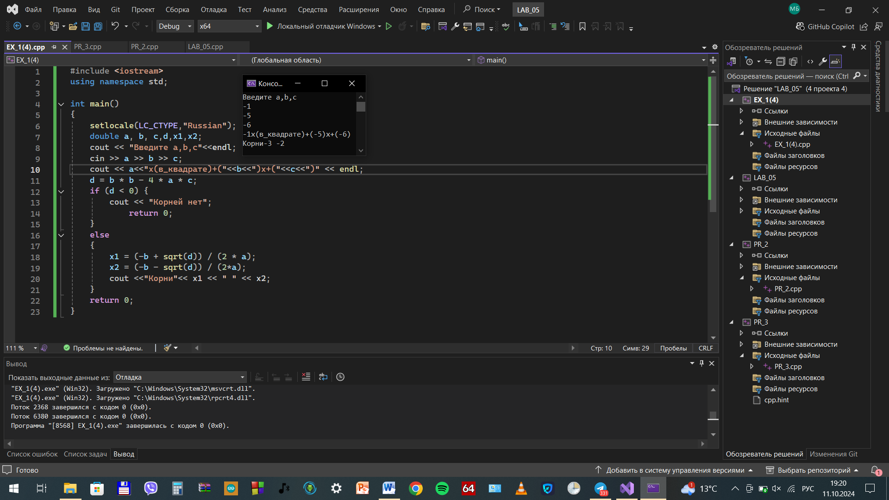

Упр5

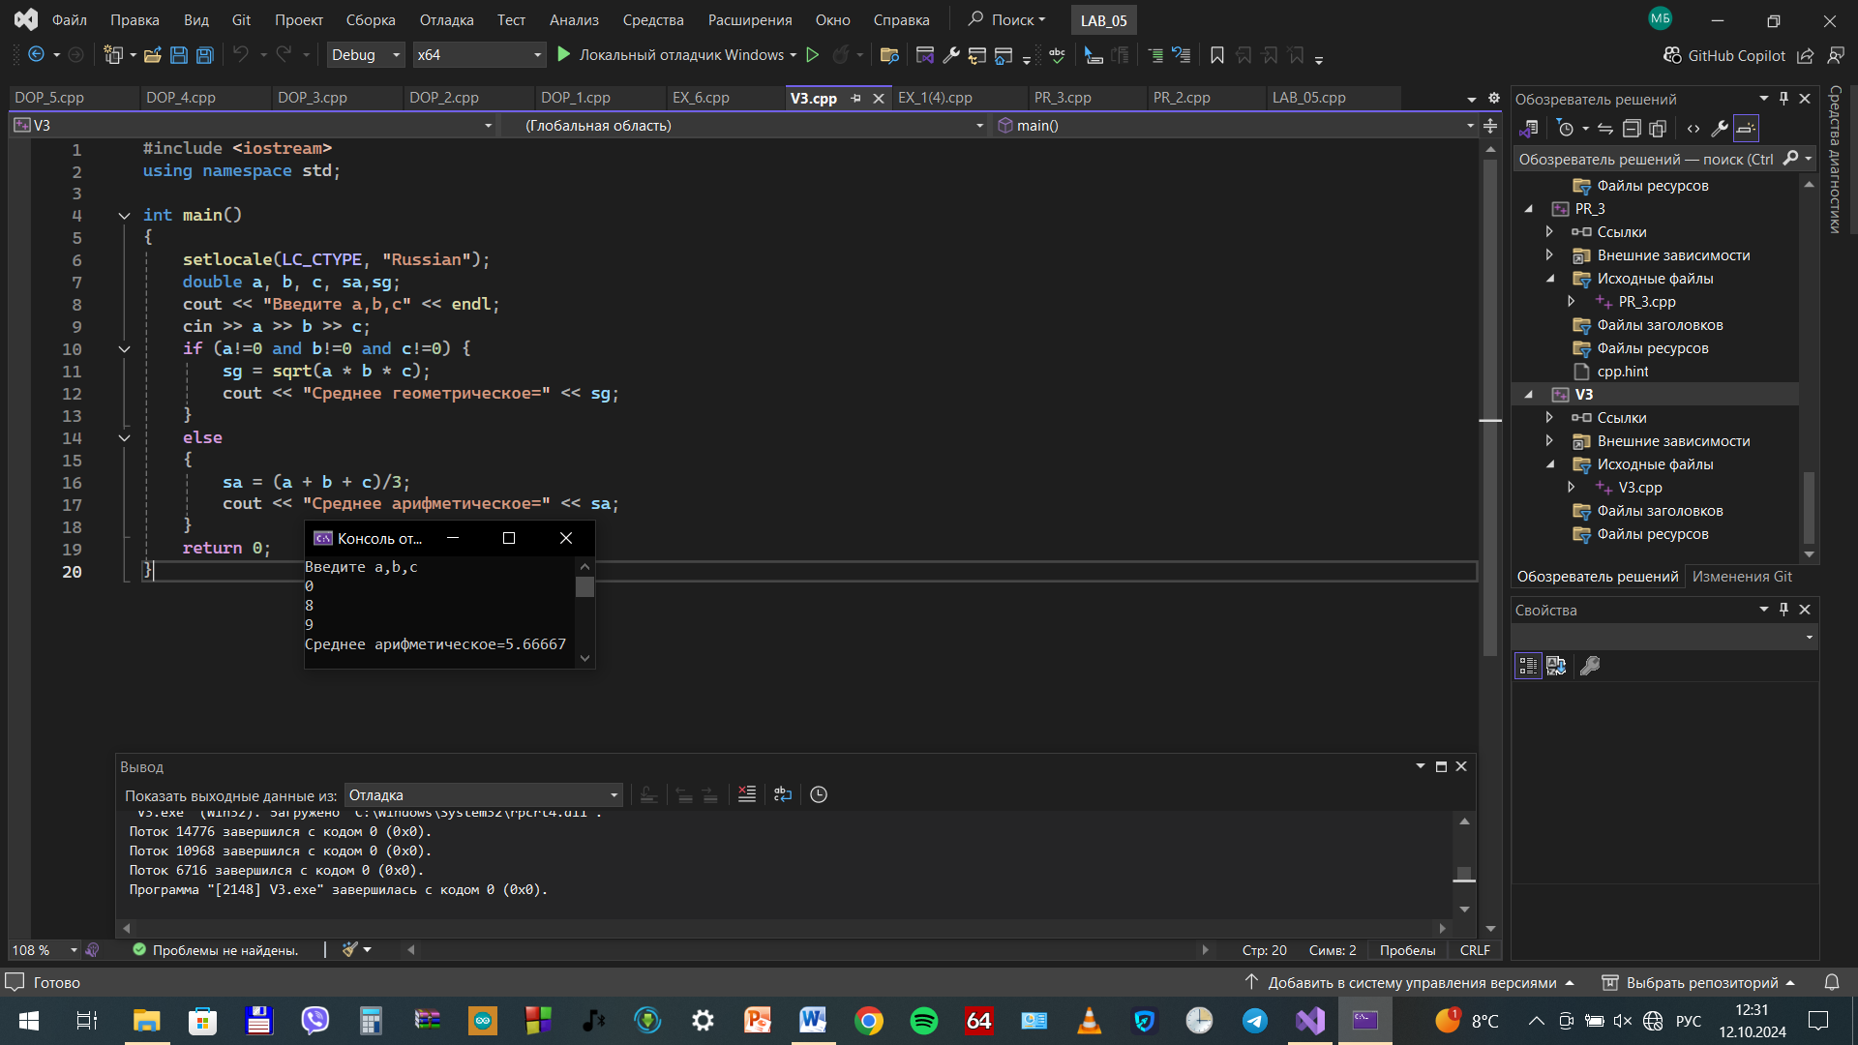

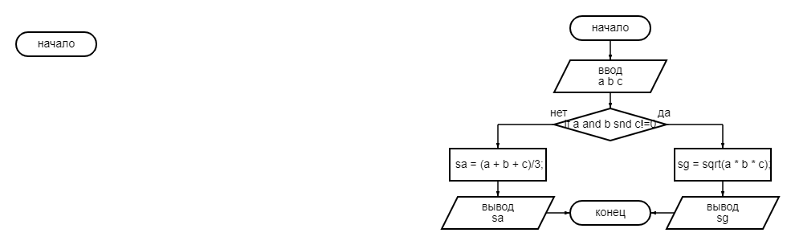

Урп6

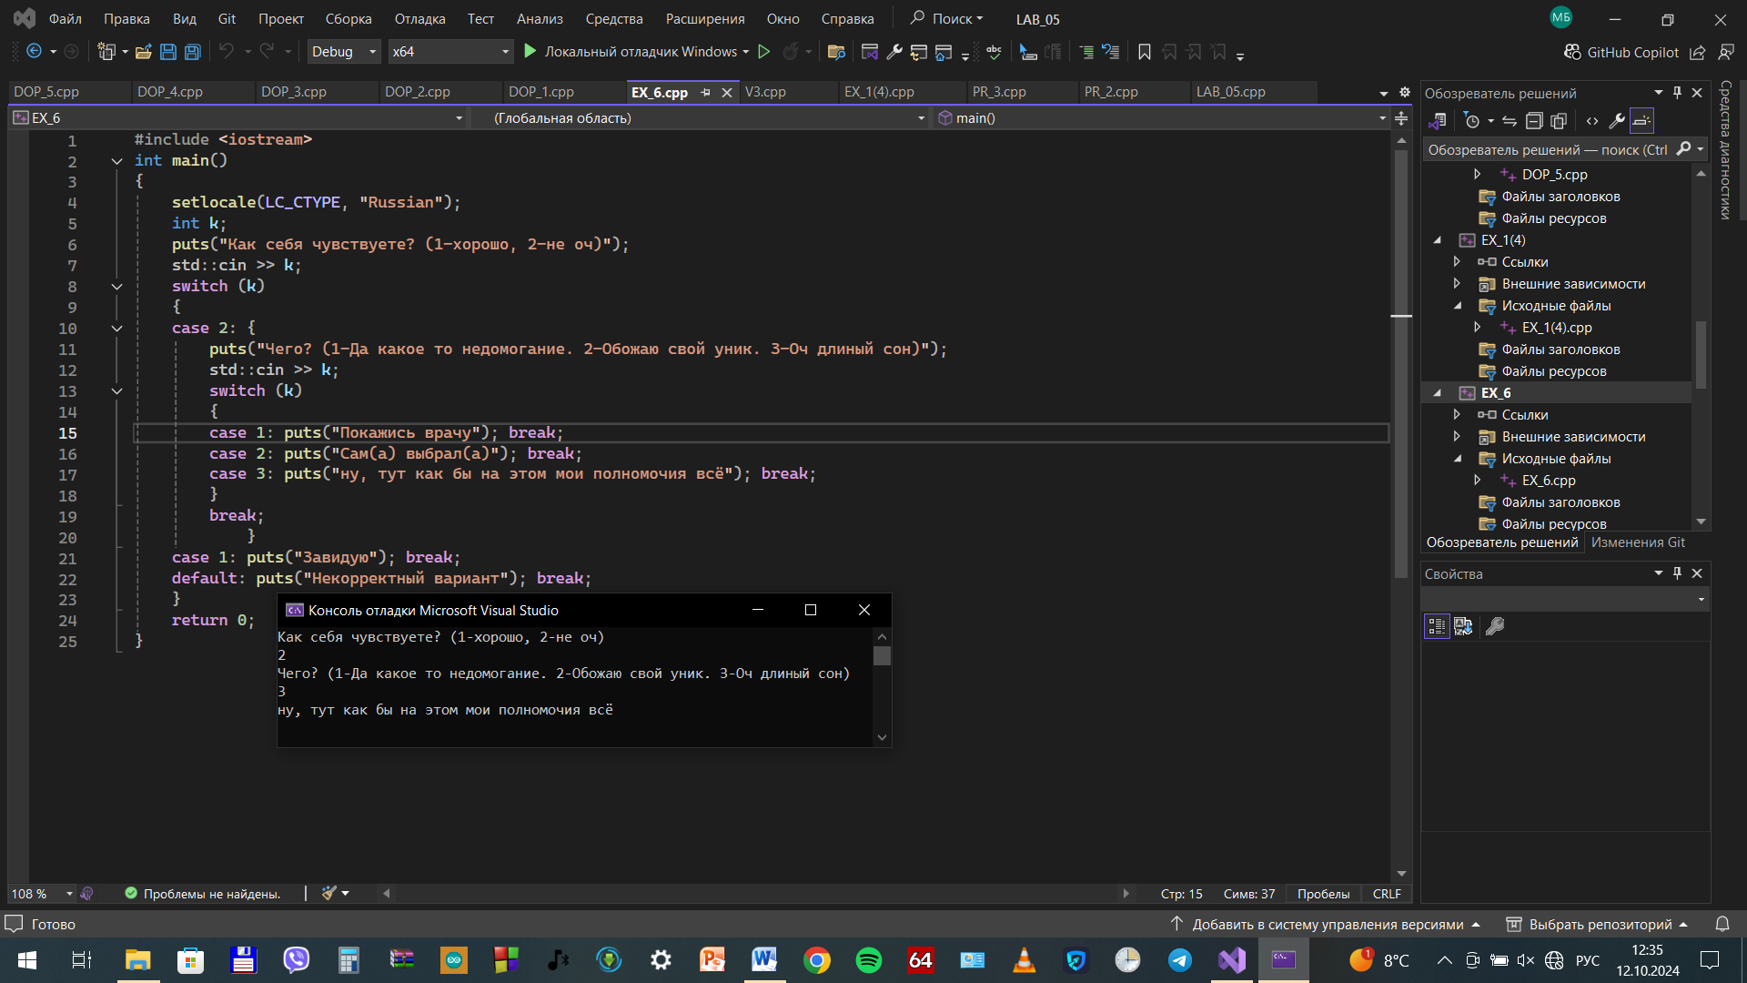

Доп1

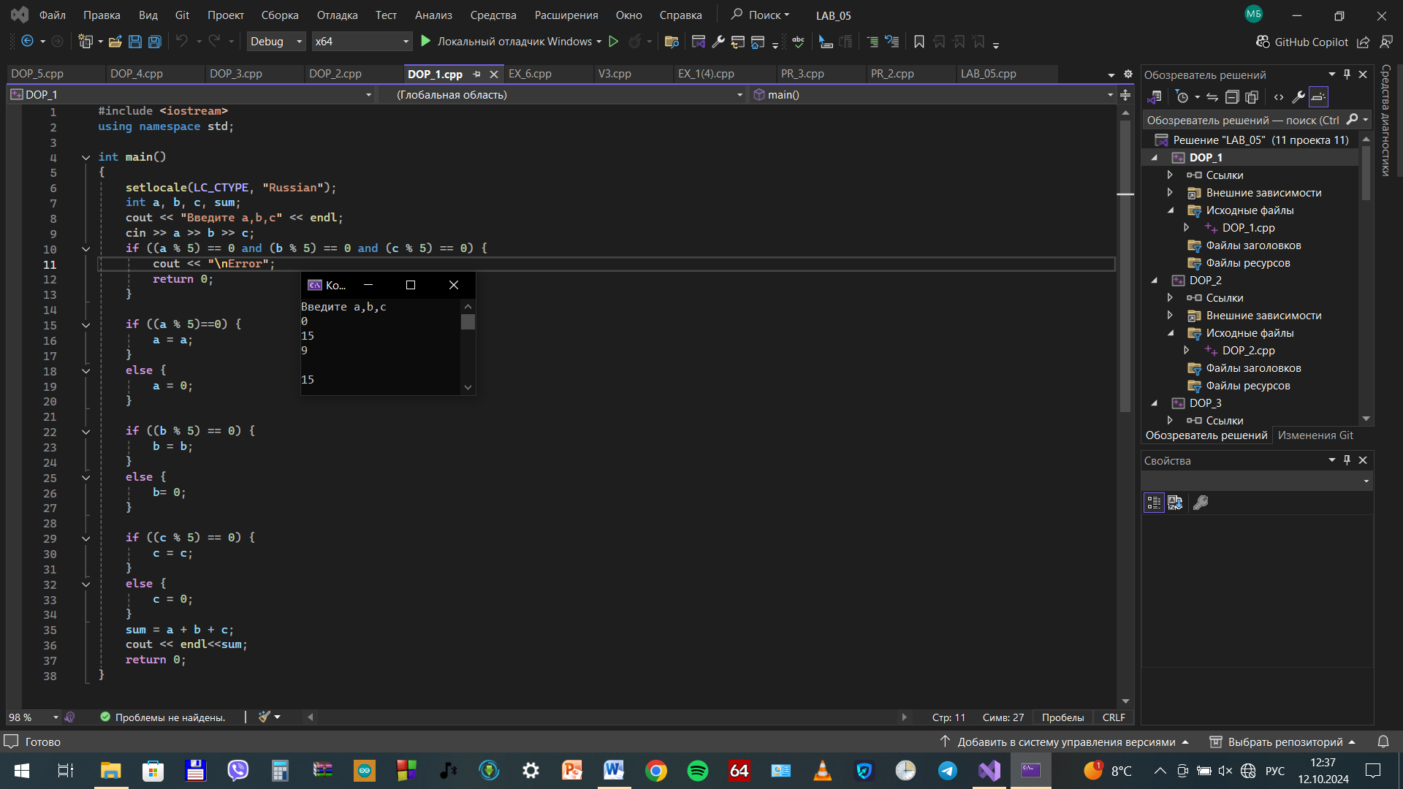

Доп2

#include <iostream>

using namespace std;

int main()

{

setlocale(LC_CTYPE, "Russian");

int k, l, m, n, k1 = 0, m1 = 0, l1 = 0, n1 = 0;

cout << "Введите k,l,m,n" << endl;

cin >> k >> l >> m >> n;

{//проверка на ошибки ввода

for (int i = 1; i < 9; i++)

{

if (k == i)

{

k1++;

}

}

if (k1 != 1)

{

cout << "error";

return 0;

}

for (int i = 1; i < 9; i++)

{

if (m == i)

{

m1++;

}

}

if (m1 != 1)

{

cout << "error";

return 0;

}

for (int i = 1; i < 9; i++)

{

if (l == i)

{

l1++;

}

}

if (l1 != 1)

{

cout << "error";

return 0;

}

for (int i = 1; i < 9; i++)

{

if (n == i)

{

n1++;

}

}

if (n1 != 1)

{

cout << "error";

return 0;

}

}

{//проверка коня

{

k = k + 3;

l = l - 1;

if (k == m and l == n)

{

cout << "Угроза";

return 0;

}

k = k - 3;

l = l + 1;

}

{

k = k + 3;

l = l + 1;

if (k == m and l == n)

{

cout << "Угроза";

return 0;

}

k = k - 3;

l = l - 1;

}

{

k = k - 1;

l = l - 3;

if (k == m and l == n)

{

cout << "Угроза";

return 0;

}

k = k + 1;

l = l + 3;

}

{

k = k + 1;

l = l - 3;

if (k == m and l == n)

{

cout << "Угроза";

return 0;

}

k = k - 1;

l = l + 3;

}

{

k = k - 1;

l = l + 3;

if (k == m and l == n)

{

cout << "Угроза";

return 0;

}

k = k + 1;

l = l - 3;

}

{

k = k + 1;

l = l + 3;

if (k == m and l == n)

{

cout << "Угроза";

return 0;

}

k = k - 1;

l = l - 3;

}

{

k = k - 3;

l = l - 1;

if (k == m and l == n)

{

cout << "Угроза";

return 0;

}

k = k + 3;

l = l + 1;

}

{

k = k - 3;

l = l + 1;

if (k == m and l == n)

{

cout << "Угроза";

return 0;

}

k = k + 3;

l = l - 1;

}

}

cout << "Угрозы нет";

return 0;

}

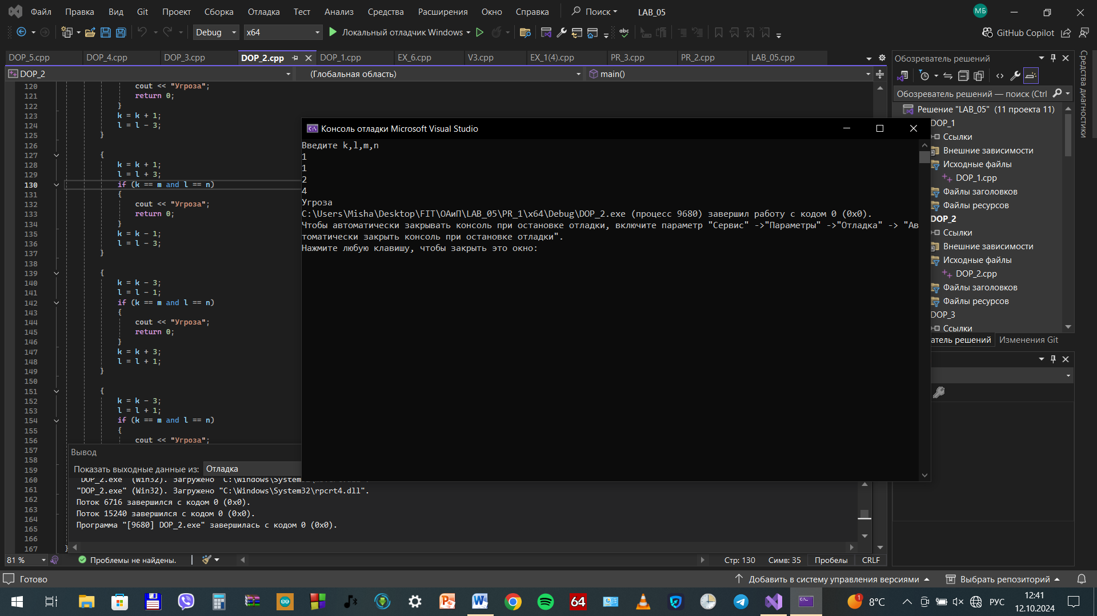

Доп3

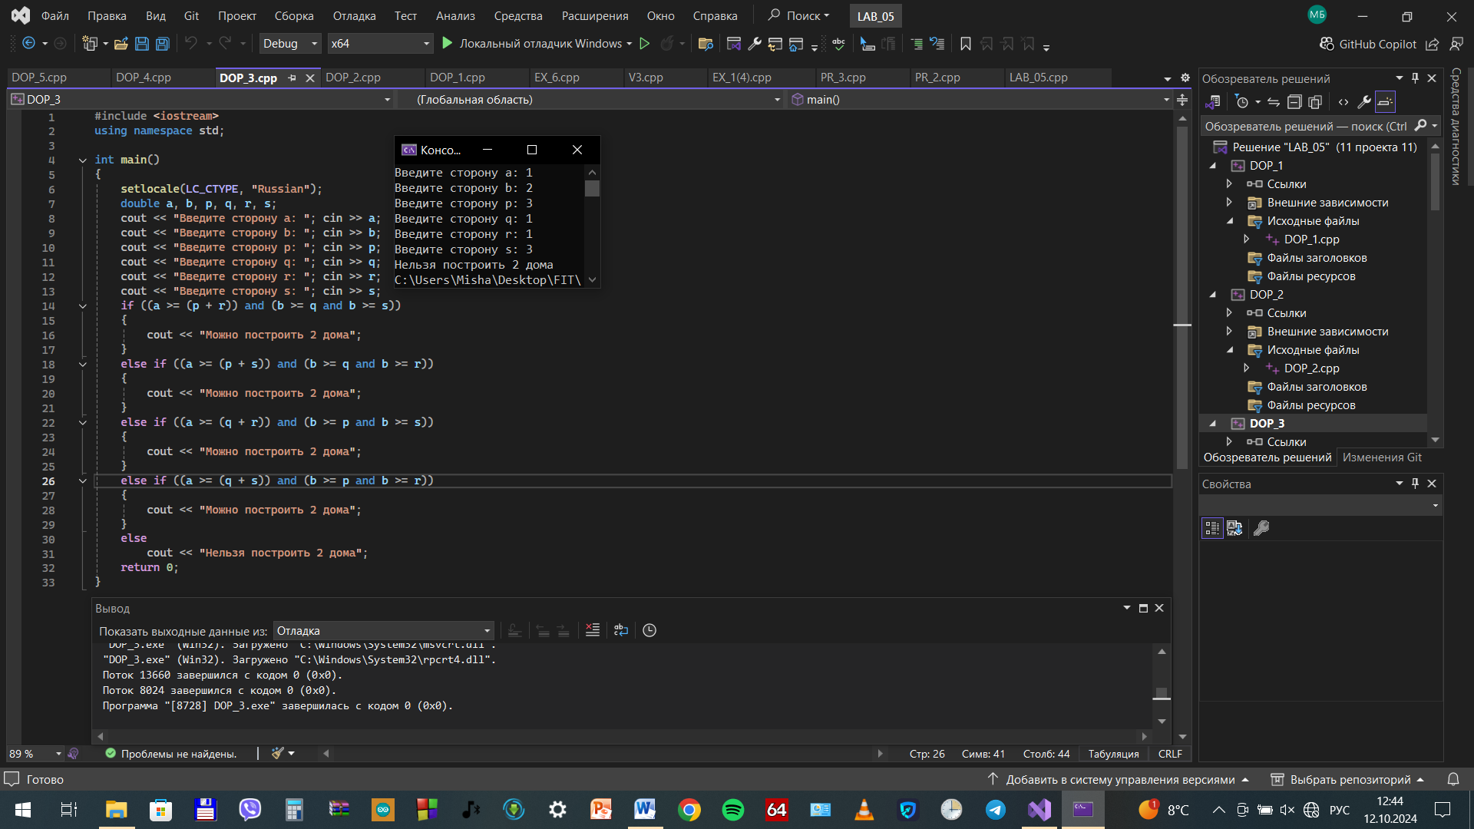

Доп4

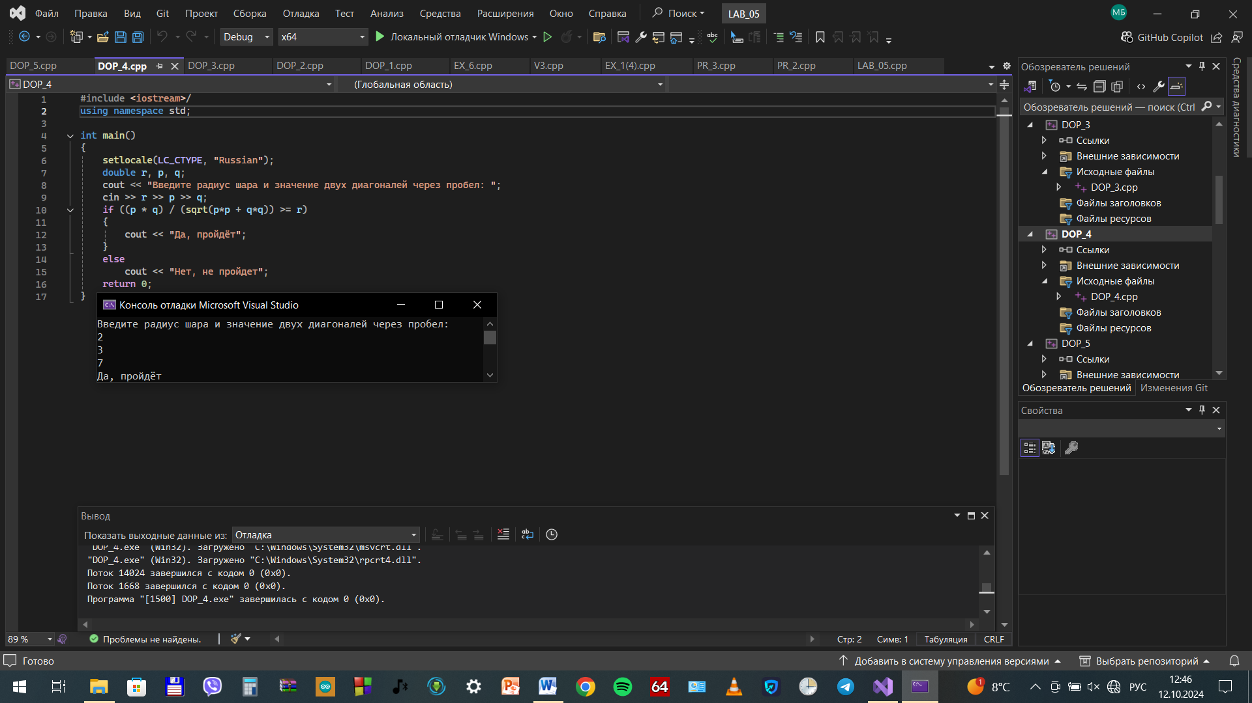

Доп5

