Game Design Document

Fill up the following document

1. Write the title of your project.

Brick Breaker Game

1. What is the goal of the game?

The player has to break the bricks by a ball, which the player has to stop from falling. They have to score a total of 100 points in 3 lives.

1. Write a brief story of your game.

1. Which are the playing characters of this game?

* Playing characters are the ones who respond to the user based on the input from the user.
* Cars, monkeys, dinos, wizards, etc., are the playing characters in the game.

|  |  |  |
| --- | --- | --- |
| Number | Character Name | What can this character do? |
| 1 | Paddle | Move, Stop the ball from falling. |
| 2 |  |  |
| 3 |  |  |
| 4 |  |  |
| 5 |  |  |
| 6 |  |  |
| 7 |  |  |
| 8 |  |  |

1. Which are the Non-Playing Characters of this game?

* Non-Playing characters are the ones that don't have an action or behavior when the user interacts with the game.
* Hurdles, stones, bananas, coins, etc., are non-playing characters in the game.

|  |  |  |
| --- | --- | --- |
| Number | Character Name | What can this character do? |
| 1 | Ball | Break the bricks |
| 2 | Bricks | Stop the ball from moving up. |
| 3 |  |  |
| 4 |  |  |
| 5 |  |  |
| 6 |  |  |
| 7 |  |  |
| 8 |  |  |

Draw your imagination of this game. What does this game look like?

* Draw the game either on your computer or on paper.
* Add images of the game scenes to show each of the playing and non-playing characters at least once.

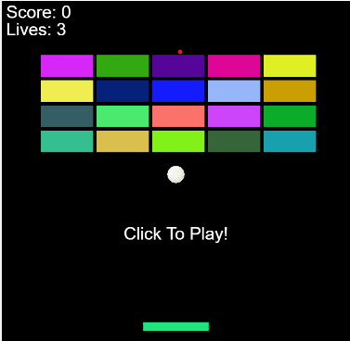

How do you plan to make your game engaging?

The bricks slowly move down, while the player has only 3 lives to break all the bricks.