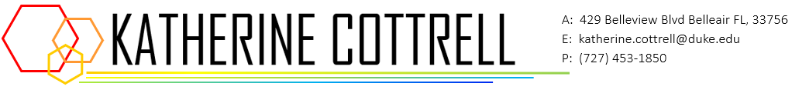

**EDUCATION**

**Duke University Durham, NC**

*B.S. in Computer Science* Expected Graduation: May 2022

* Coursework: Data Structures and Algorithms, Applications in Data Science, Data Visualization, Methods in Machine Learning, Probability and Statistical Inference, Computations with MATLAB, Databases
* Extracurricular: Nexus (Treasurer), DrawDurham (Artist), DuArts (Designer), Walla (Marketing Lead)

**TECHNICAL SKILLS**

Python, R, Java, MATLAB, C, Stata, TensorFlow, OpenRefine, Tableau, HTML/CSS, SQL, Unix/Linux, Git/Github

**EXPERIENCE**

**DATA+ (RHODES INFORMATION INITIATIVE AT DUKE UNIVERSITY) Durham, NC**

*Data Scientist*

May 2020 - Present

* Manipulated and sanitized fifty years of student enrollment data at Duke University; used R.
* Worked with a team of graduate data scientists to develop an RShiny web application for users to visualize trends in student enrollment over time; used R and OCR tools.

May 2019 - July 2019

* Manipulated and sanitized 50 years of big data collected by the IISD’s Experimental Lakes Area; used R.
* Worked with a team of graduate data scientists to develop an RShiny web application for users to visualize the relationships between environmental stressors and their effects on lake systems; used R.

**DUKE UNDERGRADUATE MACHINE LEARNING Durham, NC**

*Executive Board Member*

Aug 2018 – Dec. 2019

* Planned and hosted events to educate undergraduates on machine learning and big data topics.
* Planned and hosted panels to promote diversion and inclusivity in data science (e.g. “Women in Data Science”); attended by national experts.
* Planned and hosted annual Datathon competition (open to undergraduate and graduate students).

**RHODES iiD Durham, NC**

*Graphic Designer*

May 2019 – Present

* Designed thematic promotional materials for Rhodes iiD program events and programs.