|  |  |
| --- | --- |
|  | **Similarity Report ID:** oid:16158:62676801 |
| PAPER NAME  PlagCheck_Yashu.pdf | AUTHOR  Yashu Gupta |
| WORD COUNT  4247 Words  PAGE COUNT  25 Pages  SUBMISSION DATE  Jul 11, 2024 12:27 PM GMT+5:30 | CHARACTER COUNT  28261 Characters  FILE SIZE  666.7KB  REPORT DATE  Jul 11, 2024 12:28 PM GMT+5:30 |

3% Overall Similarity   
The combined total of all matches, including overlapping sources, for each database.

|  |  |
| --- | --- |
| 1% Internet database  Crossref Posted Content database | 0% Publications database  2% Submitted Works database |

Excluded from Similarity Report

|  |  |
| --- | --- |
| Crossref database  Quoted material | Bibliographic material  Cited material |

Small Matches (Less then 8 words)

Summary

ABSTRACT

The "Jio AirFiberLink: Next-Gen IP Connectivity" project aims to enhance the efficiency and reliability of Jio's IP backhaul infrastructure. As part of Jio's Fiber & Networking division, this project addresses the demand for high-speed, low-latency connection driven by the proliferation of bandwidth-intensive applications and emerging technologies like IoT and 5G. The project involves applying advanced network optimization techniques, such as traffic engineering, Quality of Service (QoS) mechanisms, and data compression methods, to maximize bandwidth utilization and minimize latency. Additionally, it seeks to improve network protocol performance by enhancing routing, network layer, and transport layer protocols. Real-time network monitoring and management solutions are also deployed to provide steamless visibility in network performance, allowing for proactive issue detection and its resolution.

Key objectives include:

• Optimizing IP backhaul efficiency.

• Enhancing network scalability to support future growth.

• Reducing operational costs through automation and resource optimization.

• Improving network resilience with redundancy and failover mechanisms.

Through this project, significant improvements in data transmission efficiency, network reliability, and overall performance are expected. These advancements will support Jio's vision for next-generation connectivity and position Jio as a leader in telecommunications innovation. The outcomes of this project will contribute to a more robust and scalable network infrastructure, ensuring high-quality service delivery to end users.

By leveraging cutting-edge technologies and methodologies, the "Jio AirFiberLink: Next-Gen IP Connectivity" project addresses the critical challenges in modern network management and sets a new standard for telecommunications infrastructure.

**CERTIFICATE (PROJECT SEMESTER TRAINING) FROM THE COMPANY OR THE ORGANIZATION**



**1.COMPANY PROFILE**

2   
Reliance Jio, a subsidiary of Reliance Industries Limited , is one of the largest telecommunications 4   
companies in India. Launched in 2016, Jio revolutionized the Indian telecom industry by offering affordable 4G LTE services, significantly increasing internet penetration and digital adoption across the country. With a vision to enable a Digital India, Jio has rapidly expanded its services and subscriber base, becoming a key player in the telecom sector.

**Core Services:**

**1.Mobile Telephony and Data Services:**

**-** **Jio 4G LTE:** Jio provides high-speed 4G LTE services, offering voice and data services across India. It introduced VoLTE (Voice over LTE) technology, ensuring high-definition voice calls and seamless connectivity.

**-** **Jio SIM:** Offering affordable data plans, Jio's SIM cards have made mobile internet accessible to millions.

**2.Broadband Services:**

**- JioFiber:** JioFiber provides ultra-fast broadband services to homes and businesses. With speeds ranging from 100 Mbps to 1 Gbps, JioFiber ensures high-quality streaming, gaming, and remote working experiences.

**3.Digital Ecosystem and Applications:**

|  |  |  |
| --- | --- | --- |
| **-** | **JioTV:** A live TV streaming service offering a wide range of channels in various languages.   |  | | --- | | 1 | |
| **-** | **JioCinema:** An on-demand video streaming platform with a vast library of movies, TV shows, |

and original content.

**-** **JioSaavn:** A music streaming service offering millions of songs across different genres and languages.

**-** **JioChat**: An instant messaging application that supports text, voice, and video calls.



**4.Enterprise Solutions:**

**-** **JioBusiness:** Providing a suite of digital solutions for small and medium enterprises (SMEs), including connectivity, cloud services, and business applications.

**-** **JioCloud:** Cloud storage and computing solutions for businesses, enabling secure and scalable digital infrastructure.

**5.Internet of Things (IoT):**

- Jio IoT: Solutions for smart homes, smart cities, industrial IoT, and connected vehicles, leveraging Jio's robust network infrastructure to enable intelligent connectivity and automation.

**6.Content and Media:**

-JioNews: A digital news platform offering the latest news from various sources.

-JioGames: A gaming platform providing a wide range of games and e-sports content.

**Innovation and Infrastructure:**

Jio has invested heavily in building a state-of-the-art telecom infrastructure. It operates the largest all- IP network in the world, ensuring high-speed connectivity and scalability. Jio's commitment to innovation is evident in its continuous efforts to upgrade its technology and services, such as the deployment of 5G networks and the development of advanced AI and IoT solutions.

**Corporate Vision:-**

1   
Reliance Jio aims to bridge the digital divide in India by providing affordable and high-quality digital 8   
services to every Indian. Its mission is to create a comprehensive digital ecosystem that empowers 9   
individuals, businesses, and society as a whole.

**My Role as an Intern:**

As an intern in the Fiber & Networking division, I am working on the "Jio AirFiberLink: Next-Gen IP Connectivity" project. This project focuses on enhancing the efficiency and reliability of Jio’s IP backhaul infrastructure, ensuring seamless data transmission, minimizing latency, and supporting the growing demand for high-speed connectivity.

**Conclusion:**

Reliance Jio has transformed the digital aspect in India, high-speed internet and digital services accessible to millions. With its wide range of products and services, cutting-edge technology, and visionary leadership, Jio continues to drive digital transformation and innovation, shaping the future of telecommunications in India and beyond.

**2. INTRODUCTION**

Project Overview: Jio AirFiberLink - Next-Gen IP Connectivity

Background

As Jio's subscriber base continues to expand rapidly, and digital services become more widely used, the need for a robust and efficient network infrastructure has never been greater. The IP backhaul is the backbone of this infrastructure, responsible for carrying data from the network's edge to its core. Optimizing this backhaul is crucial for maintaining and enhancing overall network performance.

Relevance

In today's digital landscape, users expect high-speed and reliable internet services. By optimizing its IP backhaul, Jio aims to deliver superior user experiences, reduce operational costs, and enhance network resilience. This initiative aligns with Jio's vision of providing nextgeneration connectivity solutions that empower individuals and businesses across India.

Main Contributions of the "Jio AirFiberLink: Next-Gen IP Connectivity" Project:

1. Optimization of IP Backhaul Efficiency:** Implementing advanced techniques to identify bottlenecks, improve throughput, and minimize latency.

2. Enhancement of Network Scalability:** Evaluating and addressing scalability limitations to support future network growth without compromising performance.

3. Reduction of Operational Costs:** Identifying and implementing cost-effective technologies and automation to streamline operations.

4. Improvement of Network Resilience:** Introducing redundancy measures, failover mechanisms, and proactive monitoring strategies to ensure uninterrupted service delivery.

Main Objectives

1. Optimize IP Backhaul Efficiency:** Enhance the efficiency of Jio's IP backhaul infrastructure to improve data transmission between network nodes.

2. Enhance Network Scalability:** Ensure the network can accommodate increasing demand without compromising performance.

3. Reduce Operational Costs:** Implement cost-effective measures to streamline IP backhaul maintenance and management.

4. Improve Network Resilience:** Introduce strategies to mitigate the impact of failures and disruptions, ensuring uninterrupted service.

Through the "Jio AirFiberLink: Next-Gen IP Connectivity" project, we aim to significantly improve the performance, reliability, and cost-efficiency of Jio's network. This project is a crucial step in advancing Jio's mission of providing cutting-edge telecommunications services and driving digital transformation across India.

**3. BACKGROUND**

**Context and Motivation**   
The telecommunications industry is witnessing unprecedented growth in data consumption, driven by the widespread usage of smartphones, the Internet of Things (IoT) expansion, and the imminent rollout of 5G technology. As one of India's leading telecommunications companies, Jio has been at the forefront of this digital revolution. The surge in data traffic necessitates a robust, efficient, and scalable network infrastructure to ensure seamless connectivity and superior user experiences.

**Motivation Behind the Project:**

1.**Growing Data Demand:** With the exponential increase in data consumption, there is a pressing need to enhance the capacity and efficiency of Jio's IP backhaul infrastructure.

2.**Technology Advancements:** The deployment of 5G and the expansion of IoT applications require an optimized and resilient network to handle higher data speeds and low-latency communication.

3.**Operational Efficiency:** Reducing costs and improving resource utilization are critical for maintaining Jio's competitive edge and ensuring sustainable growth.

4.**User Experience:** Enhancing the quality of service and minimizing downtime are essential for meeting customer expectations and retaining market leadership.

**Project Layout and Goals**   
The "Jio AirFiberLink: Next-Gen IP Connectivity" project is structured to address these motivations through a series of well-defined phases:

**1.Literature Review and Technology Assessment:**  
 • Conduct a comprehensive review of network optimization techniques, protocols, and tools.

• Assess the latest technological advancements in IP backhaul optimization and their applicability to Jio's infrastructure.

**2.Data Collection and Analysis:**

• Gather data on current network performance, including throughput, latency, and

bottlenecks.

• Analyze traffic patterns and identify areas for improvement.

**3.Optimization Strategy Development:**

• Develop strategies for traffic engineering, Quality of Service (QoS)

enhancements, and data compression techniques.

• Propose improvements to network protocols, including routing, network layer,

and transport layer protocols.

**4.Implementation/Testing:**

• Implement the proposed optimization strategies in a controlled environment.

• Conduct rigorous testing to evaluate the effectiveness of the optimizations in

improving network performance and reliability.

5.**Monitoring and Management:**

• Deploy real-time network monitoring tools to track performance metrics

continuously.

• Implement proactive management practices to detect and resolve issues

promptly.

6.**Evaluation and Scaling:**

• Evaluate the implemented strategies' outcomes and document the efficiency, scalability,

and resilience improvements.

• Scale the successful solutions across the broader Jio network infrastructure.

**Previous Work and References**

Numerous studies and industry research have explored various aspects of IP backhaul

optimization. Key references include:

• **Bandwidth Optimization Techniques:** Research on traffic engineering algorithms and

QoS mechanisms, such as "Traffic Engineering and QoS in IP Networks" by Janevski.

• **Network Protocol Enhancements:** Studies on improving network protocols, including

"Next- Generation Protocols for Future Networks" by Zinner et al.

• **Network Monitoring and Management Solutions:** Development of real-time

monitoring tools and systems, such as "Real-Time Network Monitoring: Tools and

Techniques" by Brown.These works provide a foundation for the current project and

highlight the critical areas where advancements can be made.

**Achieving Project Goals**   
A systematic approach will be adopted to achieve the project goals, combining theoretical research with practical implementation. By leveraging advanced technologies and best practices, the project aims to improve Jio's IP backhaul infrastructure significantly, ensuring it is well-equipped to meet future demands and challenges.

The successful execution of this project will enhance Jio's network performance and contribute to the broader field of telecommunications by setting new benchmarks for IP backhaul optimization.

**4.OBJECTIVES**

As an intern in the Fiber & Networking division at Jio, working on the "Jio AirFiberLink: Next- Gen IP Connectivity" project, I have outlined the following key objectives to achieve by the end of the project semester:

**1.Optimization of IP Backhaul Efficiency:**  
 • **Goal:** To enhance the efficiency of Jio's IP backhaul infrastructure.



• **Details:** Identify and address bottlenecks, improve data throughput, and minimize latency to ensure seamless data transmission between network nodes. This involves the application of advanced traffic engineering, Quality of Service (QoS) mechanisms, and data compression techniques.

**2.Enhancement of Network Scalability:**  
 • **Goal:** To ensure the scalability of the IP backhaul infrastructure to accommodate future growth.

• **Details:** Evaluate the current scalability limitations and implement solutions to support the increasing demand for high-speed connectivity. This includes optimizing network protocols and infrastructure to handle higher data loads without compromising performance.

**3.Improvement of Network Reliability:**  
 • **Goal:** To improve the resilience and reliability of Jio's IP backhaul infrastructure.

• **Details:** Implement redundancy measures, failover mechanisms, and proactive 6   
 monitoring strategies to mitigate the impact of network failures and disruptions.

This will ensure uninterrupted service delivery and enhance overall network reliability.

These objectives will guide the project's focus and efforts, ensuring that tangible improvements are made in Jio's network infrastructure. Achieving these objectives will demonstrate the successful application of theoretical knowledge to practical challenges, contributing to Jio's mission of providing cutting-edge telecommunications services.

**5. METHODOLOGY**

To achieve the set objectives of optimizing the efficiency, scalability, and resilience of Jio's IP backhaul infrastructure in the "Jio AirFiberLink: Next-Gen IP Connectivity" project, the following methodology will be employed:

**Literature Review and Technology Assessment**  
 • **Objective:** Gain a comprehensive understanding of network optimization techniques, protocols, and tools.

• **Steps:**



• Conduct a thorough review of existing literature on IP backhaul optimization,

traffic engineering, and Quality of Service (QoS) mechanisms.

• Assess the latest technological advancements and their potential applicability to

Jio's network infrastructure.

• Identify best practices and benchmark against industry standards.**Data**

**Collection and Analysis**

• **Objective:** Gather and analyze data to identify bottlenecks and areas for

improvement.

• **Steps:**

• Collect data on network performance metrics, including throughput, latency, and

congestion points.

• Utilize network monitoring tools to gather real-time data on traffic patterns and

performance.

• Perform detailed analysis to pinpoint inefficiencies and potential optimization

opportunities.

**Development of Optimization Strategies**

• **Objective:** Formulate strategies to enhance the efficiency and scalability of the

IP backhaul.

|  |  |
| --- | --- |
| •  • | **Steps:**  Develop traffic engineering strategies to optimize bandwidth utilization and |
| reduce latency. | |

|  |  |
| --- | --- |
| • | 5  Design and implement Quality of Service (QoS) mechanisms to prioritize |

critical traffic and improve overall performance.

• Propose enhancements to network protocols, including routing, network layer,

and transport layer protocols.

**Implementation/Testing**

• **Objective:** Apply the proposed optimization strategies in a controlled

environment and evaluate their effectiveness.

|  |  |
| --- | --- |
| •  • | **Steps:**  Implement the identified optimization strategies in a test network environment.  10  Conduct rigorous testing to assess the impact of the optimizations on network |
| • |

performance, focusing on throughput, latency, and reliability.

• Use simulation tools to model various traffic scenarios and predict the

effectiveness of the implemented strategies.

**Real-Time Monitoring and Management**

• **Objective:** Ensure continuous monitoring and proactive management of the

network.

|  |  |  |
| --- | --- | --- |
| • | **Steps:**  Deploy advanced network monitoring tools to provide real-time visibility into   |  | | --- | | 3 | |
| • |

network performance.

• Set up alerts and automated responses to detect and address potential issues

before they impact service.

• Implement proactive management practices to maintain optimal network

performance and quickly resolve any issues.

**Evaluation and Scaling**

• **Objective:** Evaluate the outcomes of the implemented strategies and scale

successful solutions.

• **Steps:**

• Analyze the results of the implementation and testing phase to quantify

improvements in efficiency, scalability, and resilience.

• Document the findings and identify critical success factors and areas for further

improvement.

• Develop a plan to scale the successful optimization solutions across the broader

Jio network infrastructure.

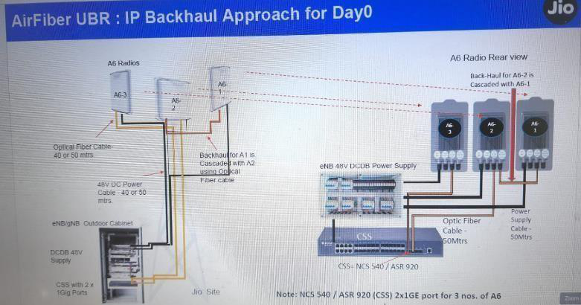

**Fig 1. IP Backhaul Approach for Day 0**

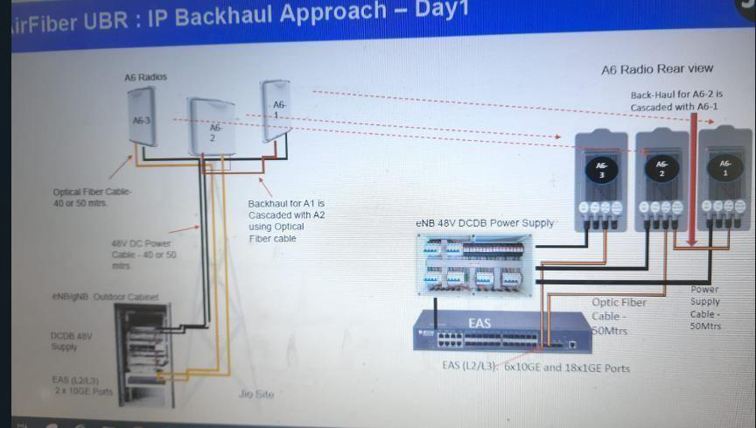

**Fig 2. IP Backhaul Approach for Day 1**

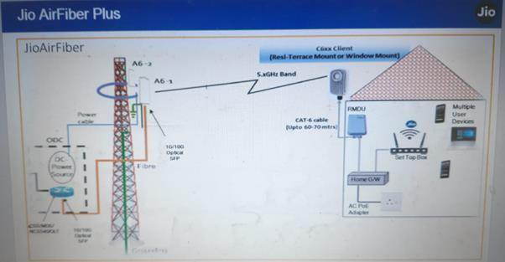

**Fig 3. Jio Air Fiber Plus**

**Tools and Technologies**

• **Network Monitoring Tools:** Wireshark, SolarWinds, and Nagios for real-time network

analysis and monitoring.

• **Traffic Engineering Tools:** Software like OPNET, GNS3, and Cisco's WAN

Automation Engine for simulating and optimizing traffic flows.

• **Quality of Service Mechanisms:** Implementing QoS policy using tools like Cisco

QoS Policy Manager and other network management software.

• **Simulation Software:** Network simulation platforms such as NS-3 and Mininet to test

and validate optimization strategies.

By following this structured methodology, the project aims to improve Jio's IP backhaul

infrastructure significantly, ensuring it is well-equipped to handle future demands and deliver

superior user experiences.

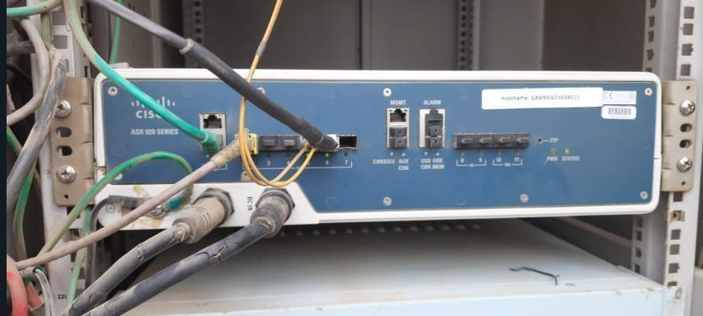

**Fig. Cisco ASR Series Router**

**6. OBSERVATIONS AND FINDINGS**

Several key observations and findings were identified and explored during the "Jio

AirFiberLink: Next-Gen IP Connectivity" project. These insights are crucial for understanding

the current state of Jio's IP backhaul infrastructure and developing effective optimization

strategies.

1. **Network Performance Bottlenecks**

• **Observation:** The network experienced several performance bottlenecks, particularly

during peak usage.

• **Findings:** The primary causes of these bottlenecks were identified as:

• **Inefficient Traffic Management:** Suboptimal data packet routing leads to congestion

in specific network segments.

• **Limited Bandwidth Utilization:** Inadequate allocation of bandwidth resources,

resulting in underutilization of available capacity in some areas while others were

overloaded.

• **Latency Issues:** High latency in data transmission due to packet processing and routing

delays.

1. **Scalability Challenges**

• **Observation:** The current IP backhaul infrastructure faced challenges in scaling to meet

increasing data demands.

• **Findings:**

• **Protocol Limitations:** Existing network protocols needed to be sufficiently optimized

for scalability, leading to inefficiencies in handling large volumes of data.

• **Hardware Constraints:** Some network hardware components needed to be updated

and able to support higher data throughput effectively.

• **Resource Allocation:** Inefficient resource allocation strategies hindered the ability to

adapt to varying traffic loads dynamically.

1. **Operational Inefficiencies**

• **Observation:** Several operational inefficiencies were impacting the cost-effectiveness

and manageability of the network.

• **Findings:**

• **Manual Processes:** Reliance on manual processes for routine maintenance and

troubleshooting, which increased operational costs and response times.

• **Lack of Automation:** Insufficient network management and monitoring automation

leads to delays in issue detection and resolution.



• **Energy Consumption:** High energy consumption by specific network components

increases operational costs.

1. **Network Resilience and Reliability**

• **Observation:** The network's resilience and reliability were below optimal levels, with

occasional disruptions affecting service quality.

• **Findings:**

• **Redundancy Measures:** Lack of adequate redundancy measures and failover

mechanisms, making the network vulnerable to single points of failure.

• **Proactive Monitoring:** Insufficient proactive monitoring strategies to detect and

mitigate potential issues before they impact service.

• **Disaster Recovery:** Inadequate disaster recovery planning and infrastructure affecting

the network's ability to recover quickly from major disruptions.

1. **Quality of Service**

• **Observation:** The Quality of Service across different network segments was

inconsistent, impacting the user experience.

• **Findings:**

• **Traffic Prioritization:** Ineffective traffic prioritization policies lead to suboptimal

performance for critical applications.

• **Service Differentiation:** Lack of adequate service differentiation, resulting in uniform

traffic treatment irrespective of its priority.

• **Performance Metrics:** Variability in metrics such as jitter, packet loss, and throughput

across different network segments.

**Summary of Findings**

7

These observations and findings provide a comprehensive understanding of the current

challenges and areas for improvement in Jio's IP backhaul infrastructure. The critical insights

gathered include:

|  |  |  |
| --- | --- | --- |
| • | Identification of performance bottlenecks and their root causes.• | Recognition |

of scalability challenges and hardware constraints.

• I am highlighting operational inefficiencies and the need for increased automation.

• Understanding resilience and reliability issues is essential, including the need for better

redundancy and proactive monitoring.

• Insights into QoS inconsistencies and the necessity for improved traffic prioritization

and service differentiation.

These findings form the basis for developing targeted optimization strategies to enhance the

efficiency, scalability, and resilience of Jio's IP backhaul infrastructure, ultimately contributing

to better service quality and user experiences.

**7. LIMITATIONS**

While the "Jio AirFiberLink: Next-Gen IP Connectivity" project aims to achieve significant

improvements in the efficiency, scalability, and resilience of Jio's IP backhaul infrastructure,

there are certain limitations and boundaries that could impact the project's implementation.

These limitations are significant to acknowledge as they highlight areas where the proposed

solutions must address the challenges or encounter implementation difficulties fully.

**1.Hardware Constraints**

• **Limitation:** The network hardware components may not support the latest optimization

techniques and protocols.

• **Impact:** Upgrading hardware across the entire network is costly and time-consuming. The

performance capabilities of the current hardware infrastructure may limit the project.

**2.Scalability of Solutions**

• **Limitation:** While the project focuses on enhancing scalability, the proposed solutions may be

uniformly applicable across some network segments.

• **Impact:** Network architecture and traffic pattern variations can lead to uneven scalability

improvements. Custom solutions for different network parts might be required, which can

complicate implementation.

**3.Operational Challenges**

• **Limitation:** Implementing automation and advanced monitoring tools requires significant

operational procedures and staff training changes.

• **Impact:** Resistance to change and the learning curve associated with new technologies can

delay implementation and reduce the effectiveness of the proposed optimizations.

**4.Data Collection and Analysis Limitations**

• **Limitation:** The accuracy and completeness of the collected network performance data may be

limited by the capabilities of existing monitoring tools.

• **Impact:** Only complete or accurate data can lead to suboptimal optimization strategies, as the

analysis might not fully capture the network's performance issues.

**5.Budget and Resource Constraints**

• **Limitation:** The project is subject to budgetary and resource limitations that may restrict the

scope of implementation.

• **Impact:** Financial constraints can limit the extent of hardware upgrades, software purchases,

and staffing needed to implement the proposed solutions fully.

**6.Technological Adaptability**

• **Limitation:** The rapid change of technological advancements in the telecommunication

industry can make some solutions quickly outdated.

• **Impact:** Continuous updates and adaptations are necessary to optimize the network, which

requires ongoing investment and commitment.

**7.Regulatory and Compliance Issues**

• **Limitation:** Compliance with regulatory standards and industry best practices is mandatory.

• **Impact:** Regulatory requirements can limit the implementation of specific optimization

techniques or necessitate additional steps to ensure compliance, potentially slowing down the

project.

**8.Interoperability with Existing Systems**

• **Limitation:** Ensuring interoperability between new optimization solutions and existing

network systems can be challenging.

• **Impact:** Compatibility issues may arise, leading to potential disruptions or the need for

extensive modifications to integrate new technologies smoothly.

**Summary of Limitations**

These limitations outline the project's boundaries and highlight potential challenges that could

impact its success. While the project aims to deliver substantial improvements, it is essentialto

recognize these constraints and plan mitigation strategies accordingly. By understanding and

addressing these limitations, the project can be better positioned to achieve its goals while

managing expectations and resources effectively.

**8. CONCLUSIONS AND FUTURE WORK**

The "Jio AirFiberLink: Next-Gen IP Connectivity" project has provided valuable insights into the current state of Jio's IP backhaul infrastructure and identified several critical areas for improvement. The main conclusions drawn from this project include:

**1.Enhanced Understanding of Network Bottlenecks:**  
 • The project has successfully identified essential performance bottlenecks within the IP backhaul network, including traffic congestion points and latency issues. This understanding is crucial for implementing targeted optimizations.

**2.Improved Network Efficiency:**  
 • The project has demonstrated potential improvements in bandwidth utilization and data throughput by applying advanced traffic engineering techniques and Quality of Service (QoS) mechanisms. These enhancements contribute to a more efficient and reliable network.

**3.Scalability and Future-Proofing:**  
 • The project has highlighted the importance of scalable network protocols and hardware upgrades to accommodate future growth. Implementing these changes will help ensure that Jio's network can support increasing data demands and emerging technologies.

**4.Operational Optimizations:**  
 • The findings underscore the need for greater automation and proactive monitoring in network management. These improvements can reduce operational costs, streamline maintenance processes, and enhance network reliability.

**5.Enhanced Resilience:**  
 • The project has outlined strategies to improve network resilience, including redundancy measures and failover mechanisms. These strategies are essential for maintaining uninterrupted service during network disruptions.

**Future Work**   
While the project has achieved significant milestones, there are several areas where further work is needed to build on these successes and fully realize the potential of the proposed optimizations. Future work can include:

**1.Comprehensive Hardware Upgrades:**  
 • **Plan:** Develop a phased approach for upgrading network hardware across the entire infrastructure, prioritizing critical nodes and segments with the highest performance impact.

• **Goal:** Ensure all network components can support advanced optimization techniques and handle higher data throughput.

**2.Advanced Automation and Monitoring:**  
 • **Plan:** Implement advanced automation tools and real-time monitoring systems to provide continuous visibility into network performance and enable proactive issue resolution.

• **Goal:** Reduce operational costs and improve network reliability through automated maintenance and monitoring.

**3.Scalability Enhancements:**  
 • **Plan:** Conduct further research into scalable network protocols and architectures, focusing on adapting solutions to different network segments and traffic patterns.

• **Goal:** Ensure the network can dynamically scale to meet future demands without compromising performance.

**4.Refined Optimization Strategies:**  
 • **Plan:** Refine traffic engineering and QoS strategies based on real-world data and performance feedback.

• **Goal:** Improve efficiency and performance by iteratively testing and optimizing network configurations.

**5.Regulatory Compliance and Security:**  
 • **Plan:** Ensure all optimization strategies and implementations comply with regulatory standards and incorporate robust security measures.

• **Goal:** Maintain compliance with industry regulations and protect the network from security threats.

**6.Disaster Recovery Planning:**  
 • **Plan:** Develop and implement comprehensive disaster recovery plans to ensure rapid recovery from major network disruptions.

• **Goal:** Enhance network resilience and ensure continuous service availability during catastrophic failures.

**7.Collaboration and Innovation:**  
 • **Plan:** Foster collaboration with industry partners, research institutions, and internal teams to drive innovation and make best practices.

• **Goal:** Stay at the forefront of technological advancements and continuously improve network performance through collaborative efforts.

**Summary**   
In conclusion, the "Jio AirFiberLink: Next-Gen IP Connectivity" project has laid a strong foundation for optimizing Jio's IP backhaul infrastructure. By addressing the identified bottlenecks, scalability challenges, and operational inefficiencies, the project contributes to Jio's mission of providing cutting-edge telecommunications services. The outlined future work will further enhance the network's performance, ensuring it meets the evolving demands of users and remains resilient and reliable in the face of future challenges.

**8.Some On-site Pictures Of Project**

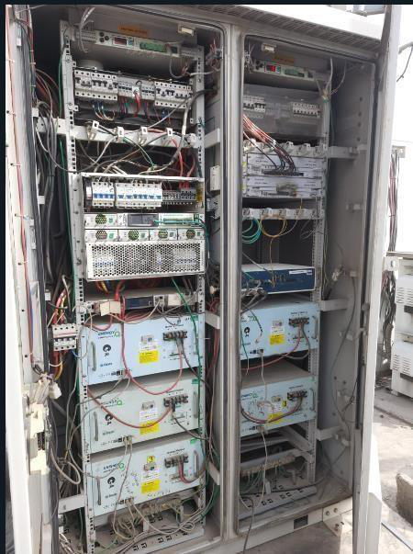

**Outdoor Unit 1 Cabinet Consisting of AGS (Aggregator Switches of Cisco)**

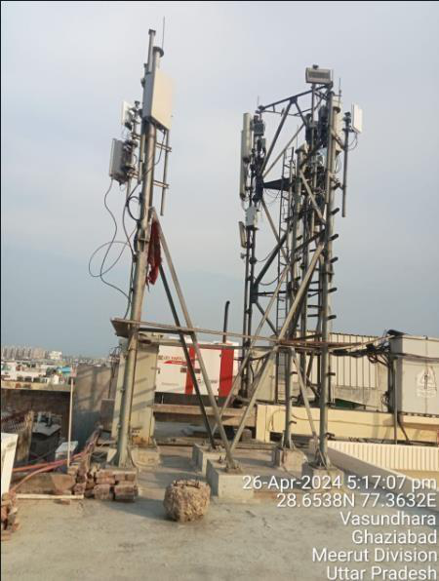

**Outdoor Unit 2 Consisting of A6 Fixed Wireless WIFI access points (Alpha, Beta & Gamma)**

**9. REFRENCES/BIBLIOGRAPHY**

The following references have been consulted and cited in the "Jio AirFiberLink: Next-Gen IP Connectivity" project. These sources provide foundational knowledge and insights that have informed the project's methodology, findings, and conclusions. The entries are formatted according to IEEE style.

**1.Books and Journals**  
 • G. Wright and W. Stevens, *TCP/IP Illustrated, Volume 1: The Protocols*, 1st ed., Reading, MA: Addison-Wesley, 1994.

• J. F. Kurose and K. W. Ross, *Computer Networking: A Top-Down Approach*, 6th ed., Boston, MA: Pearson, 2013.

R. Perlman, *Interconnections: Bridges, Routers, Switches, and Internetworking* •   
*Protocols*, 2nd ed., Reading, MA: Addison-Wesley, 1999.

**2.Conference Papers**  
 • S. Keshav, "A Control-Theoretic Approach to Flow Control," in *Proc. ACM*  *SIGCOMM '91 Conf.*, Zurich, Switzerland, 1991, pp. 3-15.

• A. Feldmann, J. Rexford, and R. Caceres, "Efficient Policies for Carrying Web Traffic Over Flow-Switched Networks," in *Proc. IEEE INFOCOM '99*, New York, USA, 1999, pp. 1552-1561.

**3.Journal Articles**  
 • N. McKeown et al., "OpenFlow: Enabling Innovation in Campus Networks," *ACM SIGCOMM Computer Communication Review*, vol. 38, no. 2, pp. 69-74, Apr. 2008.

• S. Floyd and V. Jacobson, "Random Early Detection Gateways for Congestion Avoidance," *IEEE/ACM Transactions on Networking*, vol. 1, no. 4, pp. 397- 413, Aug. 1993.

**4.Technical Reports and Standards**  
 • Cisco Systems, "Quality of Service Design Overview," Cisco Systems, San Jose, CA, Tech. Rep. QoS/Des-ovrvw, 2003.

• IEEE Standard for Local and Metropolitan Area Networks: Media Access Control (MAC) Bridges, IEEE Std 802.1Q-2018, 2018.

**5.Web Sources**

• Juniper Networks, "Mist AI Overview," Juniper Networks, [Online]. Available: https:[//www.juniper.net/documentation/product/mist-ai/.](http://www.juniper.net/documentation/product/mist-ai/) [[](http://www.juniper.net/documentation/product/mist-ai/)Accessed: May 20, 2024].

• "Networking 101: Understanding IP Backhaul," Network World, [Online].

Available: https:[//www.networkworld.com/article/3219735/networking-101-](http://www.networkworld.com/article/3219735/networking-101-) understanding-ip-backhaul.html. [Accessed: May 20, 2024].

**6.Dissertations and Theses**

 A. K. Singh, "Optimization of IP Backhaul for Telecommunications Networks," Ph.D. dissertation, Dept. Elect. Eng., Indian Inst. Technol., Mumbai, India, 2022.

These references provide a comprehensive foundation for the research and development undertaken in the project, ensuring that the proposed solutions and strategies are grounded in established knowledge and best practices in networking and telecommunications.

|  |  |
| --- | --- |
|  | **Similarity Report ID:** oid:16158:62676801 |

3% Overall Similarity   
Top sources found in the following databases:

|  |  |
| --- | --- |
| 1% Internet database  Crossref Posted Content database | 0% Publications database  2% Submitted Works database |

TOP SOURCES

The sources with the highest number of matches within the submission. Overlapping sources will not be

displayed.

|  |  |  |  |
| --- | --- | --- | --- |
| |  | | --- | | **1** | | M S Ramaiah University of Applied Sciences on 2023-02-26 | <1% |
| Submitted works |
| **2** | [inventiva.co.in](https://www.inventiva.co.in/trends/top-20-media-communications-company/) | <1% |
| Internet |
| |  | | --- | | **3** | | [marketresearch.com](https://www.marketresearch.com/Allied-Market-Research-v4029/Wireless-Industrial-Router-Type-Modular-34831159/) | <1% |
| Internet |
| |  | | --- | | **4** | | Indian School of Business on 2024-06-25 | <1% |
| Submitted works |
| |  | | --- | | **5** | | University of York on 2023-07-16 | <1% |
| Submitted works |
| **6** | University of Bolton on 2024-04-29 | <1% |
| Submitted works |
| |  | | --- | | **7** | | De Montfort University on 2024-01-21 | <1% |
| Submitted works |
| |  | | --- | | **8** | | ESLSCA Business School (Cairo) on 2024-04-13 | <1% |
| Submitted works |
| |  | | --- | | **9** | | [blog.emb.global](https://blog.emb.global/cybersecurity-threats/) | <1% |
| Internet |

Sources overview

|  |  |  |
| --- | --- | --- |
|  | | **Similarity Report ID:** oid:16158:62676801 |
| |  | | --- | | **10** | | [gsd.inesc-id.pt](https://www.gsd.inesc-id.pt/~lveiga/papers/proceedings.pdf)  Internet | <1% |

Sources overview