The frequency of optimal codons (F_{op}) reflects the balance between the optimal to non-optimal codons synonymous substitution rate (K_{on}) and the non-optimal to optimal codons synonymous substitution rate (K_{no}):

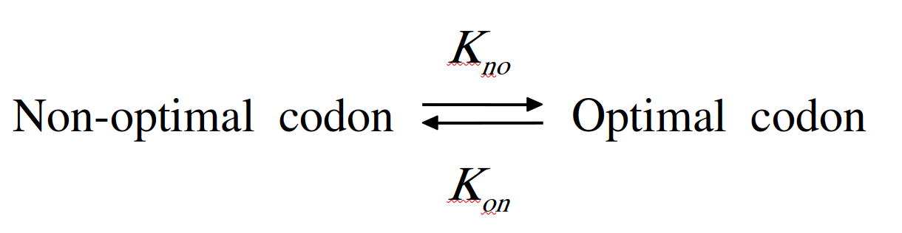
Substitution rates depend on the corresponding mutation rates (µ_{no}, µ_{on}) and fixation probabilities (P_{no}, P_{on}):

and

where N_{e} is the effective population size.

Fixation probabilities are given by:

similarly

Where s is the selection coefficient in favor of optimal codons and f₀ the allele frequency of a new arrival mutation (f₀ = 1/2N_{e}) .

At equilibrium, the frequency of optimal codons is given by:

which can be written as:

Let us note lambda, the ratio of mutation rates:

(1)

With the following simplification:

(1) →

Thus, the population-scaled selection coefficient (S=4N_{e}s) is given by:

Hence, we expect a linear correlation between logit(Fop) and S:

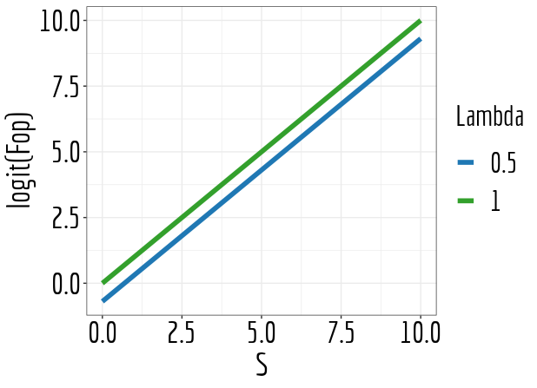

If for weakly-expressed genes there is no selection, implied by the non-variation of Fop with gene expression, S_{low-exp}~0 :

