Michael Florence

Professor Randal Root

TA: Summer Rae

Foundation of Programing: Python

October 31, 2016

Assignment 05: Working with Dictionaries

This week we are working with data from a source file and modifying it with user input. In this assignment, we are tasked with writing a program that updates a .txt file by asking the user if they would like to add or remove items from it; as well as asking if they would like to save their changes, which will export the program data back to the .txt file.

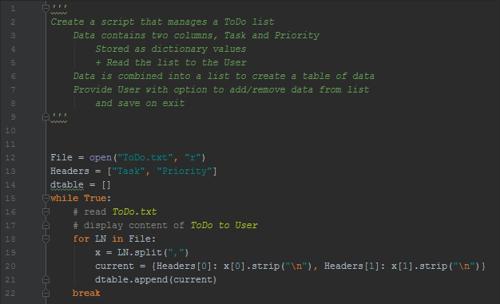

My first steps are to open the file as read-only and read the content. I created a list of headers to add to my display of data from the text file. Next I loop through each line in the data file with a For loop, splitting on the comma and assigning what was found on that line to x. My named variable assigns the correct header to each value of x and strips the trailing ‘enter’ from each Priority, brought over from the input text file. This formatting is required to save this data in a dictionary, defined by my bracket use. Finally, I append the dictionaries individually to the list variable with the end of the For loop.

We are instructed to print the current content of the txt file to the user, so that is done here, while providing a list of command options available to the user.

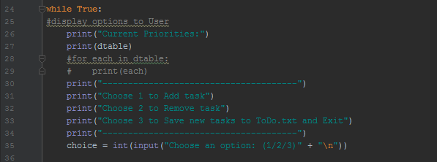

I choose to loop through the list of dictionaries so each would be printed on an individual line while the program runs, instead of a single line like the above code prints. Swapping comment notation in lines 28/29 with line 27 gets the program to print them on individual lines. You can see the dictionary values nested in the list brackets with the first print. The second only prints the dictionary values.

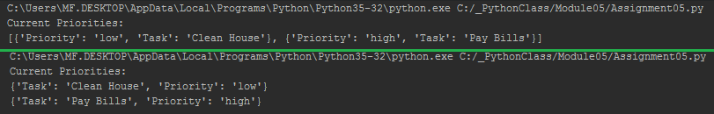

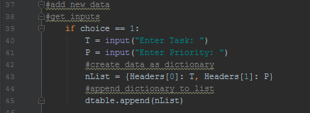

The first choice is to add a task to our table of dictionaries. We need inputs from the user, so I will get those now. To store them in a dictionary, the header info needs to be added to our input variables. Once formatted, the dictionary can easily be appended to the list of dictionaries we created earlier. At the end of this loop, we jump back to the list of options available.

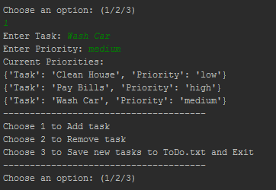

The second option is to delete an item from our list of dictionaries. From our list in the screenshot above, we have 3 different dictionaries. To delete, we choose based on a 0 starting value. Below, 1 was chosen and the entry for Pay Bills was deleted, as it is stored in value 1 of the list of dictionaries, above.

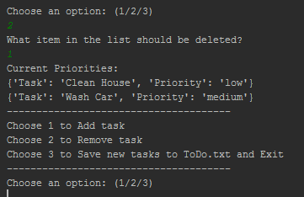

Deleting again with the same option, 1 would delete the final entry because there is now only 2 item stored in our list of dictionaries. Once the item is deleted, the program loops back to the list of options.

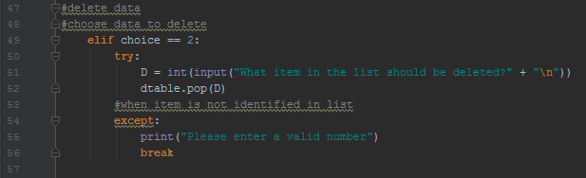

Choosing an option not available to delete will exit the program. To better enhance the program, this result should loop back to the question rather than exit. I think it could also display the available options to delete by task or priority.

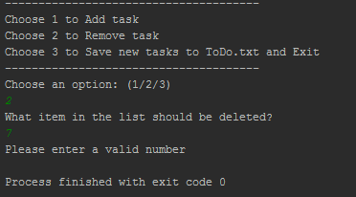

Our final option is to save the table we’ve manipulated. You’ll notice above, I started by opening the file in a read-only method. To save the data, we need to open it in a write mode. Once that is done, I need to loop through the list variable into the dictionary values themselves, and print only the data that was provided in the source. My ‘data’ variable reads the keys noted in each individual dictionary listing and separates them by a comma; the for loop loops through the entries in the list of dictionaries, and writes each to file individually.

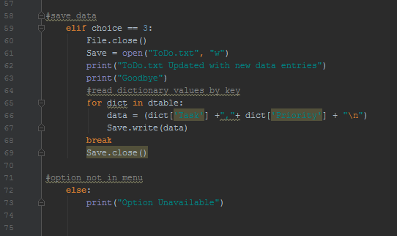

I couldn’t figure out where to put my close file command. Because I delcared the save variable in the elif loop, I couldn’t move it outside the loop without it being undefined. I’m also sure it does nothing where it is now, after the break. I also had some serious problem using variables across functions, and end up removing functions entirely from this assgnment.