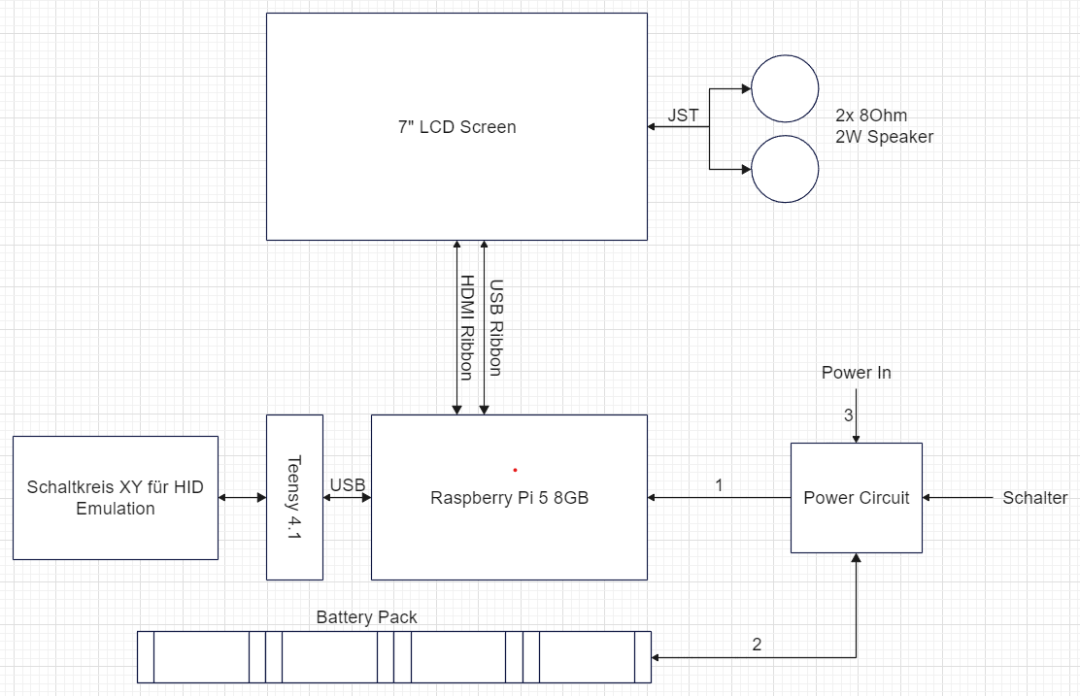

|  |  |  |
| --- | --- | --- |
|  | Schalter | !Schalter |
| Power In | 3 -> 1 | 3 -> 2 |
| !Power In | 2 -> 1 | -------- |