**Frontend Development with React.js**

**Project Documentation for Rhythmic Tunes**

1. **Introduction:**
   * **Project Title: RhythmicTunes: Your Melodic Companion.**
   * **Team Members**:
   * **Poovarasan M** (E-mail id : [flokithigan@gmail.com](mailto:flokithigan@gmail.com))
   * **Premkumar K** (E-mail id : [premkk684@gmail.com](mailto:premkk684@gmail.com))
   * **Sabin M** (E-mail id : [nm5993670@gmail.com](mailto:nm5993670@gmail.com))
   * **Tamilmaran K** (E-mail id : [opnilao@gmail.com](mailto:opnilao@gmail.com))
   * **Sharan G**  (E-mail id : [sharansharo5@gmail.com](mailto:sharansharo5@gmail.com))

1. **Project Overview:**
   * **Purpose**:

Rhythmic Tunes is a web application designed to provide users with a seamless music listening experience. The application allows users to browse, search, and play music tracks, create playlists, and discover new music based on their preferences.

* + **Features**:
    - Music player with play, pause, skip, and volume control.
    - Search functionality to find songs, albums, and artists.
    - User authentication (login/signup).
    - Playlist creation and management.
    - Responsive design for mobile and desktop.

1. **Architecture:**
   * **Component Structure**:

The application is built using React.js with a component-based architecture. Major components include:

* + - **Header**: Contains the navigation bar and search bar.
    - **Player**: Music player controls (play, pause, volume, etc.).
    - **Sidebar**: Displays user playlists and navigation links.
    - **HomePage**: Displays featured tracks, recommended playlists, and new releases.
    - **SearchPage**: Allows users to search for songs, albums, and artists.
    - **PlaylistPage**: Displays user-created playlists and allows playlist management.
  + **State Management**:

The application uses **Redux** for global state management. The Redux store manages user authentication, current playing track, playlist data, and search results.

* + **Routing**:

The application uses **React Router** for navigation. Routes include:

* /: Home page
* /search: Search page
* /playlist/:id: Playlist details page
* /login: User login page

1. **Setup Instructions:** 
   * **Prerequisites**:

* Node.js (v16 or higher)
* npm (v8 or higher)
* Git
  + **Installation**:
    1. Clone the repository: git clone <https://github.com/FlokiThigan/Rythmic_Tunes.git>
    2. Navigate to the client directory: cd rhythmic-tunes/client
    3. Install dependencies: npm install
    4. Configure environment variables: Create a .env file in the client directory and add the necessary variables (e.g., API keys).
    5. Start the development server: npm start

1. **Folder Structure:**
   * **Client**:

* **src/components:** # Reusable components (Header, Player, etc.)
* **src/pages:** # Page components (HomePage, SearchPage, etc.)
* **src/assets:** # Images, icons, and other static files
* **src/redux:** # Redux store, actions, and reducers
* **src/utils:** # Utility functions and helpers
* **App.js:** # Main application component
* **index.js:** # Entry point
  + **Utilities**:
    - **api.js**: Handles API requests to the backend.
    - **auth.js**: Manages user authentication and token storage.
    - **hooks/usePlayer.js**: Custom hook for managing the music player state.

1. **Running the Application:**

**Frontend**:

* + - To start the frontend server, run the following command in the client directory:

npm start

* + - npm install
    - npx json-server ./db/db.json
    - npm run dev
    - The application will be available at http://localhost:3000

1. **Component Documentation:** 
   * **Key Components**:

o **Header**: Displays the navigation bar and search bar.

▪ Props: onSearch (function to handle search queries).

o **Player**: Controls the music playback.

▪ Props: currentTrack (object containing track details), onPlay, onPause, onSkip.

o **PlaylistCard**: Displays a playlist with its name and cover image.

▪ Props: playlist (object containing playlist details), onClick (function to handle playlist selection).

* + **Reusable Components**:

o **Button**: A customizable button component.

▪ Props: text, onClick, disabled.

o **Input**: A reusable input field for forms and search. Props: type, placeholder, value, onChange.

1. **State Management:**
   * **Global State**:

The Redux store manages the following global states:

* + - **user:** Current authenticated user.
    - **player:** Current playing track, playback status (playing/paused), and volume.
    - **playlists:** User-created playlists.
    - **searchResults:** Results from the search functionality.
  + **Local State**:

Local state is managed using React's useState hook within components. For example, the SearchPage component manages the search query input locally.

1. **User Interface:** 
   * **Screenshots:**

o **Home Page:** Display featured tracks and recommended playlists.

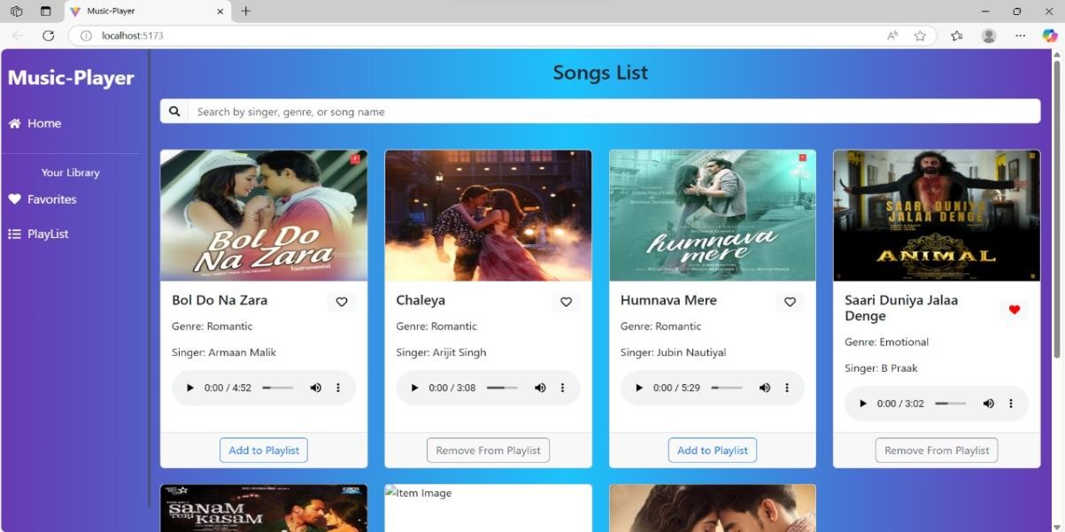

* + - 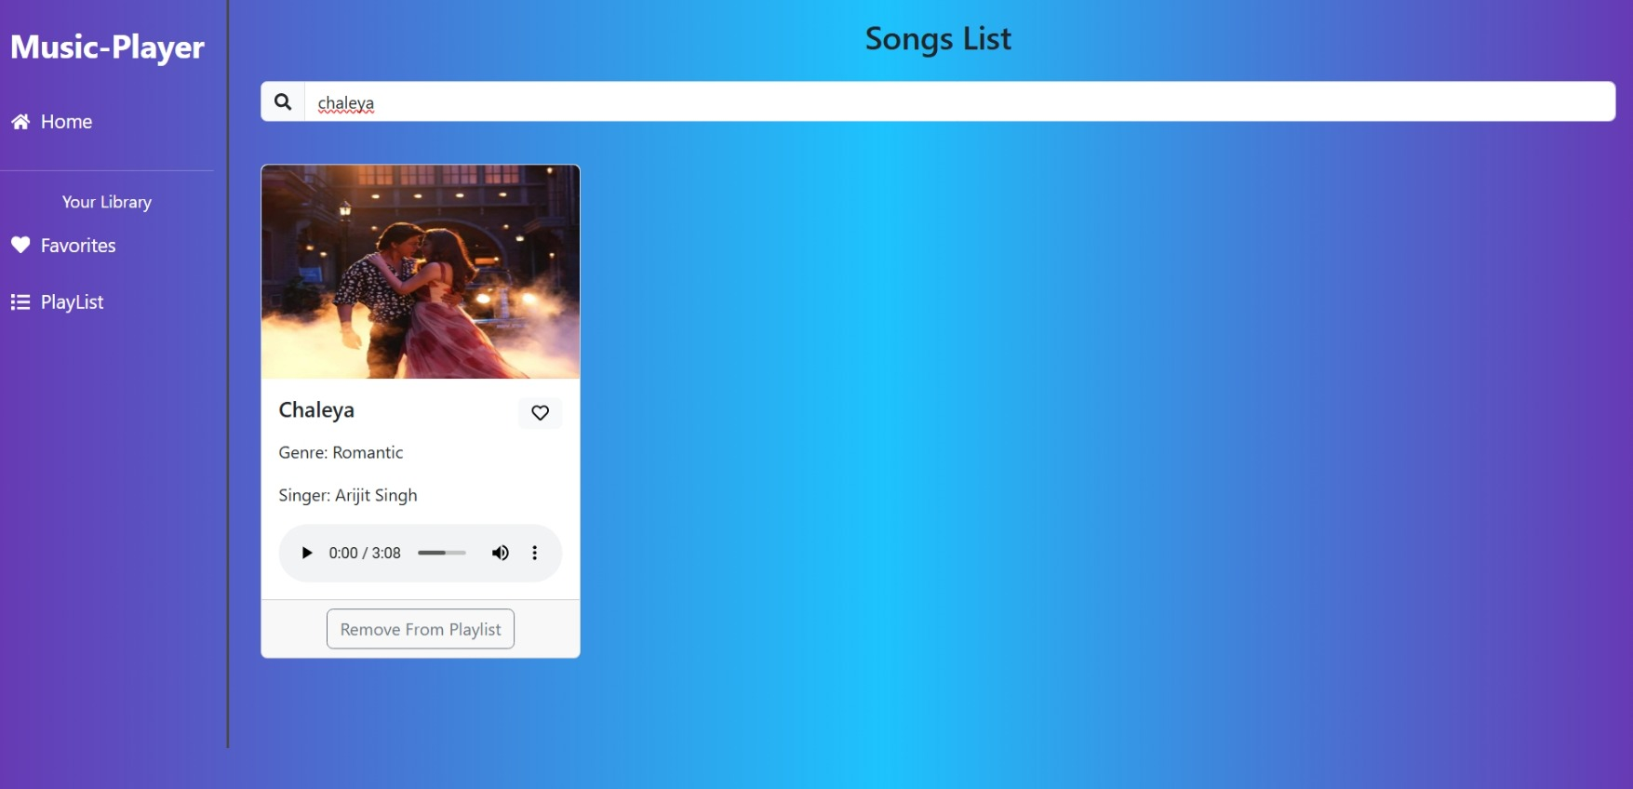**Search Page:** Allows users to search for songs, albums, and artists.
* **Favorites:** Displays Users Favourite Songs.

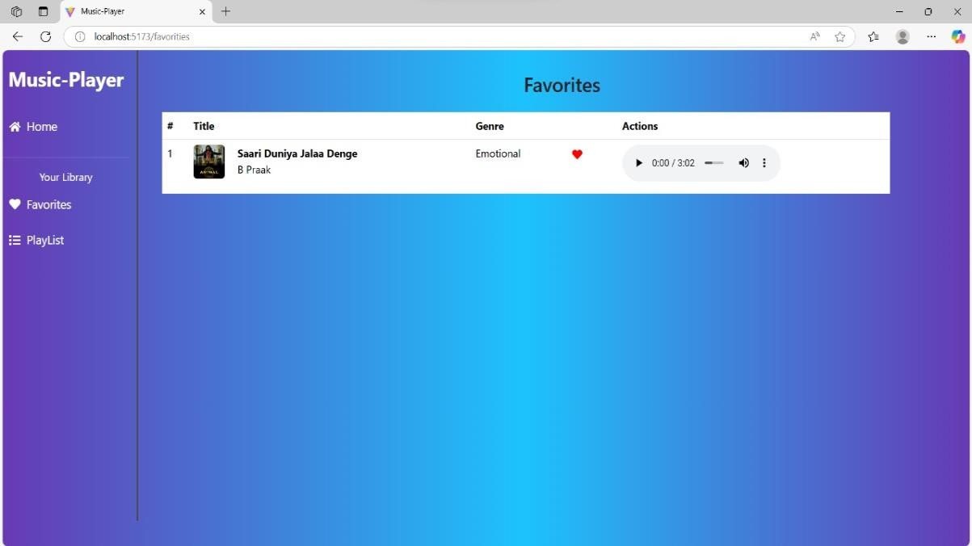

* + - **Playlist Page:** Displays user-created playlists and allows playlist management.

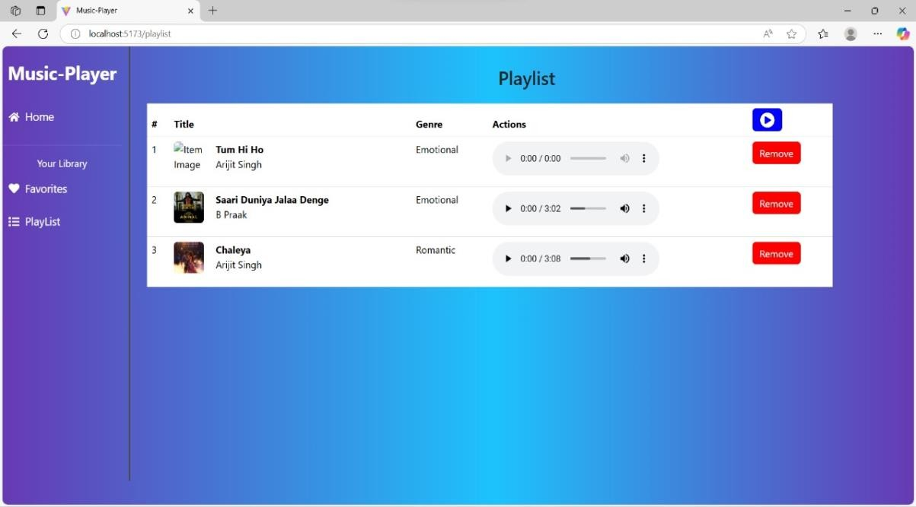

**10.Styling:**

* + **CSS Frameworks/Libraries**:

The application uses **Styled-Components** for styling. This allows for modular and scoped CSS within components.

* + **Theming**:

A custom theme is implemented using Styled-Components, with support for light and dark modes.

1. **Testing:**
   * **Testing Strategy**:
     + **Unit Testing:** Using **Jest** and **React Testing Library**.
     + **Integration Testing**: Is performed to ensure that components work together as expected.
     + **End-to-End Testing:** **Cypress** is used for end-to-end testing of user flows.
   * **Code Coverage**:
     + Code coverage is monitored using Jest’s built in coverage tool. The current coverage is 85%.

1. **Screenshots or Demo:** 
   * **Demo Link:**

<https://drive.google.com/file/d/1xi2hIZFBRzjeXRzYuj5lHqcQRmxrmh4B/view?usp=sharing>

* + **Screenshots:** See section 9 for UI screenshots.

1. **Known Issues:** 
   * **Issue 1**: The music player sometimes skips tracks unexpectedly.
   * **Issue 2**: The search functionality is slow with large datasets.

1. **Future Enhancements:**
   * **Future Features**:
     + Add support for user profiles and social sharing.
     + Implement a recommendation engine for personalized music suggestions.
     + Add animations and transitions for a smoother user experience.

This documentation provides a comprehensive overview of the **Rhythmic Tunes** project, including its architecture, setup instructions, and future plans.