HarnessVLA: A Stateful Hierarchical Harness with Dynamic Memory and Watchdog Recovery for Long-Horizon Robot Manipulation
Anonymous Authors
Abstract—Vision-language-action (VLA) policies map language and images to continuous robot actions, but long-horizon execution remains vulnerable to accumulated errors, implicit subtask boundaries, and loss of task state. This paper presents HarnessVLA, a stateful hierarchical runtime that separates a fixed π0 executor from task decomposition, dynamic memory, typed skill invocation, and Watchdog monitoring. A multimodal agent assembles environment observations, task state, registered tools, and validity-filtered persistent facts into its decision context. The Watchdog selects wait, end, replay, recover, or replan transitions from execution status, progress, and completion evidence. Monitoring frequency is specified per skill in its registration JSON, allowing finer-grained actions to be checked more frequently. On the physical Piper robot, each evaluated configuration was tested in 20 trials. The complete system succeeded in 17 trials (85%), compared with 3 trials (15%) for monolithic π0, 13 trials (65%) with subtask decomposition, and 5 trials (25%) with Watchdog alone. Independent single-component comparisons show that decomposition provides the largest observed improvement over monolithic execution. These results support the benefit of coordinated runtime control for the evaluated task setting without establishing a universal advantage for every individual module.
Index Terms—AI-Enabled Robotics, Failure Detection and Recovery, Manipulation Planning, Robot Learning, Software Architecture for Robotic and Automation.

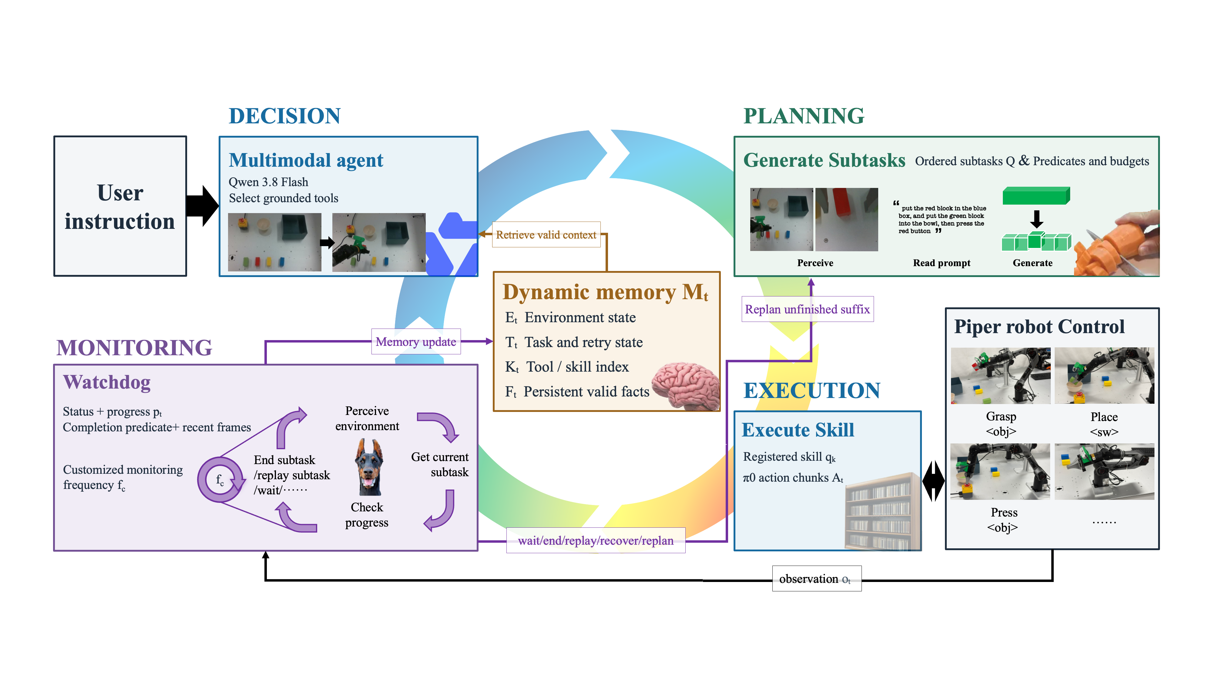
Fig. 1. HarnessVLA architecture on the Piper robot. Task decomposition, memory, registered π0 skills, and Watchdog feedback form a stateful execution loop.

I. INTRODUCTION
Vision-language-action models have advanced robot manipulation by connecting Internet-scale visual-language priors with learned action generation. OpenVLA maps images and language directly to robot actions [1], while π0 uses a vision-language backbone and a flow-matching action expert to produce high-frequency action chunks [2]. π0.5 further combines robot data, semantic subtask prediction, and web-scale supervision for open-world generalization [3]. These models are strong executors, yet long-horizon reliability cannot be obtained from policy weights alone. A small early error can change the subsequent observation distribution, a fixed action horizon can switch tasks too early or too late, and a context reset can erase facts that are still physically true.
Hierarchical systems address part of this gap by separating reasoning from control. SayCan grounds language-model proposals in learned skill affordances [4]; Code as Policies synthesizes executable feedback programs [5]; VoxPoser converts language-derived constraints into 3-D value maps [6]; and Being-0 connects a foundation-model planner to modular locomotion and manipulation skills [7]. Agentic Robot adds an explicit planner-executor-verifier loop and reports that verification and simple recovery reduce cascading failures on LIBERO-Long [8]. ChemBot contributes a dual-layer memory, model-context-protocol (MCP) skill orchestration, progress prediction, and asynchronous execution for long-horizon laboratory tasks [9]. However, these components are usually evaluated as a single bundled system, so it remains unclear whether performance arises from the VLA, the planner, the memory representation, or the monitoring logic.
Harness engineering offers a useful unit of analysis. A harness is the stateful program surrounding a model that decides what to store, retrieve, present, invoke, verify, and revise. Layer-wise externalization can expose the marginal contribution of belief tracking, planning, reflection, and model-backed revision [10], while recent harness-evolution work warns that improvements must be measured under matched search and feedback budgets and on held-out tasks [11]. We transfer this perspective from language agents to embodied VLA control: the robot policy is treated as an executor, whereas memory, decomposition, invocation, verification, and recovery are explicit harness layers.
This paper makes three contributions. First, it presents a stateful closed-loop architecture that connects a multimodal agent, dynamic memory, registered skills, a fixed VLA executor, and a Watchdog through typed interfaces. Second, it formalizes memory validity and bounded recovery transitions, with monitoring frequency configured separately for each skill. Third, it evaluates the complete system and independent single-component variants on a physical Piper robot. The complete system achieves 85% task success over 20 trials, compared with 15% for monolithic π0. The component comparison distinguishes the effect of adding one module from the performance of their joint integration.
II. RELATED WORK
A. Language-Guided Planning and Modular Robot Agents
Language models can provide procedural knowledge, but embodiment requires grounding. SayCan scores candidate language skills by both semantic usefulness and learned feasibility [4], exposing the skill repertoire as the system bottleneck when a nominally high-value skill fails. Code as Policies expands the action interface from a fixed list to generated programs that call perception and control APIs [5]. VoxPoser instead grounds free-form constraints into composable 3-D value maps and closes the loop through model-based planning [6]. These methods motivate explicit tool interfaces, but they do not directly address persistent state across conversations or attribute the contribution of individual orchestration layers.
Hierarchical agent frameworks use specialized components at different time scales. HiRT runs a computationally expensive VLM slowly and a lightweight action policy rapidly, improving control frequency for dynamic manipulation [12]. Being-0 uses a foundation model, a VLM connector, and a modular skill library to coordinate long-horizon humanoid behavior [7]. Our work shares their separation of semantics and motor control, but focuses on the surrounding stateful program and makes its memory and transition rules independently ablatable.
B. VLA Policies and Long-Horizon Execution
Diffusion Policy models multimodal action distributions through conditional denoising [13]. OpenVLA scales a token-based VLA to 970k robot demonstrations and supports parameter-efficient adaptation [1]. π0 adds a flow-matching action expert to a pretrained VLM and produces continuous action chunks across embodiments [2], whereas π0.5 co-trains high-level semantic prediction and low-level actions for open-world, multi-stage manipulation [3]. These advances improve the executor but do not guarantee explicit subtask boundaries, termination decisions, or recovery from off-distribution states. HarnessVLA therefore treats the VLA as a replaceable skill endpoint and preserves a stable orchestration contract when the checkpoint changes.
C. Memory, Verification, and Harness Attribution
Agentic Robot decomposes high-level instructions, executes each subgoal with OpenVLA, and periodically verifies a frame window with a fine-tuned VLM [8]. Its two-stage verifier distinguishes completion from stuck or still-trying states and triggers a minimal lift-and-retry recovery. ChemBot organizes short-term scene, tool, and task state in a dashboard, consolidates successful episodes in long-term memory, and predicts normalized subtask progress using cross-attention from robot state to VLM features [9]. HarnessVLA integrates these ideas but adds a cross-conversation fact store and formalizes Watchdog behavior as a finite-state machine whose decisions can be replayed and audited.
The harness perspective separates model competence from system competence. Jung and Son identify the largest positive marginal improvement in a progressive planning harness [10]. Meta-Harness searches over runtime code using execution traces [14], while Wang et al. emphasize the importance of separating harness-design effects from additional search and feedback [11]. Here, we compare independently added components against the same monolithic reference and evaluate their joint integration separately. These comparisons do not constitute a progressive layer-addition experiment.
III. PROBLEM FORMULATION
Let a long-horizon instruction g be executed in a partially observed environment with observation o_t=(I_t^a,I_t^w,s_t), where I_t^a and I_t^w are agent-view and wrist-view images and s_t is proprioception. A planner converts g and the current memory M_t into an ordered subtask sequence Q=(q_1,...,q_K). For the active subtask q_k, a VLA policy π_θ produces an action chunk A_t=(a_t,...,a_{t+H-1}) conditioned on o_t and a language instruction. The proposed harness H surrounds π_θ and updates both M_t and the control mode after each execution segment.
Aₜ ~ πθ(· | oₜ, qₖ), Mₜ₊₁ = U(Mₜ, oₜ, Aₜ, dₜ) (1)
The runtime seeks successful task completion while bounding retries and monitoring overhead. Equation (2) expresses this design objective, where R denotes retry count, C_v verifier calls, T execution time, and E_stale decisions influenced by invalid facts. The present empirical comparison reports task success; the remaining terms specify deployment trade-offs rather than measured improvements in this experiment.
J = SRtask − λr R − λv Cv − λt T − λs Estale (2)
IV. HARNESSVLA METHOD
A. Four-Layer Closed-Loop Architecture
HarnessVLA comprises a decision layer, planning layer, execution layer, and monitoring layer (Fig. 1). Only the execution layer directly drives the Piper robot. The decision layer holds a multimodal agent and the dynamic memory window. The planning layer exposes GenerateSubtasks, which converts a goal and grounded scene representation into typed subtask records. The execution layer wraps π0 or another VLA behind ExecuteSkill. The monitoring layer observes progress and recent frames, then returns a discrete decision and diagnosis. MCP supplies the tool-discovery and typed-call boundary; it does not infer which skills exist from model weights.
TABLE I
HARNESS COMPONENTS AND TYPED OUTPUTS
Layer | Component / output
Decision | Agent + M_t; next tool call
Planning | GenerateSubtasks; q_1...q_K
Execution | ExecuteSkill; actions, status, p_t
Monitoring | Watchdog; wait/end/replay/recover/replan
Persistence | Fact tools; verified key-value facts
B. Dynamic Memory Window
The memory state is M_t={E_t,T_t,K_t,F_t}. Environment memory E_t stores a structured scene description, object identifiers, affordances, poses, interaction states, and image paths. Task memory T_t stores the goal, current subtask index, subtask status, progress trace, retry counters, and action history. Tool memory K_t is populated from MCP tool discovery and remains stable for the session. Fact memory F_t persists across conversations and records verified constraints such as object state, safety conditions, or the last diagnosed failure.
Mₜ = {Eₜ, Tₜ, Kₜ, Fₜ}, fᵢ = (key, value, source, time, validity) (3)
Before each agent decision, the harness retrieves facts whose validity predicate is true. State facts expire after a task-specific time-to-live or contradictory perception; constraint facts remain until explicitly removed; failure facts are retained for diagnosis and replanning but are not used as current geometry. A newly observed object pose therefore takes precedence over an obsolete stored pose. The prototype persists F_t in JSON, keeping the fact-store interface separate from the planner and executor.
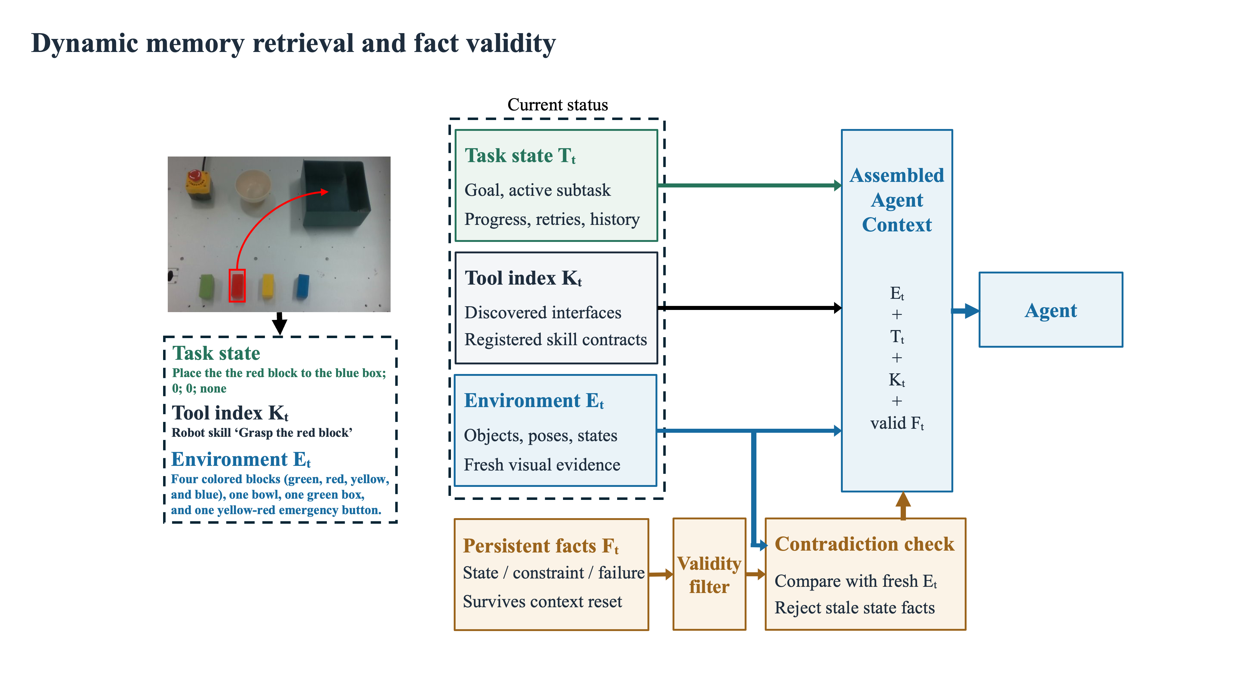
Fig. 2. Dynamic memory retrieval and fact-validity pipeline.
C. Subtask Generation and Skill Invocation
GenerateSubtasks receives g, E_t, the supported skill registry, and relevant facts. Each returned record contains an instruction, a registered skill, preconditions, expected effects, a completion predicate, and an action budget. The registry rejects unknown or unsupported skills before execution. In the atomic π0 path, language is derived from the annotated subtask rather than the parent task, preventing a nominal pick-up call from silently attempting an entire pick-and-place trajectory. The same MCP contract supports a monolithic checkpoint for comparison.
The planner is required to preserve causal order and explicitly expose subtask dependencies. If a precondition is false, the agent may regenerate only the suffix beginning at q_k; already verified subtasks remain committed unless the environment contradicts their effects. This localized replanning reduces unnecessary replay and gives the Watchdog a stable unit of verification.
D. Watchdog Finite-State Machine
Watchdog converts execution feedback into bounded control transitions. In EXECUTING, it checks status, progress p_t, recent progress change Δp, and the completion predicate using recent observations. A verified predicate with p_t≥τ_end produces end; incomplete execution with continuing progress produces wait. Failure or persistent stagnation triggers replay or an available scripted recovery. After R_max unsuccessful retries, the agent replans the unfinished suffix. An unchanged suffix or an exhausted replanning budget produces FAILED rather than an unbounded retry loop. The monitoring frequency f_c is configured in the JSON used to register each π0 skill. Higher f_c shortens the interval between checks and can be assigned to fine-grained actions such as final grasp alignment or button contact. The configuration determines the sampling schedule; it does not replace the completion predicate or the retry limit.
dₜ = end if vₜ=1 and pₜ≥τend; replay/recover if failed or Δp<ε; wait otherwise (4)
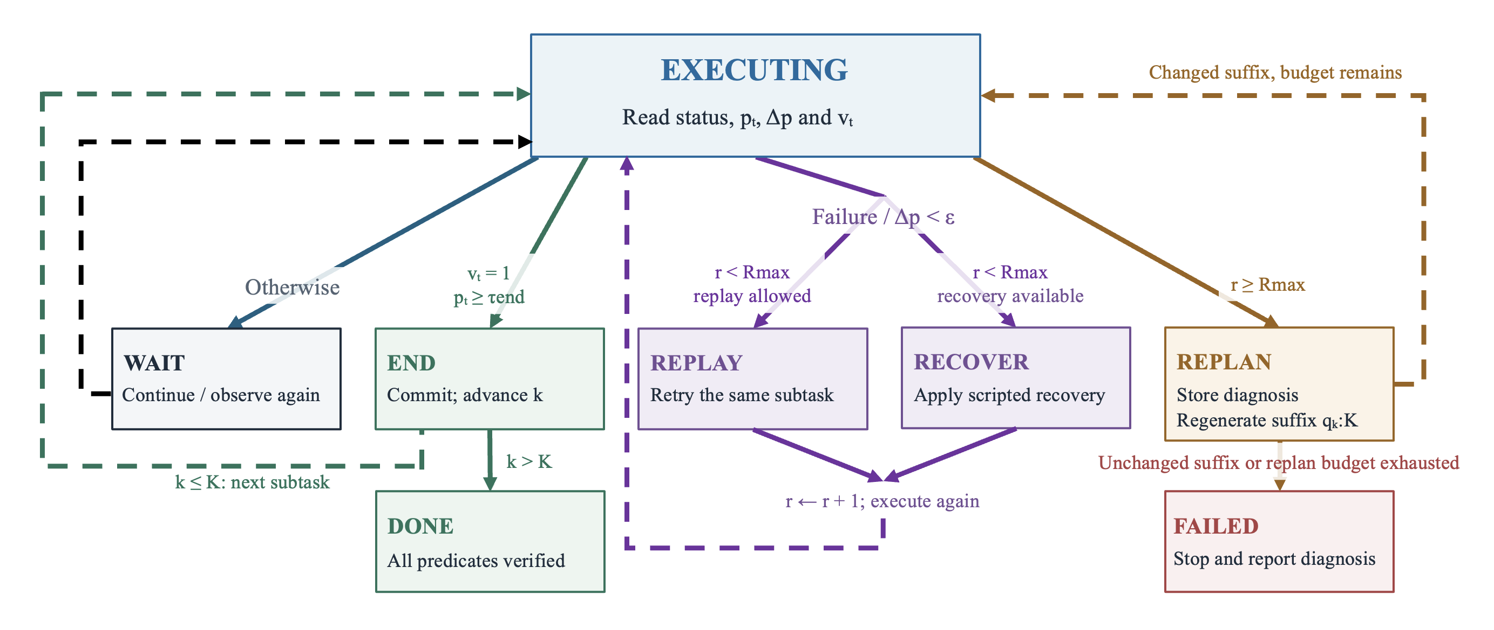
Fig. 3. Watchdog state machine for subtask completion, recovery, and replanning.
Algorithm 1: HarnessVLA control loop
load M; discover tools; Q ← GenerateSubtasks(g,E,K,F)
while k ≤ |Q| and budget remains:
y ← ExecuteSkill(Q[k], o_t); update E,T and progress trace
d ← Watchdog(Q[k], o_t, y, recent_frames)
if d=end: commit effects; k←k+1
if d=wait: continue
if d=replay/recover: apply action; increment retry
if d=replan: store diagnosis in F; regenerate suffix
return success iff all completion predicates hold
E. Progress-Aware and Asynchronous Execution
The progress signal normalizes executed steps by the subtask budget and remains below one until completion is supported by the predicate. Budget exhaustion alone is therefore not treated as success. ChemBot uses a learned progress head that combines robot state and VLM features [9]. That design is distinct from the rule-based progress signal described here; no learned-head comparison is included in the reported success counts.
The skill interface also permits asynchronous action generation, separating policy inference from command execution. Following the future-state principle of ChemBot [9], an executor can discard expired actions from a newly predicted chunk and replace only the unexecuted suffix. This scheduling option is orthogonal to memory and Watchdog decisions. The reported results do not establish a latency reduction or an asynchronous-execution advantage.
F. Independent Component Attribution
Let H_0 denote monolithic π0 and H_c denote the same reference augmented with only component c: subtask decomposition, Watchdog, short-term memory, or cross-conversation facts. The observed component gain is Δ_c=SR(H_c)−SR(H_0), expressed in percentage points. The complete HarnessVLA combines these components and is evaluated as a separate configuration. Because each component comparison starts from H_0, Δ_c is not the incremental gain from one cumulative layer to the next. It also does not identify interaction effects or the importance of removing a component from the complete system.
Δc = SR(Hc) − SR(H0), c* = arg maxc Δc (5)
V. EXPERIMENTS AND RESULTS
A. Research Questions
The evaluation addresses two questions: whether the complete HarnessVLA improves end-to-end success relative to monolithic π0, and which independently added component produces the largest observed change. The primary metric is task success rate. The task suite additionally defines context-interruption and perturbation conditions to probe continuation and recovery, but the available results are not disaggregated by task condition.
B. Platform, Benchmarks, and Tasks
The platform is a physical Piper robotic arm with a π0 executor and a multimodal Qwen planning service. Registered skills map task instructions to arm and gripper actions. The task suite is organized into sequential tidying (T1), continuation after context interruption (T2), and perturbation recovery (T3), as summarized in Table II and Fig. 4. The instruction sequence involves placing the red block in the target box, placing the green block in the bowl, and pressing the red button. Each configuration in the reported comparisons has 20 trials. The counts are reported at configuration level, not as separate T1–T3 success estimates.
TABLE II
PIPER ROBOT TASKS AND EVALUATION OBJECTIVES
Task | Example instruction | Skills | Main point
T1  Sequential  tidying | Place the red block in the blue box and the green block in the bowl; then press the red button. | Multi-step  composition +  turn_on | Long-horizon  planning and  subtask switching
T2  Multi-turn  resume | Pause the agent midway through T1, clear its short-term context, and request that it continue and complete the task. | Same as T1 | Value of cross-  conversation facts  (fact_inter_  conversation)
T3  Disruption  recovery | During T1, induce an empty grasp or drop, move the blue box, or occlude it with a panel. | replay /  recover / replan | Watchdog and the  fault-tolerant  closed loop
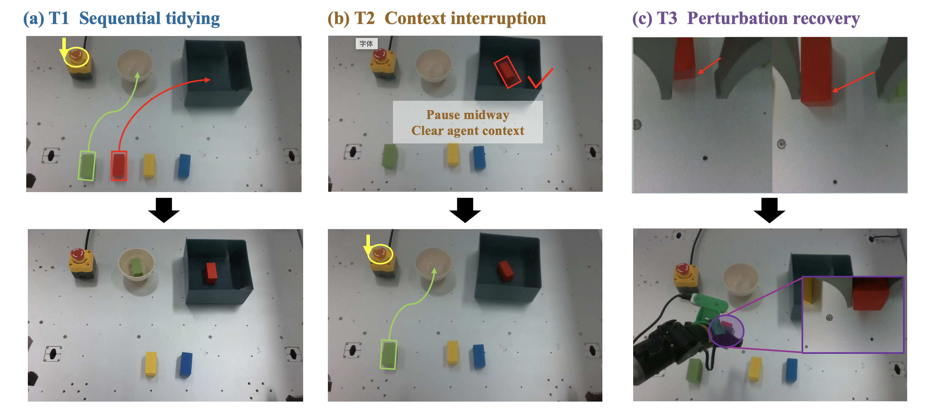
Fig. 4. Representative T1–T3 task scenes and perturbations.
C. Baselines and Fairness Controls
The main comparison includes monolithic π0, π0 with subtask decomposition alone, π0 with Watchdog alone, and the complete HarnessVLA. The component study additionally includes short-term memory alone and cross-conversation facts alone. The plus sign denotes adding only the named component to the monolithic reference, not accumulating all preceding rows. All configurations use π0 as the low-level executor; other published VLA systems are discussed as related work rather than numerical baselines on this physical task. Without per-trial inference and timing records, the present counts do not demonstrate equal computational cost.
D. Evaluation Metric
Task success requires completion of the full instruction, including the required object destinations and final button action. Success rate is SR=100×n_success/20. All tables report both the integer success count and its percentage, so one successful trial corresponds to five percentage points. Changes relative to monolithic π0 are reported in percentage points rather than relative percentages. The available aggregate counts do not support paired statistical tests, per-task recovery estimates, or claims about execution time.
E. Main Results
TABLE III
TASK SUCCESS ON THE PHYSICAL PIPER ROBOT
Method | Successes | SR (%) ↑
π0 monolithic | 3/20 | 15
+ subtasks | 13/20 | 65
+ Watchdog | 5/20 | 25
HarnessVLA | 17/20 | 85
Table III reports 17 successful trials for HarnessVLA, yielding an 85% success rate. Monolithic π0 succeeds in 3 trials (15%), decomposition alone in 13 trials (65%), and Watchdog alone in 5 trials (25%). The complete system therefore exceeds the monolithic reference by 14 successful trials, or 70 percentage points. It exceeds decomposition alone by 4 trials (20 percentage points) and Watchdog alone by 12 trials (60 percentage points). These are observed differences in task completion, not measurements of recovery efficiency or statistically established population effects.
F. Independent Component Comparison
TABLE IV
SINGLE-COMPONENT COMPARISONS AGAINST MONOLITHIC π0
Configuration | Successes / SR | Δ₀ (pp)
π0 monolithic | 3/20 · 15% | —
+ subtasks | 13/20 · 65% | +50
+ Watchdog | 5/20 · 25% | +10
+ short-term memory | 5/20 · 25% | +10
+ cross-conv. facts | 4/20 · 20% | +5
Table IV adds each module independently to monolithic π0. Decomposition yields 13/20 successes (65%), a 50-percentage-point improvement over the reference. Watchdog yields 5/20 (25%), short-term memory 5/20 (25%), and cross-conversation facts 4/20 (20%), corresponding to changes of +10, +10, and +5 percentage points. Decomposition has the largest observed single-component gain. The memory results do not establish that memory is unnecessary in the complete system: adding a memory module to monolithic execution is a different intervention from removing it from an integrated harness.
The complete system reaches 85%, above every independently augmented configuration. This ordering is consistent with a benefit from coordinated planning, state maintenance, and monitoring, but it does not isolate synergy. A full factorial or leave-one-component-out experiment would be needed to estimate interactions. Likewise, the five-percentage-point observed gain from facts alone cannot resolve their value specifically after a context reset because no interruption-specific counts are available.
G. Failure Handling and Memory Consistency
Table V associates observable failure conditions with the runtime response. Empty grasps and drops call for bounded retry or recovery; contradictory object observations invalidate stored state before replanning; poor visibility calls for renewed observation rather than an unsupported completion decision. This taxonomy describes the mechanism, not a measured distribution of failure causes. Failure attribution requires the execution trace and visual evidence, since the same unsuccessful rollout can originate in planning, motor execution, or verification.
TABLE V
FAILURE MODES AND PRESPECIFIED HARNESS RESPONSES
Failure | Evidence | Response
Empty grasp | No object in gripper; stalled p | recover + replay
Drop | Object exits gripper after lift | stop, retract, replay
Blue box moved | Pose contradicts stored fact | invalidate + replan
Panel occlusion/black frame | Image-quality gate fails | wait/reacquire view
False completion | Predicate/verifier disagree | remain in subtask
Retry exhaustion | retry ≥ R_max | store diagnosis + replan/fail
Memory consistency and physical safety impose different constraints. Fact validity determines which stored information may influence the next decision; hardware safeguards determine which actions may be executed. An emergency stop and workspace restrictions must remain independent of the language-model decision loop. Task success alone is not evidence of safe deployment, and the reported comparison does not quantify collision risk or emergency-stop frequency.
H. Scope of the Evidence
The 20-trial comparisons describe performance in the evaluated Piper setting. They do not establish transfer to other robots, a recovery-rate improvement under each perturbation, or robust continuation under all context interruptions. Component-level gains also cannot be summed to predict complete-system success. The distinction between independent addition and joint integration is necessary for interpreting both the decomposition advantage and the modest memory-only results.
VI. DISCUSSION
A. Interpretation and Limitations
The main finding is the gap between complete runtime integration and monolithic execution: 85% versus 15% observed task success. Decomposition provides the strongest isolated improvement, indicating that explicit task boundaries and skill-level instructions are useful in this setting. Watchdog and short-term memory yield smaller gains when used alone, while facts alone yield a five-percentage-point increase. These outcomes support decomposition as the dominant isolated intervention, but do not rank each component within the complete system.
Several limitations remain. The current π0 checkpoint can produce task-level behavior even when invoked with an atomic instruction, making the skill contract important but not sufficient to ensure isolation. Visual verification can fail under occlusion or ambiguous contact, and scripted recovery covers only a subset of manipulation failures. Each configuration has 20 trials, so small count differences are sensitive to individual outcomes. Aggregate success counts do not reveal per-task variation, component interactions, or computational overhead. Cross-conversation memory requires interruption-specific evaluation, and skill-dependent monitoring requires frequency and cost measurements before an optimal schedule can be claimed.
VII. CONCLUSION
This paper presents HarnessVLA, a stateful hierarchical runtime for long-horizon manipulation with a fixed π0 executor. The architecture coordinates explicit subtask invocation, dynamic memory, fact-validity checks, and bounded Watchdog recovery, with monitoring frequency configured per skill. On the physical Piper robot, the complete system succeeds in 17 of 20 trials (85%), compared with 3 of 20 (15%) for monolithic π0. Independent component comparisons identify subtask decomposition as the largest observed isolated improvement, reaching 13 of 20 successes (65%). The results distinguish the value of integrated runtime control from the effects of individual modules, while leaving component interactions and deployment cost unresolved.
REFERENCES
[1] M. J. Kim et al., “OpenVLA: An open-source vision-language-action model,” in Proc. Conf. Robot Learn. (CoRL), 2024.
[2] K. Black et al., “π0: A vision-language-action flow model for general robot control,” arXiv:2410.24164, 2024.
[3] K. Black et al., “π0.5: A vision-language-action model with open-world generalization,” arXiv:2504.16054, 2025.
[4] M. Ahn et al., “Do as I can, not as I say: Grounding language in robotic affordances,” in Proc. Conf. Robot Learn. (CoRL), 2022.
[5] J. Liang, W. Huang, F. Xia, P. Xu, K. Hausman, B. Ichter, P. Florence, and A. Zeng, “Code as policies: Language model programs for embodied control,” in Proc. IEEE Int. Conf. Robot. Autom. (ICRA), pp. 9493–9500, 2023.
[6] W. Huang, C. Wang, R. Zhang, Y. Li, J. Wu, and L. Fei-Fei, “VoxPoser: Composable 3D value maps for robotic manipulation with language models,” in Proc. Conf. Robot Learn. (CoRL), 2023.
[7] H. Yuan et al., “Being-0: A humanoid robotic agent with vision-language models and modular skills,” arXiv:2503.12533, 2025.
[8] Z. Yang et al., “Agentic Robot: A brain-inspired framework for vision-language-action models in embodied agents,” arXiv:2505.23450, 2025.
[9] X. Huang, W. Mao, Y. Li, H. Chen, and J. Zhao, “Long-term memory for VLA-based agents in open-world task execution,” arXiv:2604.15671, 2026.
[10] S. Jung and S. Son, “How much heavy lifting can an agent harness do? Measuring the LLM’s residual role in a planning agent,” arXiv:2604.07236, 2026.
[11] Y. Wang et al., “Rethinking the evaluation of harness evolution for agents,” arXiv:2607.12227, 2026.
[12] J. Zhang, Y. Guo, X. Chen, Y.-J. Wang, Y. Hu, C. Shi, and J. Chen, “HiRT: Enhancing robotic control with hierarchical robot transformers,” in Proc. Conf. Robot Learn. (CoRL), 2024.
[13] C. Chi, Z. Xu, S. Feng, E. Cousineau, Y. Du, B. Burchfiel, R. Tedrake, and S. Song, “Diffusion policy: Visuomotor policy learning via action diffusion,” in Proc. Robot.: Sci. Syst. (RSS), 2023.
[14] Y. Lee, R. Nair, Q. Zhang, K. Lee, O. Khattab, and C. Finn, “Meta-Harness: End-to-end optimization of model harnesses,” arXiv:2603.28052, 2026.

