Adam Flood

X00110480

CA 2

3D Unity Pool game

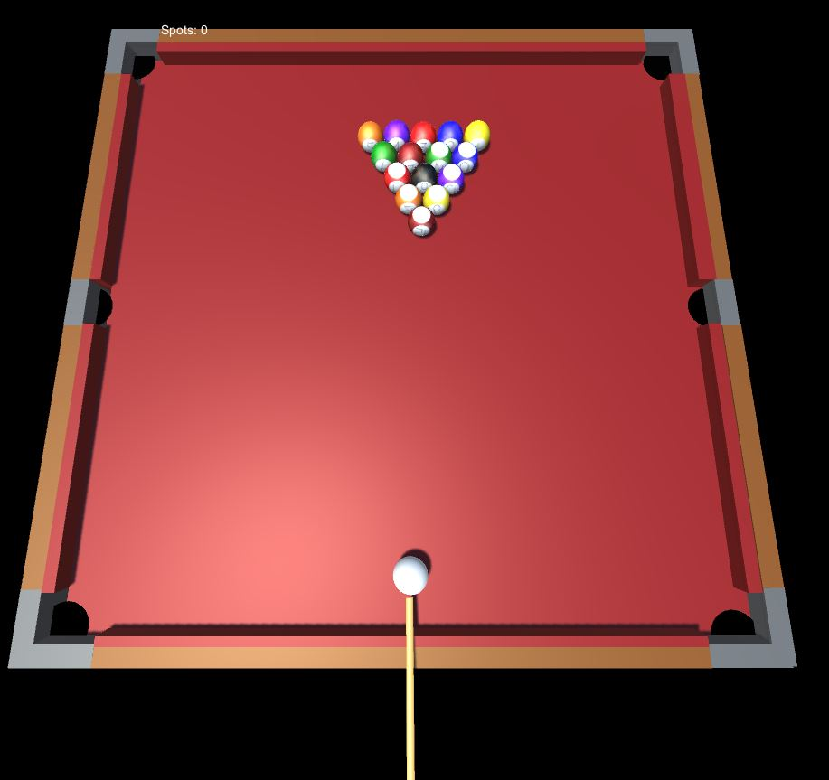

Contents

Approach **3**

Game Features 3

Challenges 3

Solutions and Conclusions 4

Repository 4

References 4

Approach

The approach that I took for this CA was to investigate the “Roll a ball” tutorials outlined on Moodle. Upon completing the first video tutorial I decided that I would be better off designing the pool table area and looking for ball sprites and prefabs while going along with the videos and implementing the table graphics as I progress rather than using the ones from the video. For example instead of using cubes that rotate in the videos I was able to use a pool ball prefab with the same rotator script that would allow the animation of the pool balls.

Game features

As I progressed through the tutorials I came to the idea of using the pickup script to delete the objects on pickup as pockets so that once the ball tags entered the OnTriggerEnter() method they would be set to inactive and the players would receive a point for the particular type of ball potted.

In regards to using a 3d model for the pool table I decided to create the table from scratch as it would add more originality to the game. The colors of the table from cloth to cushions were created using different materials and simply dragging them onto the game objects.

As for the game logic of the balls, I created tags for spots and tags for stripes and applied them to all the balls along with a tag for the white ball (player) and a tag for the black ball. I implemented multiple if statements that would check if the ball that entered the pocket was a stripe or a spot and if it was, the player would add that potted ball to each of the counters. For distinguishing whether or not the user had potted enough balls to pot the black I implemented multiple ifs that would check if the ball that entered the pocket was black and also if the count for spots/stripes was greater than 6 then display the message “You win”. To check the other way around I simply changed the if to be less than 7 and then displayed the message “you lose”. When the user pots the white the white balls position is reset on the table.

For the ball physics I had implemented “Physics materials” that were attached to the balls, player, cushions and table. The ball physics material I had set the bounciness to 1 to re-create a realistic bounce when they collided with other balls. The same was done for the player and the cushions, now when they collide they bounce off eachother realistically. Unfortunately, the balls never stop rolling so this is where I implemented the “clothFriction” material so that I could create friction for all the balls on the table. I set the bounciness to 0 as we do not want the balls to have a constant bounce and I turned up the dynamic friction to 1 to create realistic ball rolling.

For the camera and lightning I decided to increase the intensity of the lighting by a value of 10 as the table seemed a little dark after applying the red cloth. I positioned the lighting to be directly above the table to give a realistic pool-hall lighting of the lights being above the table. For the camera angles and positions I decided I wanted a top down view that was also at a slight angle to show off the 3d modelling a little more.

For the cue I had originally implemented a mouse feature where the user can click and drag the cue but I ran in to several problems so I decided to make the cue follow the ball and have its own velocity so that If I got the pivot working the cue would work fine.

Challenges

The biggest challenge I faced while doing this CA was the cue. I was trying to work with pivots for the cue and velocity but there was no resources online to help with creating a cue like pivot so I had to leave out this feature. Another challenge was creating the game to be 2 players. I was not able to do this feature and I could not find resources to help with this either so I decided to implement the spots and stripes counter that has the same logic as the game would have if the game was 2 players such as if the black is potted before the user pots all of their balls then the player would lose and if they potted the black after they potted their 7 balls then they would win the game.

Solutions and conclusion

As for fixing problems that are listed in the challenges I was not able to. But all of the problems I faced along the way such as ball velocity/bounciness/camera angles/score etc I was able to fix by constantly trying different ways of including them in the game.

All of the features in the CA specification was achieved apart from the cue being controllable and the game being multiplayer.

Repository

I was using Unity cloud to push the game to the cloud instead of github. I have added you as a collaborator and the game is available below:

<https://developer.cloud.unity3d.com/orgs/floodeh/projects/rollaball2/users/>

References

Unity. 2017. Unity - Roll-a-ball tutorial. [ONLINE] Available at: <https://unity3d.com/learn/tutorials/projects/roll-ball-tutorial>. [Accessed 06 May 2017].