TBD The Game

Manual

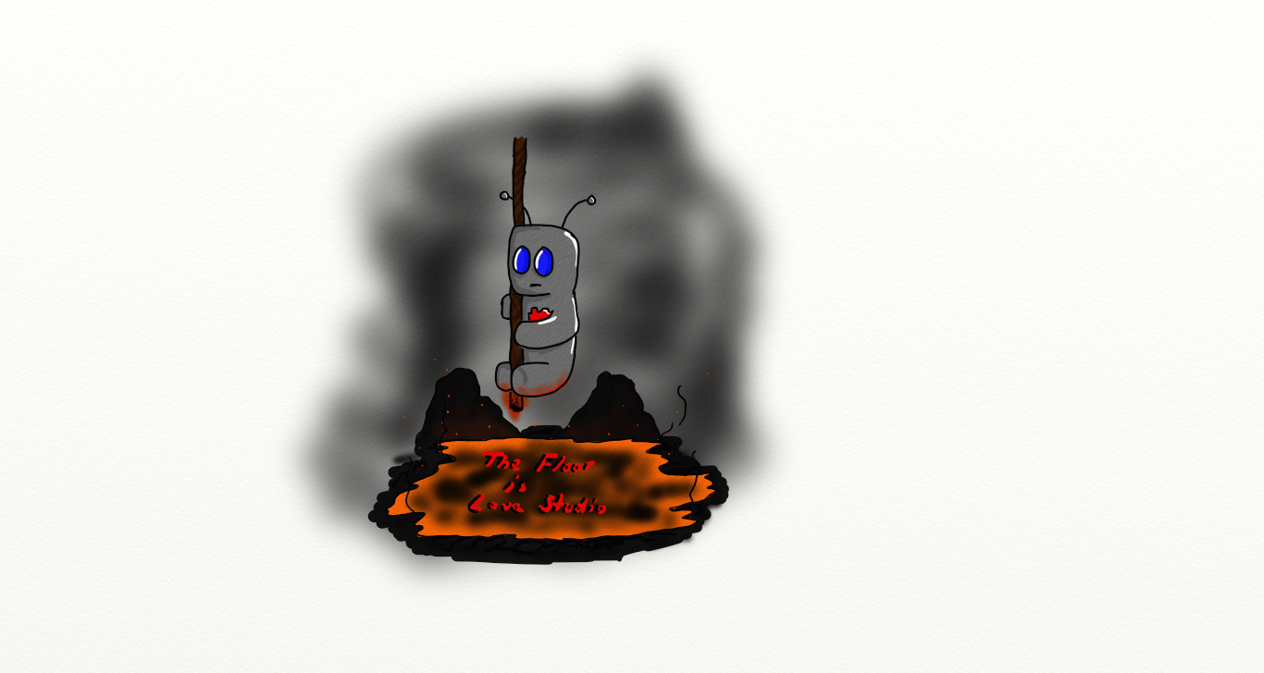

Controls

Action Keys

Movement ------------------------------------------------------------------- WASD or arrow keys

Jump ---------------------------------------------------------------------------------------- Spacebar

Double Jump ---------------------------------------------------- Spacebar after top of first jump

Grapple ------------------------------------------------------------------------------- E or Left Shift

Pause ------------------------------------------------------------------------------------------------- P

Exit Screen ------------------------------------------------------------------------------- Backspace

Quit Game ---------------------------------------------------------------------------------------- Esc

Objective

The objective of the game is to reach the goal in every level before being consumed by the lava that is continuously rising below you. Collect gems to raise your score and try to set a new highscore while navigating the deadly terrain.

Notes:

To be able to play sound, the oalinst.exe must be installed. This can be found in the monogame program folder.

Map Creator Tool

Manual

Controls

Action Keys

Select Wall ------------------------------------------------------------------------------------------ 1

Select Player ----------------------------------------------------------------------------------------- 2

Select Goal ------------------------------------------------------------------------------------------ 3

Select Gem ------------------------------------------------------------------------------------------ 4

Select Enemy ---------------------------------------------------------------------------------------- 5

Select Enemy Path ---------------------------------------------------------------------------------- 6

Select Eraser ----------------------------------------------------------------------------------------- 0

Place Selected Piece ---------------------------------------------------------------------- Spacebar

Notes:

To create the enemy path, place an Enemy Path object to the screen on both sides of the Enemy that you want to follow a path.

Credits

Creators

Alex Bellavia

Josh Malmquist

Anna Karwacki

Jacob Roos

Kasey Hilton

Music

Adventure Meme - Background Music - http://incompetech.com/