McLain Course Goal Essay

For this course, I chose to focus on important innovations over the existence of SD cards that helped increase their storage capacity. I feel there are three areas in which my writing improved: focusing on fitting the genre of a writing, considering the context of a particular source, and considering the audience in my writing. Conversely, writing to the specific conventions of a genre was very difficult. Writing to a genre was a new skill for me thus it took more revision to focus on that skill than others. From my experience in this class, I have taken away the importance of identifying an intended audience for a piece of writing as well as the importance of revising to focus a piece of writing on its genre and the questions that need to be answered.
One course goal for this class was to apply rhetorical concepts through analyzing and composing a variety of texts. This meant considering the situation in which a writing was composed using key concepts learned in class, such as intended audience, rhetorical appeals, and purpose, to create an effective, or determine the effectiveness, of a text. An example of how I’ve met this goal can be found in the first infographic analysis assignment. In this I wrote, “Being that we are dealing with computer science, there is heavy appeal towards logos. Computers (as far as we know) deal purely in logic. Even in the process of manufacturing, one step must lead to another in a robotic fashion in order to make a quality product, as shown in this graph. We cannot perform lithography until we have used the Czochralski method of refining silicon and we cannot read or write from memory until a card has been fully manufactured. The author shows us this by presenting the information in this logical order. I am convinced by this appeal; based on my knowledge, I do not see anything illogical.” This paragraph demonstrates that I’ve learned to effectively analyze the rhetorical appeals of a text.
The second course goal was to engage with texts critically, ethically, and strategically to support writing goals. To me, this means conducting careful research, analyzing potential sources to ensure that they are used responsibly. It can be shown in the source analysis assignment that I’ve achieved this goal in the section stating, “The audience should find this source reliable because it is published on Tuxera's website, who is heavily invested in their business and likely wouldn't want to spread incorrect information. Also, Denholm is listed as having 35 years of experience in the field indicating that he should know what he's talking about.” This particular section shows that I’ve analyzed the text to identify why it is a trustworthy source.
The third course goal was to develop flexible composing, revising, and editing strategies for a variety of purposes, audiences, writing situations, and genres. This meant learning how to edit drafts of a text to better fit the parameters in which I was writing and who I was writing to. An example of how I applied this can be found in the infographic and self rhetorical analysis assignment. In the Layout and Composition section, I first wrote “I used two different fonts, one font to distinguish the main title, and one for the rest of the text. I then used three different font colors. Yellow is used to highlight titles, dark red for key ideas in a section, and black for less critical text. To further segment text, I used five different font sizes to further develop the hierarchy of information.” In the revised version, I wrote “I used two different fonts, Glacial Indifference to distinguish the titles, and Canva Sans for the details. I then used two different font colors. Yellow is used to highlight titles and black to explain details. To further segment text, I used five different font sizes. The main title is 28pt, sub-titles are 17pt, then descending sizes of 7pt, 6pt, and 4pt for the details in each section. This helps the reader’s understanding by establishing the hierarchy of information, guiding the reader progressively through what is important.” We can see that the revised version is both more specific and indicates that the “dark red” color was eliminated from the infographic itself to help readability.
The fourth course goal was to reflect on knowledge and skills developed in this course and their potential applications in other writing contexts. To me, this asks whether I can take the concepts learned in this class and apply them more broadly in other works. One concept that will help me immensely is considering the intended audience that I’ll be speaking to in any given situation. For instance, when writing emails I will be more likely to consider who I am writing to. When writing to someone I’ve never met, I’ll consider more about their role in an organization and tailor the email to speak more specifically to that.
The last course goal was to demonstrate an understanding of the communal and conversational nature of research by engaging in inquiry-based processes to locate, evaluate, and integrate sources. This says that research is always an ongoing process which many people are constantly contributing to and integrating from each other. I show that I have this understanding in the creation of my infographic.
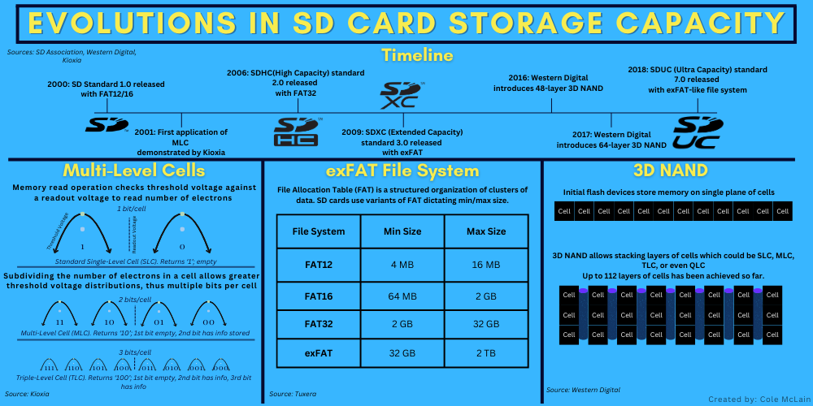
This infographic displays that I’ve synthesized information from multiple sources to create a singular work to answer the question of why SD cards have been able to increase their storage capacity over their existence.
This course has taught me much about how to focus my work to fit a rhetorical situation. Quite often I like to write in a free-form way, and this is perhaps good for creative writing but not for technical writing, analysis, or many other forms. In the future, I will use what I’ve learned about intended audience, rhetorical appeals, citing sources, and understanding genre conventions to more effectively communicate with others both in technical writing, being a computer science student, and general communications such as email or conversation. I’ve learned that stating things as they come to mind may not be an effective technique for an audience, and considering what that audience is more likely to respond to and tailoring what I say based on that is much more useful.

