Infographic
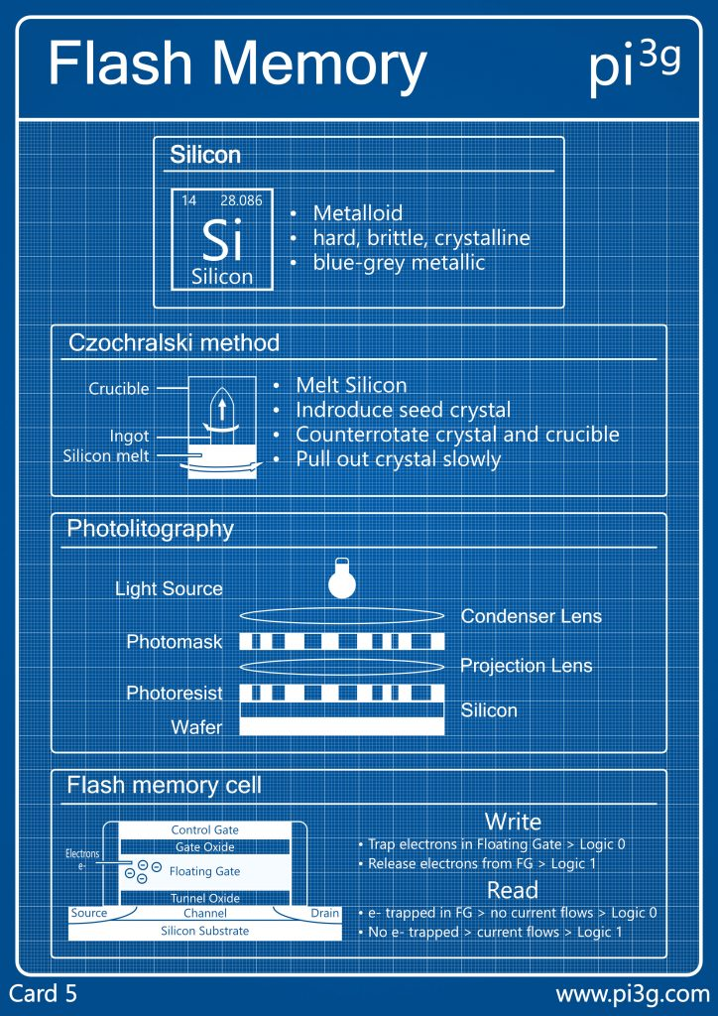
Most everybody uses flash media storage at some point in their life, whether for cameras, backups, or even running entire applications. They appear as such simple devices; just plug it in the proper slot and the computer knows what to do. But, as with most things in life, there’s a vastly complex underpinning to their creation and operation. I will be looking at the history of the manufacturing of SD cards and the physical components of them.
I have chosen this infographic because it provides an organized yet brief look at the physical makeup of modern flash memory devices and how they are made.

Audience and Purpose

The infographic is aimed at Raspberry Pi enthusiasts and advanced computer users (AKA ‘geeks’) who are interested in understanding how flash memory works. I have three reasons for thinking this:

1) The terminology used is not common knowledge. While most people may know that computer chips are made with silicon, the titles “Czochralski method” and “lithography” are likely foreign to most. Even if the reader does not possess knowledge of all the terms, a ‘geek’ is more likely to pay attention to this and seek out further explanation.

2) The “pi3g” in the upper-right corner is a reference to the company that devised this graphic. They develop various products for Raspberry Pi’s.

3) The coloring and graph paper-like background gives a feel of “This is science!” to the reader, indicating that it is not aimed at those not interested in the depths of computer science.

The purpose of the infographic is to offer a brief explanation of four different pieces of the workings of flash memory as shown by the four distinct rectangles. We know this because, with some background knowledge, the titles give us clues about what each section is communicating; the first rectangle contains the main element used in producing microchips, the second box shows a refinement process, the third overviews the process of creating a chip, and the fourth displays how memory works at the cellular level.

Main Components and Background Knowledge

The main components of this infographic are as follows:

1) A title at the top

2) Two distinct colors: blue and white

3) Four sections of information, each with a title, image, and accompanying text.

4) A URL

If you’re not a computer scientist, it would be obvious that much background knowledge is needed to piece this infographic together. The reader needs to know specific technical jargon such as “crucible”, “seed crystal”, and “condensor lens”, for example. A reader would need to know what flash memory is and its function in computing. In order to understand the order of the information present, one needs to know that it is to be read from top to bottom. Even the diagram itself does not contain all the necessary information to know everything it is trying to say, which is further elaborated on in the website where it is found.

Layout and Composition

The whole infographic has a margin at all edges and a global, vertical, rounded rectangle containing the entirety. At the top, we see a large title on a solid blue background then a line separating it from the rest. There are then four more distinct, smaller rectangles with slightly rounded corners housing each separate idea pertaining to the creation of flash memory. This clearly separates all the data into digestible chunks which aids in conveying the author’s purpose by letting us consider each idea – silicon, the Czochralski method, lithography, and reading/writing memory – on its own. These components are stacked on top of each other which helps us recognize in which order they are to be read. There is also heavy use of margins on the edges of each element to further segment the data and promote readability.
The author also is very sparing with words and uses text formatting to help readability. There are no complete sentences, interestingly, instead shortened phrases or words encapsulating the idea. Titles tend to have larger text size while bullet points are usually smaller. The labels for the image in “Czochralski method” are even smaller. There is some inconsistency though, an example being that the “Silicon” title appears bolder than the titles of the other three sections. Another example is that some of the bullet points are the same size as the section titles.
As mentioned in the previous section, only two colors are used. The background is blue with thin, white grid lines, giving the appearance of graph paper, while all text is in white. I feel the simplicity of the color scheme, the particular colors used, and the graph-like background help set the tone of the infographic as a communicator of ‘cool’ computer science. Each section also has a simple illustration showing what the section is talking about. For instance, the image in the ‘Czochralski Method’ section shows us what that process might look like which helps further our understanding of it by visualizing the parts and what is happening to them.
Overall, the composition works to help the reader understand how flash memory is produced. Dividing the infographic into distinct sections helps to clearly separate different ideas. The changes in font size further segments the hierarchy of information, despite the flaws mentioned. And the simplicity of the layout works in directing the reader’s attention to only what the author wants to communicate.

Rhetorical Appeals

Being that we are dealing with computer science, there is heavy appeal towards logos. Computers (as far as we know) deal purely in logic. Even in the process of manufacturing, one step must lead to another in a robotic fashion in order to make a quality product, as shown in this graph. We cannot perform lithography until we have used the Czochralski method of refining silicon and we cannot read or write from memory until a card has been fully manufactured. The author shows us this by presenting the information in this logical order. I am convinced by this appeal; based on my knowledge, I do not see anything illogical.
The author also hopes to appeal to us through their ethos. By using proper terminology, we are more likely to believe that they know enough about the topic to explain it to us. By presenting the associated diagrams, we further believe that they have seen or at least studied the process of manufacturing enough to relay correct information. The author unfortunately loses some of my faith in their ethos due to one spelling mistake and two instances of inconsistent capitalization in the “Silicon” section. This could indicate that the author rushed the production of the infographic, does not care about the proper use of English, or did not edit the text or even the whole graphic. In the latter case, that could even mean the author presents incorrect information because they failed to examine what they put in. Still, I am content to believe that the information itself is correct and feel it is unlikely that the author carelessly posted something false.

Conclusion

In examining this infographic, I have learned that infographics are a fun, visual way to communicate lots of information. I noticed that there is a flow that’s achieved with good design, where the reader is led through the author’s message based on the visual layout. Despite the simplicity and relatively small size, we learn a surprising amount even though it requires the author elaborating further on their website to fully understand what it is communicating.
If I had to change one thing, it would be the graph-like background intruding upon the information. I like the look of it but I feel it is distracting when put behind the text. Either the white of the lines or the font could have been a different color to make it hide behind the text more.
I really like how the information is laid out in ordered blocks and could use that in my own infographic. The way the text is formatted is a useful tool too, with titles having a large, bold font, and sub-text being smaller and medium-weight even if it’s not very consistent in this particular work. Lastly, I’d like to employ the simplicity of this infographic in my own too, with a limited color palette and no unnecessary images or details.

Citation
Pi3g. "Flash Memory." PiCockpit, Pi3g GmbH, 8 Apr. 2022, picockpit.com/raspberry-pi/wp-content/uploads/2022/04/5-Flash-Memory-724x1024.jpg. Accessed 28 Jan. 2025. Infographic.

