Infographic

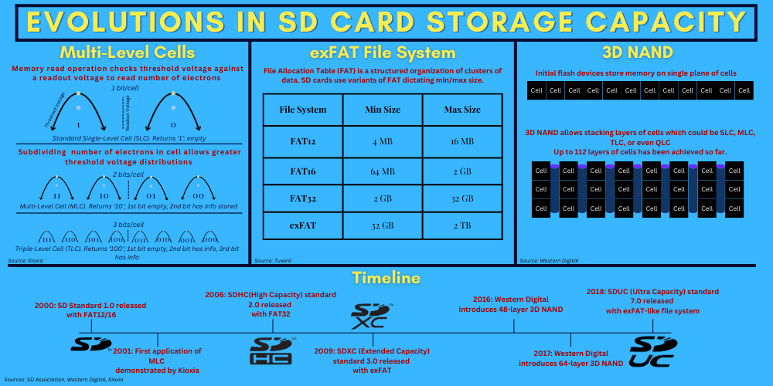

Infographic Rhetorical Analysis

Topic, Audience, and Purpose

I have chosen to focus on the evolution of innovations in increasing storage capacity for SD cards as my topic. The intended audience for this is curious first-year computer science students in the US. This is significant for the audience because it gives a logical timeline of how SD cards became able to store so much data over the 25 years of their existence. The purpose of this infographic is to present three key technologies that enhanced storage capacity: MLC, which allowed more bits to be stored per memory cell, file systems that provided more efficient data management and increased maximum storage size, and 3D NAND, which involves stacking memory cells granting an extra dimension in memory chips. Given the audience and information included, I could publish this infographic on Wikipedia under the SD Card page. This would be an appropriate place because Wikipedia strikes a balance between including highly technical concepts without intricate technical details. It could also be published on a bulletin board in a STEM education center. A bulletin board is a place students would look for quick, interesting information which is what the infographic intends to present.

Use of Source Material

Each of my sources was focused on separate concepts allowing increased flash storage capacity. I chose the information from Kioxia by searching for a section specifically about how MLC contributes to an increase in the size of flash memory drives. I ruled out information about how flash memory works and the benefits or detriments of MLC technology. I specifically took from the “Mechanism of capacity increases through multi-level cell technology” section because I felt like it would appeal to my audience the most for being a direct explanation of the concept of multi-level cells. I knew I wanted to include a timeline of . This would appeal to my intended audience because it shows the evolution of the SD standard and where the three concepts I present fit in. I sought an overview of what 3D NAND is from the Western Digital source and mostly took information from the second and third sections. I thought this would appeal to my audience because 3D NAND is a huge leap in the evolution of storage capacity and is essential to understanding the expansion of memory capacity. From Tuxera, I needed a list of different implementations of file systems in SD cards and how it affects capacity. This should be interesting to my audience because it is a more logical reason capacity increased rather than a physical innovation.

Main Components

The primary components of my infographic are:
- A title at the top
- One section on multi-layer cells, including a title, visual of its operation, and text explaining briefly how it works
- One section on file systems, including a table showing the limitations of each system and text explaining the table
- One section on 3D NAND with an abstract visual of memory cells on a 2D plane then cells stacked, and text explaining the images
- One timeline showing some of the SD standards and showing how dates relate to increased memory capacity
I realized that the concepts of 3D NAND and multi-level cells could be more easily communicated with images than a block so I chose to include two images for those. However, images weren’t enough to fully illustrate the ideas so I decided to include some explanatory text. Covering the FAT file system in such a general way as I have didn’t warrant any images though so I chose to only include a table for that with some text to explain what FAT is. I didn’t feel this infographic needed to have a wide variety of colors both because an audience of technically-minded folks likely doesn’t care for exquisite artistic displays and I intended to appeal more to logos rather than eliciting emotion through skillful use of color. I also am not very knowledgeable about color theory so choosing an intricate color scheme would likely have not worked out.
In order to understand my infographic, there are a few things a viewer would need to know. At the least, they need to know basic concepts about how memory works in a computer, such as the fact that it’s stored in binary. It also would be helpful for the viewer to have very basic knowledge of how electricity works to understand the section on MLC. Since my audience should be adept at using computers, has likely used them for many years, and is interested in how they work, I think it’s safe to assume they have the requisite knowledge.

Layout and Composition

I chose a block-like layout for my infographic. Each of the four pieces of information is laid out in its own separate block. I arranged it this way because each idea can stand on its own but collectively answers the question of why flash memory capacity has increased. Each block is the same size because they are equally important in their contributions, except for the timeline which simply needed more horizontal space to show all it needed to. The three equal blocks are not in any particular order but they stand on top of the timeline for I felt they were more interesting and important to read first. The title, of course, is draped across the top to inform the reader what they’re looking at.
I used two different fonts, one font to distinguish the main title, and one for the rest of the text. I then used three different font colors. Yellow is used to highlight titles, dark red for key ideas in a section, and black for less critical text. To further segment text, I used five different font sizes to further develop the hierarchy of information.
The different elements in each section are arranged so that important text is situated above the image it refers to. I felt this would help the reader understand what they would be looking at before seeing the accompanying image. The image sits underneath that text and any other explanatory text is placed underneath or within the image to give further context. This affects how the audience reads the individual aspects by allowing them to gradually move between the layers of information.
The colors and images are used set the tone as a discussion about electronics. The blue background color perhaps reminds the reader of a more fun shade of that used on the blue screens often seen in setup windows for primitive computer applications or, god forbid, the Blue Screen of Death. The MLC graph-like image and the text itself lends to portraying the infographic as a computer science document too.

Appeals

I appeal mostly through logos in this infographic. Computer science is a very logical-based field so this is the obvious first choice of appeal, for emotion has little bearing on how computers work. I used this appeal by keeping the color palette minimal and presenting facts about the topic rather than opinions.
My second appeal is through ethos. I hope to achieve this through proper use of the English language, having a clear layout, and presenting verifiable facts found in my research.

Timeliness

Timeliness was not a huge factor in this project. Indeed, the information is relevant now because flash memory is currently used and the innovations I cover are used in these devices. However, because I am covering such a general overview of innovations that have already occurred, this infographic could serve just as well in ten or twenty years because the innovations themselves are interesting.

Works Cited
Denholm, Thom. "What the FAT – Understanding FAT File System Types." Tuxera, 15 Sept. 2022, www.tuxera.com/blog/understanding-fat-exfat-file-system/. Accessed 13 Feb. 2025.
Editorial Team. "3 Ways We Build 3D NAND Skyscrapers." Western Digital Corporate Blog, 5 Feb. 2020, blog.westerndigital.com/3d-nand-data-skyscrapers-built-using-smart-scaling/. Accessed 13 Feb. 2025.
Kioxia. "What Is Multi-level Cell Technology Realizing Larger Capacity Flash Memory?" Kioxia, www.kioxia.com/en-jp/rd/technology/multi-level-cell.html. Accessed 13 Feb. 2025.
SD Association. "SD Standard Overview." SD Association, 11 Dec. 2020, www.sdcard.org/developers/sd-standard-overview/. Accessed 13 Feb. 2025.

