Infographic

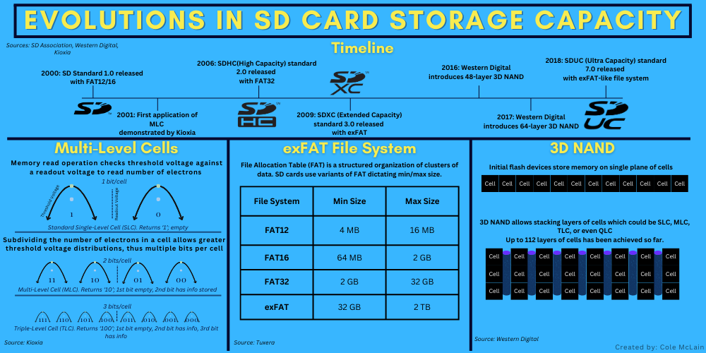

Infographic Rhetorical Analysis

Topic, Audience, and Purpose

I have chosen to focus on the evolution of innovations in increasing storage capacity for SD cards as my topic. The intended audience for this is curious first-year computer science students in the US. This is significant for the audience because it gives a logical timeline of how SD cards became able to store so much data over the 25 years of their existence. The purpose of this infographic is to present three key technologies that enhanced storage capacity: multi-level cells (MLC), which allowed more bits to be stored per memory cell, file systems that provided more efficient data management and increased maximum storage size, and 3D NAND, which involves stacking memory cells granting an extra dimension in memory chips. Given the audience and information included, I could publish this infographic on Wikipedia under the SD Card page. This would be an appropriate place because Wikipedia strikes a balance between including highly technical concepts without intricate technical details. It could also be published on a bulletin board in a STEM education center. A bulletin board is a place students would look for quick, interesting information which is what the infographic intends to present.

Use of Source Material

Each of my sources was focused on separate concepts allowing greater flash storage capacity. I chose the information from Kioxia by searching for a section specifically about how MLC contributes to this increasing capacity. I ruled out some of the information about how flash memory works in general, and the benefits or detriments of MLC technology. I specifically took from the “Mechanism of capacity increases through multi-level cell technology” section because I felt like it would appeal to my audience the most for being a direct explanation of the concept of multi-level cells.
I knew I wanted to include a timeline of when SD standards were released, so I looked for that from the SD Association source. I thought this would appeal to my intended audience because it shows the evolution of the SD standard and, along with the other sources, I could show where the technologies I’ve presented fit in with the standards.
I sought an overview of what 3D NAND is from the Western Digital source and saw the information from the second and third sections contained the bulk of the explanation of what 3D NAND is, so they seemed the most important to what I wanted to present. I thought this would appeal to my audience because 3D NAND is a huge leap in the evolution of storage capacity and is essential to understanding the expansion of it.
Lastly, from Tuxera, I searched for a quick list of the different iterations of the FAT file system and their respective capacities for SD cards. I also wanted to find a brief explanation of what FAT is. This should be interesting to my audience because it is a more logical reason capacity increased rather than a physical innovation.

Main Components

The primary components of my infographic are:
- A title
- One section on multi-layer cells, including a title, visual of its operation, and text explaining briefly how it works
- One section on file systems, including a table showing the limitations of each system and text explaining the table
- One section on 3D NAND with an abstract visual of memory cells on a 2D plane then cells stacked, and text explaining the images
- One timeline showing some of the SD standards and showing how dates relate to increased memory capacity
I realized that the concepts of 3D NAND and multi-level cells could be more easily communicated with images than a block so I chose to include images for those. However, images weren’t enough to fully illustrate the ideas so I decided to include some explanatory text. Covering the FAT file system in such a general way as I have didn’t warrant any images so I chose to include a table for that with some text to explain what FAT is.
As for written text, since I didn’t cover intricate details of how the technologies work, I felt the text should be minimal. I chose to include one to two sentence summaries in each section because I felt that was enough to give an overview of the concept and help explain how it applies to the purpose of the infographic. The diagram in the MLC section needed additional text to explain what was displayed, so I chose to include supplementary identifying descriptions in that section. I also included text in the exFAT table to show the differences between each file system type.
I didn’t feel this infographic needed to have a wide variety of colors both because an audience of technically-minded individuals likely doesn’t care for exquisite artistic displays for this type of information. Because of this, I chose three colors, yellow, black, and blue. I chose the blue for the background because I feel blue is associated with computers and electricity and it makes for a pleasing background color. Yellow was chosen because it stood out brightly against the background. Lastly, I chose black because it works as a general text color and is readable against the background.
In order to understand my infographic, there are a few things a viewer would need to know. To understand the MLC component, the reader needs to know that information is stored in binary on a computer and needs to know some basic concepts about electronics. It’s likely that a computer science student already has this basic knowledge upon entering school since they have an interest in the technology and have likely extensively used computers up to that point. The reader also needs to know how stored data is measured to understand file systems and capacity. Most computer users already know this. Lastly, the reader should understand the concept of a memory cell. It’s unlikely my audience knows details about what a memory cell is but they will be able to pick up on the concept as long as they understand binary.

Layout and Composition

In my infographic, each of the four pieces of information is laid out in its own separate block. I arranged it this way because each idea can stand on its own but collectively supports illuminating the primary purpose of the infographic. Each block is the same size because they are equally important in their contributions, except for the timeline which simply needed more horizontal space to show all it needed to. The three equal blocks are arranged loosely from right to left. The section on MLC helps provide some necessary information for the 3D NAND section so it made sense to include it on the very left. The title, of course, is draped across the top to inform the reader what they’re looking at.
I used two different fonts, Glacial Indifference to distinguish the titles, and Canva Sans for the details. I then used two different font colors. Yellow is used to highlight titles and black to explain details. To further segment text, I used five different font sizes. The main title is 28pt, sub-titles are 17pt, then descending sizes of 7pt, 6pt, and 4pt for the details in each section. This helps the reader’s understanding by establishing the hierarchy of information, guiding the reader progressively through what is important.
The different elements in each section are arranged so that important text is situated above the image it refers to. I felt this would help the reader understand what they would be looking at before seeing the accompanying image. The image sits underneath that text and any other explanatory text is placed underneath or within the image to give further context. This affects how the audience reads the individual aspects by allowing them to gradually move between the layers of information.
The colors and images are used to set the tone as a simple and fun discussion about electronics. The blue background color perhaps reminds the reader of a more enjoyable shade of that used on the blue screens often seen in setup windows for primitive computer applications, or, god forbid, the Blue Screen of Death. The graphics in each section along with the keywords themselves, such as “file system” or “readout voltage”, should help establish tone as well by tuning the reader’s mind to logical computer science.

Appeals

I appeal mostly through logos in this infographic. To start, computer science is a very logical-based field so I am using logos immediately through the topic itself. I also used this appeal by keeping the color palette minimal and presenting facts about the topic rather than opinions. Lastly, I used the layout to help this appeal by presenting information in a logical order, each successive element building on the next.
My second appeal is through ethos. One way I use this is by ensuring proper grammar and terminology is used throughout. Another way is by including in-text citations to reliable sources of information. Lastly, like with logos, I use the layout itself as an appeal through ethos by ensuring information is in a place that makes sense and in correct order.

Timeliness

When composing this infographic, I elaborated on techniques that are currently used in SD cards in order to make the infographic relevant to my intended audience now. 3D NAND, MLC, and exFAT are current technologies a reader will find in an SD card if they were to buy one today. Flash memory in general, whether in SD cards or SSDs, is a modern replacement of HDDs so my audience is more likely to encounter flash memory than any other type.

Works Cited
Denholm, Thom. "What the FAT – Understanding FAT File System Types." Tuxera, 15 Sept. 2022, www.tuxera.com/blog/understanding-fat-exfat-file-system/. Accessed 13 Feb. 2025.
Editorial Team. "3 Ways We Build 3D NAND Skyscrapers." Western Digital Corporate Blog, 5 Feb. 2020, blog.westerndigital.com/3d-nand-data-skyscrapers-built-using-smart-scaling/. Accessed 13 Feb. 2025.
Kioxia. "What Is Multi-level Cell Technology Realizing Larger Capacity Flash Memory?" Kioxia, www.kioxia.com/en-jp/rd/technology/multi-level-cell.html. Accessed 13 Feb. 2025.
SD Association. "SD Standard Overview." SD Association, 11 Dec. 2020, www.sdcard.org/developers/sd-standard-overview/. Accessed 13 Feb. 2025.

