CS 162P – Lab 1 – Reading Files

Part 1 – Python Installation

Make sure Python is installed and running on your machine. This can be a Windows machine, Linux, or Mac OS X. Make sure you have an editor that you can use to edit the Python scripts.

I will be demonstrating code using Windows 11, Python 3, and Notepad++. I will also be executing the programs from the windows command line. You can start the command line using the cmd command on Windows.

Part 2 – Git Repository and Directory Structure

You will need to install a Git client on your machine if you do not already have one installed.

If you do not already have an account on GitHub, you will need to create one. Once you have an account, you will need to create a repository that you will use for all of the labs in this class. You should probably keep the repository private, but you will need to invite josephcolton@gmail.com to the repository. This way, I should be able to see the code you commit and see when you have it turned in.

You probably want to create a default README file, a .gitignore file using the Python template, and pick a license. I usually use the GPL 3 as my default license, but it is up to you.

Enter the URL for your repository below:

https://github.com/GinghamJones/cs162p/

Check out your repository on your computer. Make sure you can see the README file and any others in your project. Try modifying and committing changes to the README file.

In the repository, create 8 directories for each of the projects. These should be named as follows: lab1, lab2, lab3, lab4, lab5, lab6, lab7, lab8. It is not necessary to commit empty directories to the repository at this time.

Part 3 – Write a Program

Write a basic Python script called linecount.py in the lab1 directory that takes a filename as an argument and prints out the number of lines in the file to the screen. Test your program and make sure that it is working correctly.

Take a screen print of the output of the program run from the command line (not IDE) and paste it below.
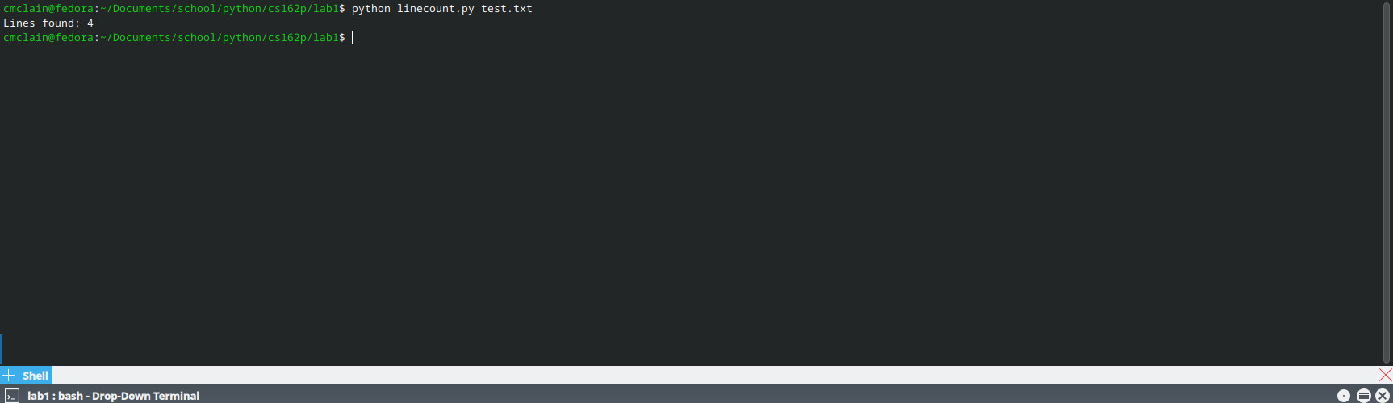
Once you have the program working correctly, commit it to the repo.

Part 4 – Submission

Make sure all of your code changes, updates, etc. have been committed to the Git repo. Use the git push command to make sure they have been sent to GitHub. Submit this document to Moodle when you are ready for grading.

