CS 162P – Lab 2 – List Processing

Part 1 – Downloading Files for Processing

Download the file lab2-data.txt from https://citstudent.lanecc.edu/courses/cs162p/labs/lab2-data.txt
Then look at the file and figure out the format. You will need to parse the file for all three of the programs that you will be writing below.

Make sure all three of the programs and the data file are all committed to your GitHub repo in the lab2 sub-directory. All screen prints should be generated from running the program from the operating system command line (not an IDE).

Part 2 – Sorting Lists – lab2a.py

Write a program in Python called lab2a.py that does the following:
- Reads in the lab2-data.txt file
- Splits the lines into parts
- Recombines the age and name into a line
- Put the new lines into a list
- Sort the list using the builtin sort method
- Use a for loop to look at each line
- Split the age and name into different parts
- Display the names in age order
You should be displaying the names in order of age, then if there are more than one with the same age, they will be sorted alphabetically.

Take a screen print of the output of the list when run from the command line and paste it below.
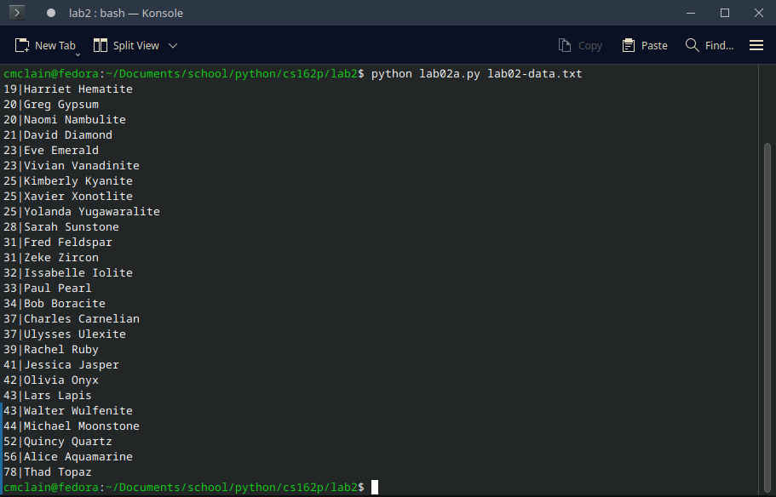
Make sure you commit your code as lab2a.py to the repo and push it.

Part 3 – Generating Statistics Part 1 – lab2b.py

Write a program in Python called lab2b.py that reads in the lab2-data.txt file and counts the number of people with each age. Display the list of ages followed by the count. The following is an example output line:

Age: 25 -> Count: 3

I am not concerned with how the output is formatted, but it must display the information above for each age. While you are not required to add up the counts, they should add up to 26, since there are 26 people.

Take a screen print of the output run from the command line and paste it below.
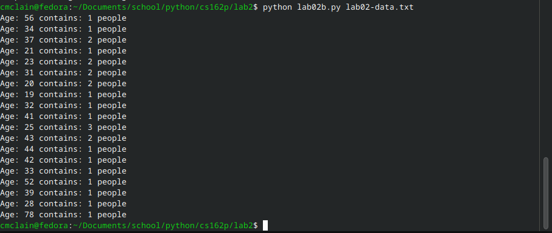

Make sure you commit your code as lab2b.py to the repo and push it.

Part 4 – Generating Statistics Part 2 – lab2c.py

Write a program in Python called lab2c.py that reads in the lab2-data.txt file and calculates the average rate for each profession. You will need to keep track of the different professions, the number of people in each profession, and the sum of their hourly rates so that you can later calculate averages.

Display the professions in alphabetical order followed by the average rate. The average pay rate should be a floating point number and you should display 2 digits after the decimal point. Take a screen print of the output run from the command line and paste it below.
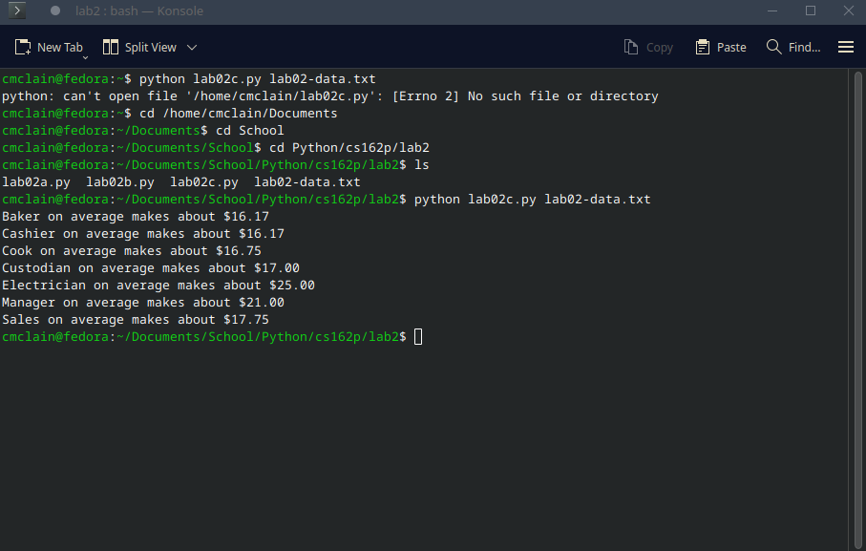

Make sure you commit your code as lab2c.py to the repo and push it.

Part 5 – Submission

Make sure all of your code changes, updates, etc. have been committed to the Git repo. Use the git push command to make sure they have been sent to GitHub.

Paste the URL to your lab2 directory on GitHub below:

https://github.com/GinghamJones/cs162p

Submit this document to Moodle when you are ready for grading.

