CS 162P – Lab 3 – Recursion

Part 1 – Downloading Files for Processing

Download the file lab3-data1.txt from https://citstudent.lanecc.edu/courses/cs162p/labs/lab3-data1.txt
Download the file lab3-data2.txt from https://citstudent.lanecc.edu/courses/cs162p/labs/lab3-data2.txt

Then look at the file and figure out the format. You are encouraged to complete Part 3, but you have the option to instead do the easier program in Part 4. You will need to parse the file for Part 3 below.

Make sure both of the programs and the data files are all committed to your GitHub repo in the lab3 sub-directory. All screen prints should be generated from running the program from the operating system command line (not an IDE).

Part 2 – Factorial – lab3a.py

Factorial is the product of all integers from 1 to the number. So 5 factorial written as 5! is equal to 5 * 4 * 3 * 2 * 1. That means that 5! = 120.

Write a program in Python called lab3a.py that has two methods factorial1 and factorial2:
- factorial1 – Should take an integer as input and using an iterative approach calculate factorial for the integer.
- factorial2 – Should take an integer as input and using a recursive approach calculate factorial for the integer.
- The program should accept two arguments from the command line. The first is a method (ie. iterative, recursive) and the second is an integer from the command line.
- Using the requested method calculate factorial and print the result on the screen.

Run the program twice, once with each method. Take a screen print of the output of the list when run from the command line and paste it below.
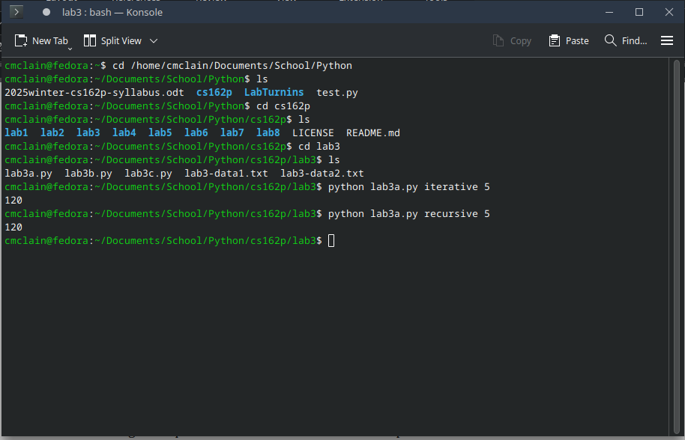

Make sure you commit your code as lab3a.py to the repo and push it.

Part 3 – Recursive Searching (Option 1) – lab3b.py

Write a program in Python called lab3b.py that reads in the file specified on the command line as well as a maximum number of hops, a source node, and a destination node. The file should be in the format of either the lab3-data1.txt or lab3-data2.txt file.

Example CLI: ./lab3b.py lab3-data2.txt 3 gcp.us-east1 gcp.southamerica-west1

The program should report the default delay from the source to the distance, then it should try to find a route from the source to the destination that is more efficient.

Write a function that takes a source node, a destination node, and maximum hops, then tries to find a path with a lower delay. New paths are those that start at the source node, end at the destination node, and use different intermediate relay node(s) to get there. Each relay node is a hop and the maximum number of hops should not be exceeded. You want your program to actually complete in a reasonable amount of time.

Take a screen print of the output run from the command line and paste it below.

<Replace with required screen print>

Make sure you commit your code as lab3b.py to the repo and push it.

Part 4 – Recursive Searching (Option 2) – lab3c.py

Write a program that takes a single argument on the command line. This argument should be a string of characters to see if it is a palindrome.

Your program should do the following:
- Convert the argument string to a list of characters
- Write a function that returns True if the list is a Palindrome
  - Base Case: Return True if there are 1-2 characters in the list that are the same
  - Recursive Case: Return True if the first and last character match and the middle characters (ie. list[1:len(list)-1] ) are a Palindrome.
- Call the function on the list of characters and print “Palindrome” or “Not Palindrome”
- Your program must use recursion to solve it to receive any credit.

Take a screen print of the program running a couple of strings and paste it below.
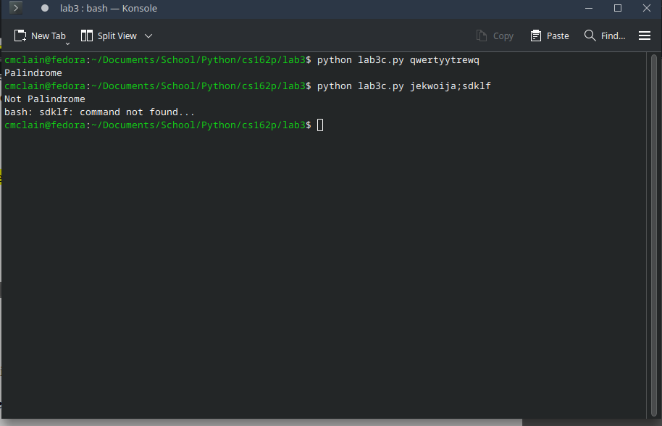

Make sure you commit your code as lab3c.py to the repo and push it.

Part 5 – Submission

Make sure you have completed Part 2 and either Part 3 (Option 1) or Part 4 (Option 2).

Make sure all of your code changes, updates, etc. have been committed to the Git repo. Use the git push command to make sure they have been sent to GitHub. Use git pull afterwards to make sure you have all the updates.

Paste the URL to your lab3 directory on GitHub below:

https://github.com/GinghamJones/cs162p/tree/main/lab3

Submit this document to Moodle when you are ready for grading.

