CS 162P – Lab 4 – Classes

Part 1 – Class Creation

Create a class of your choosing that does the following:
- Stores a private instance attribute (starts with underscore)
- Write getters and setters to access and modify that private instance attribute
- Create properties that use the getters and setters

Your class can contain multiple private instance attributes if you like. Some examples of possible classes you could create include Person, Car, Food, Pet, Team, Location, etc. Be creative and try not to use the same class as other people who might be in this or other Python classes.

Make sure you commit your class code to the lab4 sub-directory in the repo and push it. All screen prints should be generated from running the program from the operating system command line (not an IDE).

Part 2 – Program Driver – lab4a.py

Write a program called lab4a.py that imports the class you created and creates multiple instances of class objects. Make sure your program displays some information from the class to show that you know how to access private instance attributes using the properties.

Take a screen print of your programs execution. Paste the screen print below.

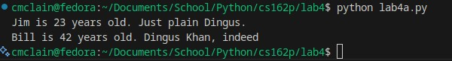

Make sure you commit your code as lab4a.py to the repo and push it.

Part 3 – Class Functions – lab4b.py

Create a class called MyMath that is either inline or in an external file and a driver program called lab4b.py that creates an instance of the MyMath class and runs some methods in the class and displays the results.

The MyMath class should include the following method functions:
- absolute – Returns the absolute value of a number (removes the sign)
- average – Returns the average value from a list of numbers passed in

You are free to add additional functions if you want, but they are not required. Run the lab4b.py program and make sure the output looks correct.

Take a screen print of the output run from the command line and paste it below.

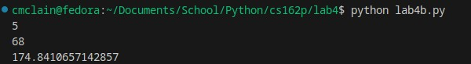

Make sure you commit your code to the repo and push it.

Part 4 – Submission
Make sure all of your code changes, updates, etc. have been committed to the Git repo. Use the git push command to make sure they have been sent to GitHub. Use git pull afterwards to make sure you have all the updates.

Paste the URL to your lab4 directory on GitHub below:

https://github.com/GinghamJones/cs162p/tree/main/lab4

Submit this document to Moodle when you are ready for grading.

