CS 162P – Lab 5 – Overloads and Properties

Part 1 – Class Creation

In the lab5 sub-directory, create a file called reversemath.py and in the file create a class called ReverseFloat. This class will have addition, subtraction, multiplication, and division, however, they will all do the opposite of what they are supposed to do. (ie. addition performs the subtraction operation). The class should take a single number as input. You will need to create the following overloaded methods:

__init__(self, value) – Sets the internal value
__str__(self) – Returns a string of the value with 2 digits after the decimal (ie. “%.2f”)
__add__(self, other) – Returns a new ReverseFloat with the value of other subtracted from self
__sub__(self, other) – Returns a new ReverseFloat with the value of other added to self
__mul__(self, other) – Returns a new ReverseFloat with the value of self divided by other
__truediv__(self, other) – Returns a new ReverseFloat with the value of self multiplied by other

Create a file called lab5a.py that takes 2 command line arguments, converts them to floats, then uses them to create instances of the ReverseFloat class. It should then test all of the operators and methods. It should print out the results. Example output line from the multiplication:

6 x 3 = 2

Take a screen print of your codes execution on the command line and paste it below.
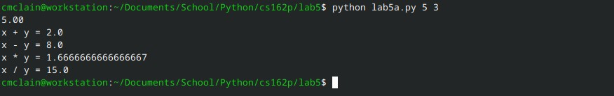

Make sure you commit your class code to the repo and push it.

Part 2 – Properties – lab5b.py

In the lab5 sub-directory, write a class in file by itself. You can call it whatever you want. The class should have at least two attributes. Make sure the attribute names start with an underscore to indicate that they are private (ie. self._name). Create class modifiers (ie. getName, setName) for all of the attributes. Create properties for the attributes.

Create a driver program called lab5b.py that imports and uses the class. It should be able to create objects and then use the properties to change the values and display them.

Take a screen print of your programs execution. Paste the screen print below.
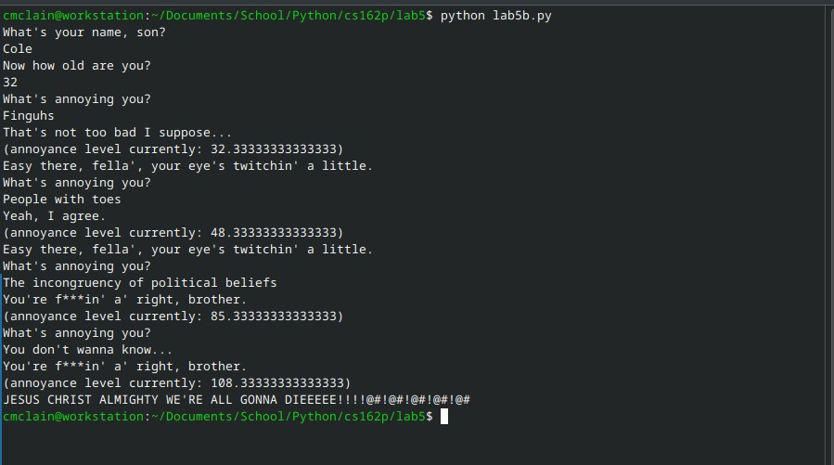

Make sure you commit your code to the repo and push it.

Part 3 – Submission
Make sure all of your code changes, updates, etc. have been committed to the Git repo. Use the git push command to make sure they have been sent to GitHub. Use git pull afterwards to make sure you have all the updates.

Paste the URL to your lab5 directory on GitHub below:

https://github.com/GinghamJones/cs162p

Submit this document to Moodle when you are ready for grading.

