CS 162P – Lab 6 – Inheritance and Polymorphism

Part 1 – Shape Class Creation – shapes.py

In the lab6 sub-directory, create a file called shapes.py that contains classes for drawing multiple shapes. Your shape classes should practice inheritance as described below:

Point – Base class
Triangle – Inherit from Point
Diamond – Inherit from Point
Rectangle – Inherit from Point
Square – Inherit from Rectangle

The point class should have an initialization method, setSymbol method, and draw method. You should also have attributes for each of the shapes for things like size, width, height, etc.

You can add additional shapes to your class if you can think of any that you would like to use. The video on Moodle should be helpful in getting started, but will not be what you want since the Square class inherits from the Rectangle class instead of the Point class. The way the shape is displayed is not that important, just that you actually display the correct shape.

Make sure you commit your class code to the repo and push it.

Part 2 – Shape Driver – lab6.py

In the lab6 sub-directory, you should download and commit the lab6-data.txt file. This file contains a list of shapes that need to be displayed.

https://citstudent.lanecc.edu/courses/cs162p/labs/lab6-data.txt

You should create a program called lab6.py that takes the list file from the command line and displays each of the shapes in order.

The format of the file is as follows. Each argument in the file is space separated. The first character/argument is the required shape (ie. P=Point, S=Square, T=Triangle, D=Diamond, R=Rectangle). The second argument is character used to draw the shape. Some shapes will have additional argument for size or for width and height. You will need to look at the lines and determine how to parse the file.

Your program should parse the file and create shape class objects for each shape. These objects should then be inserted into a list. Your program should then iterate over the list and call the draw method in each object.

Take a screen print of your programs execution. Paste the screen print below.
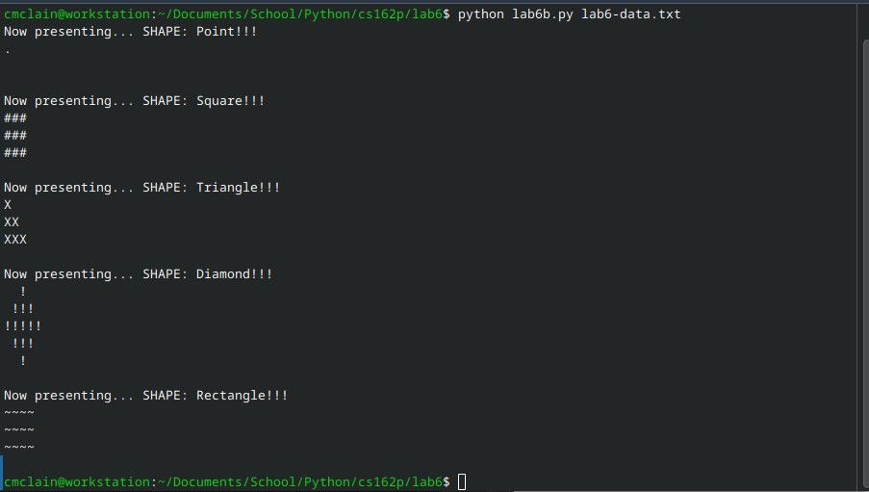

Make sure you commit your code to the repo and push it.

Part 3 – Submission
Make sure all of your code changes, updates, etc. have been committed to the Git repo. Use the git push command to make sure they have been sent to GitHub. Use git pull afterwards to make sure you have all the updates.

Paste the URL to your lab6 directory on GitHub below:

https://github.com/GinghamJones/cs162p/tree/main/lab6

Submit this document to Moodle when you are ready for grading.

