CS 162P – Lab 7 – Abstract Classes

Part 1 – Shape Class Creation – shapes.py

In the lab7 sub-directory, copy the shapes.py file, that you made in lab6, that contains classes for drawing multiple shapes. Replace the Point class with an abstract class that creates abstract methods.

Point – Base class
Triangle – Inherit from Point
Diamond – Inherit from Point
Rectangle – Inherit from Point
Square – Inherit from Rectangle

Make sure you commit your class code to the repo and push it.

Part 2 – Shape Driver – lab7.py

In the lab7 sub-directory, create a data file similar to the one you used in lab6. You should not create points, but should create all of the other shapes. Make sure you commit the data file.

You should create a program called lab7.py that takes the list file from the command line and displays each of the shapes in order.

Your program should parse the file and create shape class objects for each shape. These objects should then be inserted into a list. Your program should then iterate over the list and call the draw method in each object.

Take a screen print of your programs execution. Paste the screen print below.
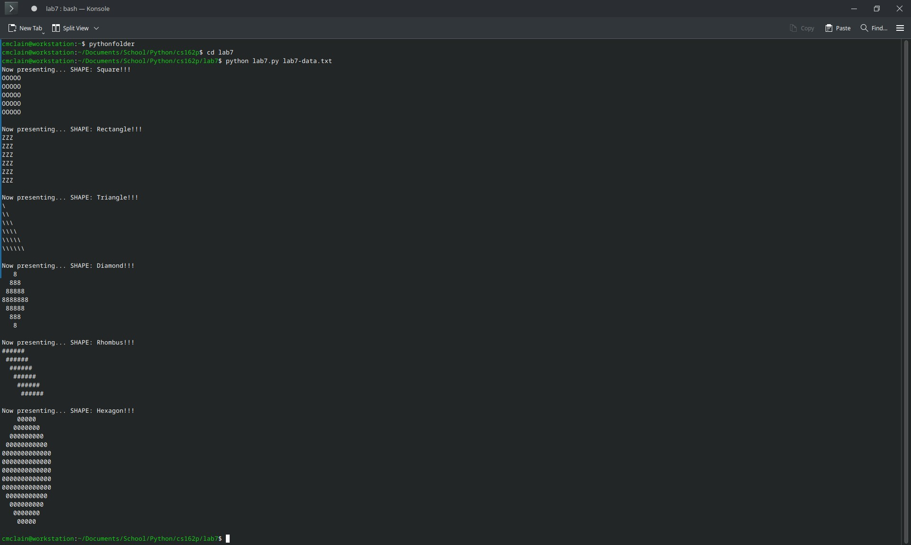

Make sure you commit your code to the repo and push it.

Part 3 – Submission
Make sure all of your code changes, updates, etc. have been committed to the Git repo. Use the git push command to make sure they have been sent to GitHub. Use git pull afterwards to make sure you have all the updates.

Paste the URL to your lab7 directory on GitHub below:

https://github.com/GinghamJones/cs162p/tree/main/lab7

Submit this document to Moodle when you are ready for grading.

