CS 162P – Lab 8 – Data Structures

Part 1 – Sorting Information – sorting.py

In the lab8 sub-directory, create a program called sorting.py and a text file for information input.

The text file should contain a series of lines with multiple fields that are delimited with a character of your choosing. I like to use either the pipe character or a comma. The lines could be for people, objects of some sort, sports teams, foods, etc. You can pick the contents. Make sure you commit the text file.

Your program should load your text file information into a dictionary. Use a list of tuples to sort the information by one of the fields. Display the contents in sorted order.

Take a screen print of your programs execution. Paste the screen print below.
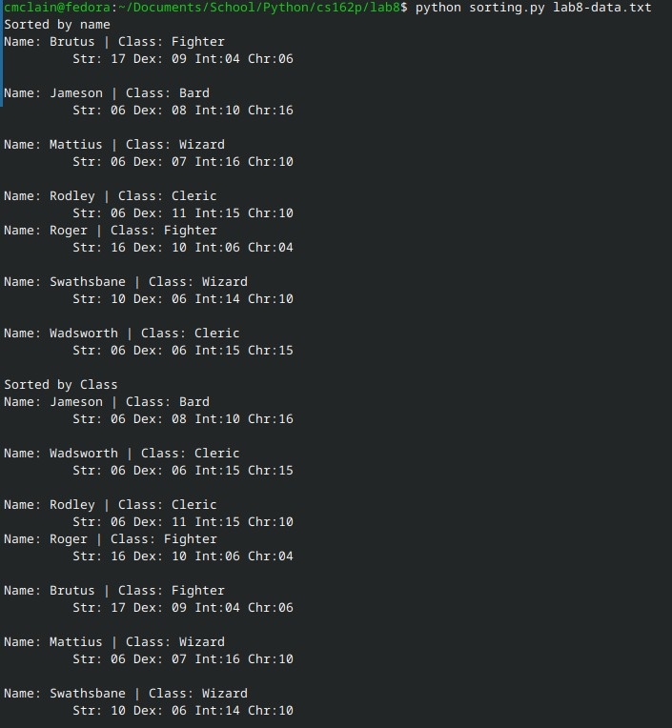

Make sure you commit your code to the repo and push it.

Part 2 – Pascals Triangle – pascal.py

Create a class called Pascal that is used to calculate pascals triangle. The class should have the following features:

- A dictionary to store calculated values. The dictionary should store values using a tuple index which included the row and the column. (ie. data[(row, col)] = value).
- A method to get values. The method should take a row number and column number as input parameters and return the value at that location in Pascals triangle. The method should see if the value has already been calculated and is stored in the dictionary. If not, it should recursively calculate the value and save it in the dictionary before returning it.
- A method to display Pascals triangle up to a given number of lines. It should use the other method for getting the values and display them properly.

Write code that loads your class and displays Pascals triangle for a given number of lines.

Take a screen print of your programs execution. Paste the screen print below.

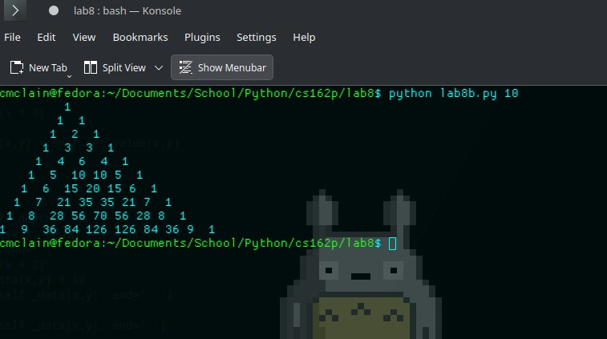
Make sure you commit your code to the repo and push it.

Part 3 – Submission
Make sure all of your code changes, updates, etc. have been committed to the Git repo. Use the git push command to make sure they have been sent to GitHub. Use git pull afterwards to make sure you have all the updates.

Paste the URL to your lab8 directory on GitHub below:

https://github.com/GinghamJones/cs162p/tree/main/lab8

Submit this document to Moodle when you are ready for grading.

