CS 240W – Lab 2- Configuring
Name: ____________________________________

Part 1: Network Settings
- Update your Virtual Machine Network to Bridge network.
  - Verify that your Server and Host are on the same network.
  - NOTE: I am not able to use bridged mode. I don’t know why it’s not working. In fact, no other mode besides NAT works. I can complete question 5 so I’m assuming this is okay for now. In the future, I’ll create another VM to use as a client.
- What is your server’s IP address and Host IP address?
Ans: Server IP = 10.0.2.15/24
Host IP = 10.154.217.244/16

- Explain how and why you would make your Server have a Static IP address.
Ans: Because you would need a specified location to access the services offered on the server

- Enable ICMP messages for both Host and Server.
- Ping from Server to Host. Take a screenshot.
Screenshot:
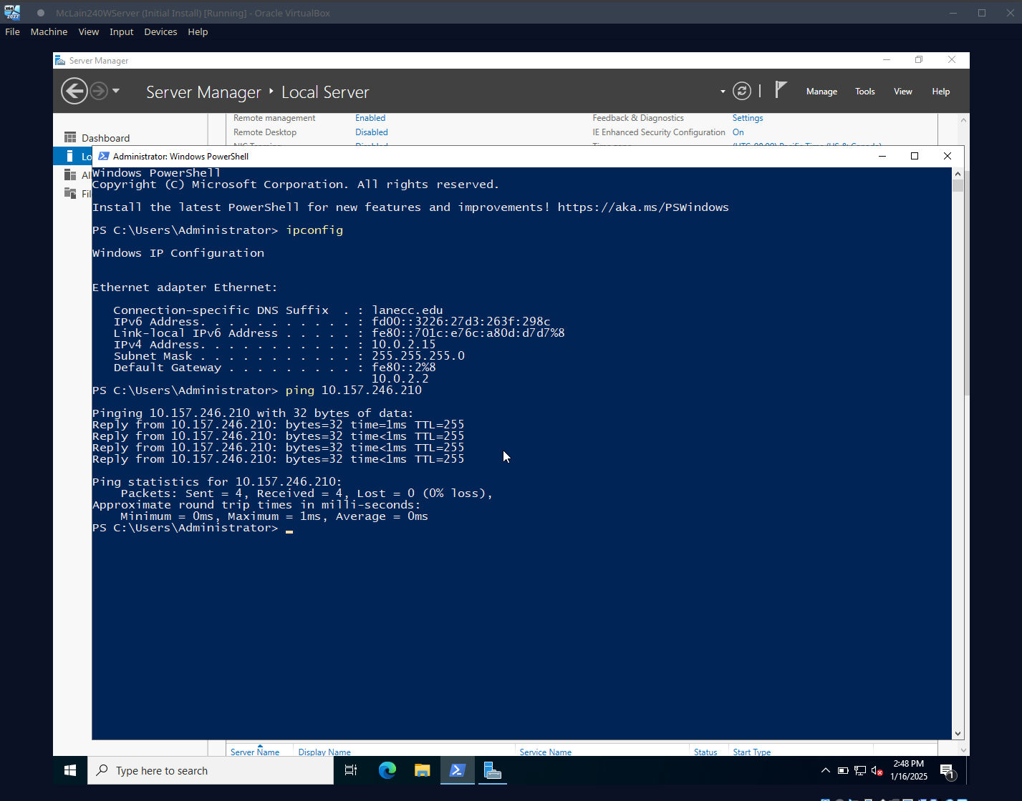
Part 2: Connect Your Server to Azure Arc
- Set Up Azure Prerequisites:
  - Log in to the Azure Portal (https://portal.azure.com).
  - Navigate to Azure Arc and click Add a new machine.
  - Download the onboarding script provided in the Generate script step.
- Prepare the Server:
  - Open Windows PowerShell as Administrator in your VM.
  - Install the required agent by running:
  - Open your server in Azure Arc and insert a screenshot of it.
Screenshot:
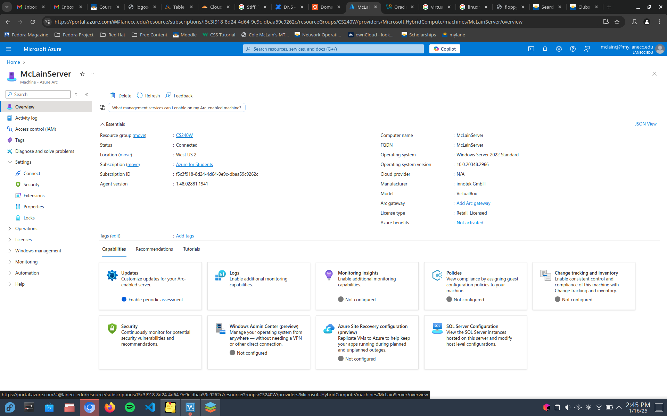

Part 3: Install Windows Admin Center
- Connect to the server through Windows Admin Center.
- Monitor server performance using dashboards insert a screenshot of it.
Screenshot:
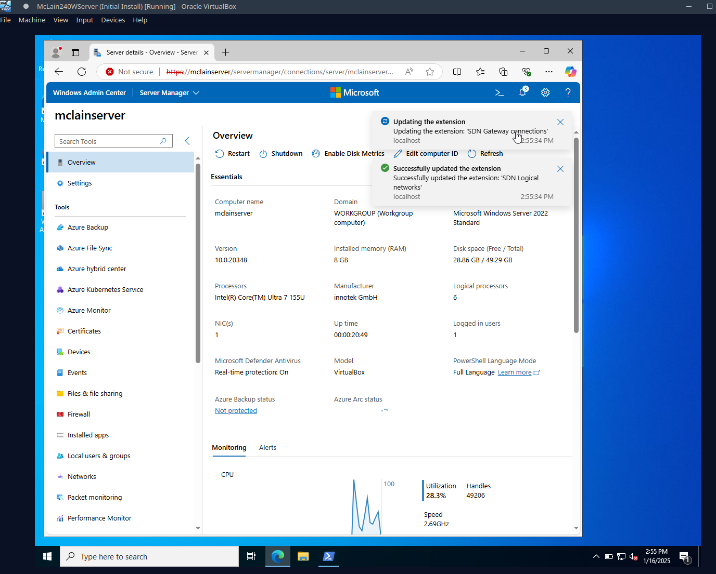
Part 4:
- Research and describe the key features and primary use cases of each management tool.
Ans:
Azure management allows one to monitor multiple Windows or Linux servers in a web-based interface. It is useful for its web management interface, auto-management tools, and Microsoft Defender for Cloud
Windows Admin Center is also browser-based but can be locally based. It offers administration for single Windows Server deployments and provides ‘modernized versions’ of tools like Server Manager.

Part 5: Turn into Moodle (2 points)
Save the completed document as a PDF. Name it as Lab2_YourlastnameFirstInitial.pdf. Be sure to have your name on the top line in this document. Upload to Moodle.

