CS 240W - Lab 4 – DNS & DHCP
Name: ____________________________________

Topic:
Total Points: 25

Section 1: DNS (6 Points)
- Explain the role of DNS in a Windows Server 2022 environment. (2 points
Ans: In a Windows Server environment, DNS is used to locate AD domain controllers. It can also be used as a standard DNS service to host an organization’s public lookup zones.
- What is the difference between forward lookup zones and reverse lookup zones in DNS? Provide examples of when each would be used. (2 point)
Ans: A forward lookup zone translates a domain name to an IP address. This is most commonly used when trying to access a website. A reverse lookup zone translates an IP address into a domain name. This might be used in troubleshooting or to discover domain names of known IP addresses.
- What is DNS caching, and how does it improve performance? What are the potential risks associated with DNS cache? (2 points)
Ans: A DNS cache temporarily stores the results of a DNS lookup. This allows a machine to forego traversing the lookup process every time a request is made. The danger of this is that a malicious user could potentially insert a false DNS cache in a system directing lookups to the wrong location.

Section 2: DHCP (4 points)
- Describe the purpose of DHCP in a network environment. (2 point)
Ans: DHCP is used to automatically assign IP addresses to host machines. This negates the need to map static IPs to every machine on a network if they’re not hosting services that need to be reached.
- What is the significance of a DHCP scope? (2 point)
Ans: DHCP scopes allow an administrator to define the IPs allowed on DHCP and segment the IPs offered to certain types of machines.

Section 3: Configure DNS & DHCP

NOTE: I have used Kali Linux because my host PC isn’t very powerful and (I’m pretty sure) Linux runs lighter than Windows. I do have a Windows 11 guest installed and can provide screenshots from that if you require it. Let me know!

Task 1: Configure DNS on Windows Server 2022 (8 points)
- DNS Server Role should already be installed on your Windows Server 2022. If it isn’t install it.
- Create a Forward Lookup Zone with the name dns.lastname.lab point to your IP address.
Insert Screenshot of a successful ping to dns.lastname.lab. (2 Points)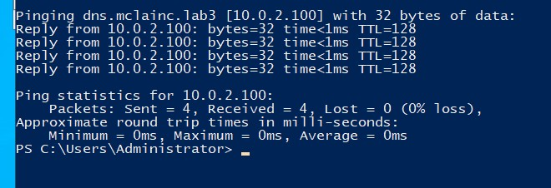
- Add at least two A (Host) records to the zone.
Insert Screenshot of 2 records. (2 Points)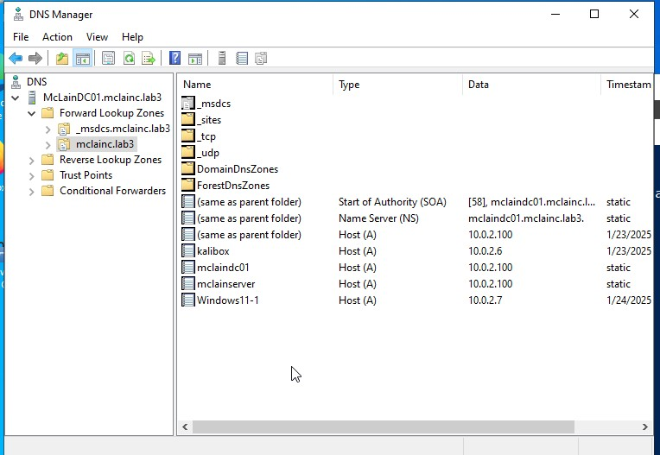
- Bring up your client system (Win11 desktop) and ping dns.lastname.lab
Insert Screenshot of Win 11 ping. (2 Points)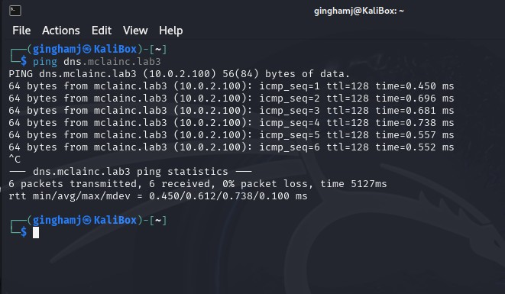
- Add a reverse lookup records for your Win 11 machine and your dns.lastname.lab.
- On your client machine perform a nslookup for your ip address of your Windows 11 machine and for your Server.
Insert Screenshot of nslookup. (2 Points)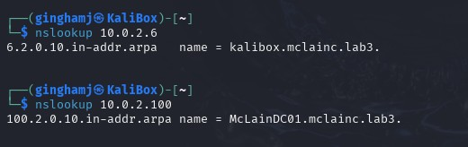

Task 2: Configure DHCP on Windows Server 2022 (5 points)
- Install the DHCP Server Role on your Windows Server 2022 instance. (2 points)
- Create a new DHCP scope with the following details:
  - Name: CS240WNetwork
  - IP Range: 10.0.2.50 – 10.0.2.75
  - Subnet Mask: 255.255.255.0
  - Default Gateway: 10.0.2.1
  - DNS Server: 10.0.2.100
Insert Screenshot of CS240WNetwork Scope Properities. (3 Points)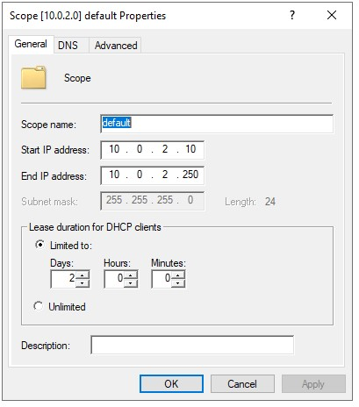

NOTE: This doesn’t show all the configured properties. I have also set the DNS server and excluded the 10.0.2.100 address.
- Note: These IP addresses might be different for you. It should be what you’ve configured your network.
- Shutdown both Server and Client
- In VirtualBox uncheck DHCP
- Start Server and when it is up and running start Client.
(Note: this can take awhile)
- In Client show IP address Note: It should be 10.0.2.50
Insert Screenshot of ipconfig from Client. (2 Points)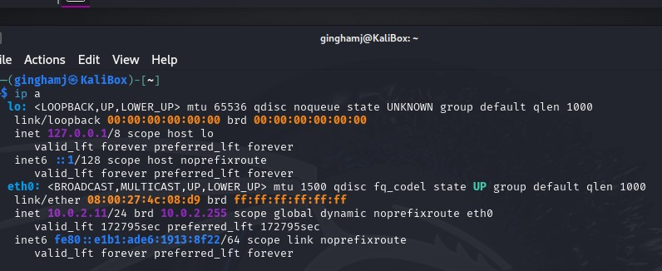

Section 4: Turn into Moodle (2 points)
Save the completed document as a PDF. Name it as Lab4_YourlastnameFirstInitial.pdf. Be sure to have your name on the top line in this document. Upload to Moodle.

