CS 240W - Lab 5 – Group Policy Lab

Name: Cole McLain
Total Points: 25

Section 1: Create Organizational Units/Users (5 points)

Create Organizational Units (OUs):
- Create at least two OUs name them whatever you want.
- Move your client to one of the Ous.

Create Multiple Users:
- Create at least two user accounts.
- Add one in each of your OUs.
- Name one account after yourself, and choose any name for the second account.
- Assign appropriate passwords. (Note: Since these are not production accounts I suggest you keep the password the same as your admin).
Insert Screenshots of groups and users. 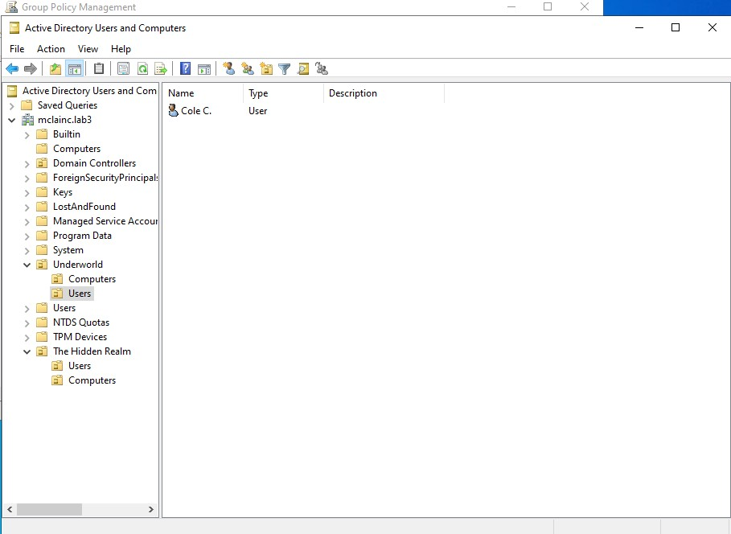

Section 2: Configuring Group Policies (8 points)

Create three Different Group Policies:
- GPO 1: Apply to the 1st OU
  - Add various group policies
- GPO 2: Apply to the 2nd OU
  - Add various group policies
- GPO 3: Apply to both OUs
  - Modify Password Options
Insert Screenshot of groups policies.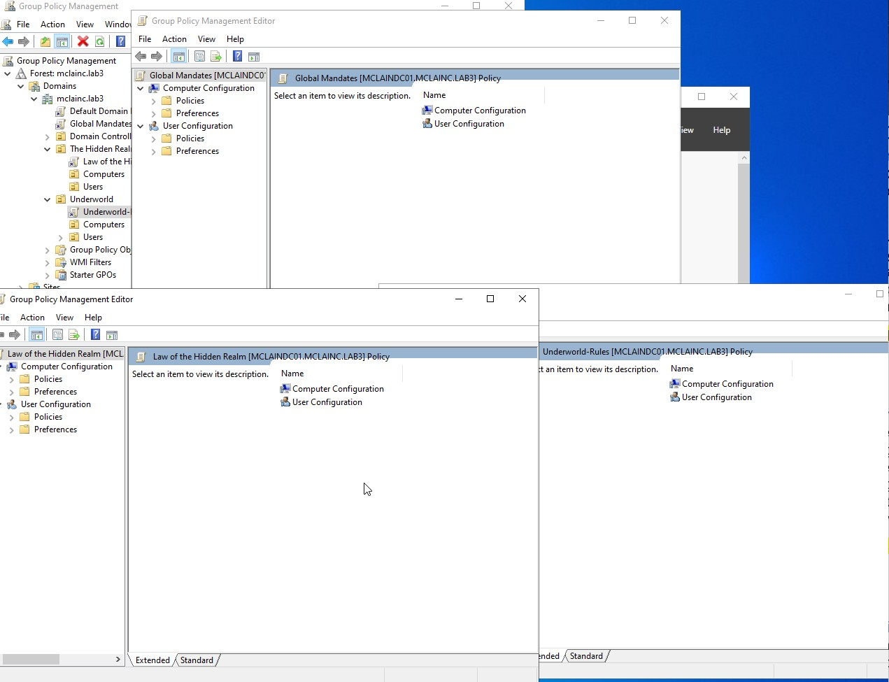

Section 3: Testing & Verification (5 points)

Verify Group Policy Application:
  - On your client machine.
  - Log in with your username with your name.
  - Use gpresult /h gpresults.html to confirm that the policies are applied correctly. Suggest changing directory to your desktop to easily find file.
  - Open the resulting file and find the information on the updates you added.
  - Note for screenshots ensure that they are legible. Use snips instead of full screenshots. Should be able to see all three GPOs.
Insert Screenshots from client of results. 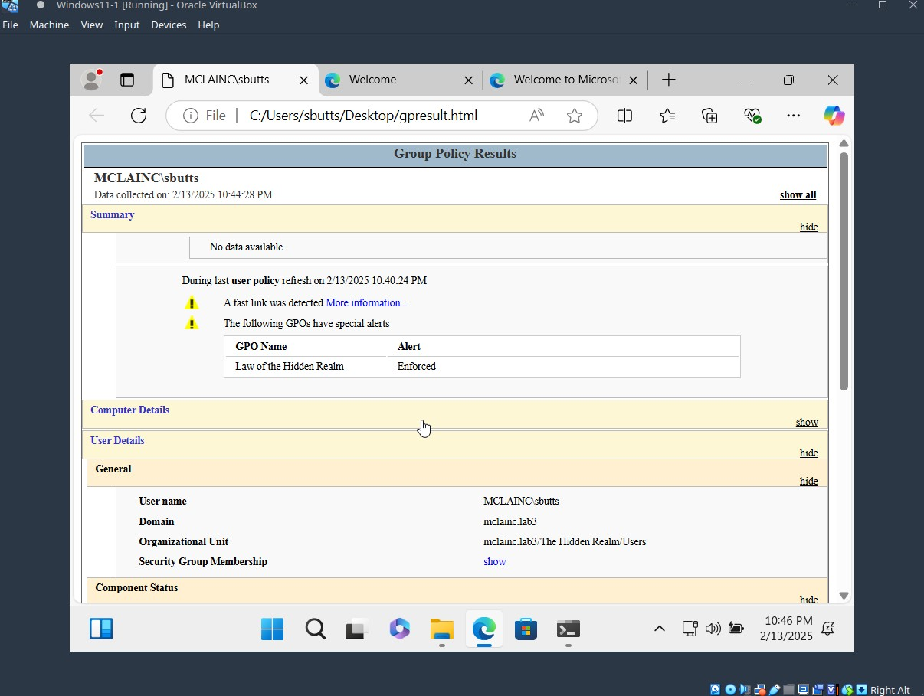

Section 4: Explanation (5 points)
- What is Group Policy, and what is its primary purpose in a Windows Server environment?
Ans: Group Policy is a tool that allows administrators to control many aspects of user experience on a network, from blocking certain features of Windows to specifying password requirements.
- What does Block Inheritance do in Group Policy?
Ans: Block Inheritance prevents a certain policy object from inheriting properties of policy objects higher up in the hierarchy.
- How do Group Policy Objects (GPOs) help administrators manage user and computer settings?
Ans: GPOs help administrators by allowing them to apply settings to groups of objects. Different groups can be given different settings and settings can be inherited by parent groups too if needed.

Section 5: Turn into Moodle (2 points)
Save the completed document as a PDF. Name it as Lab5_YourlastnameFirstInitial.pdf. Be sure to have your name on the top line in this document. Upload to Moodle.

