CS 240W - Lab 6 – File Share Lab

Name: _Cole McLain___________________________________
Total Points: 25

Section 1: SMB (8 points)

Use Powershell to verify that File Server is installed.
- Send the following command into Powershell on your Windows Server 2022
  - Get-WindowsFeature | Where-Object { $_.Name -match "FS-" }
Insert Screenshots showing File Server is installed. (2 points)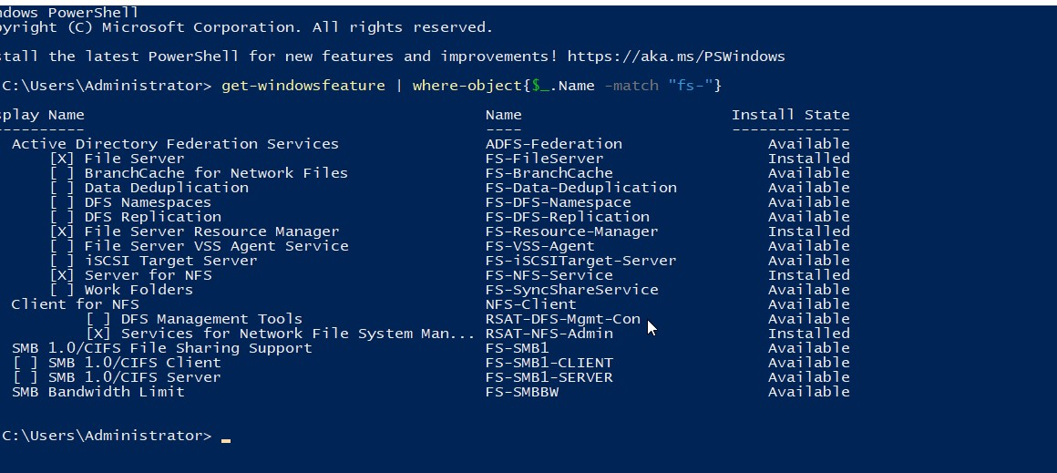

NOTE: This image shows that all file services are installed for the other 2 screenshot requests regarding installing file servers

Create an SMB Share
- Create 2 groups called Lab6rw in one of the OUs you created last week and Lab6ro in the other. Add a user into each of those groups.
- Create a folder with Lab6 and your initials example: C:\Lab6-JG.
- Share the folder. Add both groups giving the group Lab6rw both read and write capabilities and the one Lab6ro only read only.
Take a screenshot showing the shared folder in Server Manager > File and Storage Services > Shares. (2 points)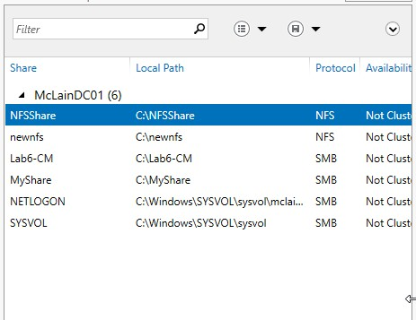

Access the share from Client Machine
- On a different Windows client, open File Explorer and access the share using \\<Server-IP>\<sharename>. Ex: \\goudreauj\ServerShare
- Take 2 screenshots of the client showing on the properties of server share folder of each group with their permissions. (4 points)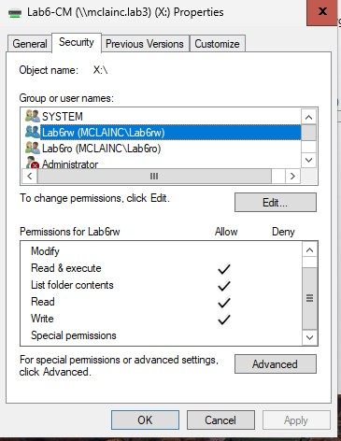

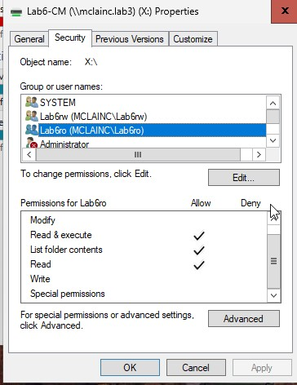

Section 2: NFS (5 points)
(Note: In File and Storage Services -> File and iSCSI Services -> Server for NFS
- Send the following command into Powershell on your Windows Server 2022
  - Get-WindowsFeature | Where-Object { $_.Name -match "FS-" }
Insert Screenshots showing File Server is installed. (2 points) SHOWN ABOVE

Create a NFS Share
- Create a folder with Lab6NFS and your initials example: C:\Lab6NFS-JG.
- In the Shares section in Server Manager create a new NFS Share – Quick. Add both groups giving the group Lab6rw both read and write capabilities and the one Lab6ro only read only.
Take a screenshot showing the shared folder in Server Manager > File and Storage Services > Shares. Be sure to include Protocols. (3 points)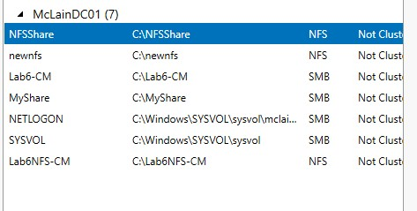

Part 3: Configuring FSRM (5 Points)

Install File Server Resource Manager (FSRM)
- Send the following command into Powershell on your Windows Server 2022
  - Get-WindowsFeature | Where-Object { $_.Name -match "FS-" }
Insert Screenshots showing File Server is installed. (2 points) SHOWN ABOVE
Set a Quota on a Folder
- Modify the 100MB limit to 100KB.
- Apply the quota to the SMB share folder created in Section 1.
- Try to add a file that is larger than 100k on the client to the folder.
Implement File Screening (Block MP3 Files)
- Prevent MP3 files from being stored in SMB share folder created in Section 1.

- What happens when you attempt to add a large file or a MP3 file to the SMB folder? Expectations vs reality (3 points)
Ans:
When trying to upload a document larger than 100kb, I was told there isn’t enough space on the drive for the file. For the mp3 file (though I did cheat and just change the file extension of a text file to mp3. My client VM has no space available so I couldn’t download one.), I was told I need permission to perform the action.
I was expecting to be given specific error messages explaining why the upload was blocked, so it was surprising to see such vague, roundabout reasons.

Section 4: Research (5 points)
- What are the security risks associated with file sharing in Windows Server 2022, and how can they be mitigated?
Ans: Some security risks include:
- Improper use of permissions allowing users to see info they shouldn’t. Mitigated by verifying permissions are configured correctly.
- Using weak, easily guessed passwords. Mitigated by enforcing the use of strong passwords on a network
- If a file with malware is uploaded to the file server, much damage could be caused to the server or anyone else who downloads the file. Mitigated with anti-virus software and ensuring the network is hardened against outside attackers
- Vulnerabilities present due to outdated software. Obviously mitigated by updating as security patches are rolled out.

- With the increasing shift toward cloud technology, what are the benefits and challenges of using cloud environments for file sharing and data accessibility?
Ans: The benefits of using cloud storage is that a lot of storage can be had for relatively little cost and, considering you’re purchasing the service from a dedicated provider, security and redundancy should be reliable. Conversely, reliance on another company for the security of your files may be a negative too. Also, you have less control over the file sharing service if using cloud storage and rely on an internet connection to reach the files.

Section 5: Turn into Moodle (2 points)
Save the completed document as a PDF. Name it as Lab6_YourlastnameFirstInitial.pdf. Be sure to have your name on the top line in this document. Upload to Moodle.

