CS 240W - Lab 8 – Backups and Disaster Recovery

Name: _____Cole McLain_______________________________
Total Points: 25

Windows Server Backup (15 points)
Use your Windows Server 2022 virtual machine to complete the following tasks.
Part 1: Install Windows Server Backup: (2 points)
- In the Server Manager, click on Add roles and features.
- Click Next through the wizard until you reach the Select features screen.
- Scroll down and check the box for Windows Server Backup.
Insert Screenshots showing Windows Server Backup is installed.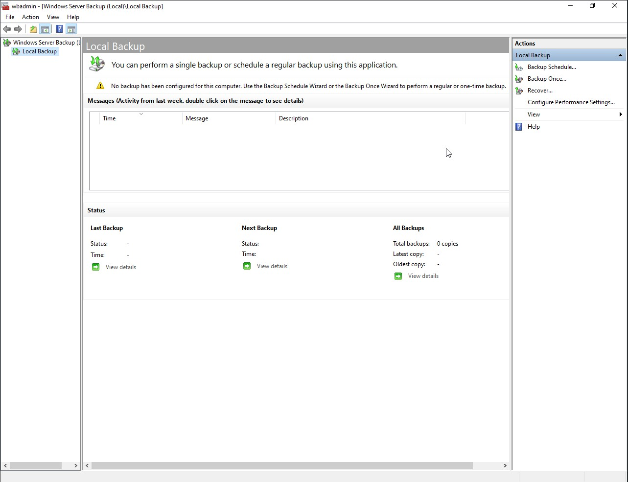
Part 2: Prep for backing up: (2 points)
- Before you begin the backup, in your share folders from the last lab, add a text file. Make sure you make some content inside the file. You can put your favorite quote in it, a listing of the files on your server, or gibberish, anything you want. Just have some data in the file.
Insert Screenshots of the content of your file. 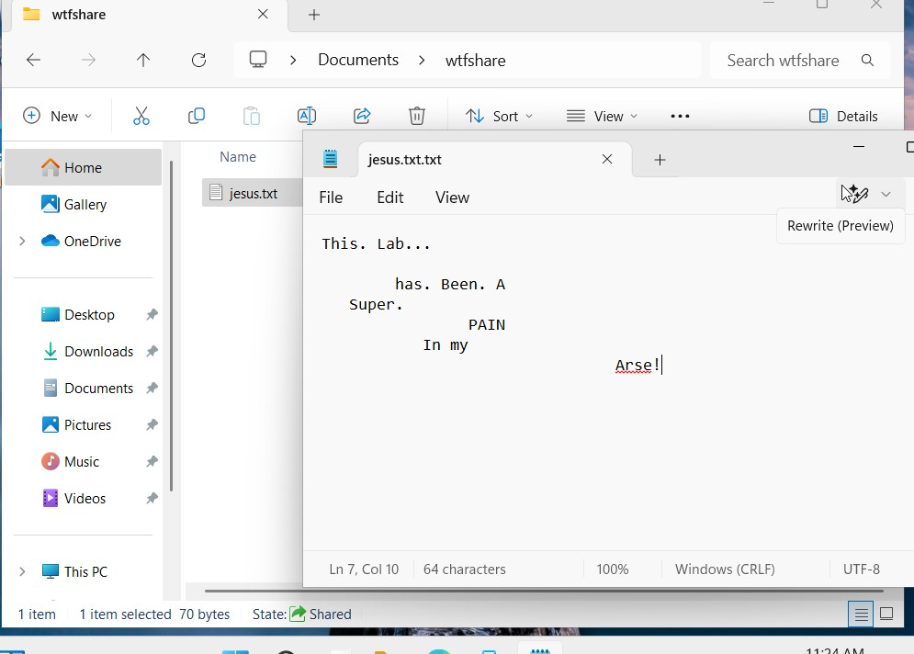
- On your Windows 11 client machine create a shared drive and share it with the administrator on the Server 2022 machine.
- Insert Screenshots of Windows Explorer of the file on your Windows 11 client.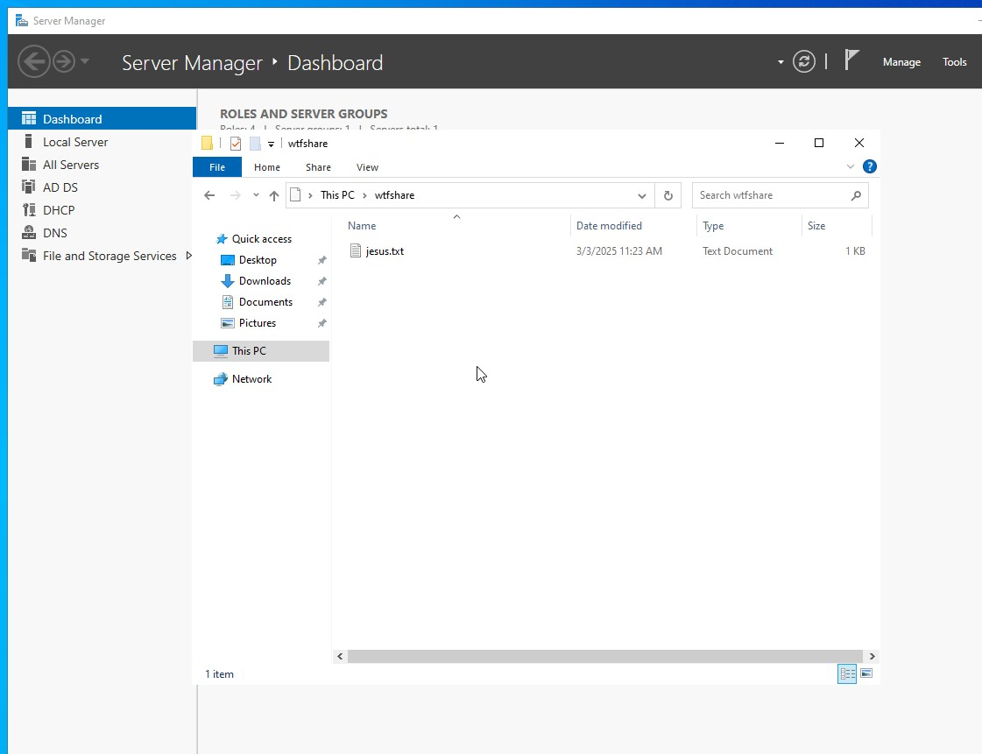
Part 3: Creating an Initial Backup (4 points)
- Open Windows Server Backup:
  - From the Start menu, search for Windows Server Backup, and launch the application.
- Select Backup Options:
  - In Windows Server Backup, click on Backup Once in the right panel.
  - Select Different options.
  - Choose Custom backup configuration, and click Next.
- Select Items to Back Up:
  - Under the Select Backup Configuration screen, click on Add Items.
  - Choose Files and Folders and browse to select the shared files or folder you wish to back up.
  - After selecting the shared folder, click OK.
- Specify Backup Location:
  - For Backup Destination, choose Remote shared folder.
  - Select Windows 11 folder share from Part 2.
  - Click Next and then Backup to start the backup process.
Insert Screenshots of Windows Server Backup of the share. 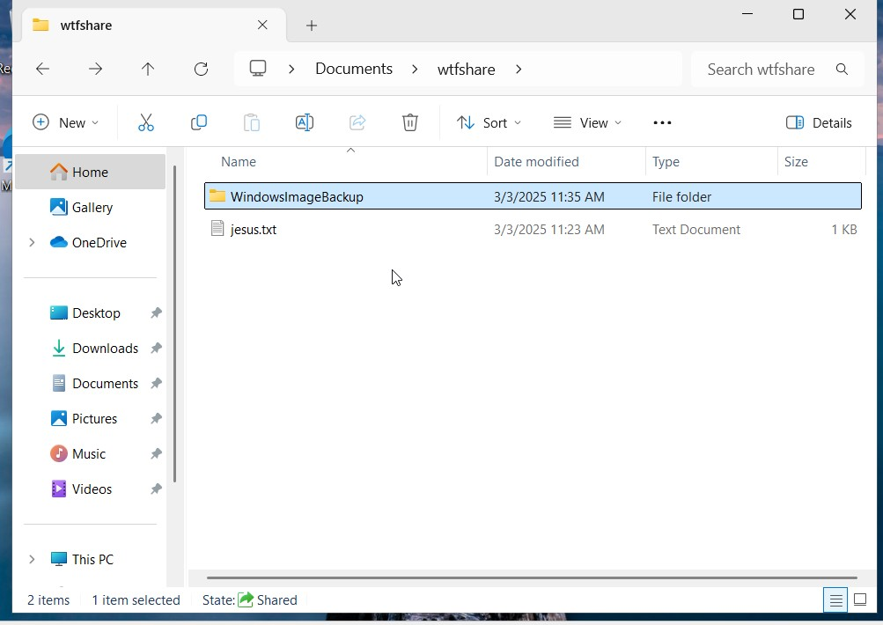
Part 4: Create a Scheduled Backup: (4 points)
- In Windows Server Backup, click Backup Schedule on the right panel.
- Choose Next to begin the backup schedule configuration.
- Select Custom to configure the backup of shared files or folders, just as you did for the initial backup.
- Set a desired schedule for when you want this backup to run. You can select options like Daily, Weekly, or Monthly. Choose a time that best fits your organization's needs.
- For Backup Destination, choose the Remote shared folder from Part 2.
- Click Next, review your configuration, and click Finish to set the scheduled backup.
Insert Screenshots of Scheduled Backup Windows Server Backup of the backup. 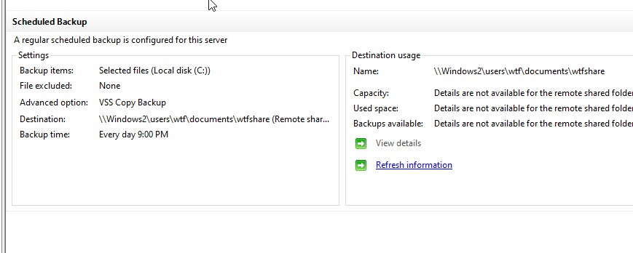
Part 5: Recovering the File from Backup (3 points)
- Select Recovery Options:
  - In the Windows Server Backup window, click on Recover in the right panel.
- Choose the Backup Location:
  - Select the Backup Once or Backup Schedule where you stored the backup.
- Choose the Date and Time of the Backup:
  - You will see a list of backups. Choose the one you performed earlier (the initial backup you made of the shared files).
- Select the Item to Recover:
  - In the recovery options, choose Files and Folders.
  - Browse through the backup and select the file(s) or folder(s) you wish to recover.
- Choose the Destination for Recovery:
  - When asked for the Recovery Destination, select Alternate location to specify Documents as the alternate recovery destination.
- Complete the Recovery Process:
  - Review your selections and click Recover to begin the restoration process.
  - Wait for the recovery process to complete.
- Verify the Recovery:
  - Open File Explorer and navigate to your Documents folder.
  - Verify that the file you recovered from the backup is now in your Documents folder.
Insert Screenshots of recovered file in Documents.

Section 4: Research (8 points)
- In your own words, explain the purpose of a disaster recovery plan. Why is it important for businesses, and what key elements should it include?
Ans: The purpose of a disaster recovery plan is to, as the phrase states, allow a business to recover lost data in the event of a disaster that affects some device(s). A good plan should include preventative measures, such as following best security practices, monitoring the network, and backing up critical information. It should also include processes to detect when unwanted activity is happening so that reaction to a potential disaster can be swift. Lastly, it should include instructions on performing backups and recovering data should a disaster hit.
- How often should a backup be performed for critical business data, and how do you determine this frequency?
Ans: Backups should be performed at least once a day for critical business data, possibly multiple times per day depending on the data. Determining the frequency of backups depends on how often the data is changed. Frequently changed data should be backed up more frequently.
- Explain the difference between business continuity and disaster recovery. How do these concepts work together in an organization's overall resilience plan?
Ans: Business continuity is a wide-reaching plan for keeping business operations running during a catastrophe. Disaster recovery focuses on restoring infrastructure and data to a normal state following disaster. These two work together in an overall resilience plan by covering two different stages in a disaster; continuity for during the event, disaster recovery for after an event.
- What are some of the challenges that could prevent a successful recovery after a disaster, and how can they be mitigated during the planning phase?
Ans: Most of the challenges preventing successful recovery involve neglecting certain aspects of a good disaster recovery plan. This could involve failing to focus on prioritizing assets that would need recovering, improper security policies, not focusing on prevention techniques or testing, or failing to backup important data. These can be mitigated during the planning phase by ensuring all aspects have been covered, perhaps having a checklist of items that need addressing.

Section 5: Turn into Moodle (2 points)
Save the completed document as a PDF. Name it as Lab8_YourlastnameFirstInitial.pdf. Be sure to have your name on the top line in this document. Upload to Moodle.

