CS 240W - Lab 1 - Windows Servers
Name: ____________________________________

Section 1: Definitions and Concepts (5 points)
Explain the difference between a Windows Server and a regular desktop operating system (e.g., Windows 11).
Ans. | A Windows server is intended to provide services to multiple clients. A desktop OS is intended to provide an environment for a single user.

Section 2: Server Roles and Features (5 points)
Pick two Windows Server types and explain their purpose.
Ans. | I’m not sure if the question is asking different servers in general or specific Windows types. I’m going to answer the former: a file server is intended to allow clients to share files on the server. A web server is intended to provide access to html pages on a web site. Please let me know if I’ve answered incorrectly and if I can fix it!

Section 3: Client-Server Interaction (5 points)
Explain the client-server model in your own words.
Ans. | The client-server model involves servers, which provide access to services to many computers known as clients, which are machines that serve one user at a time.

Section 4: Virtual Machine (8 points)
Create a Windows Server 2022 Desktop Virtual Machine.
Update the server’s name to be your last name. Note: This will require you to reboot your server.
Screen Print of Local Server screen displaying your name.
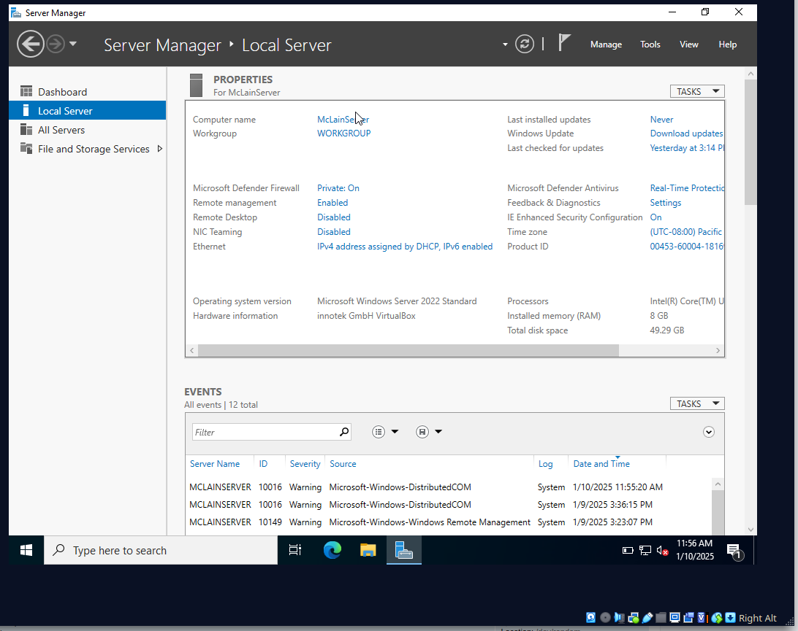

Section 5: Turn into Moodle (2 points)
Save the completed document as a PDF. Name it as Lab1_YourlastnameFirstInitial.pdf. Be sure to have your name on the top line in this document. Upload to Moodle.

