Exercise 1

An agent may have many customers.
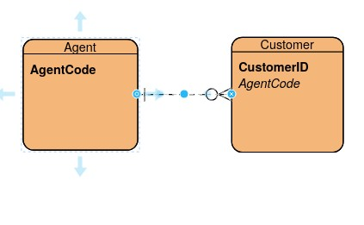

Exercise 2

One region can have many stores. A store belongs to one region.
An employee belongs to one store A store can belong to many employees.
A store can have many jobs. A job belongs to one store.
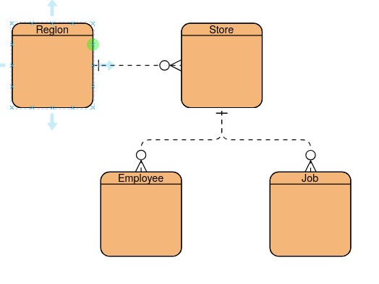

Exercise 3
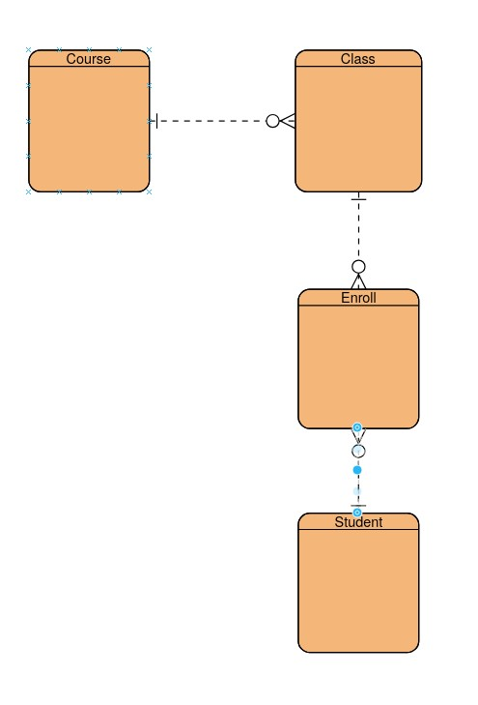

Exercise 4

Part 1:

A patient can have many orders. An order has one patient

An order can have many medications. A medication has one order.

