Cole McLain
Foundation Module 4 Labs
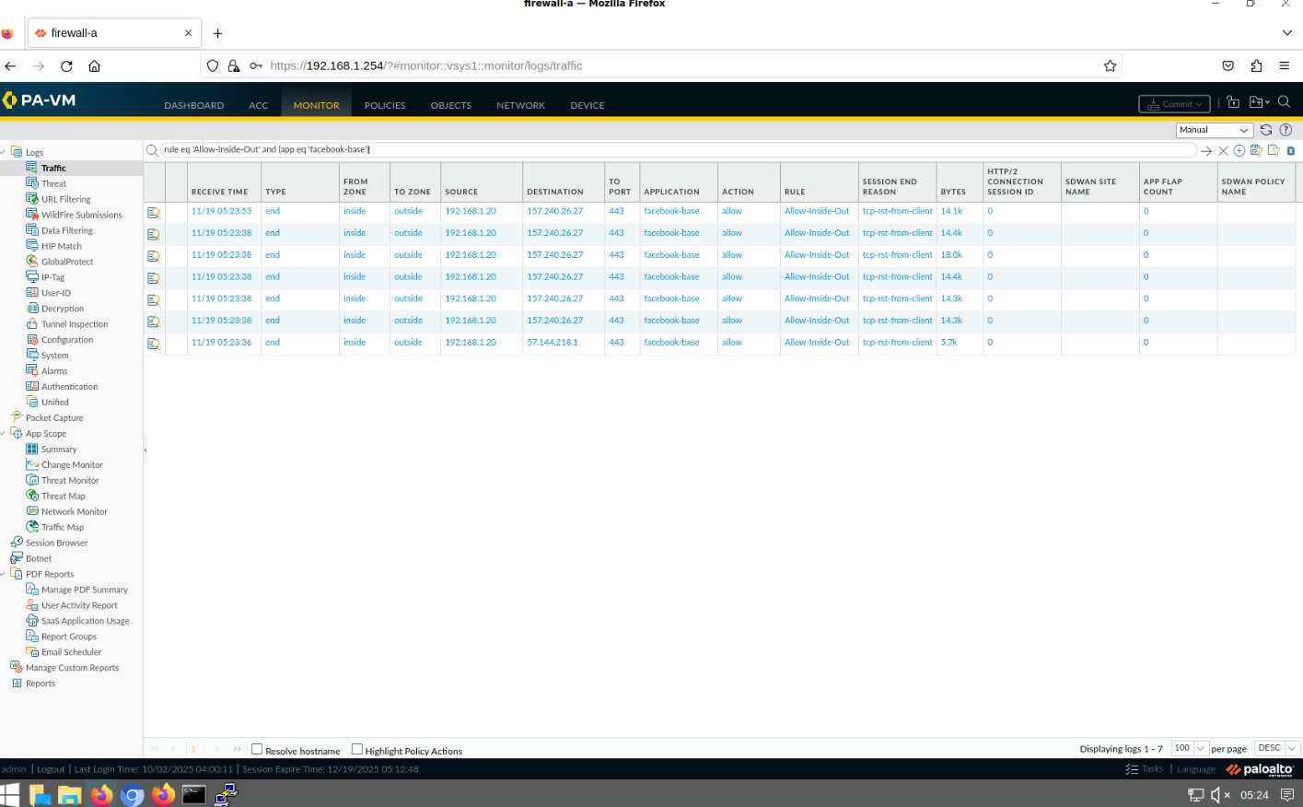
How fun!

