Deliverable 3.5
Implementation of the Platform for Monetary Claim Procedures

Project Name | Digitalising European Uncontested Claims Enforcement
Grant Agreement No. | 101138437
Call | JUST-2023-JCOO
Start date | 1 April 2024
Duration | 24 months
Work Package | WP3 - Simplification and Digitalisation of the Enforcement Procedures
Deliverable Number | D3.5
Deliverable Title | Implementation of the Platform for Monetary Claim Procedures
Type | OTHER - Software Platform
Dissemination Level | PU - Public
Lead Beneficiary | UNINA - Universita degli Studi di Napoli Federico II
Contractual Date | Month 24 (March 2026)

'Funded by the European Union. Views and opinions expressed are however those of the author(s) only and do not necessarily reflect those of the European Union or the European Commission. Neither the European Union nor the granting authority can be held responsible for them.'

Document Information
Project short name | DEUCE (101138437)
Work package | 3
Number | D3.5
Title | Implementation of the Platform for Monetary Claim Procedures
Type | OTHER
Dissemination level | PU
Contractual date | March 2026

Document History
Version | Date | Status | Authors, Reviewers | Description
v 0.01 | 15.09.2025 | Draft | A: F. Amato, A. Moccardi [UNINA] | Initial structure
v 0.02 | 20.11.2025 | Draft | A: F. Amato, R.C. Ghosh, M. Fonisto [UNINA] | Architecture and backend
v 0.03 | 10.01.2026 | Draft | A: F. Amato [UNINA] R: M. Giacalone [VUB] | Frontend, blockchain
v 0.04 | 25.02.2026 | Draft | A: F. Amato, F. Moscato [UNINA] R: A. Bojarchuk, T. Hoffmann [TalTech] | Validation
v 1.0 | 15.03.2026 | Final | A: F. Amato [UNINA] R: M. Giacalone, S. Picariello [VUB] | Final revision

Table of Contents
1. Introduction
2. Requirements Elicitation and Analysis
2.1 Stakeholder Interviews and User Research
2.2 Use Cases and Scenarios
2.3 Functional Requirements
2.4 Non-Functional Requirements
3. Platform Architecture and Technology Stack
3.1 Three-Container Sidecar Architecture
3.2 Dual Database Design
3.3 Technology Stack
4. Domain Model
4.1 Core Entities and Relationships
4.2 State Machines and Lifecycle Management
5. Backend Implementation
5.1 Claims Management
5.2 Enforcement Instruments
5.3 Document Management
5.4 Cryptographic Key Management
5.5 Event Service and Unified Timeline
6. Blockchain Integration
6.1 Raft Consensus and Finite State Machine
6.2 Block and Transaction Processing
6.3 Blockchain Explorer and Verification
7. Frontend Implementation
7.1 EU Standardised Forms (Forms A-D)
7.2 Enforcement Workflow Interface
7.3 Document and Blockchain Interfaces
7.4 Internationalisation and Accessibility
8. Authentication, Authorisation, and Security
8.1 Authentication Mechanisms
8.2 Role-Based Access Control
8.3 Data Protection and GDPR Compliance
9. Deployment and Infrastructure
10. Integration Testing and Validation
10.1 Testing Strategy
10.2 Stakeholder Validation
11. Conclusions and Future Work

1. Introduction
This deliverable documents the implementation of the DEUCE platform for monetary claim procedures, corresponding to Task 3.5 of Work Package 3. The platform represents the culmination of the technical development activities carried out under WP3, integrating the workflow design (D3.1), the system architecture (D3.2), the intelligent interface components (D3.3), and the validation activities (D3.4) into a fully operational web-based system.
The DEUCE platform addresses the critical gaps identified in the enforcement of European Enforcement Order (EEO) and European Order for Payment (EOP) judgments across the 26 EU Member States (excluding Denmark). As established in the project proposal and confirmed through the Comprehensive Roadmap (WP2), creditors, lawyers, and bailiffs face significant obstacles when attempting to enforce cross-border monetary claims due to fragmented national enforcement rules, lack of digitalisation, and insufficient awareness of the applicable procedures.
The platform is engineered as a modular, secure, and scalable web application deployed on the cloud and accessible from any device without installation. It integrates three core pillars: a workflow engine that guides users through the enforcement procedure step by step, a blockchain-based audit trail that guarantees data integrity and traceability, and a document management system that ensures secure storage and verification of all claim-related documentation.
This document is organised as follows. Section 2 presents the requirements elicitation process. Section 3 describes the platform architecture and technology stack. Section 4 introduces the domain model through a UML class diagram. Sections 5 and 6 detail the backend and blockchain implementation. Section 7 covers the frontend. Section 8 addresses security and GDPR compliance. Section 9 describes deployment infrastructure. Section 10 presents the testing and validation strategy. Section 11 concludes with future directions.

2. Requirements Elicitation and Analysis
The requirements elicitation process followed a systematic approach combining stakeholder interviews, use case analysis, and scenario-based design. This process was conducted in close collaboration with all consortium partners, and particularly with the legal unit partners (VUB, VU, UniZg, UL, UB) and the supporting entities (Adiconsum, EUBF, FBE, ZEV) who provided direct access to end-users and legal practitioners across the European Union.

2.1 Stakeholder Interviews and User Research
The requirements gathering phase involved structured interviews with representatives from each category of target users identified in the project proposal. Interviews were conducted with creditors and consumer association representatives from multiple Member States to understand the practical difficulties encountered when attempting to enforce EEO and EOP judgments in foreign jurisdictions. Legal practitioners, including lawyers from the FBE network and bailiffs from the EUBF, provided detailed insights into the procedural requirements and information gaps that hinder effective cross-border enforcement. Notaries, as issuing authorities for authentic instruments, contributed their perspective on the certification process.
The interview methodology followed a semi-structured approach, allowing interviewers to explore specific themes while maintaining comparability across jurisdictions. Key findings from the interview process included the following: the need for a centralised and reliable information source on national enforcement rules across all 26 Member States; the requirement for step-by-step procedural guidance that adapts to the selected enforcement jurisdiction; the critical importance of multilingual support for cross-border cases; the necessity of secure document exchange with verifiable integrity guarantees; and the consistent demand for transparent tracking of enforcement proceedings from initiation to conclusion.
In addition to formal interviews, the consortium conducted informal consultations during the national webinars organised under WP5, which provided valuable feedback from a broader audience of practitioners and end-users. The webinar participants confirmed the interview findings and highlighted additional usability requirements, particularly regarding the complexity of the official EU forms and the need for guided form completion with contextual explanations.

2.2 Use Cases and Scenarios
Based on the stakeholder interviews and the findings from the Comparative and Analytical Study of Best Practices (D2.1), the development team identified and documented the primary use cases. These were validated against the workflow definitions established in D3.1 and against the data collected in the Roadmap (D2.2) to ensure alignment between the business process model, the national enforcement rules, and the technical implementation.
The core use cases include: (UC1) a creditor initiating an EEO enforcement procedure by creating a claim, registering the debtor as participant, attaching supporting documentation, and selecting the enforcement Member State; (UC2) a lawyer preparing an EOP application by completing the standardised EU Form A with guided step-by-step assistance; (UC3) a court authority issuing a European Order for Payment through Form B; (UC4) a creditor requesting a review of an EOP through Form C; (UC5) an authority certifying an EEO through the official certification workflow using Form D; (UC6) a creditor tracking the status of their enforcement instrument through the platform dashboard with real-time notifications; (UC7) an auditor verifying the integrity of the complete enforcement trail through the blockchain explorer; and (UC8) an external system importing an orphan enforcement instrument for integration with the platform workflow.

2.3 Functional Requirements
The functional requirements derived from the elicitation process were organised into five principal categories, aligned with the platform components defined in the system architecture (D3.2):
- Claims Management: The platform shall enable the creation, tracking, and complete lifecycle management of monetary claims, including participant registration (creditors and debtors), claim review and validation, acceptance by authorised personnel, and assignment to the appropriate enforcement procedure. The system shall maintain a complete audit trail of all claim state transitions.
- Enforcement Instruments: The platform shall support the creation and management of both EEO and EOP enforcement instruments, with dedicated workflows for certification (EEO) and modification (EOP), following the official EU form structure. The system shall support orphan instruments imported from external judicial systems.
- Document Management: The platform shall provide secure upload, storage, retrieval, and verification of all claim-related documentation, with automatic blockchain anchoring for integrity assurance. Documents shall be associated with specific claims and enforcement instruments.
- Blockchain Audit Trail: All significant events in the claim lifecycle shall be recorded on an immutable distributed ledger with cryptographic verification, ensuring transparency and non-repudiation throughout the cross-border enforcement process.
- User Interface: The platform shall provide a user-friendly, multilingual web interface that guides users step by step through the enforcement procedure. The interface shall implement role-based access control, provide contextual help, and render the official EU forms in their standardised format.

2.4 Non-Functional Requirements
The non-functional requirements address the quality attributes essential for production use in a cross-border legal context:
- Scalability: The platform shall support horizontal scaling to accommodate growing transaction volumes across the 26 Member States. The architecture shall allow independent scaling of the frontend, authentication, and business logic layers.
- Security: All data in transit shall be encrypted using TLS. Sensitive data at rest shall be encrypted. The platform shall implement multi-factor authentication and role-based access control.
- GDPR Compliance: The platform shall implement data minimisation and pseudonymisation, particularly in the blockchain layer where the right to erasure must be reconciled with immutability. Personal data shall be stored only in the application database.
- Availability: The platform shall be deployed on cloud infrastructure with redundancy. The Raft consensus protocol shall ensure continued operation even in the presence of node failures.
- Interoperability: The platform shall expose well-documented RESTful APIs enabling integration with external systems, national judicial platforms, and the future e-CODEX infrastructure.
- Usability: The interface shall be accessible from any modern web browser without installation, responsive across devices, and available in at least three EU languages.

3. Platform Architecture and Technology Stack
The DEUCE platform implements the system architecture defined in Deliverable 3.2, realised as a three-container sidecar deployment with clearly separated concerns. Figure 1 illustrates the complete architectural backbone.
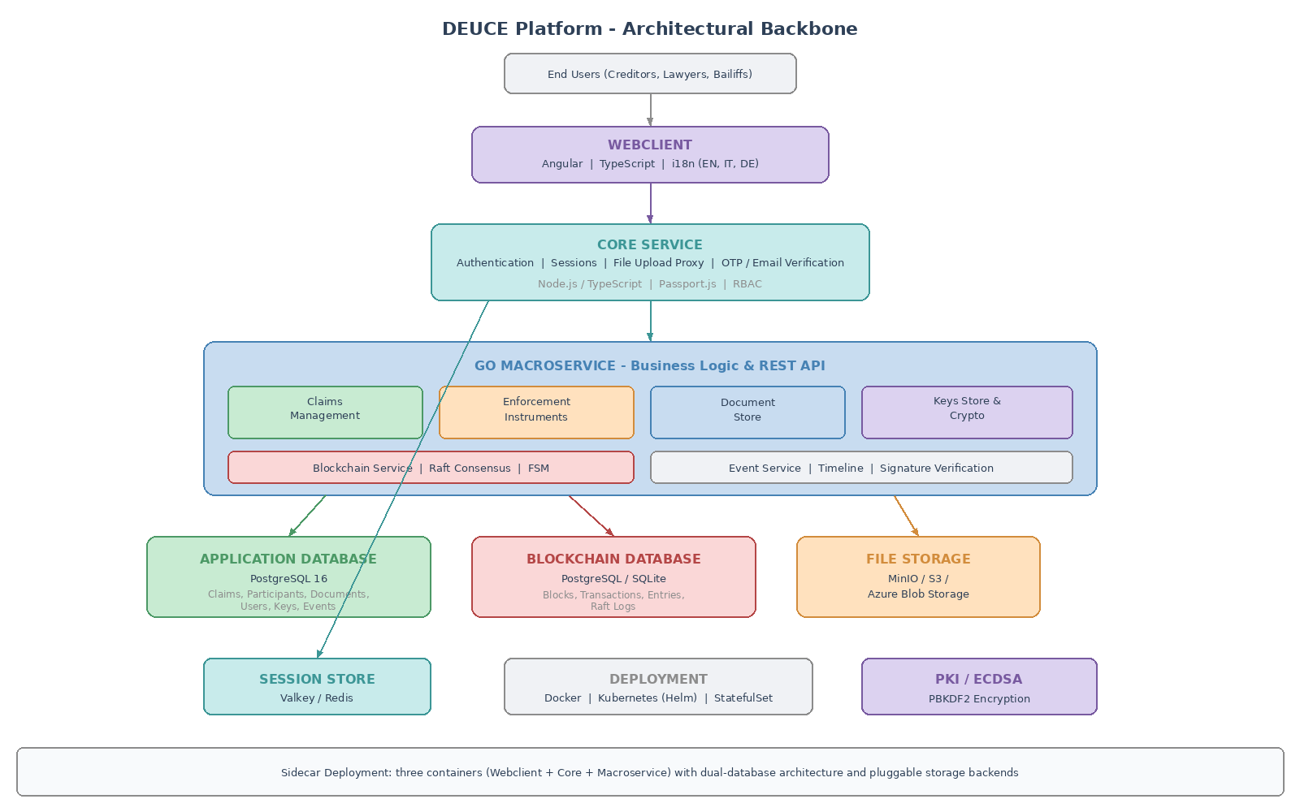
Figure 1: DEUCE Platform - Architectural Backbone

3.1 Three-Container Sidecar Architecture
The platform is deployed as three co-located containers that work together as a single logical unit. The sidecar pattern enables independent development, testing, and scaling while maintaining tight integration through well-defined internal interfaces.
- Core Service: Handles authentication, session management, user profile operations, file upload proxying to cloud storage, email verification with confirmation tokens, and OTP-based two-factor authentication. This service acts as the security gateway, validating all incoming requests before routing them to the business logic layer.
- Macroservice: Implements the complete business logic, the full REST API surface, the blockchain consensus engine, and all cryptographic operations. This service exposes four distinct functional domains: claims management, document store, keys store, and blockchain store.
- Webclient: Provides the user-facing interface as a single-page application served through a lightweight web server. The client communicates with the backend exclusively through the Core service, which proxies authenticated requests to the macroservice.

3.2 Dual Database Design
A distinctive architectural feature is the dual database design, separating application data from blockchain data into independent storage systems. The Application Database stores all business entities including claims, participants, enforcement instruments, document metadata, cryptographic keys, user accounts, roles, and event logs. It uses a relational database engine with full ACID compliance.
The Blockchain Database stores the immutable chain state including blocks, transactions, entries, and consensus logs. It supports two storage engines: a full relational database for production and a lightweight embedded database for demonstrations. This separation enables independent scaling, backup strategies, and retention policies for each data domain.

3.3 Technology Stack
The backend business logic layer is implemented in Go, chosen for its strong concurrency model and suitability for blockchain operations. The authentication service uses TypeScript on Node.js. The frontend uses Angular with TypeScript. Session management uses Valkey, a high-performance key-value store. File storage is abstracted through a pluggable interface supporting S3-compatible storage and Azure Blob Storage. The primary database is PostgreSQL 16, with SQLite as a lightweight alternative. The system is containerised with Docker and orchestrated through Kubernetes using Helm charts with StatefulSet deployments for blockchain consensus nodes.

4. Domain Model
This section presents the domain model of the DEUCE platform through a UML class diagram that captures the principal entities, their attributes, operations, and relationships. The domain model serves as the conceptual foundation for the backend implementation and database schema. Figure 2 presents the complete UML class diagram.
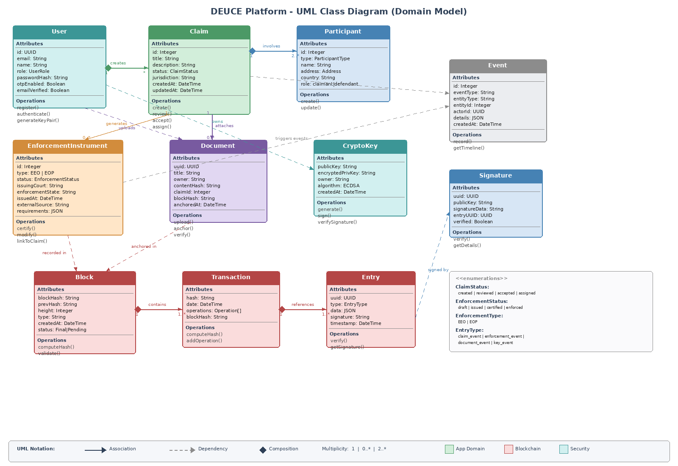
Figure 2: DEUCE Platform - UML Class Diagram (Domain Model)

4.1 Core Entities and Relationships
The domain model is organised around three principal layers, distinguished by colour coding in Figure 2: the application domain (green), the blockchain layer (red), and the security layer (teal). The central entity is the Claim, which represents a monetary claim initiated by a creditor against a debtor. Each Claim is created by a User and involves two or more Participants (at minimum a claimant and a defendant). Claims may have attached Documents and may generate one or more EnforcementInstruments of type EEO or EOP.
The Document entity represents any file uploaded to the platform in support of a claim or enforcement procedure. Each document is characterised by its content hash, computed at upload time and subsequently anchored to the blockchain for immutable integrity verification. The EnforcementInstrument entity models the two European enforcement mechanisms, each following a distinct lifecycle. The support for orphan enforcement instruments reflects the practical reality of cross-border enforcement where instruments may originate from external judicial systems.
The blockchain layer comprises three entities: Block, Transaction, and Entry. Blocks are linked through cryptographic hashes to form an immutable chain. Each block contains one or more transactions, and each transaction references one or more entries representing atomic domain events. The Event entity captures all platform activities and feeds the unified timeline that provides a comprehensive chronological view of all operations. The Signature entity links entries to their cryptographic verification data, enabling independent non-repudiation checks.

4.2 State Machines and Lifecycle Management
Two principal state machines govern the lifecycle of the core business entities. The Claim state machine progresses through four states: created, reviewed, accepted, and assigned. Each transition is triggered by an explicit user action and validated by the business logic layer.
The EnforcementInstrument state machine defines four states: draft, issued, certified, and enforced. For EEO instruments, the certification transition requires detailed certification information and digital signatures. For EOP instruments, the modification operation allows updates while in draft or issued status. Both state machines record every transition as a blockchain event, ensuring the complete history is permanently and verifiably recorded.
The CryptoKey and Signature entities form the security layer. Each user may generate ECDSA key pairs with private keys encrypted at rest. Signatures are recorded as blockchain entries, and the verification operation allows any party to independently confirm signature validity, providing non-repudiation guarantees essential for cross-border legal proceedings.

5. Backend Implementation
The macroservice constitutes the core business logic layer, implementing the domain model through four distinct functional domains, each protected by JWT-based authentication middleware.

5.1 Claims Management
The claims management module implements the complete lifecycle of monetary claims as defined in the BPMN workflow (D3.1). A claim progresses through the state machine described in Section 4.2, with each transition validated and recorded as a blockchain event. The module supports full operations on claims, participant management with batch processing, and lifecycle actions. The timeline service provides a unified chronological view aggregating all event categories.

5.2 Enforcement Instruments
The enforcement subsystem implements EEO and EOP instruments following the state machine in Section 4.2. For EEO, the platform supports certification as defined by Regulation No. 805/2004, with detailed certification information and digital signatures. For EOP, the modification workflow follows Regulation No. 1896/2006. The system supports orphan enforcement instruments that can be created independently and later linked to claims, accommodating instruments from external judicial systems.
The enforcement lifecycle is fully traceable through the event service. Every state transition generates an event that records the previous state, the new state, the actor who initiated the transition, and the timestamp. These events are immediately submitted to the blockchain service, ensuring that the complete enforcement history is immutably recorded. The blockchain entry associated with each enforcement event includes a reference to the enforcement instrument identifier, enabling any party to reconstruct the complete lifecycle of a specific EEO or EOP instrument by querying the blockchain explorer.
The platform also addresses the practical challenge of cross-border service of documents. When an enforcement instrument transitions from issued to certified status, the system generates a notification event that can be consumed by external notification services to inform the relevant parties in the enforcement Member State. This mechanism, while currently implemented as an internal event, is designed to be extended for integration with the e-CODEX communication infrastructure in future iterations of the platform.

5.3 Document Management
The document store provides secure lifecycle management with blockchain anchoring. Documents are uploaded through the Core service, with the macroservice creating metadata records including owner, claim identifier, and content hash. Asynchronous blockchain anchoring creates immutable integrity records. Retrieval supports filtering by owner and claim, with time-limited pre-signed download URLs ensuring authenticated access. The dashboard displays total, anchored, and pending document counts.

5.4 Cryptographic Key Management
The key management module implements ECDSA key pair generation with PBKDF2 encryption using 100,000 iterations and SHA-256. Signature verification integrates with the blockchain service, allowing independent verification of entries against public keys, providing non-repudiation guarantees for cross-border legal proceedings.

5.5 Event Service and Unified Timeline
The event service records all platform activities, persisting events in the application database while simultaneously submitting them to the blockchain. Events capture the type, entity reference, actor, detailed JSON payload, and timestamp. The unified timeline aggregates claim events, enforcement events, document events, and key events into a comprehensive chronological record essential for operational monitoring and regulatory compliance.

6. Blockchain Integration
The blockchain component implements a permissioned blockchain with Raft consensus, as specified in D3.2. Figure 3 illustrates the complete workflow from event capture to immutable block storage.
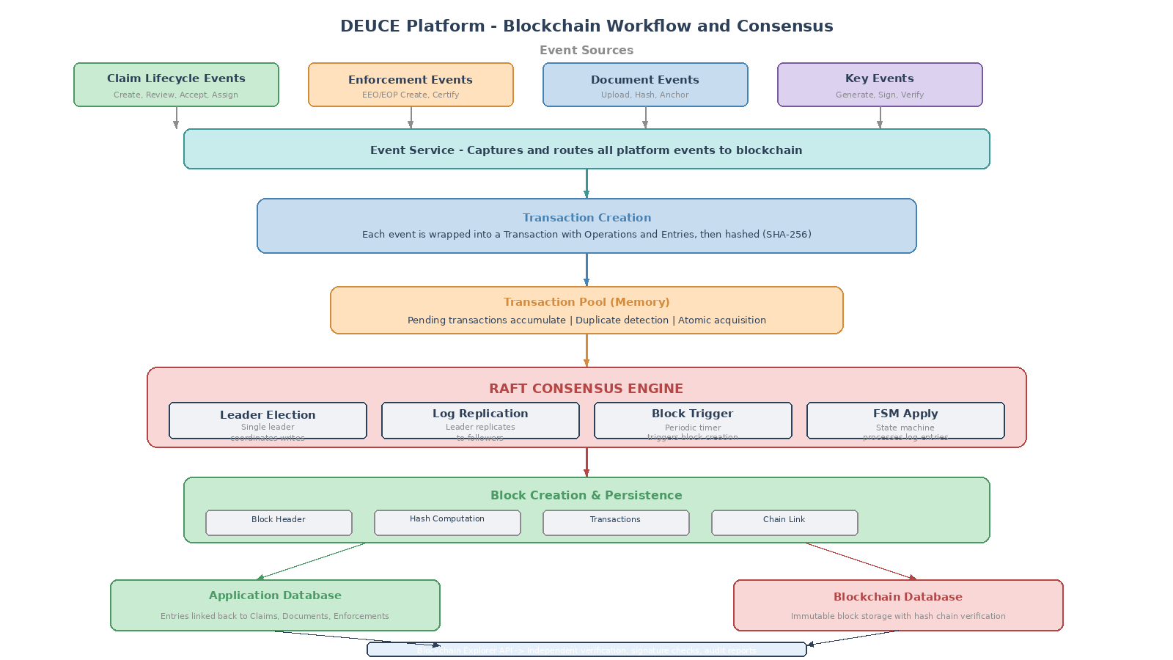
Figure 3: Blockchain Workflow and Consensus Mechanism

6.1 Raft Consensus and Finite State Machine
The consensus uses a custom Finite State Machine processing two log entry types: transaction logs adding to a memory pool, and block creation logs triggering aggregation into blocks. The Raft leader periodically triggers block creation at configurable intervals. The FSM maintains current blockchain state and supports snapshot and restore operations for node recovery and cluster membership changes.
When a transaction log arrives, the FSM computes the hash, checks for duplicates, and adds unique transactions to the pool. Block creation atomically acquires pending transactions, constructs the block with chain linkage, persists to the database, and updates internal state. Failure during persistence triggers automatic transaction pool restoration.
The choice of Raft over the Byzantine Fault Tolerant (BFT) protocol initially envisaged in D3.2 was driven by practical considerations for the DEUCE deployment context. In a permissioned environment where all participating nodes are operated by known and trusted consortium partners, the crash fault tolerance provided by Raft is sufficient while offering significantly better performance characteristics. Raft provides immediate transaction finality once a majority of nodes confirm the log entry, eliminating the possibility of chain reorganisation that could create uncertainty in legal proceedings. The protocol also offers well-understood leader election semantics, making operational management and debugging substantially simpler than multi-phase BFT protocols.
The multi-node deployment model enables the distribution of blockchain validation across different consortium partners, ensuring that no single organisation has unilateral control over the audit trail. Each Raft node maintains a complete copy of the blockchain, providing redundancy and enabling independent verification. The configurable block time parameter allows operators to balance between transaction latency and blockchain throughput based on the expected workload of the deployment.

6.2 Block and Transaction Processing
Block creation follows an atomic sequence: pool acquisition under lock, block header construction with sequential height and previous hash reference, transaction incorporation, SHA-256 hash computation over all contents, and atomic database persistence with rollback capability. Each transaction contains operations referencing entries that correspond to domain events. The dual database architecture prevents blockchain writes from contending with application queries.

6.3 Blockchain Explorer and Verification
The explorer provides read access for verification and auditing: individual block retrieval, paginated block listing, entry retrieval, cryptographic signature verification, and aggregate statistics. This powers the webclient explorer interface, enabling independent integrity verification of the enforcement trail. Signature verification is essential for cross-border scenarios where parties in different Member States need to confirm the authenticity of enforcement actions.

7. Frontend Implementation
The webclient provides the user-facing interface as a single-page application with modular architecture. Figure 4 illustrates the complete web application workflow from user entry to enforcement resolution.
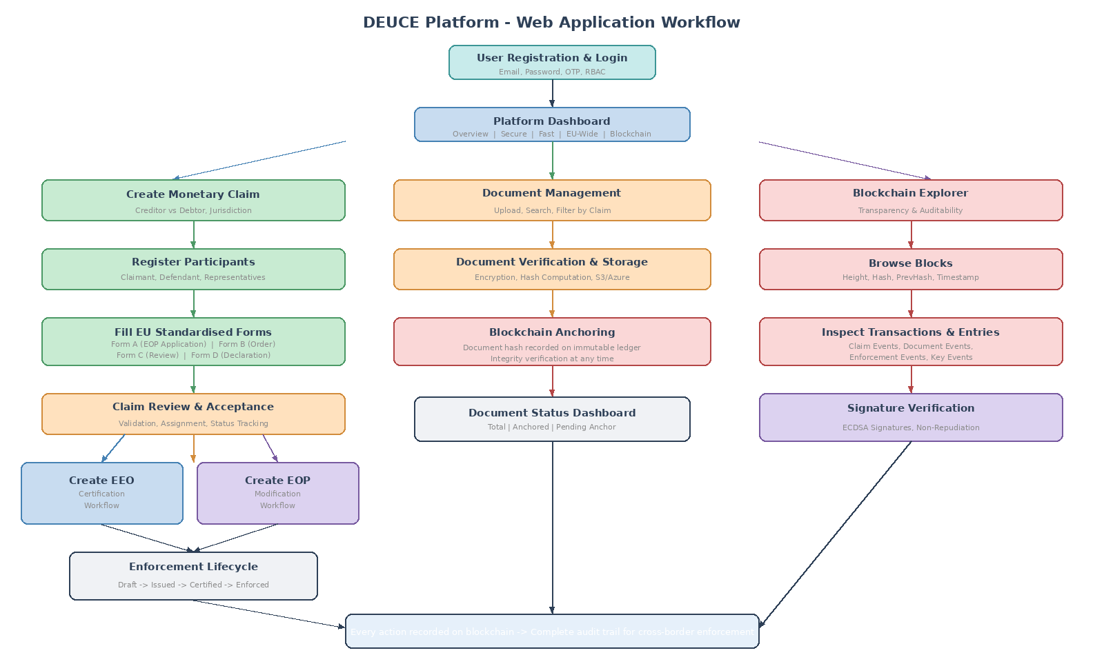
Figure 4: DEUCE Web Application Workflow

7.1 EU Standardised Forms (Forms A-D)
The largest frontend component is the digitalisation of official EU forms for EEO and EOP procedures, implemented as multi-step wizard interfaces. Form A (Application for European Order for Payment) covers claimant and defendant details, jurisdiction, claim description with amount calculations, and evidence. Form B captures the court's decision and payment terms. Form C handles the defendant's review application. Form D manages the enforceability declaration.
Each form includes comprehensive validation with real-time feedback, contextual legal explanations, jurisdiction-specific adaptations, preview functionality rendering in official EU format, and the ability to save partial progress. The forms constitute the largest portion of the frontend codebase, reflecting the complexity of the legal procedures they digitalise.
A particular challenge in the form digitalisation was the handling of jurisdiction-specific variations. While the EU Regulations define a standardised form structure, the actual procedural requirements differ across Member States, as documented in the Comprehensive Roadmap (D2.2). The form implementation addresses this through a data-driven approach where jurisdiction-specific rules and field requirements are configured externally, enabling the platform to adapt its form guidance based on the selected Member State without requiring changes to the form components themselves. This design decision ensures that the platform can incorporate updates to national enforcement rules as they are identified by the DEUCE Network, without requiring a new software release.
The preview functionality deserves particular attention as it was highlighted during stakeholder validation as one of the most valued features. Before submitting a completed form, users can view a rendered version that closely matches the official paper form layout. This enables legal practitioners to verify that all information has been correctly entered and formatted before the form is officially submitted to the system. The preview is generated entirely on the client side, ensuring that no incomplete or unvalidated data is transmitted to the server.

7.2 Enforcement Workflow Interface
The enforcement module uses a master-detail layout with a searchable, filterable list and a detailed view. Users create instruments through multi-step wizards (three steps for EOP, four for EEO). The detail view displays lifecycle status, associated claim and participants, linked documents, certification details, and complete event history. The certification panel allows EEO certification by authorised users, while the modification panel enables EOP updates.

7.3 Document and Blockchain Interfaces
The document module displays three metrics (total, anchored, pending), with search, filter, and upload capabilities. The blockchain explorer shows paginated blocks with height, status, hash, previous hash, timestamp, and contained transactions. Users navigate between blocks and inspect transactions and entries, with bidirectional traceability between the audit trail and application data.

7.4 Internationalisation and Accessibility
The platform supports English, Italian, and German, with structured translation files and runtime language switching. Coverage includes all interface elements, form labels, validation messages, status indicators, and contextual help. The architecture supports adding further languages through new translation files. The platform is responsive across desktop, tablet, and smartphone devices, ensuring accessibility for all stakeholder categories across Member States.

8. Authentication, Authorisation, and Security

8.1 Authentication Mechanisms
Authentication spans both the Core service and macroservice. The Core implements session-based authentication with PBKDF2 password hashing, optional OTP two-factor authentication, and email verification. Upon authentication, JWT tokens are issued for macroservice API access, validated through dedicated middleware on every protected request.

8.2 Role-Based Access Control
Authorisation follows an RBAC model with system roles initialised at startup. The webclient enforces client-side access control while server-side middleware ensures API-level authorisation. Users access only their own claims, documents, and enforcement instruments unless explicitly granted broader access through role assignment. Administrative functions are restricted to privileged roles.

8.3 Data Protection and GDPR Compliance
Data protection includes encryption of private keys with PBKDF2, TLS for data in transit, time-limited pre-signed document URLs, and GDPR-compliant blockchain pseudonymisation as described in D3.2, Section 4.5. The blockchain stores only hashes and non-personal identifiers on-chain. Personal data remains in the application database for proper erasure capability. When erasure is required, encryption keys linking blockchain references to individuals are destroyed, rendering on-chain references permanently unlinkable while preserving blockchain integrity.

9. Deployment and Infrastructure
The primary deployment target is Kubernetes with a Helm chart configuring all containers as a StatefulSet with persistent blockchain storage, configurable replicas for multi-node Raft consensus, and automatic cluster formation with leader election.
Docker Compose configurations support both full-stack deployment (relational database, session store, object storage) and lightweight demonstration mode (embedded database, no external dependencies). The platform supports horizontal scaling: stateless frontend and authentication containers scale independently, while the macroservice scales through Raft cluster membership. Storage is abstracted through pluggable backends enabling deployment on any major cloud provider.
The system includes comprehensive health check endpoints for container orchestration, database migration management with versioned migrations for both databases, and standardised build and deployment commands. The demonstration mode enables rapid setup for stakeholder demonstrations and testing, which proved essential during the validation activities documented in D3.4.
The infrastructure design also addresses the long-term sustainability requirements specified in the project proposal. The platform is designed to be maintainable by a small technical team, with clear separation of concerns that allows individual components to be updated independently. The use of widely adopted open-source technologies ensures that the knowledge required for maintenance is broadly available in the developer community. The Helm chart and Docker Compose configurations encode the complete deployment knowledge, enabling the platform to be redeployed in new environments without requiring deep expertise in the specific technology stack. This is particularly important for the post-project phase, where the platform will be maintained by the DIKE research team at VUB with periodic contributions from consortium partners.
The monitoring and observability strategy relies on structured logging across all three containers, with configurable log levels that enable operators to increase verbosity for debugging specific issues. Health check endpoints expose the status of all critical dependencies (databases, session store, file storage), enabling container orchestration platforms to automatically restart unhealthy containers. The blockchain statistics endpoint provides operational metrics including the current block height, transaction count, and chain integrity status, which can be integrated with external monitoring dashboards for production oversight.

10. Integration Testing and Validation

10.1 Testing Strategy
The validation strategy encompasses multiple levels aligned with D3.4. Unit tests cover the blockchain FSM, cryptographic operations, database operations, and API handlers, including race condition detection for thread safety in concurrent blockchain processing. Integration tests in a dedicated containerised environment verify end-to-end flows: complete claim lifecycle, document anchoring, key generation and signature verification, and Raft consensus including leader election and log replication.

10.2 Stakeholder Validation
Stakeholder validation followed the feedback process described in Milestone MS6: interactive questionnaires across target groups, detailed usage reports from structured testing sessions, one-to-one discussions with legal practitioners, user workshops during national webinars (WP5), and technical support session feedback. Validation confirmed that the platform meets requirements for usability, security, and functional completeness.
Specific feedback highlighted the value of step-by-step form guidance, the transparency of the blockchain explorer, and efficiency gains from centralised cross-border enforcement management. Areas for improvement, including form navigation refinements and additional contextual help for complex legal fields, were addressed through iterative development and incorporated into the final release.
The validation process also confirmed the appropriateness of the technology choices made during the architecture design phase. The three-container sidecar architecture demonstrated the expected benefits of independent scalability and development flexibility, with the frontend team able to iterate on form usability improvements without affecting the backend services. The dual database design proved valuable during testing, as the blockchain database could be reset independently during development cycles without losing application test data. The Raft consensus mechanism performed reliably across the test configurations, with block creation completing within the configured time intervals even under concurrent load from multiple simultaneous test sessions.
The Committee of External Professional Evaluators (CEPE), as established in WP1, provided an independent assessment of the platform against the EC DAC criteria of relevance, coherence, effectiveness, efficiency, impact, and sustainability. The CEPE evaluation confirmed that the platform implementation is consistent with the project objectives, that the technical approach is appropriate for the target users, and that the system architecture supports long-term sustainability through its modular design and use of widely adopted technologies.

11. Conclusions and Future Work
This deliverable documents the implementation of the DEUCE platform for monetary claim procedures, fulfilling Task 3.5 objectives within WP3. The platform integrates all components from the preceding deliverables: the workflow engine (D3.1), system architecture with blockchain components (D3.2), intelligent interface capabilities (D3.3), and validated testing framework (D3.4).
The platform delivers a complete digital solution addressing the three obstacles identified in the proposal: lack of digitalisation, through guided workflows and EU form digitalisation; lack of transparent enforcement data, through WP2 Roadmap integration; and lack of awareness, through the user-friendly multilingual interface that lowers access barriers to EEO and EOP enforcement procedures.
The platform is deployed as a web-accessible application that will remain available beyond the project end, hosted on VUB servers as specified in the sustainability plan. The complete source code, deployment configurations, and documentation provide a package for long-term maintenance by the DIKE research team at VUB.
Future directions include expanding the intelligent interface with advanced multilingual NLP capabilities leveraging WP2 legal corpora, integration with the e-CODEX infrastructure within the eu-LISA framework for national judicial system interoperability, extension of the blockchain network to include partner organisations as validator nodes, addition of further EU languages to the internationalisation framework with translations from DEUCE Network members, and ongoing adaptation to evolving regulatory requirements through the platform's modular architecture.
The expansion of the intelligent interface represents the most significant planned enhancement. As documented in D3.3, the semantic processing and machine learning pipeline has been designed to operate over the legal corpora assembled through WP2, comprising national enforcement rules, case studies, and best practices from all 26 Member States. The integration of this intelligent component into the production platform will provide users with context-aware guidance tailored to their specific cross-border enforcement scenario, including jurisdiction-specific procedural recommendations and identification of potential issues based on historical patterns. The human-in-the-loop validation mechanism ensures that the intelligent interface's recommendations remain aligned with current legal standards and practices, with legal professionals from the DEUCE Network providing ongoing feedback and annotation.
The integration with e-CODEX represents a strategic alignment with the broader European effort to digitalise cross-border judicial cooperation. The platform's RESTful API architecture and standardised data formats provide a natural integration surface for the e-CODEX communication infrastructure, which enables secure and authenticated exchange of judicial documents between Member State authorities. The planned integration would allow enforcement instruments created and certified on the DEUCE platform to be transmitted directly to the competent enforcement authorities in the target Member State, eliminating the current need for manual transmission and significantly reducing processing times.
From a governance perspective, the extension of the blockchain network to additional partner organisations strengthens the distributed trust model underlying the platform's audit trail. The current Raft consensus implementation supports dynamic cluster membership, allowing new validator nodes to be added without disrupting ongoing operations. Each participating organisation would operate its own validator node, contributing to the consensus process and maintaining an independent copy of the blockchain. This distribution of trust is particularly important in the cross-border context, where no single national authority should have exclusive control over the enforcement records that span multiple jurisdictions.

References
[1] DEUCE Project Proposal, Part B - Technical Description, Call JUST-2023-JCOO, 2023.
[2] D3.1 - Workflow for monetary claim procedure, DEUCE Project, 2024.
[3] D3.2 - System Architecture of the platform, DEUCE Project, March 2025.
[4] D3.3 - Semantic Processing and ML/DL procedures for the Intelligent Interface, DEUCE Project, 2025.
[5] D3.4 - Monitoring and evaluation of the validation activities, DEUCE Project, 2026.
[6] D2.1 - Comparative and Analytical Study of Best Practices, DEUCE Project, 2024.
[7] D2.2 - Roadmap for EU Enforcement Rules on EEO and EOP Judgments, DEUCE Project, 2024.
[8] Regulation (EC) No 805/2004 creating a European Enforcement Order for uncontested claims.
[9] Regulation (EC) No 1896/2006 creating a European order for payment procedure.
[10] COM(2021)759 final - Proposal for a Regulation on the digitalisation of judicial cooperation.
[11] HashiCorp Raft Consensus Protocol.
[12] General Data Protection Regulation (GDPR), Regulation (EU) 2016/679.

