Technology Stack
Technical Reference Document

Agentic Fact-Checking & Risk Intelligence Platform
Confidential — For Authorized Recipients Only

Core Technologies
FastAPI • Pydantic • Uvicorn
Ollama • Hugging Face Transformers • ChromaDB
PyPDF2 • pdfplumber • python-docx • faster-whisper
ReportLab • SQLite • Docker • Docker Compose

Date: February 2026
Version: 1.0

1. STACK OVERVIEW

This document provides a comprehensive technical reference for the technology stack powering the Agentic Fact-Checking & Risk Intelligence Platform. The stack is organized across five functional layers: API & Orchestration, Intelligence & RAG, Document Ingestion, Reporting, and Persistence. Every component is independently replaceable, ensuring long-term adaptability as the AI ecosystem evolves.
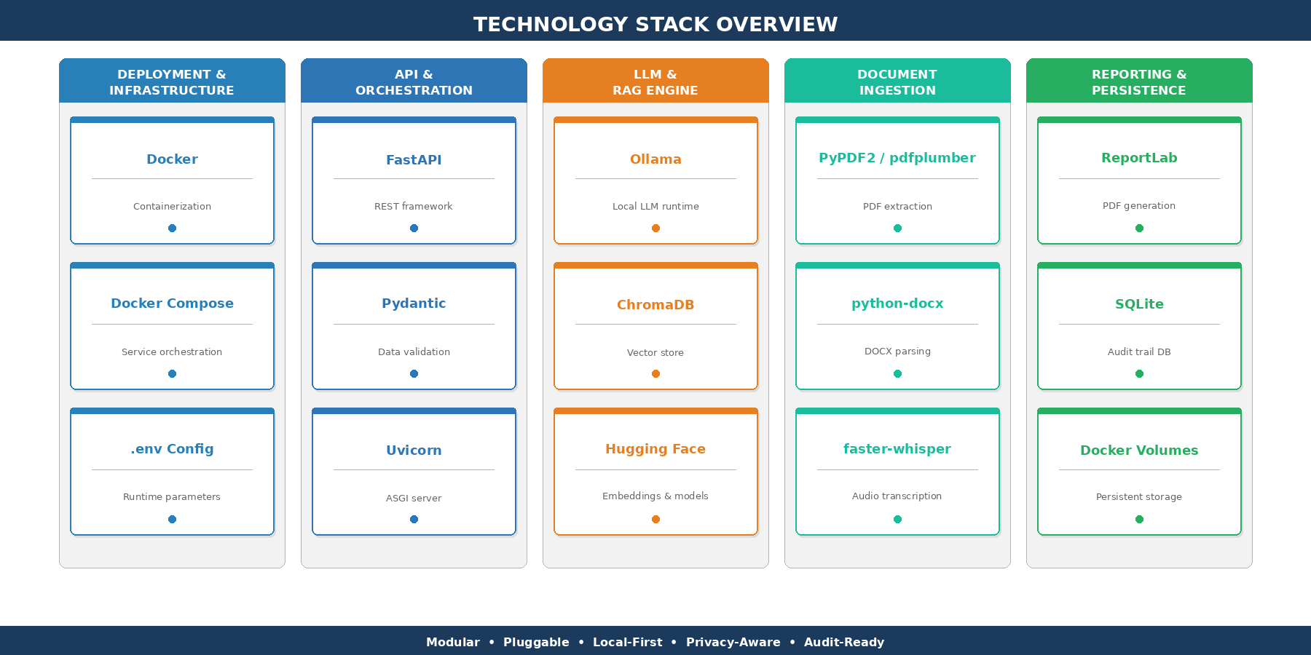
Figure 1 — Technology Stack Overview: five functional layers with core components
2. LAYERED ARCHITECTURE

The platform follows a strict layered architecture where each tier communicates only with its adjacent layers through well-defined interfaces. This design enables independent scaling, testing, and replacement of any component without affecting the rest of the system.
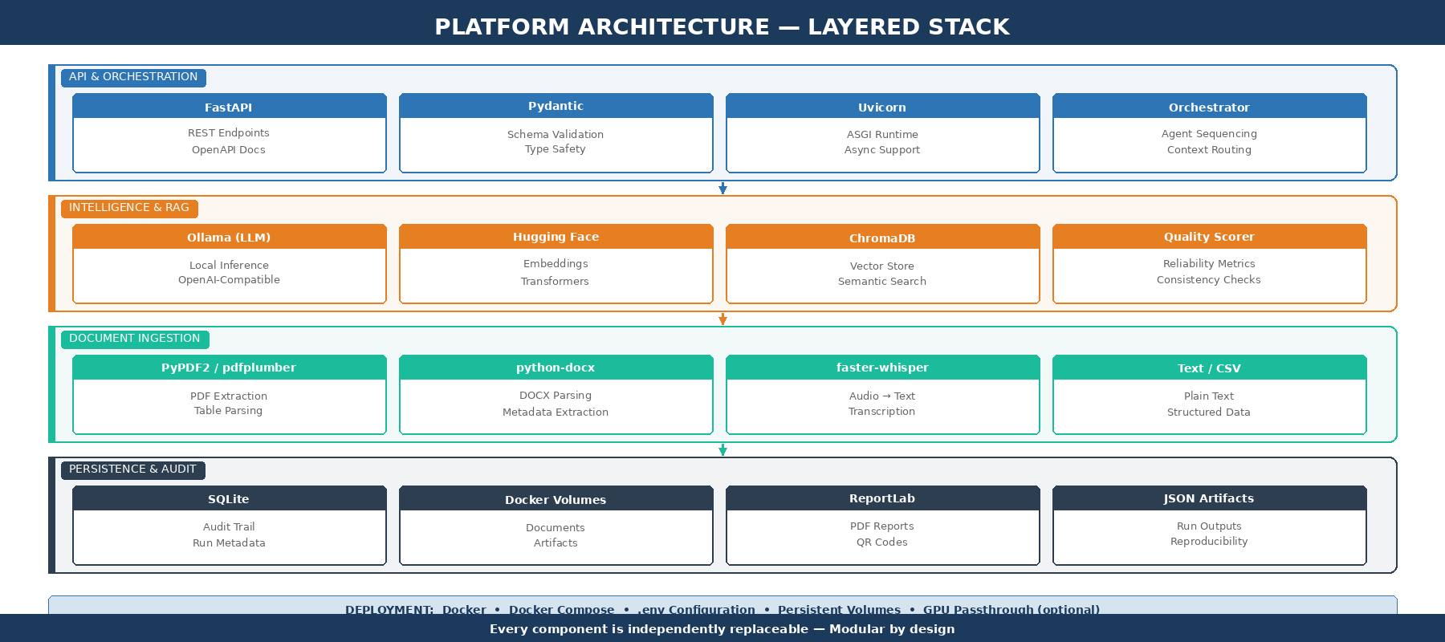
Figure 2 — Platform Architecture: API, Intelligence, Ingestion, and Persistence layers
3. API & ORCHESTRATION LAYER

The API layer serves as the central nervous system of the platform, exposing RESTful endpoints that drive the entire fact-checking pipeline. It handles request validation, agent sequencing, context routing, and response assembly.
Component | Role | Technical Details
FastAPI | High-performance REST API framework with automatic OpenAPI/Swagger documentation generation. | Async-native, dependency injection, middleware support. Serves all orchestration and agent pipeline endpoints.
Pydantic | Data validation and serialization with strict type enforcement for all request/response schemas. | BaseModel definitions for case inputs, agent outputs, reliability scores, and report payloads. Ensures schema consistency across the pipeline.
Uvicorn | Production-grade ASGI server providing the runtime for the FastAPI application. | Supports async request handling, configurable workers, graceful shutdown. Deployed behind Docker networking.
Orchestrator | Pipeline controller managing agent sequencing, context passing, and conditional escalation logic. | Implements the 7-stage workflow: Ingest → Category → RAG → Reasoning → Scoring → Escalation → Report.

4. LLM & RAG ENGINE

The intelligence layer combines large language model inference with Retrieval-Augmented Generation to ensure that all outputs are grounded in verifiable evidence. The LLM runtime follows a local-first, provider-pluggable architecture.
Component | Role | Technical Details
Ollama | Local-first LLM runtime for on-premise inference with zero external API dependencies. | Supports LLaMA, Mistral, Phi, Gemma, and other open-weight models. GPU passthrough via Docker for accelerated inference. No data leaves the infrastructure.
Pluggable Provider | OpenAI-style client pattern enabling seamless backend switching via configuration. | Compatible with OpenAI, Azure OpenAI, Anthropic, Groq, Together AI. Provider selection via .env without code changes.
ChromaDB | Persistent vector database for semantic embedding storage and cosine similarity search. | Supports metadata filtering, collection management, and persistent storage via Docker volumes. Handles the evidence index for all RAG operations.
Hugging Face | Embedding models for converting documents and queries into dense vector representations. | Sentence Transformers library (all-MiniLM-L6-v2, multilingual-e5, BGE, etc.). Produces high-dimensional embeddings optimized for semantic similarity search.

Hugging Face Embedding Strategy
The Hugging Face integration provides access to the full Sentence Transformers ecosystem, enabling model selection based on language requirements, domain specificity, and latency constraints. Models can be swapped without pipeline changes.

5. DOCUMENT INGESTION PIPELINE

The ingestion layer is responsible for converting heterogeneous input sources into clean, indexed text segments ready for RAG retrieval. It supports multiple document formats and implements intelligent chunking with configurable overlap to preserve semantic context across segment boundaries.
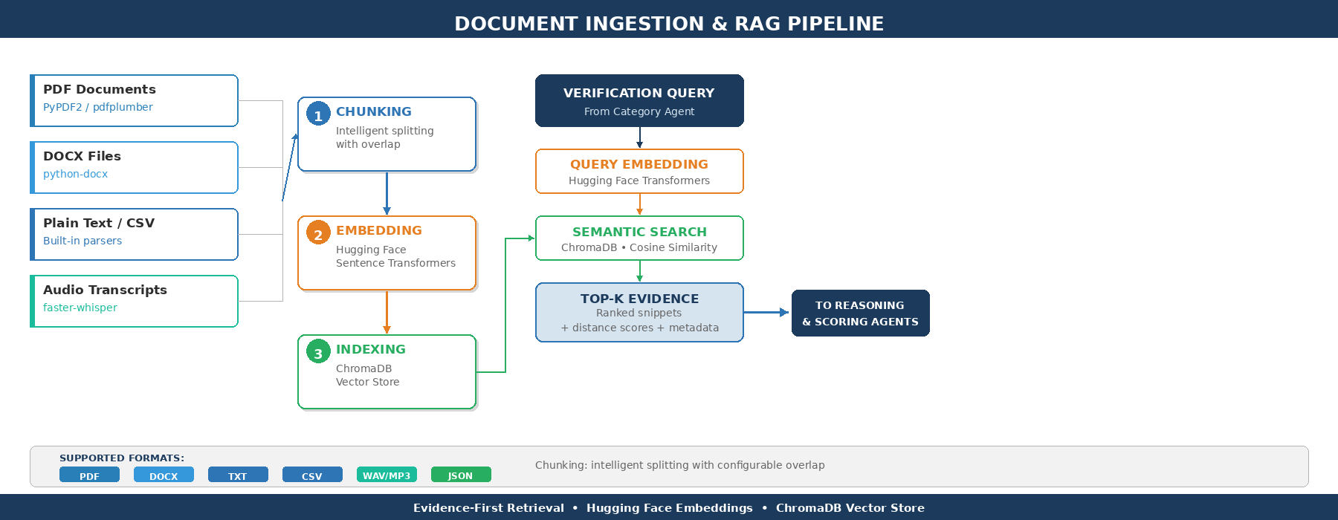
Figure 3 — Document Ingestion & RAG Pipeline: from source files to evidence retrieval
5.1 PDF Extraction
Library | Description & Use Case
PyPDF2 | General-purpose PDF text extraction. Handles standard text-based PDFs, page-by-page parsing, and metadata extraction (author, title, creation date). Used as the primary extraction layer for well-formed PDF documents.
pdfplumber | Advanced PDF extraction with table detection, layout-aware text positioning, and bounding box analysis. Used for complex PDFs containing tables, multi-column layouts, and structured data that PyPDF2 cannot reliably parse.

5.2 Office Document Parsing
Library | Description & Use Case
python-docx | Native DOCX parsing library for extracting text, headings, tables, lists, and metadata from Microsoft Word documents. Preserves document structure and paragraph hierarchy for intelligent chunking.

5.3 Plain Text & Structured Data
Format | Description & Handling
TXT / Markdown | Direct text ingestion with encoding detection (UTF-8, Latin-1). Paragraph-based segmentation preserving logical document structure.
CSV / TSV | Tabular data parsing via Python’s csv module. Row-level or cell-level chunking depending on content density. Useful for structured questionnaire responses.
JSON | Structured data ingestion for pre-formatted questionnaire responses and case metadata. Schema validation via Pydantic before indexing.

5.4 Audio Transcription
Library | Description & Use Case
faster-whisper | High-performance speech-to-text engine based on OpenAI Whisper with CTranslate2 optimization. Supports multilingual transcription of interviews, calls, and depositions. Produces timestamped segments for precise evidence anchoring.

5.5 Chunking & Indexing Strategy
After extraction, documents are segmented into chunks using an intelligent splitting strategy with configurable parameters. The chunking process preserves semantic coherence by respecting paragraph and sentence boundaries where possible, and applies overlap between adjacent chunks to prevent information loss at segment boundaries.
- Chunk size: Configurable target size (default: 500–800 tokens) balancing retrieval precision and contextual completeness.
- Overlap: Configurable overlap window (default: 50–100 tokens) ensuring cross-boundary continuity for evidence retrieval.
- Metadata preservation: Each chunk retains source document reference, page number, section heading, and position index for audit traceability.
- Embedding: Chunks are embedded via Hugging Face Sentence Transformers and indexed in ChromaDB with associated metadata for filtered retrieval.
6. REPORTING & EXPORT

The reporting layer transforms structured fact-checking outputs into professional, shareable deliverables. All generated artifacts are persisted alongside the audit trail for governance compliance.
Component | Role | Technical Details
ReportLab | Professional PDF generation engine for structured audit reports. | Produces multi-page reports with tables, metric visualizations, category summaries, narrative text, and configurable layouts. Supports custom fonts and branding.
Pillow | Image processing library for report graphics and visual elements. | Generates chart images, visual indicators, and processes any embedded graphics for inclusion in PDF reports.
qrcode | QR code generation for embedding verification links in exported reports. | Each report includes a QR code linking to the audit trail entry, enabling rapid verification of report authenticity and provenance.

7. PERSISTENCE & AUDIT TRAIL

The persistence layer ensures full reproducibility and governance compliance by maintaining comprehensive records of every pipeline execution. The design prioritizes simplicity, portability, and zero-configuration operation.
Component | Role | Technical Details
SQLite | Lightweight relational database for audit trail and run metadata. | Stores: run timestamps, input hashes, agent outputs, reliability scores, escalation decisions, and report references. Zero server configuration required.
Docker Volumes | Persistent storage surviving container restarts and rebuilds. | Four volume mounts: data/ (documents), audit/ (SQLite DB), vectorstore/ (ChromaDB), ollama/ (optional cached LLM weights).
JSON Artifacts | Structured run artifacts for full reproducibility. | Each pipeline execution produces a timestamped JSON artifact containing inputs, intermediate outputs, agent configurations, and scoring data.

7.1 Volume Map
Volume | Contents & Purpose
data/ | Ingested case documents, uploaded questionnaires, and transcript files. Source material for the RAG index.
audit/ | SQLite database with complete audit trail, run metadata, reliability metrics, and escalation logs.
vectorstore/ | ChromaDB persistent storage containing semantic embeddings, collection indices, and metadata.
ollama/ (optional) | Cached LLM model weights for Ollama, avoiding re-download across container rebuilds. GPU-accelerated inference supported.

8. DEPLOYMENT & CONFIGURATION

The platform is delivered as a fully containerized application stack deployable in any Docker-compatible environment. The local-first design ensures all core capabilities function without external cloud dependencies.
8.1 Docker Compose Services
- api: FastAPI application exposing orchestration endpoints. Communicates with ChromaDB, Ollama, and SQLite within the Docker network.
- chromadb: ChromaDB vector store with persistent volume mount for embedding durability across restarts.
- ollama: Local LLM runtime with optional GPU passthrough (nvidia-docker) for accelerated inference.
8.2 Configuration (.env)
All runtime parameters are managed through .env files, enabling environment-specific configuration without code modifications. Key configuration domains include:
- LLM_PROVIDER / LLM_MODEL: Provider selection (ollama, openai, azure) and model identifier. Switching providers requires only .env changes.
- EMBEDDING_MODEL: Hugging Face model name for Sentence Transformers (e.g., all-MiniLM-L6-v2, paraphrase-multilingual-MiniLM-L12-v2).
- CHROMA_HOST / CHROMA_PORT: ChromaDB connection settings for the vector store service.
- CHUNK_SIZE / CHUNK_OVERLAP: Document chunking parameters controlling segment size and overlap window.
- VOLUME_PATHS: Mount points for data, audit, vectorstore, and ollama volumes.

Scalability Note
Redis is not included in the current configuration. It can be integrated in subsequent iterations for queue management, response caching, and rate limiting as the platform scales to multi-user concurrent workloads.

9. COMPLETE DEPENDENCY SUMMARY

The following table provides a consolidated view of all libraries and tools composing the platform stack, organized by functional domain.
Domain | Libraries / Tools | Purpose
API | FastAPI, Pydantic, Uvicorn | REST endpoints, validation, ASGI runtime
LLM | Ollama, OpenAI Python SDK | Local and cloud LLM inference via pluggable client pattern
Embeddings | Hugging Face Transformers, Sentence Transformers | Document and query embedding for semantic search
Vector Store | ChromaDB | Persistent vector index with cosine similarity search
PDF Ingestion | PyPDF2, pdfplumber | Text and table extraction from PDF documents
DOCX Ingestion | python-docx | Parsing Word documents with structure preservation
Audio | faster-whisper | Speech-to-text transcription (Whisper + CTranslate2)
Data Parsing | csv (stdlib), json (stdlib) | Structured data ingestion for CSV, TSV, JSON formats
PDF Generation | ReportLab | Professional PDF report creation with tables and metrics
Image Processing | Pillow | Graphics and visual elements for reports
QR Codes | qrcode | Verification QR codes embedded in audit reports
Database | SQLite (stdlib) | Audit trail, run metadata, reliability scores
Deployment | Docker, Docker Compose | Containerization and multi-service orchestration
Web Enrichment | SerpAPI, BeautifulSoup, lxml | Optional external corroboration via web search and HTML parsing

Modular • Pluggable • Local-First • Privacy-Aware • Audit-Ready

