Exercises:

1)

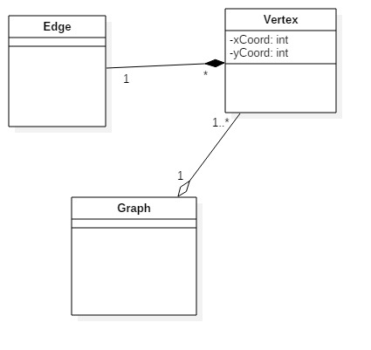

2)

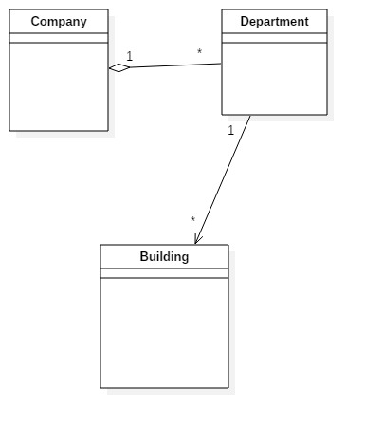

3)

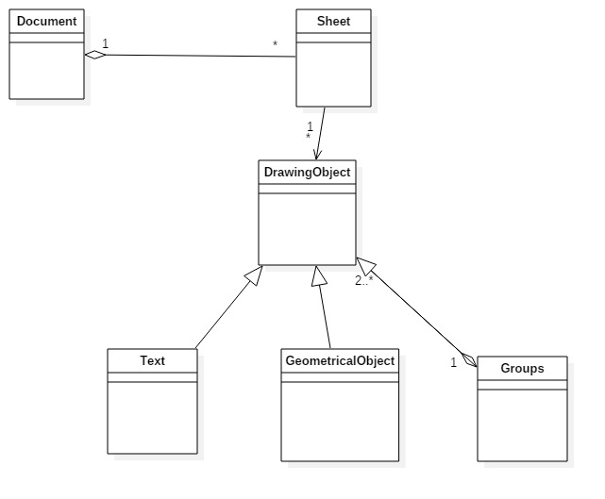

4)

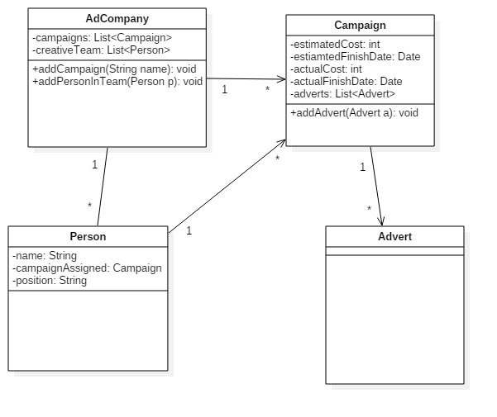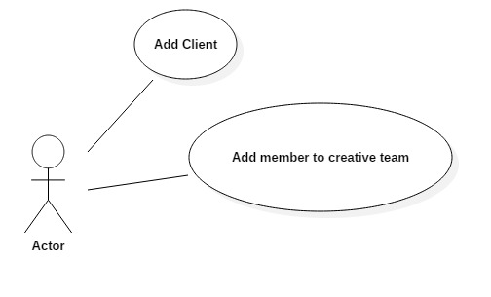

5)

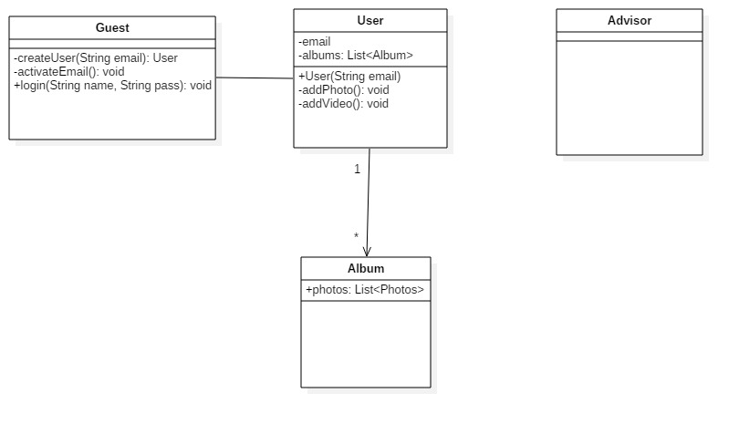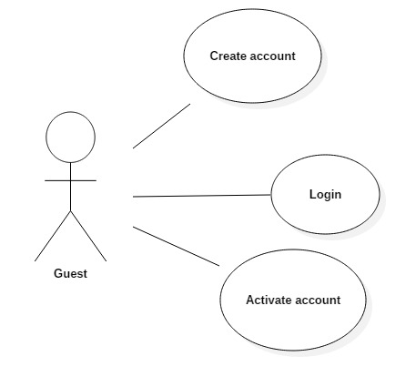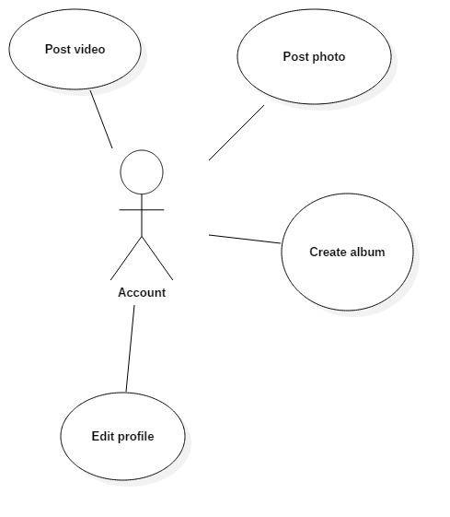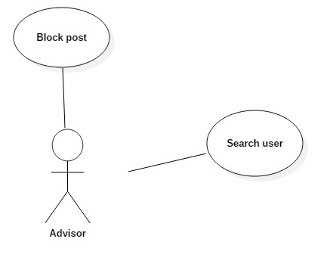

6)

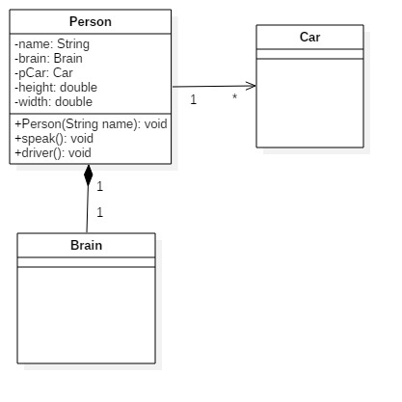

7)

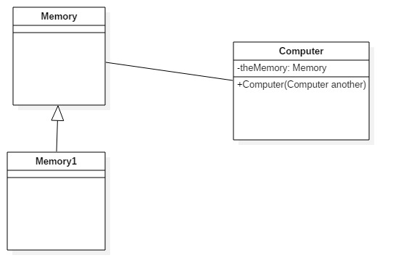

8)

class EventSource extends Observable implements Runnable {

public void run() {

while (true) {

String response = new Scanner(System.in).next();

setChanged();

notifyObservers(response);

}

}

}

class MyApp {

public static void main(String[] args) {

out.println("Enter Text >");

EventSource eventSource = new EventSource();

eventSource.addObserver( (Observable obj, Object arg) -> {

out.println("\nReceived response: " + arg);

});

new Thread(eventSource).start();

}

}

