

**KENYATTA UNIVERSITY**

**SCHOOL OF ENGINEERING AND TECHNOLOGY**

**DEPARTMENT OF COMPUTING AND INFORMATION TECHNOLOGY**

**SIT 400 PROJECT**

**ONLINE JOB PORTAL**

**SUBMITTED**

**BY**

**Name: FLORENCE KAMAU**

**Reg No. J31S/15851/2015**

**PROJECT SUPERVISOR: DR. JOHN KANDIRI**

(This project proposal is submitted in partial fulfilment of the requirements for a *Bachelor of Information Technology* Degree at Kenyatta University)

**CHAPTER 4: SYSTEM ANALYSIS**

**INTRODUCTION**

System analysis is a technique used to decompose a system into independent components with an aim of investigating the working and interaction of the components with each other. It allows the developer to investigate and study a business area and/or process in order to identify its goals and objectives and develop a system that meet the same.

System analysis seeks to answer questions of who the intended user of the system is, what the system will do, when it will be used and where it will be used. The researcher will investigate the current system, identify opportunities that can be improved and develop concepts for a proposed system.

According to the system the structured system analysis and design methodology method, system analysis would constitute the following steps:

1. The development of a feasibility study – this includes the technical, economic, operational and social feasibility tests.
2. Fact finding measures – different methods of information gathering will be used to collect the requirements of the end – user of the system being developed.
3. Gauging how the users will use the system and what the developed system will be used for.

Use cases will be drawn and used by the researcher to identify and express the functional requirements of the system.

The researcher will be investigating National Industrial Training Authority (NITA). She will keenly investigate on the registration process of new students enquiring for attachments and new graduates who are enquiring for internship opportunities, the record keeping process, the matching process and how reports are generated in the NITA offices. She will investigate all the processes that are in the manual system that is being currently used and also the services offered.

**Description of the current system**

**Job Application**

The current system is manual which requires the job applicant to physically go to the NITA offices in order to apply for a job. They are made to queue and this makes it time consuming. The interested persons are required to download and duly fill the NITA APPLICATION FOR EMPLOYMENT. Registration is done by the staff on duty on that specific day. Once registration is done, the person handling that sector takes the details and matches them manually by searching through all the records of the students and employers requiring the said profession. The process is usually very time-consuming and also hectic as there may be numerous job seekers registered in the same course.

**Job reservation**

After filing in the form, you are supposed to drop them in their offices as there is a filing system that keeps records of job’s applied, applicant’s details, type of job applied and where the job is located. This consumes a lot of paper work which becomes expensive to have all the papers at all time.

The data stored and retrieved is huge and this causes problems when tracking and maintaining all records. It makes hard for a manager to keep track of the jobs applied and the ones still available as he/she has to confirm from the company if the vacancy is still available.

After an applicant has applied for a certain position, he/she is given a date to go back to the offices and check whether the slot is available or not. This makes it tiresome and time consuming as there is no assurance of getting that specific job. After the matching process the details are then sent to the company or the organization the student has been posted for approval. The student is also sent a copy of the letter to take to the company followed by a contract between the student, organization and NITA. All these processes must be approved by the director in NITA offices so as the student may start their internship/ job.

Board of Directors

Director General

ge

Departmental Heads

Departmental workers

Receptionist

*Figure 4.1: Organizational structure of NITA.*

**Problems of the current system**

1. The current manual system does not keep proper records of the students and the organizations which brings a huge issue whenever certain records are being retrieved.

2. The current system does not automatically match the students and the organizations when the vacancies are available. Manual matching is very hard and at times is erroneous which leads to giving out jobs to un-qualified individuals or even some jobs lacking workers and yet there are students who are qualified in the said field.

3. The current system is not secure as anybody can access the students and the organizations information that is stored within the NITA offices. This means that it is possible to alter details or even erase students from the system which is not professionally ethical.

4. The current system is takes up more human effort and physical space since data is stored in traditional files that are stacked in a room.

**THE PROPOSED SYSTEM**

1. **User requirements**

i. The system should allow login through the use of usernames and passwords.

ii. The system should have a graphical user interface.

iii. The system should have a help section.

1. **Business requirements**

i. The system should allow the registration of new users that will use the system.

ii. The system should allow the deletion of records in case of complications like mismatch so as to avoid complications.

iii. The system should have a count of all students and the job offering organization for the budget process.

1. **Functional requirements**

i. The system will allow the automatic matching of the compatible graduates/ students and the company.

ii. The system will keep records of the students and the companies.

iii. The system will be able to generate reports.

1. **Non-functional requirements**

i. The system should run on PCs to be used by management, staff, receptionists and the director.

ii. The system should allow the backup of the company and students details.

**4.7. DATA FLOW DIAGRAMS**

**a. Proposed system context diagram**

Generate reports

View matched students and companies

Grouping

Viewing and examination by directors

Register students and companies

Visit NITA

Receptionist

Student/Company

staff

Director

*Figure 4.2: Proposed system context diagram*

**b. Proposed system logical data flow diagram**

**i. Level 0 data flow diagram**

Login Management

Applicant and Company Management

Applicant and company Management

System User Management

*Figure 4.3: Level 0 Data Flow Diagram for the proposed system*

**ii. Level 1 data flow diagram**

Generate applicants reports

Generate company reports

Check user log in details

Generate matching reports

Log in management

System user management

Company management

Applicant’s management management

*Figure 4.4: Level 1 Data Flow Diagram for the proposed system*

**iii. Level 2 data flow diagram**

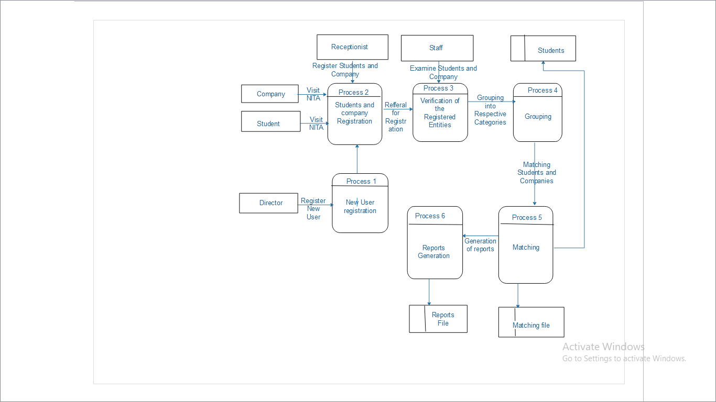

*Figure 4.5: Level 2 data flow diagram for proposed system*

**c. Proposed system use case diagram**

Receptionist

Staff

*Figure 4.6: Proposed system use case diagram*