**Evaluating Biomagnification of Organohalogenated Pollutants in Juvenile Fish from Estuarine Nurseries: A Field Methodological Comparison**

Mounier Florence1, Labadie Pierre2, Loizeau Véronique3, Munschy Catherine 4, Budzinski Hélène2, Aminot Yann4, Gallien Marine2, Chouquet Bastien5 & Lobry Jérémy1*

1 INRAE, EABX, 50 avenue de Verdun Gazinet, F-33612, Cestas cedex, France.

2 Université de Bordeaux, UMR 5805 CNRS, EPOC, LPTC Research Group, Talence, France

3 Ifremer, LBCN, Plouzané, France

4 Ifremer, LBCO, Nantes, France

5 Cellule de Suivi du Littoral Normand, CSLN, Le Havre 76600, France

**\*Corresponding author:** Jérémy Lobry [jeremy.lobry@inrae.fr]

# Abstract

This study examines the **trophodynamics of organohalogenated pollutants** from three families in **juvenile *Solea solea*** from a temperate estuary (Seine, France). A total of **31 perfluoroalkyl substances (PFASs)** and **19 polychlorinated biphenyl (PCB) congeners** were measured in juvenile soles and their benthic prey.

Among the **16 Young-of-the-Year juvenile *Solea solea* (G0) samples** and **50 prey samples** collected across **three taxonomic groups** (Bivalvia, Arthropoda, Polychaeta), **PCBs were by far the predominant contaminant family** in both fish and prey (ΣPCBs = 465.20 ng/g dry weight in soles and 292.50 ng/g in prey). **PFAS contamination was approximately 10 times lower.** Among PFAS compounds, **L-PFOS** was the most abundant, representing ~50% of total PFAS contamination.

A high **inter-species variability** in contamination levels was observed, with no clear explanation related to taxonomic group or feeding mode. However, **bivalves and soles appeared to be more contaminated with PCBs than polychaetes and crustaceans**. Conversely, **bivalves were less contaminated with PFASs than the other taxa**, suggesting that **bivalves have a particular capacity for bioaccumulation** compared to other organisms.

**Biomagnification factors (BMFs)** were assessed using two approaches: (1) **comparing contaminant concentrations in individual prey species and soles**, (2) **comparing contaminant concentrations in the overall diet and soles.**

The first method indicated that **PCBs exhibited limited biomagnification** (mean BMF for ΣPCBs = 1.8), with **BMFs ranging from 1 to 2 across nearly all prey species**. **PFASs showed stronger bioaccumulation (mean BMF = 4.0)**. Across all contaminant families, **BMFs varied significantly between species**, and higher-than-average BMFs were observed in a limited number of species, differing among contaminant families.

The second method, which incorporates diet composition, **yielded slightly lower BMFs** for PCBs (by ~+0.1 to +1), except for **CB149**. However, for PFASs, **BMFs based on diet composition were significantly higher (+1 to +7) than those calculated for individual prey species**, indicating **strong biomagnification for all PFASs**—particularly for **L-PFOS (BMF = 7 instead of 1.5) and PFNA (BMF = 7.5 instead of 1.3)**.

These findings suggest that **disregarding diet composition when assessing BMFs may result in an underestimation of biomagnification potential, particularly for the emerging contaminant family studied, PFASs**.

# Keywords

Seine estuary; important nursery ground ; flatfish juvenile; *Solea solea*; high organic chemical contamination; PCBs; PFASs; BMF, TMF, assimilation efficiency

# Highlights

# Revues

* Integrated Environmental Assessment and Management
* Science of the Total Environment

# Table of contents

Abstract 2

Keywords 2

Highlights 3

Revues 3

Table of contents 4

1. Introduction 6

2. Materials and methods 8

2.1. Dataset 8

2.1.1. Sampling 8

2.1.2. Diet composition 8

2.1.3. Chemical 9

2.2. Magnification factors 10

2.2.1. BMF 11

2.2.1. TMF or TL-BMF 12

2.3. Accounting for nondetect concentrations 13

3. Results 14

3.1. Contamination data 14

3.1.1. Total levels of contamination 14

3.1.1. Relationship with lipid content for PCB 15

3.1.2. Average contamination profiles 15

3.2. BMFs for PCBs 15

3.2.1. Predator-prey BMF (BMFPP) 15

3.2.2. Diet-based BMF (BMFD) 17

3.2.1. Predator-prey trophic level–normalized BMF (TL-BMFPP) 18

3.2.2. Diet-based trophic level–normalized BMF (TL-BMFD) 19

3.2.3. BMF methodological comparison 20

3.3. Diet-based BMFs for PFASs 22

4. Discussion 24

4.1. Niveaux et profiles de contamination 24

4.1.1. Niveaux généraux entre les familles 24

4.1.2. Niveaux et profils pour les PCB 24

4.2. Biomagnification des contaminants 28

4.2.1. Des différences entre familles 28

4.2.2. Une variabilité inter-spécifique marquée des BMFs prédateur-proie 28

4.2.3. Influence de l’intégration du régime alimentaire dans l’estimation des BMFs 29

4.2.4. BMF vs TMF 30

4.2.5. Influence de la prise en compte des valeurs manquantes 31

5. Conclusions et perspectives 31

6. References 32

- TMFs 37

# Introduction

Exploited marine ecosystems are inherently complex, characterized by significant variability in biophysical conditions, species-specific biology and behaviour, and intricate trophic interactions. Beyond these ecological dynamics, anthropogenic pressures — such as fishing — can further disrupt habitats and ecosystem functioning, especially in densely populated coastal regions (Halpern *et al.*, 2008, 2012). Coastal and estuarine zones serve as critical nursery habitats for numerous fish species, offering unique environmental conditions essential for feeding, growth and survival during early life stages (Le Pape *et al.*, 2003; Rochette *et al.*, 2010). These nurseries are fundamental to the completion of life cycles and the renewal of fish populations, and are therefore recognized as essential fish habitats (Beck *et al.*, 2001). This is particularly true for many flatfish species, including the common sole (*Solea solea*).

However, nursery habitats do not always provide optimal conditions for juvenile fish development, and their degradation can markedly affect key biological functions such as survival, growth performance, and the capacity of individuals to contribute to stock replenishment. Both controlled experimental studies and *in situ* comparisons between estuaries have shown that environmental quality — particularly levels of chemical contamination — has direct influence on nursery function, as reflected in juvenile growth and survival rates (Gilliers *et al.*, 2006; Amara *et al.*, 2007). Due to their hydrodynamic and physicochemical properties, estuarine nurseries are especially vulnerable to contamination. These environments often act as long-term sinks for a wide range of micropollutants, with sediments serving as the main reservoir for persistent contaminants (Ridgway and Shimmield, 2002).

Over time, a scientific consensus has developed regarding the environmental risk assessment of chemicals that meet the PBT criteria — persistence (P), bioaccumulation (B), and toxicity (T) (Matthies *et al.*, 2016). Environmental persistence is linked to the structural stability of compounds, both in the environment and within organisms. Bioaccumulation, the process by which chemicals accumulate in living organisms from their surroundings, depends on several chemical, biological and ecological factors, including bioaccessibility (i.e., the fraction of a compound that can be released from its matrix), bioavailability (i.e., the fraction that is readily available for uptake), biotransformation into other compounds, and affinity for biological molecules (e.g., lipids), all of which affect uptake and accumulation at the cellular level (Gobas *et al.*, 2009). Toxicity refers to adverse biological effects of accumulated chemicals and can vary widely depending on the organism’s developmental stage, with early life stages being particularly sensitive to endocrine-disrupting effects (Matthies *et al.*, 2016). Therefore, evaluating the bioaccumulation of persistent organic pollutants (POPs) in early-life stages juvenile fish — during growth and maturation stages — feeding on benthic organisms in contact with contaminated estuarine sediments is essential for understanding environmental risks in these critical nursery areas.

In the context of chemical registration and regulation, bioaccumulation assessments rely on a range of methods and metrics, each associated with inherent uncertainties that complicate decision-making processes (Gobas *et al.*, 2009). Among the most commonly used indicators are the bioconcentration factor (BCF), which reflects chemical uptake from water, and the biomagnification factor (BMF), which indicates uptake through dietary exposure (Arnot et al., 2023). For hydrophobic organic chemicals (HOCs), such as POPs, diet is considered the primary route of bioaccumulation. However, experimentally derived BMFs—typically based on controlled feeding experiments using spiked pellets—often fail to accurately reflect field conditions, where organisms are exposed to contaminants through both dietary and aqueous pathways, as well as from complex and variable sources (Schäfer et al., 2015). Furthermore, bioaccumulation is influenced by a multitude of abiotic factors (e.g., site-specific water and sediment quality parameters such as pH or clay content), biotic factors (e.g., organism growth rate, lipid content, age, and sex), and ecological factors (e.g., trophic level, feeding habits) (Liu, Haffner and Drouillard, 2010; Deribe *et al.*, 2011; Van Ael *et al.*, 2013; Li *et al.*, 2018; Masset *et al.*, 2019). These variables underscore the complexity of reliably estimating bioaccumulation in natural systems (van der Oost, Beyer and Vermeulen, 2003). Consequently, there is a growing consensus that field-derived data should play a more prominent role in evaluating the bioaccumulation potential of chemicals and in assessing the chemical status of aquatic ecosystems (Schäfer et al., 2015). In this context, this study aimed to evaluate and compare field-based approaches for assessing biomagnification potential of several POPs in juvenile fish under natural exposure conditions.

To achieve this, common sole and their prey were sampled from the Seine Estuary, a key nursery ground for Eastern English Channel sole stocks (Riou, Le Pape and Rogers, 2001; Rochette et al., 2010). This estuary is subject to nursery habitat degradation due to substantial contaminant inputs from both local intra-estuarine sources and upstream watershed discharges (Gilliers et al., 2006; Le Pape et al., 2007; Rochette et al., 2010). We first focused on legacy POPs, specifically polychlorinated biphenyls (PCBs), for which contamination levels (Dargnat and Fisson, 2010) and bioaccumulation properties have been extensively documented (Loizeau, Abarnou and Ménesguen, 2001; van der Oost, Beyer and Vermeulen, 2003; Borgå *et al.*, 2005; Arnot and Gobas, 2006). However, for many other regulated or emerging contaminants, available data remain sparse or entirely lacking (Daughton, 2005; Covaci et al., 2011), despite their potential contribution to the ecotoxicological effects observed in estuarine organisms chronically exposed to complex and dynamic contaminant mixtures (Poisson et al., 2011). Among these compounds, we also included (i) substances recently listed under the Stockholm Convention on POPs, such as perfluorooctane sulfonate (PFOS, since 2009); (ii) substances currently under evaluation for inclusion in the same convention, including certain per- and polyfluoroalkyl substances (PFASs). These contaminants are known to be particularly prevalent in the Seine Estuary, notably PFOS (Munschy et al., 2013), and PFASs more broadly (Labadie and Chevreuil, 2011; Munoz et al., 2018). Due to their strong bioaccumulative properties and widespread detection in aquatic organisms, including fish, Environmental Quality Standards (EQS) have been established for these compounds in wild fish tissues (Directive 2013/39/EU, 2013). Improving our understanding of their environmental fate and bioaccumulation in natural ecosystems is therefore essential for both scientific advancement and the effective management of aquatic environmental quality.

The present study aims improve our understanding of bioamplification — the process by which the concentration of a chemical compound in a predator exceeds that found in its prey, primarily due to dietary accumulation (Gobas and Morrison, 2000). This mechanism is hypothesized to be predominant for these contaminant families studied here, and it explains why these chemicals are bioaccumulative despite their relatively low bioconcentration factors (i.e. accumulation from water) (Loizeau, Abarnou and Ménesguen, 2001; Schäfer *et al.*, 2015; Fremlin, Elliott and Gobas, 2025). To assess dietary exposure and bioaccumulation potential of these compounds, two commonly used indicators are the BioMagnification Factor (BMF) and Trophic Magnification Factor (TMF) (Fremlin, Elliott and Gobas, 2025). Several reviews have discussed the use of monitoring-based trophic magnification metrics to assess chemical bioaccumulation potential and have issued methodological recommendations to improve experimental design, data handling, and statistical treatment in such studies (Borgå *et al.*, 2012; Conder *et al.*, 2012; Kim *et al.*, 2016; Arnot *et al.*, 2023; Fremlin, Elliott and Gobas, 2025). These recommendations were followed or discussed in the present study.

The simplest method to estimate BMFs involves calculating concentration ratios between predator (in this case, juvenile common sole) and each of its prey species within the nursery area. Although this approach is rapid, it does not account for the relative dietary contribution of each prey item. A more refined method incorporates dietary weighting, whereby contaminant concentrations are adjusted according to the relative abundance of each prey item in the predator’s diet (Mackay and Fraser, 2000), offering a more accurate estimate of dietary exposure. Additionally, a third method employed in this study involves estimating TMFs based on nitrogen stable isotope levels (δ¹⁵N), which provide ecologically relevant information on trophic position and thus offer an integrated perspective on dietary exposure. For all three approaches, special care was taken to align with recent methodological recommendations for BMF and TMF calculation (Fremlin, Elliott and Gobas, 2025). Comparisons between these biomagnification estimates were conducted using PCB congeners with a 100% detection frequency to avoid bias due to left-censored data. In the case of PFAS compounds, for which non-detects were common, several innovative strategies were applied to address left-censored data and improve the robustness of the analysis.

Materials and methods

## Dataset

### Sampling

The dataset used in this study originates from the CHOPIN and CAPES research projects and is based on sampling of first-year juvenile common sole (*Solea solea*) and their main prey species in the Seine estuary (northern France) (see Table 1). A detailed description of the sampling methodology is provided in Supplementary Information, Section 1.1.

Sixteen composite samples of first-year sole were prepared by pooling individuals of similar size to obtain sufficient material for chemical analysis. A total of 50 samples were collected from 16 targeted prey species, based on their presence in sole’s diet (see next section) and sufficient biomass for chemical analysis. These encompassed three different taxonomic groups and three distinct feeding modes. Bivalves were the most represented group, with nine targeted species represented across 27 samples. The crustacean group included only two species, totalling 7 samples. Five annelid species were included, represented by 16 samples, and exhibited the widest range of trophic strategies: including suspension feeding, surface deposit feeding, and omnivory.

Table 1 - List of sampled benthic prey species and *Solea solea* analyzed for contaminants, along with their taxon, feeding mode, corresponding sample size (N = number of sampled pools) and proportion analyzed for each chemical family, and percentage in stomach contents.

| Species | Taxon | Feeding mode | Sample size | %N PCB | %N PFAS | % stomach |
| --- | --- | --- | --- | --- | --- | --- |
| *Abra alba* | Bivalve | Suspension feeder | 3 | 100% | 100% | 0.59 |
| *Cerastoderma edule* | Bivalve | Suspension feeder | 5 | 60% | 100% | 1.51 |
| *Corbula gibba* | Bivalve | Suspension feeder | 1 | 100% | 0% | - |
| *Donax vittatus* | Bivalve | Suspension feeder | 1 | 100% | 0% | - |
| *Ensis directus* | Bivalve | Suspension feeder | 1 | 0% | 100% | - |
| *Limecola balthica* | Bivalve | Deposit feeder | 5 | 100% | 80% | 0.06 |
| *Nucula nitidosa* | Bivalve | Deposit feeder | 1 | 100% | 0% | 0.03 |
| *Scrobicularia plana* | Bivalve | Deposit feeder | 6 | 100% | 100% | - |
| *Spisula subtruncata* | Bivalve | Suspension feeder | 4 | 100% | 75% | 0.06 |
| *Corophium volutator* | Crustacean | Deposit feeder | 1 | 100% | 100% | 11.46 |
| *Crangon crangon* | Crustacean | Omnivore | 6 | 100% | 100% | 1.59 |
| *Hediste diversicolor* | Polychaete | Omnivore | 2 | 100% | 100% | - |
| *Lagis koreni* | Polychaete | Deposit feeder | 7 | 57% | 100% | 0.53 |
| *Lanice conchilega* | Polychaete | Deposit feeder | 1 | 100% | 100% | 0.18 |
| *Nephtys sp.* | Polychaete | Omnivore | 4 | 100% | 100% | - |
| *Owenia fusiformis* | Polychaete | Suspension feeder | 2 | 100% | 100% | 0.44 |
| *Solea solea* | Actinopterygii | Omnivore | 16 | 100% | 94% | NA |

### Diet composition

Due to the limited knowledge available in the literature regarding the diet of early-stage G0 sole, stomach content analyses were carried out on 255 individuals to identify the main prey species and assess their relative abundance. The prey items found in the stomachs were used to reconstruct the typical diet composition of first-year juvenile sole. Dietary proportions were calculated as the number of prey items per taxonomic group, divided by the total number of identified prey individuals. The resulting diet composition consisted of 51% arthropods, 33% annelids, and 16% molluscs. The diet composition by taxonomic class is represented in Figure 1 and the detail by species can be found in the SI section 2.1.Haut du formulaire

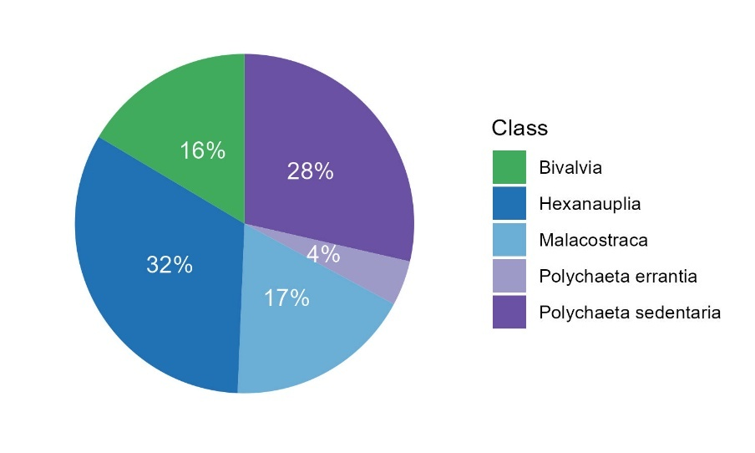

Figure 1 – Diet composition in taxonomic classes for those above 2% in the diet.

### Chemical

This study focused on two families of organohalogenated compounds: PCBs and PFASs (see SI section 1.2.1 for the presentation of use and reglementation). More precisely, concentrations of 19 PCB congeners and 26 PFAS components were determined in sole and prey samples (see SI section 1.2.2 for chemical acronyms, full names and CAS numbers). Technical details on sample preparation, chemical analysis, as well as quality assurance and control for contaminants, are provided in the SI section 1.2.3. Despite a significant sampling effort, the three contaminant families could not be systematically analysed across all samples due to occasionally insufficient material quantities. Therefore, the sample sizes for each species and chemical family are reported in Table 1 (above).

As the objective of this study was to investigate trophic transfer mechanisms, subsequent analyses were restricted to chemical compounds that were both detected and sufficiently prevalent in soles and their prey. Only PFAS compounds quantified simultaneously in more than 20% of the samples in both groups were retained for subsequent analyses. Based on this criterion, 12 out of the 26 PFAS compounds were selected for further analysis (Table 2, the list of the 26 compounds can be found in SI section 1.2.2). Additionally, the 19 PCB congeners were included (Table 3).

For each analysed sample, moisture content was measured to standardize contamination levels in ng/g dry weight (dw), ensuring comparability across species despite differences in moisture content. Additionally, lipid content was quantified as it is preferable to express contamination levels on a lipid weight basis (ng/g lipid weight lw), given the lipophilic properties of PCB (Conder *et al.*, 2012). Indeed, lipid content of test organisms can have major impact on bioaccumulation of these compounds (Schäfer *et al.*, 2015). Other biochemical markers—such as polar and neutral lipids, total proteins, or albumin—which could further assist in normalizing PCB and PFAS concentrations or refining trophic positioning (Fremlin, Elliott, and Gobas, 2025), were not analyzed due to limited sample material. The total concentrations (in ∑ ng/g for each normalisation ww, dw and lw) for each contaminant family were calculated to express their relative proportions, enabling the determination of contamination profiles within each sample.

We also studied the relationship between structural and chemical properties and bioaccumulation. For PFASs, the end-group nature and the number of carbon atoms in perfluoroalkyl chain were considered (Table 2) as they could influence bioaccumulation (Labadie and Chevreuil, 2011; Munoz *et al.*, 2017). For PCBs, we were interested in their partitioning octanol-water coefficients (log KOW) (Mackay *et al.*, 2016) and number of chlorine substitutions (Loizeau, Abarnou and Ménesguen, 2001).

Table 2 – List of PFASs searched in benthic preys and sole juveniles’ samples along with their end-group nature, chemical formula, perfluoroalkyl chain length (n carbon atoms) and percent of detection in prey and sole samples.

|  |  |  |  | Detection % | |
| --- | --- | --- | --- | --- | --- |
| Group | Compound | Formula | nC | preys | sole |
| PFCA | PFOA | F3C(CF2)6CO2H | 8 | 20 | 27 |
|  | PFNA | F3C(CF2)7CO2H | 9 | 91 | 100 |
|  | PFDA | F3C(CF2)8CO2H | 10 | 64 | 93 |
|  | PFUnDA | F3C(CF2)9CO2H | 11 | 69 | 27 |
|  | PFDoDA | F3C(CF2)10CO2H | 12 | 98 | 100 |
|  | PFTrDA | F3C(CF2)11CO2H | 13 | 62 | 87 |
|  | PFTeDA | F3C(CF2)12CO2H | 14 | 53 | 40 |
| PFSA | L-PFOS | F3C(CF2)6SO3H | 8 | 98 | 100 |
|  | Br-PFOS | F3C(CF2)7SO3H | 8 | 27 | 87 |
| FOSA | FOSA | F3C(CF2)7SO2NH2 | 8 | 91 | 73 |
| N-Alkyl FOSAA | EtFOSAA | F3C(CF2)7SO2N(C2H5)CH2CO2H | 8 | 60 | 73 |
| FTS | 8:2-FTSA | F3C(CF2)7(C2H4)SO3Na | 8 | 71 | 40 |

Table 3 - List of PCB congeners searched in benthic preys and sole juveniles’ samples. Group reflects the number of chlorine substitutions for PCBs. Octanol-water partition coefficients (logKow) are from (Hawker & Connell, 1988).

|  |  |  |  |  |
| --- | --- | --- | --- | --- |
|  |  |  | Detection % | |
| Compound | **Group** | **log Kow** | preys | sole |
| CB 28 | Tri-CB | 5.67 | **100** | **100** |
| CB 31 | 5.67 | **100** | **100** |
| CB 44 | Tetra-CB | 5.75 | **100** | **100** |
| CB 49 | 5.63 | **100** | **100** |
| CB 52 | 5.84 | **100** | **100** |
| CB 101 | Penta-CB | 6.38 | **100** | **100** |
| CB 105 | 6.65 | **100** | **100** |
| CB 110 | 6.48 | **100** | **100** |
| CB 118 | 6.74 | **100** | **100** |
| CB 128 | Hexa-CB | 6.74 | **100** | **100** |
| CB 132 | 6.58 | **100** | **100** |
| CB 138 | 6.83 | **100** | **100** |
| CB 149 | 6.67 | **100** | **100** |
| CB 153 | 6.92 | **100** | **100** |
| CB 156 | 7.18 | **100** | **100** |
| CB 170 | Hepta-CB | 7.11 | **100** | **100** |
| CB 180 | 7.36 | **100** | **100** |
| CB 187 | 7.17 | **100** | **100** |
| CB 194 | 7.8 | **100** | **100** |

## Magnification factors calculations

Recent workshops have highlighted the importance of using field-derived trophic magnification factors (TMFs) and biomagniﬁcation factors (BMFs) to assess bioaccumulation potential of chemicals (Conder *et al.*, 2012). These approaches rely on the assumption that dietary intake is the primary route of contaminant exposure, as chemical concentrations may increase in the gastrointestinal tract during digestion—a valid assumption for the chemical families investigated in this study (Gobas, Zhang and Wells, 1993).

The bioaccumulation potential of chemicals can be estimated using several field-based approaches, which we aimed to compare in the present study. In each case, bioaccumulation was assessed using appropriately normalized concentrations: lipid-normalized values (in ng/g lw) for PCBs, and dry weight-normalized values (in ng/g dw) for PFASs (Conder *et al.*, 2012).

### BMF

Estimating BMFs requires prior confirmation of trophic relationships between predator and prey species (Fremlin, Elliott, and Gobas, 2025). In our study, such relationships were established through stomach content analysis, which provided direct evidence of feeding links.

One empirical method for estimating BMFs involves calculating the ratio of contaminant concentrations in predators to those of their food (Conder *et al.*, 2012). The simplest commonly used approach applies this calculation individually for each prey species consumed by the predator—referred to here as the predator-prey BMF (BMFPP). In this approach, a separate BMF value is computed for each prey type (Schäfer *et al.*, 2015). Although straightforward and easy to implement, this method does not consider the relative contribution of each prey item to the predator’s diet.

A more accurate reflection of the theoretical definition of BMF can be achieved by incorporating the relative abundance of prey in the predator’s diet — referred to in this study as diet-based BMF (BMFD). This method requires knowledge of both contaminant concentrations in each prey item and the proportional composition of the predator's diet. In our study, these dietary proportions were determined through stomach content analysis (see Section 2.1.2). As taxonomic resolution was limited to higher-level groupings, the analysis focused on three main prey categories: bivalves, polychaetes, and crustaceans.

To ensure a robust comparison between BMFPP and BMFD, we limited the analysis to PCB congeners with a 100% detection frequency, thereby avoiding bias due to non-detects. Additionally, CB153 was used as a benchmark compound for evaluating method performance, as it is known to consistently biomagnify across most food chains.

To explore patterns in BMF values across different PCB congeners (CB), we examined their relationships with physicochemical properties such as logKow (Hawker & Connell, 1988) using a second-order polynomial regression. This was performed with geom_smooth() function from the ggplot2 package, employing the “lm” method). We also considered the effect of the number of chlorine substitutions.

The predator-prey BMF (BMFPP) for each CB in the was calculated as:

where is the lipid-normalized concentration of the CB in the sole, and is the corresponding concentration in a given prey species (Conder *et al.*, 2012).

The diet-based BMF (BMFD) was calculated as:

where is the concentration of the PCB congener in prey group *p* (bivalves, polychaetes, or crustaceans), and is the relative proportion of that prey group in the sole's diet (Conder *et al.*, 2012).

To explore variability in BMF estimates, we considered three scenarios: (1) Median BMF: using median concentrations for each prey group and for sole; (2) Minimum BMF: using third-quartile concentrations for prey and first quartile for sole; (3) Maximum BMF: using first-quartile concentrations for prey and third quartile for sole.

To enable a direct comparison between BMFPP with BMFD, we computed the median values of the median, minimum, and maximum BMF estimates across all prey species.

### TMF or TL-BMF

While the BMF approach is straightforward to implement, its predictive power can be limited by its dependency on the specific prey species considered, with varying sensitivity depending on the calculation method used. In this context, the trophic magnification factor (TMF) approach offers a more integrative and holistic perspective. TMFs represent the average biomagnification potential of a chemical across an entire food web by accounting for multiple trophic interactions. This method helps mitigate confounding effects related to species-specific differences biotransformation and elimination capacities, which may otherwise obscure the chemical’s overall biomagnification behaviour within the ecosystem (Conder *et al.*, 2012).

However, the estimation of a robust TMF requires comprehensive sampling across the full spectrum of trophic levels within the food web (Conder *et al.*, 2012)—an approach not feasible in our case due to incomplete food web characterization and limited sample size (Borgå *et al.*, 2012). Therefore, as an alternative, we calculated trophic level–normalized BMFs (TL-BMF), which are methodologically analogous to TMFs and allow direct comparison (Conder *et al.*, 2012). The TL-BMF for each predator-prey pair was computed using the following equation:

Where denotes the concentration of the PCB congener in the predator (*sole*) and in prey , and is the corresponding trophic level.

Trophic levels for all sampled species were derived from stable nitrogen isotope ratios (), measured in sole individuals (n = 67; CAPES project) and benthic prey (n = 102 from CAPES and n = 8 from CHOPIN). Trophic levels were calculated using the following equation:

where λ is the trophic position of the baseline organism, is the nitrogen isotopic value of the baseline species (set to the minimal measured value of in our dataset), is the trophic enrichment factor. Constants are based on values from (Munoz *et al.*, 2017), who studied comparable ecosystems (i.e., and ). Median δ¹⁵N values per species were used for TL estimation.

In addition to the predator-prey TL-BMF (TL-BMFPP), an analogous diet-based TL-BMF (TL-BMFD) was also computed. This approach integrates prey proportions in the predator’s diet and considers both the weighted mean prey concentration () and their trophic levels () (Conder *et al.*, 2012). The corresponding equations are:

and

Where denotes the relative contribution of prey taxon to the predator’s diet, based on stomach content analysis

## Accounting for left-censored concentrations

It is essential to report whether contaminant concentrations in samples fall below the limit of quantification (LOQ) and to appropriately address these nondetect (left-censored) values when estimating biomagnification factors. A commonly used but simplistic method for handling such data involves substituting nondetects with arbitrary values — typically half the LOQ (Borgå *et al.*, 2012). However, this approach can introduce bias and uncertainty. Therefore, current recommendations advocate for the evaluation of uncertainty associated with substitution methods and encourage the use of statistically robust alternatives (Helsel, 2006; Fremlin, Elliott and Gobas, 2025). Tools such as the NADA package (Julian and Helsel, 2021) in R (R core team, 2025) are specifically designed for the analysis of censored environmental data are supposed to offer more reliable solutions.

In this study, several methods for handling nondetects in PFAS concentration data were compared in the calculation of diet-based BMFs (i.e., using the same methodology as previously described for PCBs). Summary statistics for contamination levels within each dietary taxon (i.e., first quartile, median, and third quartile) were estimated under the following scenarios: (1) “Uncensored” - using only quantified values; “Half-LOQ substitution” – replacing with one-half the LOQ; (3) “Log-normal model” - fitting a log-normal distribution to the detected values and predicting censored values; (4) “Kaplan-Meier method” – using the *cenfit* function in the NADA package; (5) “Regression Order Statistic (ROS)” – using the *ros* function in the NADA package). These last two methods directly estimate summary statistics for contaminant levels while explicitly accounting for censored data. They were particularly well-suited for the characteristics of our dataset, as they offer greater robustness in the context of small sample sizes and low detection frequencies. The Kaplan-Meier method is a non-parametric approach that doesn’t require assumptions about the underlying data distribution, whereas the ROS method assumes a log-normal distribution – a common characteristic of environmental contaminant concentrations.

# Results

## Contamination data

### Total levels of contamination

Figure 2 displays contaminant concentrations (ng/g dw), expressed as the sum per chemical family, in soles and the three prey taxa. Results are summarized hereafter and detailed results by contaminant family, taxonomic group, feeding mode, and species are presented in Supplementary Information section 2.1.

Among soles and their prey, PCBs are by far the most predominant contaminant family, followed by PFASs. Prey exhibit significantly lower PCB contamination than soles, approximately by a factor of two, while PFAS levels are similar between prey and soles.

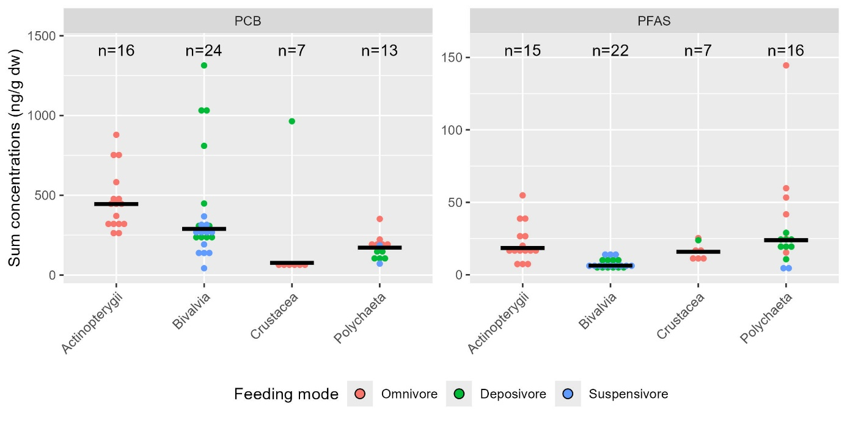

Figure 2 - Sum of contaminant families in soles and three benthic prey taxa (ng/g dw). Group means are shown in black. Colors indicate feeding modes.

Overall, contaminant concentrations displayed considerable variability within species, taxonomic groups, and feeding modes. Among prey, the effects of taxon and feeding mode differed depending on the contaminant family. For the PCB family, bivalves tend to have distinct contamination levels, largely driven by *Limecola balthica*, which exhibits elevated PCB concentrations without any obvious explanatory factor. Interestingly, contamination levels in *Crangon crangon* are lower than in other omnivores and crustaceans. Regarding PFASs, both bivalves and suspension feeders are significantly less contaminated than other taxa and feeding modes.

### Relationship with lipid content for PCB

Examining the relationship between lipid content and total concentrations for PCB family, a significant positive correlation was observed (Spearman’s test: p-value = 0.01, ρ = 0.43). See SI section 2.2 for graphs and more detailed results.

While the positive relationship with lipids for PCBs is expected (Conder et al., 2012), some species deviate from this pattern. For instance, *Crangon crangon* exhibits highly variable lipid levels without corresponding increases in PCB contamination, whereas *Limecola balthica* maintains relatively stable lipid content despite a wide range of PCB concentrations.

### Average contamination profiles

The average contamination profiles of soles and prey are shown in Figure 3.

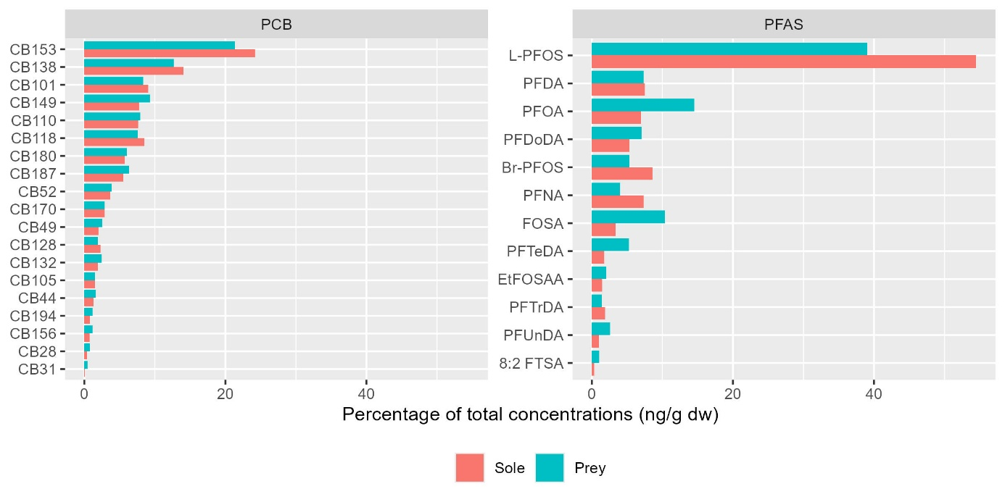

Figure 3 - Average contamination profiles of soles and prey for PCBs (left) and PFASs (right).

For the PCB family, soles and prey exhibit similar profiles, both dominated by CB153, which accounts for 24% of the total in soles and 21% in prey. The second most abundant congener, CB138, is present in slightly lower proportions — 14% in soles and 13% in prey. This congener pattern aligns with previous observations in biota from the Scheldt estuary (Van Ael *et al.*, 2012), the Seine estuary (Bodin *et al.*, 2007) and the Gironde estuary (Bodin *et al.*, 2014), where CB153 and CB138 were also reported as the most and second most prevalent congeners, respectively.

In contrast, for PFAS, L-PFOS is by far the most prevalent compound, representing 55% of the total PFAS concentration in soles and 39% in prey. The subsequent most abundant compounds have much lower proportions and differ between the two groups: in prey, PFOA (15%) and FOSA (10%) are most prominent, while in soles, Br-PFOS (9 %), PFDA (7 %), and PFNA (7%) follow L-PFOS.

## BMFs for PCBs

### Predator-prey BMF (BMFPP)

Predator-prey BMF estimates for each prey are presented for the congener CB153 in Figure 4 (see SI section 3.1 for detailed results by PCB congener). The bioaccumulative potential of PCBs varies markedly among prey taxa. For instance, within the crustacean group, the BMFPP estimate based on *C. volutator* suggests strong biodilution (0.44[0.35-0.49]), whereas the estimate based on *C. crangon* indicates pronounced bioaccumulation (6.41[4.99-9.25]). Moreover, for the majority of species (8 out of 15), the variability in BMFPP estimates spans both sides of the threshold value of 1, encompassing both biodilution and biomagnification. As a result, it is difficult to draw definitive conclusions regarding the overall bioaccumulation potential of PCBs based solely on these estimates.

The relationship between logKow, the number of chlorine substitutions, and BMF estimates under the BMFPP scenario is shown in Figure 5. A non-significant polynomial relationship is observed between logKow and BMFPP values (R² = 0.23, p-value = 0.125). For the vast majority of congeners (16 out of 19), as well as for the sum of PCBs (1.05[0.77-1.15]), the range of BMFPP estimates spans both below and above 1, reflecting substantial variability and precluding firm conclusions regarding their biomagnification behavior. However, BMFPP values for CB28 and CB31 (tri-chlorinated biphenyls), and for CB132 and CB149 (hexa-chlorinated biphenyls), clearly indicate biodilution (BMFPP max < 1). Conversely, the sum of PCBs and 8 out of the 19 congeners show median BMFPP values exceeding 1, indicating biomagnification. The median BMFPP estimate for CB153 — a benchmark compound for evaluating method performance due to its consistent biomagnification across food chains — also indicates biomagnification (1.1 [0.83–1.28]).

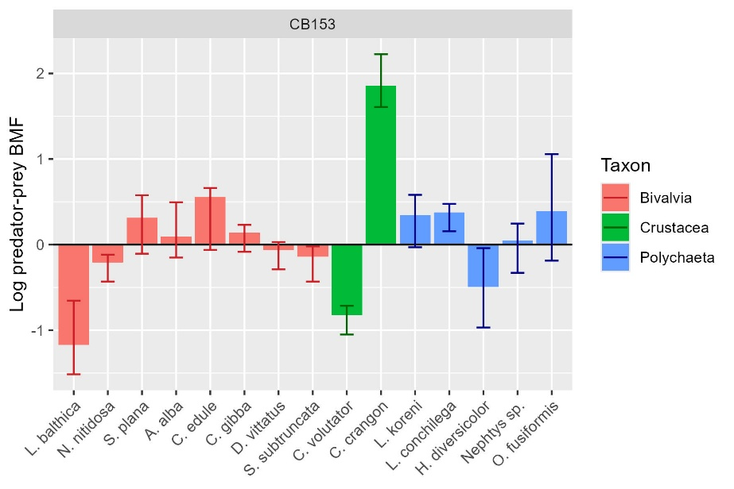

Figure 4 – Log-transformed minimum, median, and maximum BMF estimates (BMFPP scenario) for the CB153 congener across species. Taxa are color-coded; values > 0 indicate biomagnification.

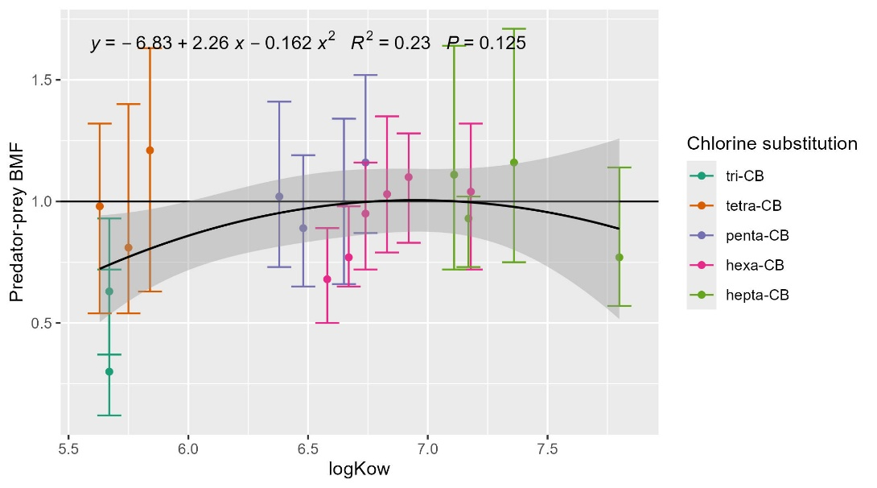

Figure 5 – Median BMF values of min, median, and max estimates by species, under BMFPP scenario in relation to logKow and chlorine substitution. The black curve represents a global quadratic regression (second-order polynomial) fitted across all chlorination classes.

### Diet-based BMF (BMFD)

The relationship between logKow, the number of chlorine substitutions, and BMF estimates under the BMFD scenario is shown in Figure 6. A significant polynomial relationship is observed between logKow and BMF values (R² = 0.45, p-value = 0.009). For most congeners, median BMFD values exceed 1, indicating biomagnification, with the exception of those containing only three chlorine atoms (CB28 and CB31). BMFD estimates for CB153 clearly indicate biomagnification (2.01 [1.24–2.68]). Similar conclusions were drawn for the sum of PCBs (1.72[1.07-2.41]) and 6 of the 18 other congeners: CB101, CB110, CB118, CB128, CB138, and CB149, which are penta- and hexa-chlorinated biphenyls). However, for the remaining congeners — except for CB31 which indicates biodilution (0.31 [0.11-0.93]) — the range of BMFD estimates spans both below and above 1, reflecting a wide variability that prevents firm conclusions regarding their specific biomagnification behavior.

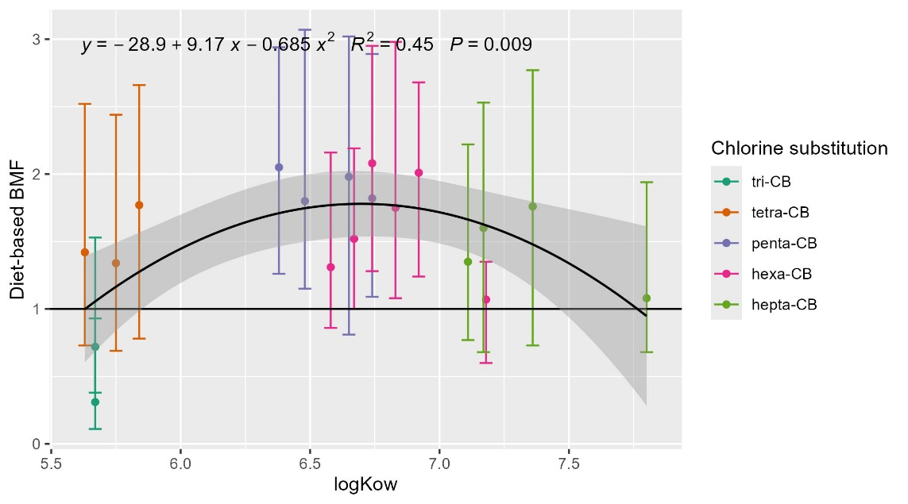

Figure 6 - BMF estimates (min, median, max) under BMFD scenario in relation to logKow and chlorine substitution. The black curve represents a global quadratic regression (second-order polynomial) fitted across all chlorination classes.

### Predator-prey trophic level–normalized BMF (TL-BMFPP)

The trophic positions used in this scenario, inferred from species-specific δ¹⁵N isotopic signatures, are presented in SI section 3.2. TL-BMFPP estimates for each prey species, based on the CB153, are shown in Figure 7 (see SI sections 3.2 for detailed values for CB153 and 3.3 for congener-specific results). Due to insufficient material, isotopic measurements could not be obtained for *D. vittatus*, and consequently, no TL-BMFPP could be derived for this species. For *C. crangon*, TL-BMFPP was equal to zero, as its median trophic level exceeded that of the sole. Among the remaining 13 species, 8 exhibited median TL-BMFPP values above 1, suggesting potential biomagnification. However, the variability of these estimates spans both below and above the threshold of 1 (except for *Lanice conchilega*), preventing definitive conclusion. Five species clearly showed evidence of biodilution.

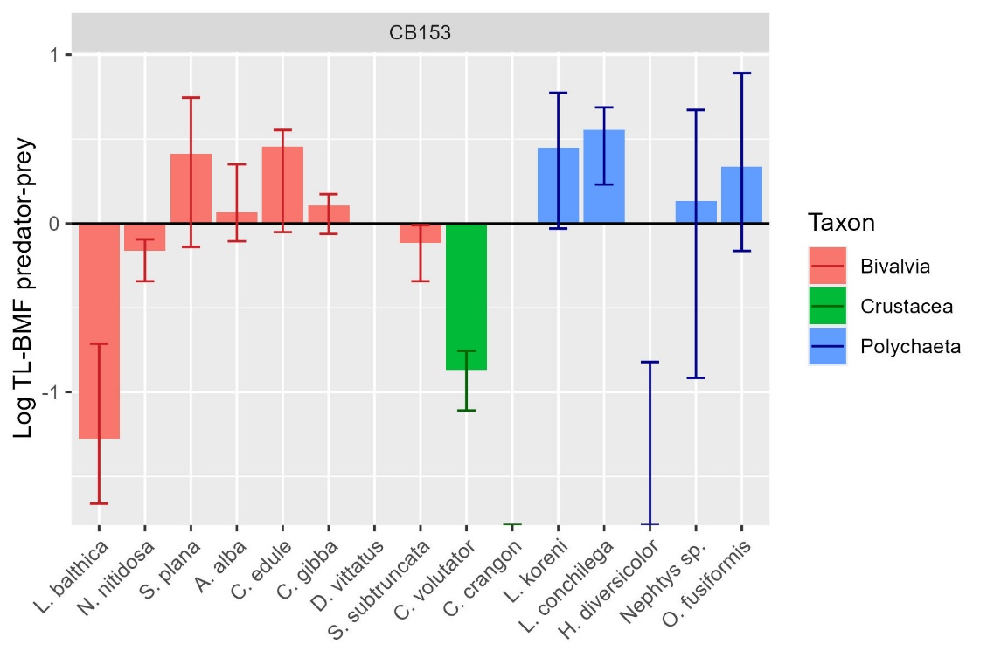

Figure 7 - Log-transformed minimum, median, and maximum BMF estimates (TL-BMFPP scenario) for the sum of PCB congeners across species. Taxa are color-coded; values > 0 indicate biomagnification.

The relationship between logKow, the number of chlorine substitutions, and BMF estimates under the TL-BMFPP scenario is shown in Figure 8. A non-significant polynomial relationship was observed between logKow and TL-BMFPP values (R² = 0.27, p-value = 0.079). For 13 out of 19 congeners, median TL-BMFPP values were below 1. However, except for five congeners whose variability clearly indicated biodilution — CB28, CB31, CB132, CB149 and CB187 — the TL-BMFPP ranges for the other congeners, including CB153 (1.09[0.78-1.3]) and the sum of PCBs (1.05[0.71-1.31]) extended both below and above 1, reflecting high variability and uncertainty in biomagnification patterns.

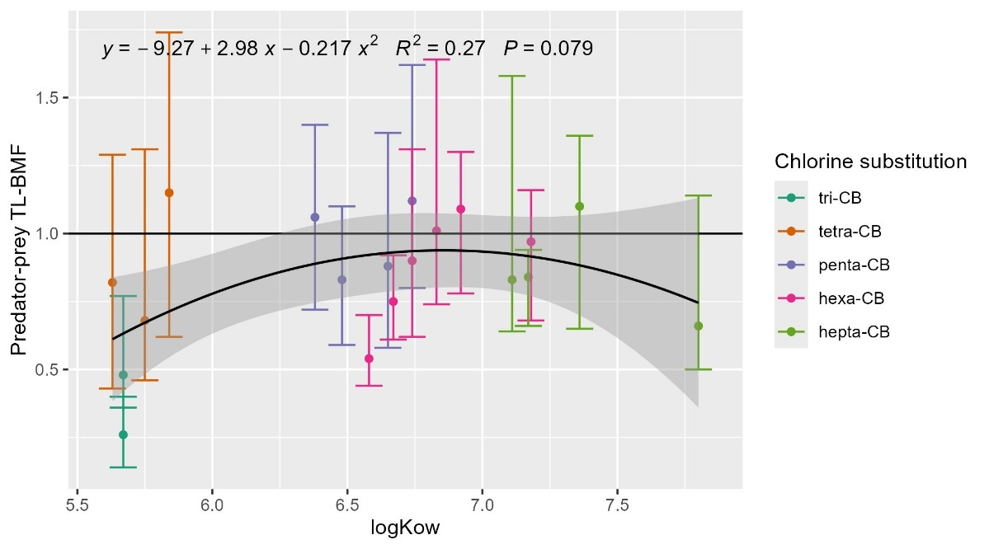

Figure 8 - Median BMF values of min, median, and max estimates by species, under TL-BMFPP scenario in relation to logKow and chlorine substitution. The black curve represents a global quadratic regression (second-order polynomial) fitted across all chlorination classes.

### Diet-based trophic level–normalized BMF (TL-BMFD)

Diet-based TL-BMFs were estimated using the same dietary composition as in the BMFD scenario. The relationship between logKow, the number of chlorine substitutions, and BMF estimates under the TL-BMFD scenario is shown in Figure 9 (see SI section 3.2 for results for CB153). A significant polynomial relationship was observed between logKow and BMF values (R² = 0.42, p-value = 0.014). For 18 out of 19 congeners median TL-BMFD values exceeded 1, indicating biomagnification, except for one containing only three chlorine atoms (CB28 and CB31). Strong evidence of biomagnification was found for 7 out of 19 congeners, including CB153 (7.78 [1.90–17.95]), as well as for the sum of PCBs (4.94 [1.23-13.22]). For the other 12 congeners, however, TL-BMFD estimates ranged both below and above 1, reflecting high variability and limiting the certainty of their biomagnification potential.

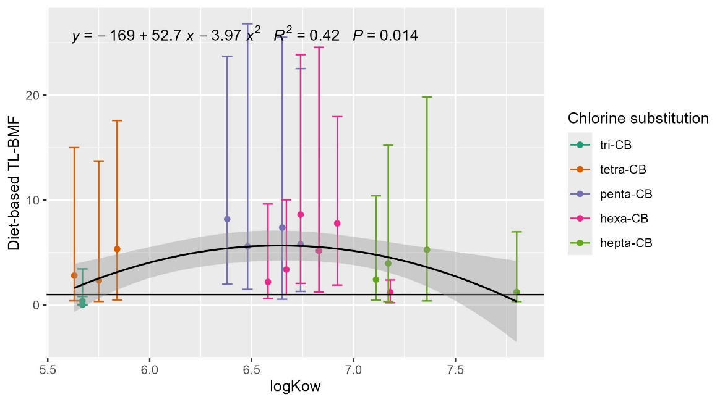

Figure 9 - BMF estimates (min, median, max) under TL-BMFD scenario in relation to logKow and chlorine substitution. The black curve represents a global quadratic regression (second-order polynomial) fitted across all chlorination classes.

### Influence of computational method on BMF estimates

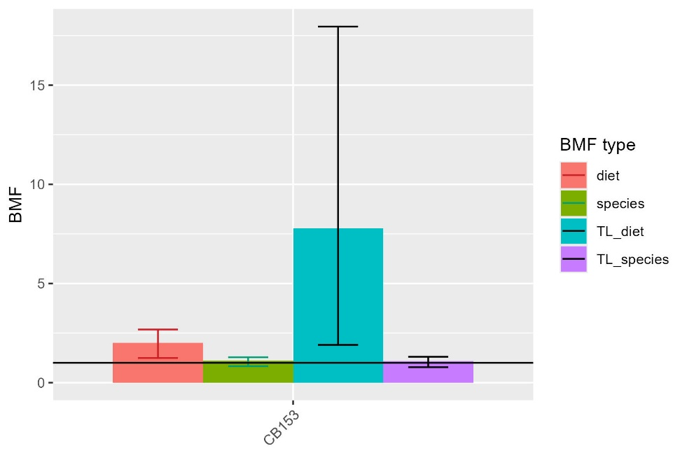

Figure 10 – Influence of BMF computation scenario on BMF estimates for CB153.

Summary statistics of BMF estimates for each computation method are presented in Figure 10, with detailed values by PCB congener and for the sum of PCBs available in SI section 3.4. Results indicate BMF estimates show greater variability in scenarios based on diet composition. Notably, only the diet-based scenarios clearly support bioaccumulation of CB153, with an estimated BMF of 2.01 [1.24-2.68] for BMFD scenario and 7.78 [1.9-17.95] for TL-BMFD scenario, while estimates for the predator-prey methods span both above and below the bioaccumulation threshold of 1. Diet-based scenarios also yield higher median BMFs values compared to predator-prey scenarios, suggesting that the dierary contamination level in CB153 (1 325 [1 093-1 716] ng/g lw) is lower than the median contamination level observed in preys species (2 428 [145-13 874] ng/g lw). Diet-based TL-BMF scenario is much higher than predator-prey BMF-TL scenario than expected by the relative difference between the BMF scenarios. This is due to the lower delta of trophic level in the diet-based scenario (3.97-3.63 = 0.34) compared to that of the delta with median trophic length across species (3.97-3.03 = 0.94) (see SI section 3.2)

## Diet-based BMFs for PFASs

### Influence of nondetect handling methods on BMF estimates

Comparison of diet-based BMF estimates for PFASs using five methods for addressing nondetects is presented in Figure 11 and detailed values are available in SI section 3.5. Regardless of the method used to estimate contamination levels in dietary taxa, the ranges of diet-based BMF estimates overlapped across all PFAS compounds. However, for certain compounds, the “uncensored” scenario (based solely on detected values) yielded median BMF estimates that differed from those obtained with the other approaches. Slight differences were observed for PFDA, PFTrDA, FOSA, EtFOSAA, and Br-PFOS. More substantial discrepancies occurred for PFUnDA, PFTeDA, and 8:2 FTSA — compounds with detection frequencies below 50% in the sole group — where the uncensored scenario indicated biomagnification, whereas the other methods consistently suggested strong biodilution.

The two substitution-based scenarios (i.e., half-LOQ and log-normal imputation) produced comparable results. Similarly, the Kaplan-Meier method yielded results consistent with the substitution approaches, except for eight compounds with detection frequencies below 70% in either sole or prey groups, for which summary statistics could not be estimated. Finally, the ROS method produced results that were generally consistent with other approaches, except for PFUnDA, PFTeDA, Br-PFOS, and 2:2 FTSA — compounds with detection frequency below 50% in at least one group — where median BMF estimates indicated a reduced effect of either biodilution or biomagnification.

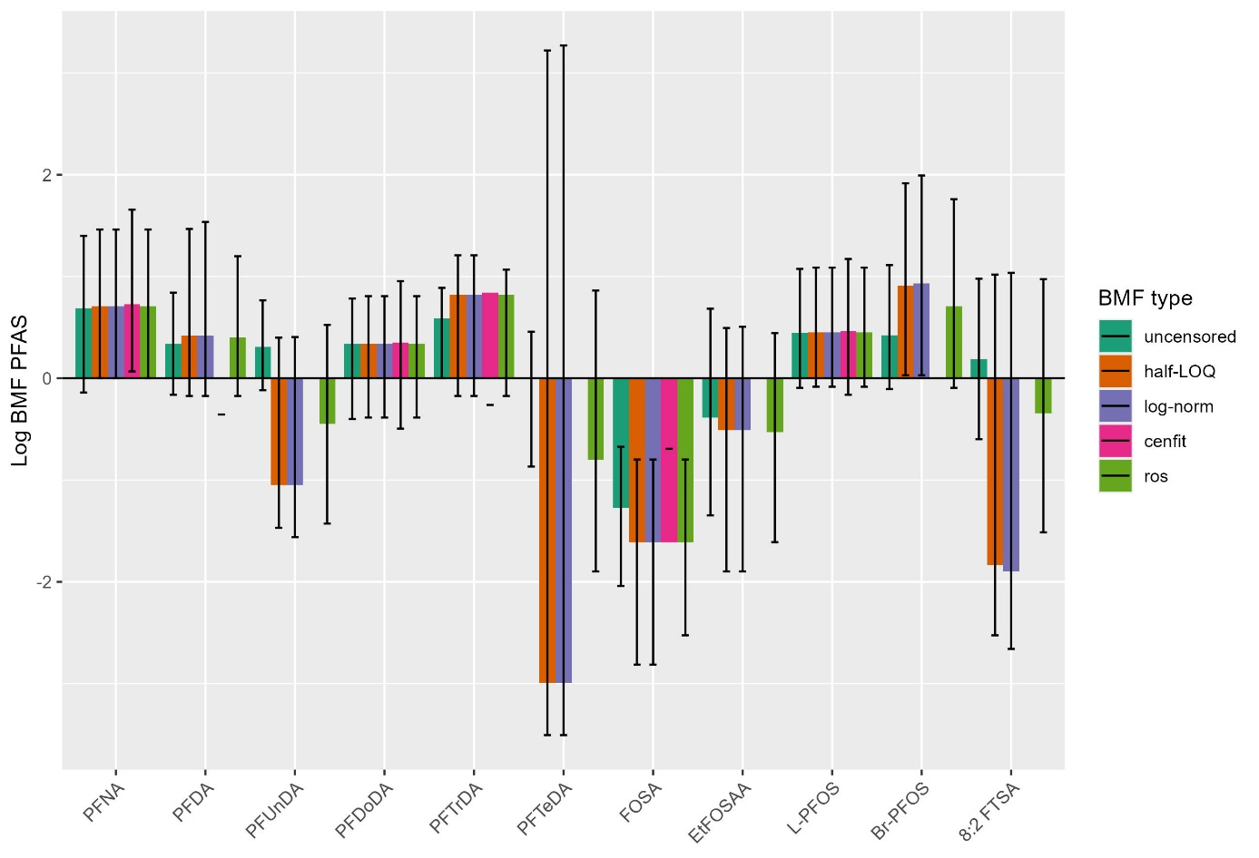

Figure 11 - Comparison of diet-based BMF estimates for PFASs using five methods for addressing nondetects.

### Influence of structural properties on BMF estimates with ROS method

For a given perfluorinated chain length of eight carbon atoms, perfluoroalkyl sulfonates (PFSAs) exhibit higher median BMF estimates, indicating biomagnification, whereas the other sub-families show patterns consistent with biodilution. In contrast, within the perfluoroalkyl carboxylic acids (PFCAs) sub-family, BMF estimates show no clear trend with increasing chain length: compounds with 11 (PFUnDA) and 14 (PFTeDA) carbon atoms in their perfluorinated chains have median values below 1 whereas the others are above 1.

L-PFOS, commonly used as a reference compound for PFAS biomagnification, showed median BMF values above 1 across all scenarios, suggesting its biomagnification despite minimum values slightly below 1. Six out of eleven PFAS exhibited median BMF values greater than 1, indicating potential biomagnification, in good agreement with previous findings on PCBs and PFAS in the Gironde estuary (Munoz *et al.*, 2017; Lauzent, 2018).

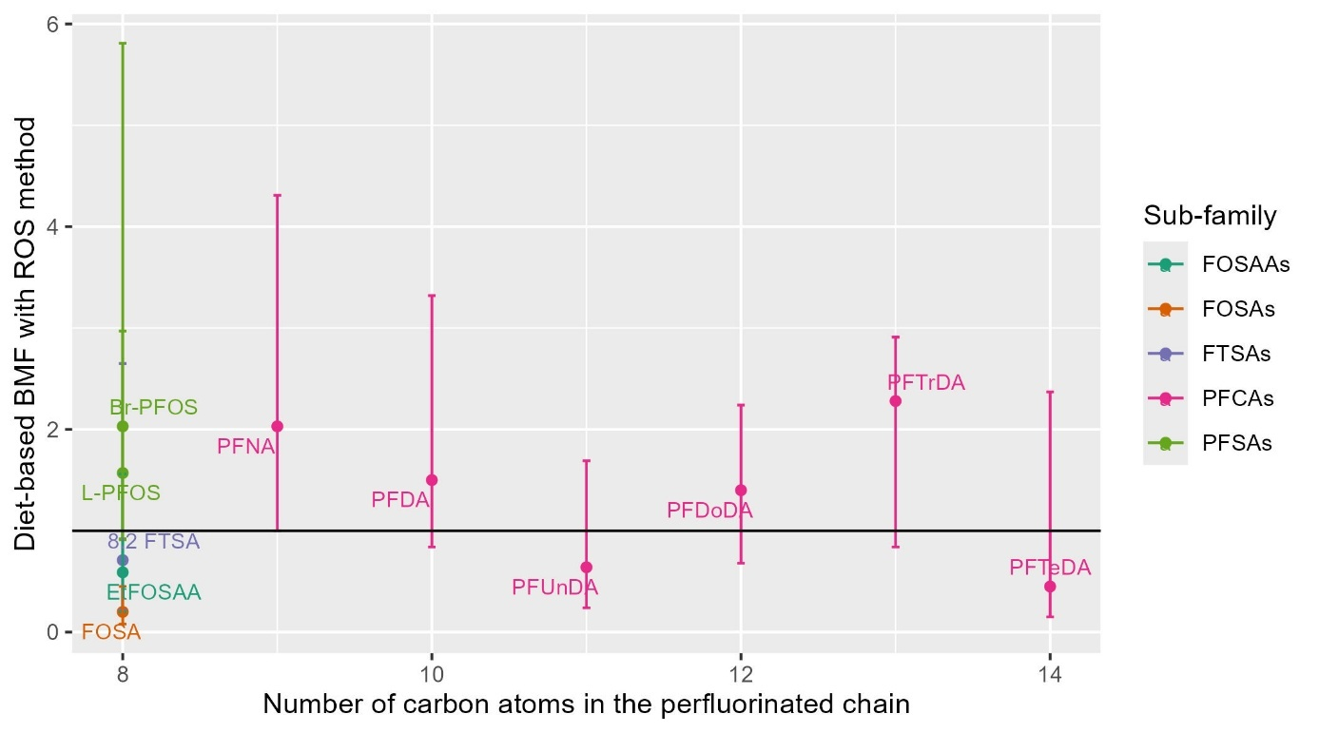

Figure 12 – Comparison of diet-based BMFs for PFASs estimated using the ROS method, by perfluorinated chain length and sub-family.

# Discussion

## Influence of BMF Calculation Methods for PCBs

### Marked inter- and intra-specific variability in predator-prey BMFs

#### The high variability of predator-prey BMFs was not explained by taxon or feeding habits

Regarding this interspecific variability, our study could not be able to clearly attribute a determining role to prey taxonomic group —which could reflect metabolic differences— or feeding strategy, which may influence exposure pathways (e.g., greater waterborne uptake in filter feeders or increased sediment exposure in burrowers). Although these factors are well known to affect contaminant uptake and biomagnification potential (Borgå *et al.*, 2004; Bodin *et al.*, 2008), they did not appear to consistently explain the observed variability in our dataset.

For example, in our study, PCB contamination levels in *Limecola balthica* were found to be two to three times higher than in other deposit-feeding bivalves, resulting in BMF values indicative of strong biodilution, which is unexpected from PCBs and unexplained by taxonomic group or feeding mode.

Strong biodilution was also observed for *C.volutator*, due to its high contamination levels relative to the other prey species in general, and especially relative to the other crustacean, *C. crangon*. This was unexpected given their respective feeding strategies —omnivorous for *C. crangon* and deposit-feeding for *C. volutator*— which are also supported by stable isotope data. However, as only a single *C. volutator* sample was analyzed, this result may reflect strong intra-specific variability, similar to that observed in *L. blathica*. Given its significant occurrence in stomach content analyses (11%), gaining a more robust understanding of *C. volutator* contamination levels would be valuable.

In the case of *Hediste diversicolor*, the unexpected marked biodilution for PCBs observed in its predator-prey BMFs may be explained by its omnivorous feeding strategy and its relatively high trophic position among polychaetes, as indicated by isotopic analysis. Indeed, among polychaetes, stable isotopic ratios seems to be more clearly related to inter-specific variations of BMFs (see SI section 3.2).

#### The intra-specific high variability could be attributed to spatio-temporal heterogeneity of environmental contamination and internal factors

*L. balthica* also exerts a large intra-specific variation, that may be partly attributed to spatio-temporal heterogeneity (SI section 2.2 – a threefold difference between the least and most contaminated individuals) while each of the five samples was collected from a different site, and at different seasons. Contaminant levels in estuarine environments are known to vary both spatially and temporally (Van Ael *et al.*, 2012; Olisah, Adams and Rubidge, 2021; Pitacco *et al.*, 2021; Fremlin, Elliott and Gobas, 2025), but this aspect could not be fully investigated here due to insufficient sampling across all species. Sediment-to-benthos transfer of PCBs may also be influenced by local sediment characteristics such as clay content, or water parameters like conductivity, which varies along the estuarine gradient (Van Ael *et al.*, 2012). In addition, individual-level factors such as age and body size can influence bioaccumulation and contribute to intra-specific variability, underscoring the importance of pooling individuals by size class during sampling (Borgå *et al.*, 2004; Schäfer *et al.*, 2015).

#### Considering spatio-temporal and individual variabilities may reduce error in biomagnification estimation

Overall, numerous factors contribute to the variability of BMF estimates based on predator-prey pairs. Failing to consider this complexity can compromise both the monitoring of persistent organic pollutants (POPs) and the reliability of BMF assessments. In field studies, spatio-temporal variations in prey contamination introduce uncertainties that may challenge the accuracy of BMF values. To investigate spatio-temporal effects, complementary approaches using standardized passive (Schäfer *et al.*, 2015) or sentinel organisms —such as the burrowing polychaete *Nereis diversicolor*, a common estuarine species and known prey of sole (Durou *et al.*, 2007)— could help normalize observed contaminant levels in prey species. However, while such methodologies offer means to account for or reduce intra-specific and spatio-temporal variability, they alone may not yield representative BMF values. This is because prey species differ in their bioaccumulation capacities depending on taxonomy and feeding behavior. Their relative contribution to the predator’s diet thus remains essential, and stomach content analysis provides a robust method to estimate it.

### Diet-based scenarios provide clearer evidence of PCB biomagnification

#### Diet-based scenarios were the only ones indicating biomagnification of most of the PCB congeners

All four scenarios yielded similar results, indicating the biomagnification of CB153. However, only the diet-based scenarios showed biomagnification for most PCB congeners, with the exception of the two trichlorinated biphenyls. But this observation of general biomagnification is in good agreement with numerous in situ studies of TMF or TL-BMFs that have reported biomagnification across all investigated PCB congeners (Fisk, Hobson and Norstrom, 2001; Hop *et al.*, 2002; Borgå *et al.*, 2004, 2004; Bodin *et al.*, 2008; Di Paolo *et al.*, 2010; Walters *et al.*, 2011; Van Ael *et al.*, 2013; Kobayashi *et al.*, 2015). Indeed, this conclusion on the preponderant role of considering diet in biomagnification estimation is consistent with the theoretical definition of BMF (Gobas *et al.*, 1999) and has already been observed to explain fish species differences in PCB contamination (Masset *et al.*, 2019).

#### The high variability of predator-prey BMFs was flattened after summarization

BMFs results for predator-prey couples revealed substantial interspecific variability, ranging from biodilution to biomagnification. This variability appears to be closely linked to the heterogeneous contamination levels of prey species (SI section 2.2). As previously noted by (Schäfer *et al.*, 2015) and (Borgå *et al.*, 2012), the selection of prey species included in BMF calculations can significantly influence the outcome of biomagnification assessments. Indeed, they preconized that information on prey/predator trophic interaction and exact trophic positions of the studied species have to be confirmed (e.g. by stomach content analyses or carbon and nitrogen stable isotope ratio shifts). In our study, all these prey species could potentially contribute to the diet of sole, which was supported by comparable estimates for predator-prey BMFs and trophic-level normalized BMFs (Borgå *et al.*, 2004). However, we summarized the predator-prey approach computing BMF estimates as the median of species-specific median, minimum, and maximum BMFs. This summarization computationally flattened the interspecific variability while assigning equal weight to each species, regardless of their dietary relevance. As a result, predator-prey BMFs appeared less variable compared to diet-based BMFs but also concluded to too much lower BMFs, compared to the expected ones for PCBs. Summarizing predator-prey couples BMFs seems to be insufficient to estimate biomagnification properties.

#### BMFs from predator-prey scenarios was lower than in diet-based scenarios

In our study, biomagnification was higher, thus closer to the expected one for PCBs, when considering the diet composition. Indeed, it was because the median level of contamination of the diet (1325 ng/g lw) was lower than the median concentration across prey species (2428 ng/g lw). This was expected as the diet was mainly composed of crustaceans, while this taxonomic group was the least contaminated (lipid-normalised concentrations). Moreover, this group represented only 7 out of 44 predator-prey BMF estimates in the computation of median BMFs statistics after summarization, explaining its low impact on this latter. Also, predator-prey median scenario considered a strong influence of low BMF values from bivalves, mainly due to *L. balthica* exerting the highest level of contamination among species, even though this taxon was less frequently consumed.

#### Considering diet composition is essential to estimate biomagnification

These results suggest that the traditional approach based on prey-predator couples may under-estimate biomagnification and its summarization to assess general biomagnification may influence conclusions. It underlines the necessity to have a more integrative approach considering complex diets, with prey species differing in relative proportions in the diet and contamination levels (Liu, Haffner and Drouillard, 2010; Mounier *et al.*, 2020). Also, differences in prey lipid content (in the case of PCBs), and digestibility should also be considered. Indeed, these factors could lead to differential levels of contamination of the food bowl during digestion, and thus, to differential biomagnification (Gobas *et al.*, 1999). For example, surprisingly, the crustacean group presented the lowest contamination level but the highest lipid content (see SI section 2), suggesting that either it feeds on less contaminated mater or it is able to better eliminate PCBs, compared to polychaetes and bivalves. This species difference in lipid-normalized contamination is also supposed to increase the assimilation efficiency of PCBs, and thus BMFs (Gobas *et al.*, 1999). All these differences among preys could be taken into account through more complex models that better describe PCB uptake from a complex food diet (Masset *et al.*, 2019; Mounier *et al.*, 2020).

### Defining diet composition is challenging

#### Influence of digestibility in species identification

For most species that were dosed in contaminants, their relative importance in the diet could not be directly estimated from stomach content analyses. Indeed, stomach content may not represent well diet composition because of the challenging identification of prey species from tractus content, mostly depending on species digestibility. As a consequence, stomach content may overestimate the presence of less digested prey, easer to identify. On the contrary, rapidly digestible prey presence may be underestimated.

#### Proportions in diet in terms of number of individuals and not in biomass

Also, to study dietary intake, diet composition should be estimated from prey species masses ingested. However, diet composition was only estimated based on the number of individuals found in stomach compared to the overall number of individuals. This leads to important bias when prey species masses are very different. For example, crustacean group was found to be the prevalent group with 51 % of individuals in stomachs. However, this corresponds to 11.5 % of *Corophium volutator*, 1.6 % of *Crangon crangon* and 32 % represent the class of Hexanauplia (see SI section 2.1). This last group corresponds to harpacticoïd copepods, thus with an importantly small mass compared to bivalves, shrimps or polychaetes. Thus, the proportion of crustaceans in diet may have been overestimated. A better way to estimate diet composition could have been to ponderate the number of individuals by the mean weight of the species or taxonomic group considered.

#### Discrepancies between species identified and species studied in contaminant levels

Another limitation in estimating diet contamination was the fact that species dosed in contaminant may not have been the most found in stomach content. For example, copepods was not studied chemically, even though they are known to bioconcentrate PCB from water (Loizeau, Abarnou and Ménesguen, 2001; Borgå *et al.*, 2004, 2005), adding uncertainty on the level of contamination considered for crustaceans. In the case of arthropods from the malacostraca group, 36 species were identified in stomach content whereas only 2 of them were dosed in contaminant. For example, the species *Diastylis bradyi* was as frequently found as the *C. crangon* species dosed in contaminant (1.03 and 1.59 %, respectively). In the case of polychaetes, the prevalent prey species in stomach content, Polydora ciliata (24 %) was not dosed whereas those dosed represented less than 1 % of the prey individuals (0.4% for *O. fusiformis*, 0.53% for *L. koreni*, and 0.18% for *L. conchilega*), even two species was never found in stomachs (*H. diversicolor* and *Nepthys sp.*). All these observations emphasize the importance of studying the diet before selecting prey species for contaminant studies. In the case of bivalves, most of the time (11.5 % of prey individuals), only syphons are found in stomach, which is insufficient to identify a species whereas the bivalve group was found to have a strong inter-specific contamination variation. Indeed, among the 6 species study for contamination, only 4 of them could have been, sometimes, identifiable from stomach contents. To compensate this limitation, genetic studies of stomach content may also be used.

#### Importance of spatio-temporal variability of diet in fish life history

Moreover, stomach content may vary across zones and seasons, as a result of sole opportunistic comportment and the presence/absence of different prey species at a given moment and place. The use of stable isotopes may be an alternative way to estimate feeding habits over a longer period (Borgå *et al.*, 2004). However, sole contamination may also be spatio-temporally variable, as a result of their life history across the estuaries since their settlement. Thus, the knowledge of diet composition and prey contamination variations may be useful to predict the life histories of environmental contamination and thus, better understand sole contamination and, as a consequence, reduce uncertainties in biomagnification.

#### Alternative method based on stable isotopic ratios

Recently, (Ballutaud *et al.*, 2019) developed an original method, implemented within a Bayesian framework, to account for the propagation of uncertainties in the calculation of TMFs. This model, named ESCROC, is based on the principle of classical isotopic mixing models: it assumes that the chemical signature (contaminant or isotope) of a predator is the weighted average of the chemical signatures of its prey, plus an enrichment factor. In the case of isotopes, this factor is referred to as the isotopic enrichment factor; for contaminants, it corresponds to the TMF. Initially, the use of ESCROC was planned for the data acquired in this project. Unfortunately, despite significant efforts in sampling and data acquisition, project constraints did not allow the construction of a dataset that included (1) enough isotopic data collected from the same individuals as those analyzed for contamination, (2) a sufficient number of organisms along the food chain, and (3) representation from primary consumers to various predators. Therefore, we were unable to implement ESCROC with our data.

### BMF and TL-BMF can be compared to each other and with TMF from literature

Although BMFs explicitly describe enrichment of chemicals between predator and prey, BMFs represent only a single trophic transfer. A BMF > 1 indicates that the substance has biomagnified in the predator, compared to the given prey (Fremlin, Elliott and Gobas, 2025). Variation in the ability of organisms to biotransform and eliminate chemicals can produce variation in BMFs among predator-prey relationships in a food web, and this can obscure the chemical’s overall food web biomagniﬁcation behaviour. TMFs provide a characterization of the average degree of biomagniﬁcation that occurs with increasing trophic position within organisms of an entire food web (Fremlin, Elliott and Gobas, 2025). Thus, it is more accurate in predicting biomagnification when incorporating multiple food web interactions (Conder et al., 2012). The scientific consensus is that chemicals are considered bioaccumulative if TMF > 1. However, TMF couldn’t be estimated from our limited part of trophic web, coupled with small sample size for prey species (Borgå et al., 2012). Moreover, with a small sample size as ours, a TMF below 2 or 3 is unlikely to show a statistical difference from 1, even if the true TMF is above 1 (Conder et al., 2012). Indeed, we preferred considering trophic level-normalized biomagniﬁcation factors (TL-BMFTL). TL-BMF is still the second preferred metric of bioaccumulation potential recommended by (Conder et al., 2012).

Indeed, although TL-BMF does not reflect bioaccumulation across the entire food web, the studied predator-prey relationship (i.e., soles feeding on invertebrates) remains relevant for stakeholders. It can aid in risk assessments, as sole is a commercially consumed fish (with muscle contamination posing potential human health risks), and early-life contamination may negatively impact fish stocks. Moreover, TL-BMF values vary but they generally include the TMF range. This is expected since TMF can be viewed as the average BMF in the studied food web. When TMF data are unavailable, TL-BMF can be a useful substitute, though it may overestimate TMFs in cases where no biomagnification occurs (Conder et al., 2012).

As in our case the number of food web interactions is the same for BMF and TL-BMF, they are representing the same thing, and thus can be directly compared to each over. Moreover, the formula chosen from TL-BMF is mathematically equivalent to TMF, regardless of predator-prey pairing and their difference in trophic levels, allowing direct comparison with literature (Conder *et al.*, 2012), at least for comparable ecosystems and range of trophic level. For example, TMFs are typically higher in marine food webs compared to freshwater food webs, in food webs having consumers with high lipid content, in food webs including warm-blooded apex predators with inscreased metabolism activity (birds and mammals), and food webs with longer food chains (Fisk, Hobson and Norstrom, 2001; Hop *et al.*, 2002; Borgå *et al.*, 2004; Kobayashi *et al.*, 2015). However, methodological differences within and among studies may still darken this comparison (Hoekstra *et al.*, 2003; Walters *et al.*, 2011). For example, contamination may have been measured in whole body, muscle, liver or blubber for mammals. For instance, in our study we measured whole body contamination of fish whereas in some other studies it is rather measured in muscle.

### Higher diet-based TL-BMF compared to diet-based BMF for CB153

Considering BMF and TL-BMF for CB153, we observed quite the same levels and variability between prey-predator scenarios. Indeed, for both scenarios the median summarization applied flattened the variability of observed BMFs for the different predator-prey couples.

On the contrary, a higher level and a larger variability was observed for diet-based TL-BMF compared to diet-based BMF. The higher level was due to the division of diet-based BMF by a delta of TL between sole and diet inferior to 1 (see SI section 3.2.) in the formula of TL-BMF. Moreover, this formula emphasis the variations of BMF due to the transformation in log and exponential ten (see SI section 3.2). This result indicates that considering the small delta of TL between sole and diet (0.34), the difference between sole and diet contamination (simple BMF) lead to higher TL-BMF as it corresponds to the BMF if we would have considered a difference of TL equal to one.

Interestingly, considering the diet in TL-BMFs yielded to higher values of biomagnification than prey-predator TL-BMFs because of the smaller difference of trophic level between diet and sole, compared to sole and the median of species trophic level.

### Comparison of diet-based TL-BMF with TMF literature for CB153

The TL-BMF diet scenario may be compared to in situ measurements of TMFs from literature for CB153 (Table 4). However, as TMFs depend on species constituting the food web, comparison between studies should be done with caution. Indeed, TMFs from the reported literature have been studied in various ecosystems and considering various species and trophic levels. Few of these studies estimated TMF closed to 1 (1.06-1.16) (Van Ael *et al.*, 2013; Kobayashi *et al.*, 2015), thus closer to prey-based TL-BMFs from our work (1.09 [0.78-1.3]). Other studies reported greater TMFs (2.2 to 15.3), thus closer to diet-based TL-BMFs (7.78 [1.9-17.95]).

Many factors may influence biomagnification (Borgå *et al.*, 2004). For example, lower values of TMF observed could be due to relatively low lipid contents of consumers (Fisk *et al.*, 1998; Antunes *et al.*, 2008) and/or high lipid contents in the prey (Burreau *et al.*, 1997; Fisk *et al.*, 1998; Gobas *et al.*, 1999; Liu, Haffner and Drouillard, 2010), thus limiting the transfer of these lipophilic compounds from prey to consumers. It could have been the other way around considering higher values of TMFs.

For example, it seems that the lowest TMF values are found in foodwebs including low trophic level organisms such as algae, deposit feeders, grazers and suspension feeders (Bodin *et al.*, 2008). On the contrary, the highest TMF values from literature corresponded to trophic links between fish and predators such as seabirds or marine mammals, which exhibit strong bioaccumulation likely due to (1) seabird scavenging behaviors on marine mammals (Fisk, Hobson and Norstrom, 2001), (2) their long lifespan and higher energetic demands, and thus higher feeding rates as homeotherms (Borgå *et al.*, 2004), or (3) simply because measurements are typically based on high lipid content tissues (e.g., liver or blubber) where it is known that PCBs tend to accumulate (Hop *et al.*, 2002; Borgå *et al.*, 2004; Walters *et al.*, 2011) whereas whole-body of muscle concentrations are often used for fish. However, strong values were also reported in crab foodwebs (4-15.3) from French coastal areas near our study site (Bodin *et al.*, 2008).

Table 4 – Comparison of biomagnification factors with literature.

|  |  |  |  |  |
| --- | --- | --- | --- | --- |
| Source | Food web type | Main trophic groups | Type of estimate | Values |
| This study | Estuarine (Seine estuary) | Fish, macroinvertebrates | TL-BMF CB153 (TL 2.7-3.97; consumer 13.7) | Diet-based : 7.78 [1.9-17.95]  Prey-based : 1.09 [0.78-1.3] |
| (Bodin *et al.*, 2008) | Bay (Seine, 2 spots in Iroise Sea) | Crab, macroinvertebrates, macroalgae, sediment organic matter | TMF CB153 (TL 1.1 – 3.9) | 9  15.3  4.1 |
| (Di Paolo *et al.*, 2010) | Estuarine (Terneuzen, Western Scheldt estuary) | Plankton, macroinvertebrates, fish | TMF CB153 (TL 1.3-3.8) | 3.03 (CI: 2.35-3.91) |
| (Van Ael *et al.*, 2013) | Estuarine (Terneuzen, Western Scheldt estuary) | Plankton, macroinvertebrates, fish | TMF CB153 ( 13.7-21.6) | 1.16 |
| (Kobayashi *et al.*, 2015) | Estuarine (Omuta river, Japan) | Snail, fish | TMF CB153 (TL 1.8-3.5) | 1.06 |
| (Verhaert *et al.*, 2017) | Freshwater sub-tropical | Macroinvertebrates, fish | TMF CB153 (TL 2.0-4.0) | ~ 2.5 |
| (Fisk, Hobson and Norstrom, 2001) | Arctic marine | Copepod, fish, marine birds, marine mammals | TL-BMF CB153 | 9.7 |
| (Hop *et al.*, 2002) | Arctic marine (Barents Sea) | Poikiloterms: macroinvertebrates, fish | TMF CB153 (TL 1.6-3.5) | 4.1 |
| (Kelly *et al.*, 2008) | Arctic marine | Plankton, bivalves, fish, marine mammals | TMF CB153 (TL 2.3 vs 3.1-5.5) | 11 (CI : 8.6-14) |
| (Hoekstra *et al.*, 2003) | Arctic marine | Zooplankton, fish, marine mammals | TMF CB153 (TL 2.0-4.1) | 6.69 |
| (Houde *et al.*, 2008) | Lake | Lake trout, benthic macroinvertebrate, zoo-plankton | TMF CB153 (TL 0-6) | 3.4 (sd = 1.2) |

## Influence de la prise en compte des valeurs manquantes

(Schäfer *et al.*, 2015) indique que bien souvent, les résultats sont transférés depuis les analyses chimiques vers la modélisation des facteurs de transfert, sans que les incertitudes associées au niveau précédent ne soient prises en compte. Cela conduit fréquemment à des précisions et fiabilités **apparentes** c’est pour cela que la variabilité de contamination du biote a été inclue dans le calcul des BMFs et que la présence de valeurs manquantes pour les PFAS a été considérée.

Le calcul du TMF est basé sur l’examen de la relation statistique entre le niveau moyen de contamination des espèces et leur niveau trophique moyen le long d’une chaine trophique (Borgå *et al.*, 2012). Récemment, (Munoz *et al.*, 2017) ont listé et évalués différentes méthodes statistiques pour estimer de façon pertinente les TMF compte-tenu des différents biais statistiques potentiels liés à la présence de valeur censurées (Borgå *et al.*, 2012; Mackay *et al.*, 2016). Parmi ces méthodes, le package R « LMEC » (Vaida and Liu, 2009) permet de tenir compte des données censurées à gauche (valeurs < LOD ou LOQ suivant le seuil retenu), de l’incertitude de mesures et de la variabilité intra et interspécifique via l’introduction d’un effet aléatoire « espèce » dans le modèle linéaire décrivant la relation statistique entre le log de la contamination mesurée à l’échelle individuelle et le niveau trophique. Ce dernier est estimé au moyen des concentrations en δ15N, en utilisant un ou deux organismes pour la définition de la ligne de base.

## Influence of physico-chemical properties on BMFs

### Family comparison

PCB TL-diet : 0.02 CB31 – 3.94 CB118 (min : 0 CB31 – max : 12.31 CB118)

PFAS : médiane 0.05 PFTeDA - 2.54 Br-PFOS (min 0.03 pour PFTeDA, max : 7.3 Br-PFOS)

biblio : TMF et BMFTL PFOS (Houde et al., 2006 Sarasota Bay + Tomy et al., 2004 Arctic + Verhaert 2017 subtropical freshwater

Ce résultat est en accord avec les observations récentes sur la bioaccumulation des PFASs dans les écosystèmes aquatiques (Houde et al., 2006; Conder et al., 2008; Ng and Hungerbuhler, 2014; Cara et al., 2022). Pour une meilleure estimation des BMFs, la normalisation des concentrations par le taux de protéine aurait pû être mesurée, les PFAS étant connus pour se lier aux protéines (Conder et al., 2012; Schäfer et al., 2015). Cette normalisation par les lipides polaires est aujourd’hui recommandée pour ces substances dites « ionisantes » dans l’estimation des BMFs et TMFs (Kelly et al., 2009; Fremlin, Elliott and Gobas, 2025).

Several studies indicate that chemicals with a log KOW > 4 have the potential to biomagnify in the food web and can exhibit a TMF>1 (Conder et al., 2012)

### Within PCB family

As expected based on numerous studies, the BMF estimation methods used for PCBs revealed a parabolic relationship with an increase in bioaccumulation with rising logKow values, followed by a decline for logKow values above approximately 6.5–7 (Connolly, 1991; Fisk *et al.*, 1998; Borgå *et al.*, 2004; Kelly *et al.*, 2008). The bioaccumulation is expected as the logKow values of all PCBs are above 5.5 and the reduced bioaccumulation for the most lipophilic compounds is presumed to result from low absorption efficiency (Kobayashi *et al.*, 2011), likely due to their high molecular weight and steric hindrance, which may limit their ability to cross cellular membranes by chemical diffusion (Niimi and Oliver, 1988; Gobas, McCorquodale and Haffner, 1993). In our study, the most pronounced curvilinear relationship was observed under the BMFD scenario.

### Within PFAS family

Ce biais méthodologique (predator-prey vs diet methods) pourrait expliquer certaines incohérences dans la littérature concernant les tendances de transfert trophique des PFASs (Houde *et al.*, 2006; Conder *et al.*, 2008; Loi *et al.*, 2011; Munoz *et al.*, 2017).

De plus, ils confirment que les PFASs, en particulier L-PFOS et PFNA, présentent un fort potentiel de biomagnification, ce qui doit être pris en compte dans les stratégies de surveillance environnementale et de gestion des polluants émergents.

(Kelly *et al.*, 2009)

Poids moléculaire : (Niimi and Oliver, 1988)

PFOS métabolisable faible biomagnification (Walters *et al.*, 2011)

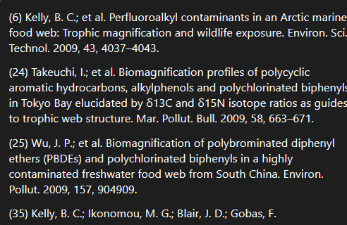

Conclusions et perspectives

Cette étude met en évidence des différences marquées dans la bioaccumulation et la biomagnification des organohalogénés chez *Solea solea*, avec des implications pour la compréhension des dynamiques trophiques des contaminants. Les résultats confirment que les PCBs, bien que persistants, ne présentent qu’une biomagnification limitée par rapport aux PFASs..

À l’avenir, des travaux complémentaires pourraient explorer :

* L’influence des facteurs physiologiques des soles sur la métabolisation des contaminants.
* L’analyse des métabolites de PFASs et PCBs pour mieux comprendre leur devenir dans l’organisme.
* L’impact de la variabilité saisonnière et spatiale sur la contamination des proies et des prédateurs.

En intégrant ces dimensions, il sera possible d’améliorer les modèles de prédiction de la bioaccumulation et de mieux évaluer les risques écotoxicologiques associés aux contaminants émergents dans les écosystèmes estuariens.

References

Amara, R. *et al.* (2007) ‘Growth and condition indices in juvenile sole Solea solea measured to assess the quality of essential fish habitat’, *Marine Ecology Progress Series*, 351, pp. 201–208. Available at: https://doi.org/10.3354/meps07154.

Antunes, P. *et al.* (2008) ‘Organ-specific accumulation and elimination patterns of PCBs in adult seabass (Dicentrarchus labrax)’, *Science of the Total Environment*, 407(1), pp. 204–210. Available at: https://doi.org/10.1016/j.scitotenv.2008.09.005.

Arnot, J.A. *et al.* (2023) ‘A weight of evidence approach for bioaccumulation assessment’, *Integrated Environmental Assessment and Management*, 19(5), pp. 1235–1253. Available at: https://doi.org/10.1002/ieam.4583.

Arnot, J.A. and Gobas, F.A. (2006) ‘A review of bioconcentration factor (BCF) and bioaccumulation factor (BAF) assessments for organic chemicals in aquatic organisms’, *Environmental Reviews*, 14(4), pp. 257–297. Available at: https://doi.org/10.1139/a06-005.

Ballutaud, M. *et al.* (2019) ‘EStimating Contaminants tRansfers Over Complex food webs (ESCROC): An innovative Bayesian method for estimating POP’s biomagnification in aquatic food webs’, *Science of the Total Environment*, 658, pp. 638–649. Available at: https://doi.org/10.1016/j.scitotenv.2018.12.058.

Beck, M.W. *et al.* (2001) ‘The identification, conservation, and management of estuarine and marine nurseries for fish and invertebrates’, *BioScience*, 51, pp. 633–641. Available at: https://doi.org/10.1641/0006-3568(2001)051[0633:TICAMO]2.0.CO;2.

Bodin, N. *et al.* (2007) ‘PCB, PCDD/F and PBDE levels and profiles in crustaceans from the coastal waters of Brittany and Normandy (France)’, *Marine Pollution Bulletin*, 54(6), pp. 657–668. Available at: https://doi.org/10.1016/J.MARPOLBUL.2007.01.018.

Bodin, N. *et al.* (2008) ‘Congener-specific accumulation and trophic transfer of polychlorinated biphenyls in spider crab food webs revealed by stable isotope analysis’, *Environmental Pollution*, 151(1), pp. 252–261. Available at: https://doi.org/10.1016/j.envpol.2007.01.051.

Bodin, N. *et al.* (2014) ‘PCB contamination in fish community from the Gironde Estuary (France): blast from the past.’, *Chemosphere*, 98, pp. 66–72. Available at: https://doi.org/10.1016/j.chemosphere.2013.10.003.

Borgå, K. *et al.* (2004) ‘Biological and chemical factors of importance in the bioaccumulation and trophic transfer of persistent organochlorine contaminants in arctic marine food webs’, *Environmental Toxicology and Chemistry*, 23(10), pp. 2367–2385.

Borgå, K. *et al.* (2005) ‘Bioaccumulation Factors for PCBs Revisited’, *Environmental Science & Technology*, 39(12), pp. 4523–4532. Available at: https://doi.org/10.1021/es050376i.

Borgå, K. *et al.* (2012) ‘Trophic magnification factors: Considerations of ecology, ecosystems, and study design’, *Integrated Environmental Assessment and Management*, 8(1), pp. 64–84. Available at: https://doi.org/10.1002/ieam.244.

Burreau, S. *et al.* (1997) ‘Dietary uptake in pike ( Esox lucius ) of some polychlorinated biphenyls, polychlorinated naphthalenes and polybrominated diphenyl ethers administered in natural diet’, *Environmental Toxicology and Chemistry*, 16(12), pp. 2508–2513. Available at: https://doi.org/10.1002/etc.5620161211.

Cara, B. *et al.* (2022) ‘Bioaccumulation and trophic transfer of perfluorinated alkyl substances (PFAS) in marine biota from the Belgian North Sea: Distribution and human health risk implications’, *Environmental Pollution*, 311, p. 119907. Available at: https://doi.org/10.1016/j.envpol.2022.119907.

Conder, J.M. *et al.* (2008) ‘Are PFCAs Bioaccumulative? A Critical Review and Comparison with Regulatory Criteria and Persistent Lipophilic Compounds’, *Environmental Science & Technology*, 42(4), pp. 995–1003. Available at: https://doi.org/10.1021/es070895g.

Conder, J.M. *et al.* (2012) ‘Use of trophic magnification factors and related measures to characterize bioaccumulation potential of chemicals’, *Integrated Environmental Assessment and Management*, 8(1), pp. 85–97. Available at: https://doi.org/10.1002/ieam.216.

Connolly, J.P. (1991) ‘Application of a food chain model to polychlorinated biphenyl contamination of the lobster and winter flounder food chains in New Bedford Harbor’, *Environmental Science & Technology*, 25(4), pp. 760–770. Available at: https://doi.org/10.1021/es00016a022.

Covaci, A. *et al.* (2011) ‘Novel brominated flame retardants: a review of their analysis, environmental fate and behaviour’, *Environment International*, 37(2), pp. 532–556. Available at: https://doi.org/10.1016/j.envint.2010.11.007.

Dargnat, C. and Fisson, C. (2010) *Les PolyChrloroBiphényles (PCB) dans le bassin de la Seine et son estuaire.*

Daughton, C.G. (2005) ‘“Emerging” Chemicals as Pollutants in the Environment: a 21st Century Perspective’.

Deribe, E. *et al.* (2011) ‘Bioaccumulation of persistent organic pollutants (POPs) in fish species from Lake Koka, Ethiopia: The influence of lipid content and trophic position’, *Science of The Total Environment*, 410–411, pp. 136–145. Available at: https://doi.org/10.1016/j.scitotenv.2011.09.008.

Di Paolo, C. *et al.* (2010) ‘Black Carbon Inclusive Multichemical Modeling of PBDE and PCB Biomagnification and -Transformation in Estuarine Food Webs’, *Environmental Science & Technology*, 44(19), pp. 7548–7554. Available at: https://doi.org/10.1021/es101247e.

Durou, C. *et al.* (2007) ‘Biomonitoring in a clean and a multi-contaminated estuary based on biomarkers and chemical analyses in the endobenthic worm *Nereis diversicolor*’, *Environmental Pollution*, 148(2), pp. 445–458. Available at: https://doi.org/10.1016/j.envpol.2006.12.022.

Fisk, A.T. *et al.* (1998) ‘Dietary accumulation and depuration of hydrophobic organochlorines: Bioaccumulation parameters and their relationship with the octanol/water partition coefficient’, *Environmental Toxicology and Chemistry*, 17(5), pp. 951–961. Available at: https://doi.org/10.1897/1551-5028(1998)017<0951:DAADOH>2.3.CO;2.

Fisk, A.T., Hobson, K.A. and Norstrom, R.J. (2001) ‘Influence of chemical and biological factors on trophic transfer of persistent organic pollutants in the Northwater Polynya marine food web’, *Environmental Science and Technology*, 35(4), pp. 732–738. Available at: https://doi.org/10.1021/es001459w.

Fremlin, K.M., Elliott, J.E. and Gobas, F.A.P.C. (2025) ‘Guidance for measuring and evaluating biomagnification factors and trophic magnification factors of difficult substances: application to decabromodiphenylethane’, *Integrated Environmental Assessment and Management*, 21(2), pp. 263–278. Available at: https://doi.org/10.1093/inteam/vjae025.

Gilliers, C. *et al.* (2006) ‘Are growth and density quantitative indicators of essential fish habitat quality? An application to the common sole Solea solea nursery grounds’, *Estuarine, Coastal and Shelf Science*, 69(1–2), pp. 96–106. Available at: https://doi.org/10.1016/j.ecss.2006.02.006.

Gobas, F. a P.C. *et al.* (1999) ‘Mechanism of biomagnification in fish under laboratory and field conditions’, *Environmental Science and Technology*, 33(1), pp. 133–141. Available at: https://doi.org/10.1021/es980681m.

Gobas, F.A. *et al.* (2009) ‘Revisiting Bioaccumulation Criteria for POPs and PBT Assessments’, *Integrated Environmental Assessment and Management*, 5(4), pp. 624–637. Available at: https://doi.org/10.1897/IEAM_2008-089.1.

Gobas, F.A.P.C. and Morrison, J.B. (2000) ‘Bioconcentration and Biomagnification in the Aquatic Environment’, in *Handbook of Property Estimation Methods for Chemicals*. CRC Press.

Gobas, F.A.P.C., Zhang, X. and Wells, R. (1993) ‘Gastrointestinal magnification: The mechanism of biomagnification and food chain accumulation of organic chemicals’, *Environmental Science and Technology*, 27(13), pp. 2855–2863. Available at: https://doi.org/10.1021/es00049a028.

Gobas, F.A.P.C.P.C., McCorquodale, J.R. and Haffner, G.D.D. (1993) ‘Intestinal absorption and biomagnification of organochlorines’, *Environmental Toxicology and Chemistry*, 12(3), pp. 567–576. Available at: https://doi.org/10.1002/etc.5620120316.

Halpern, B.S. *et al.* (2008) ‘A Global Map of Human Impact on Marine Ecosystems’, *Science*, 319(5865), pp. 948–952. Available at: https://doi.org/10.1126/science.1149345.

Halpern, B.S. *et al.* (2012) ‘An index to assess the health and benefits of the global ocean’, *Nature*, 488(7413), pp. 615–620. Available at: https://doi.org/10.1038/nature11397.

Helsel, D.R. (2006) ‘Fabricating data: How substituting values for nondetects can ruin results, and what can be done about it’, *Chemosphere*, 65(11), pp. 2434–2439. Available at: https://doi.org/10.1016/j.chemosphere.2006.04.051.

Hoekstra, P.F. *et al.* (2003) ‘Trophic transfer of persistent organochlorine contaminants (OCs) within an Arctic marine food web from the southern Beaufort–Chukchi Seas’, *Environmental Pollution*, 124(3), pp. 509–522. Available at: https://doi.org/10.1016/S0269-7491(02)00482-7.

Hop, H. *et al.* (2002) ‘Food Web Magnification of Persistent Organic Pollutants in Poikilotherms and Homeotherms from the Barents Sea’, *Environmental Science & Technology*, 36(12), pp. 2589–2597. Available at: https://doi.org/10.1021/es010231l.

Houde, M. *et al.* (2006) ‘Biological monitoring of polyfluoroalkyl substances: A review’, *Environmental Science and Technology*, 40(11), pp. 3463–3473. Available at: https://doi.org/10.1021/es052580b.

Houde, M. *et al.* (2008) ‘Influence of lake characteristics on the biomagnification of persistent organic pollutants in lake trout food webs’, *Environmental Toxicology and Chemistry*, 27(10), pp. 2169–2178. Available at: https://doi.org/10.1897/08-071.1.

Julian, P. and Helsel, D. (2021) ‘NADA2: Data Analysis for Censored Environmental Data.’ Available at: https://github.com/SwampThingPaul/NADA2.

Kelly, B.C. *et al.* (2008) ‘Bioaccumulation behaviour of polybrominated diphenyl ethers (PBDEs) in a Canadian Arctic marine food web’, *Science of The Total Environment*, 401(1), pp. 60–72. Available at: https://doi.org/10.1016/j.scitotenv.2008.03.045.

Kelly, B.C. *et al.* (2009) ‘Perfluoroalkyl Contaminants in an Arctic Marine Food Web : Trophic Magnification and Wildlife Exposure’, *Environmental Science & Technology*, 43, pp. 4037–4043. Available at: https://doi.org/10.1021/es9003894.

Kim, J. *et al.* (2016) ‘Evaluating the roles of biotransformation, spatial concentration differences, organism home range, and field sampling design on trophic magnification factors’, *Science of the Total Environment*, 551–552, pp. 438–451. Available at: https://doi.org/10.1016/j.scitotenv.2016.02.013.

Kobayashi, J. *et al.* (2011) ‘Dietary uptake kinetics of polychlorinated biphenyls from sediment-contaminated sandworms in a marine benthic fish (Pseudopleuronectes yokohamae)’, *Chemosphere*, 82(5), pp. 745–750. Available at: https://doi.org/10.1016/j.chemosphere.2010.10.087.

Kobayashi, J. *et al.* (2015) ‘Trophic magnification of polychlorinated biphenyls and polybrominated diphenyl ethers in an estuarine food web of the Ariake Sea, Japan’, *Chemosphere*, 118, pp. 201–206. Available at: https://doi.org/10.1016/j.chemosphere.2014.08.066.

Labadie, P. and Chevreuil, M. (2011) ‘Partitioning behaviour of perfluorinated alkyl contaminants between water, sediment and fish in the Orge River (nearby Paris, France)’, *Environmental Pollution*, 159(2), pp. 391–397. Available at: https://doi.org/10.1016/J.ENVPOL.2010.10.039.

Lauzent, M. (2018) ‘Etude de l’écodynamique des polluants organiques persistants et des micropolluants halogénés d’intérêt émergent dans les milieux aquatiques’.

Le Pape, O. *et al.* (2003) ‘Quantitative description of habitat suitability for the juvenile common sole (Solea solea, L.) in the Bay of Biscay (France) and the contribution of different habitats to the adult population’, *Journal of Sea Research*, 50(2–3), pp. 139–149. Available at: https://doi.org/10.1016/S1385-1101(03)00059-5.

Le Pape, O. *et al.* (2007) ‘Convergent signs of degradation in both the capacity and the quality of an essential fish habitat: state of the Seine estuary (France) flatfish nurseries’, *Hydrobiologia*, 588(1), pp. 225–229. Available at: https://doi.org/10.1007/s10750-007-0665-y.

Li, J. *et al.* (2018) ‘Importance of Growth Rate on Hg and PCB Bioaccumulation in Fish’, *Environmental Toxicology and Chemistry* [Preprint]. Available at: https://doi.org/10.1002/etc.4114.

Liu, J., Haffner, G.D. and Drouillard, K.G. (2010) ‘The influence of diet on the assimilation efficiency of 47 polychlorinated biphenyl congeners in Japanese koi (Cyprinus carpio)’, *Environmental Toxicology and Chemistry*, 29(2), pp. 401–409. Available at: https://doi.org/10.1002/etc.47.

Loi, E.I.H. *et al.* (2011) ‘Trophic Magnification of Poly- and Perfluorinated Compounds in a Subtropical Food Web’, *Environmental Science & Technology*, 45(13), pp. 5506–5513. Available at: https://doi.org/10.1021/es200432n.

Loizeau, V., Abarnou, A. and Ménesguen, A. (2001) ‘A steady-state model of PCB bioaccumulation in the sea bass (Dicentrarchus labrax) food web from the Seine estuary, France’, *Estuaries*, 24(6), pp. 1074–1087. Available at: https://doi.org/10.2307/1353019.

Mackay, D. *et al.* (2016) ‘Processes influencing chemical biomagnification and trophic magnification factors in aquatic ecosystems: Implications for chemical hazard and risk assessment’, *Chemosphere*, 154, pp. 99–108. Available at: https://doi.org/10.1016/j.chemosphere.2016.03.048.

Mackay, D. and Fraser, A. (2000) ‘Bioaccumulation of persistent organic chemicals: mechanisms and models’, *Environmental Pollution*, 110(3), pp. 375–391. Available at: https://doi.org/10.1016/S0269-7491(00)00162-7.

Masset, T. *et al.* (2019) ‘Trophic position and individual feeding habits as drivers of differential PCB bioaccumulation in fish populations’, *Science of the Total Environment*, 674, pp. 472–481. Available at: https://doi.org/10.1016/j.scitotenv.2019.04.196.

Matthies, M. *et al.* (2016) ‘The origin and evolution of assessment criteria for persistent, bioaccumulative and toxic (PBT) chemicals and persistent organic pollutants (POPs)’, *Environmental Science: Processes & Impacts*, 18(9), pp. 1114–1128. Available at: https://doi.org/10.1039/C6EM00311G.

Mounier, F. *et al.* (2020) ‘Dietary bioaccumulation of persistent organic pollutants in the common sole *Solea solea* in the context of global change. Part 2: Sensitivity of juvenile growth and contamination to toxicokinetic parameters uncertainty and environmental conditions variability in estuaries’, *Ecological Modelling*, 431, p. 109196. Available at: https://doi.org/10.1016/j.ecolmodel.2020.109196.

Munoz, G. *et al.* (2017) ‘Evidence for the Trophic Transfer of Perfluoroalkylated Substances in a Temperate Macrotidal Estuary’, *Environmental Science and Technology*, 51(15), pp. 8450–8459. Available at: https://doi.org/10.1021/acs.est.7b02399.

Munoz, G. *et al.* (2018) ‘Spatio-temporal dynamics of per and polyfluoroalkyl substances (PFASs) and transfer to periphytic biofilm in an urban river: case-study on the River Seine’, *Environmental Science and Pollution Research*, 25(24), pp. 23574–23582. Available at: https://doi.org/10.1007/s11356-016-8051-9.

Munschy, C. *et al.* (2013) ‘Levels and trends of the emerging contaminants HBCDs (hexabromocyclododecanes) and PFCs (perfluorinated compounds) in marine shellfish along French coasts’, *Chemosphere*, 91(2), pp. 233–240. Available at: https://doi.org/10.1016/j.chemosphere.2012.12.063.

Ng, C.A. and Hungerbuhler, K. (2014) ‘Bioaccumulation of Per fl uorinated Alkyl Acids : Observations and Models’, *Environmental science & technology*, 48, pp. 4637–4648. Available at: https://doi.org/10.1021/es404008g.

Niimi, A.J. and Oliver, B.G. (1988) ‘Influence of Molecular Weight and Molecular Volume on Dietary Absorption Efficiency of Chemicals by Fishes’, *Journal canadien des sciences halieutiques et aquatiques*, 45(2), pp. 222–227.

Olisah, C., Adams, J.B. and Rubidge, G. (2021) ‘The state of persistent organic pollutants in South African estuaries: A review of environmental exposure and sources’, *Ecotoxicology and Environmental Safety*, 219, p. 112316. Available at: https://doi.org/10.1016/j.ecoenv.2021.112316.

van der Oost, R., Beyer, J. and Vermeulen, N.P.E. (2003) ‘Fish bioaccumulation and biomarkers in environmental risk assessment: A review’, *Environmental Toxicology and Pharmacology*, 13(2), pp. 57–149. Available at: https://doi.org/10.1016/S1382-6689(02)00126-6.

Pitacco, V. *et al.* (2021) ‘Habitat heterogeneity: A confounding factor for the effect of pollutants on macrobenthic community in coastal waters’, *Marine Environmental Research*, 172, p. 105499. Available at: https://doi.org/10.1016/j.marenvres.2021.105499.

Poisson, E. *et al.* (2011) ‘Effets de la contamination chimique. Des organismes en danger ?’, *Fascicule Seine-Aval 2.7*, p. 68.

R core team (2025) ‘R: The R Project for Statistical Computing.’ Available at: https://www.r-project.org/.

Ridgway, J. and Shimmield, G. (2002) ‘Estuaries as Repositories of Historical Contamination and their Impact on Shelf Seas’, *Estuarine, Coastal and Shelf Science*, 55(6), pp. 903–928. Available at: https://doi.org/10.1006/ecss.2002.1035.

Riou, P., Le Pape, O. and Rogers, S.I. (2001) ‘Relative contributions of different sole and plaice nurseries to the adult population in the Eastern Channel : application of a combined method using generalized linear models and a geographic information system’, 14, pp. 125–135.

Rochette, S. *et al.* (2010) ‘Effect of nursery habitat degradation on flatfish population: Application to Solea solea in the Eastern Channel (Western Europe)’, *Journal of Sea Research*, 64(1–2), pp. 34–44. Available at: https://doi.org/10.1016/j.seares.2009.08.003.

Schäfer, S. *et al.* (2015) ‘Bioaccumulation in aquatic systems: methodological approaches, monitoring and assessment’, *Environmental Sciences Europe*, 27(1), p. 5. Available at: https://doi.org/10.1186/s12302-014-0036-z.

Vaida, F. and Liu, L. (2009) ‘Fast Implementation for Normal Mixed Effects Models With Censored Response’, *Journal of computational and graphical statistics : a joint publication of American Statistical Association, Institute of Mathematical Statistics, Interface Foundation of North America*, 18(4), pp. 797–817. Available at: https://doi.org/10.1198/jcgs.2009.07130.

Van Ael, E. *et al.* (2012) ‘Persistent organic pollutants in the Scheldt estuary: Environmental distribution and bioaccumulation’, *Environment International*, 48, pp. 17–27. Available at: https://doi.org/10.1016/j.envint.2012.06.017.

Van Ael, E. *et al.* (2013) ‘Factors Influencing the Bioaccumulation of Persistent Organic Pollutants in Food Webs of the Scheldt Estuary’, *Environmental Science & Technology*, 47(19), pp. 11221–11231. Available at: https://doi.org/10.1021/es400307s.

Verhaert, V. *et al.* (2017) ‘Persistent organic pollutants in the Olifants River Basin, South Africa: Bioaccumulation and trophic transfer through a subtropical aquatic food web’, *Science of the Total Environment*, 586, pp. 792–806. Available at: https://doi.org/10.1016/j.scitotenv.2017.02.057.

Walters, D.M. *et al.* (2011) ‘Trophic magnification of PCBs and its relationship to the octanol-water partition coefficient’, *Environmental Science and Technology*, 45(9), pp. 3917–3924. Available at: https://doi.org/10.1021/es103158s.

Résultats : Trophic magnification transfers

**Discussion**

Méthode de calcul des TMF : Plus récemment encore, Ballutaud et al. (2019) ont développé une méthode originale, implémentée dans un cadre bayésien, afin de tenir compte de la propagation des incertitudes dans le calcul des TMF. Ce modèle, baptisé ESCROC, repose sur le principe des modèles de mélange isotopiques classiques : il postule que la signature chimique (contaminant ou isotope) d’un prédateur est la moyenne pondérée de la signature chimique de ses proies plus un facteur d’enrichissement. Dans le cas des isotopes, ce facteur est appelé facteur d’enrichissement isotopique ; dans le cas des contaminants, il correspond au TMF. Initialement, il était prévu d’utiliser ESCROC sur les données acquises dans ce projet. Malheureusement, malgré un important effort d’échantillonnage et d’acquisition de données, les contraintes du projet n’ont pas permis de construire un jeu de données regroupant (1) suffisamment de données isotopiques acquises sur les mêmes individus que pour les données de contamination pour (2) assez d’organismes le long de la chaîne trophique (3) depuis les consommateurs primaires jusqu’à différents prédateurs. Nous n’avons donc pas pu implémenter ESCROC sur nos données. Aussi, dans le cadre de ce CHOPIN, la méthode LMEC a été privilégiée.

De plus, selon les familles, les valeurs de TMF ne sont pas tout à fait convergentes avec les diagnostics établis au regard des BMF. Ainsi, quel que soit le mode de calcul du BMF, tous les congénères de PCB apparaissent bioamplifiés entre proies benthiques et soles G0 alors que seul le CB-153 ressort si l’on considère les TMF. Différentes hypothèses ont été avancées pour expliquer les différences entre BMF et TMF (ex : forte contamination de certains bivalves situés en bas de chaine trophique). Les approches sont plus cohérentes entre elles pour le HBCDD (jamais bioamplifié ici) et les PFAS. Pour ces derniers, tous les composés fréquemment détectés dans les soles apparaissent bioamplifiés au regard des valeurs de TMF et de BMF obtenues même si la conclusion est plus nuancée lorsque l’on tient compte du bol alimentaire dans le calcul du BMF.