Evaluating Biomagnification of Organohalogenated Pollutants in Juvenile Fish from Estuarine Nurseries: A Field Methodological Comparison

Mounier Florence1, Labadie Pierre2, Loizeau Véronique3, Munschy Catherine 4, Budzinski Hélène2, Aminot Yann4, Gallien Marine2, Chouquet Bastien5 & Lobry Jérémy1*

1 INRAE, EABX, 50 avenue de Verdun Gazinet, F-33612, Cestas cedex, France.

2 Université de Bordeaux, UMR 5805 CNRS, EPOC, LPTC Research Group, Talence, France

3 Ifremer, LBCN, Plouzané, France

4 Ifremer, LBCO, Nantes, France

5 Cellule de Suivi du Littoral Normand, CSLN, Le Havre 76600, France

**\*Corresponding author:** Jérémy Lobry [jeremy.lobry@inrae.fr]

# Table of contents

Table of contents 2

1. Materials and methods 4

1.1. Sampling 4

1.1.1. Study area 4

1.1.2. Benthic macrofauna 4

1.1.3. Sole juveniles 4

1.2. Chemical analysis 4

1.2.1. Organohalogenated families’ presentation 4

1.2.2. Screened compounds 6

1.2.3. Samples preparation and analysis protocoles 7

2. Dataset description 7

2.1. Lipid contents 7

2.2. Total contamination levels by family 8

2.3. Mean contamination profiles 10

2.4. Lipid content, taxon and feeding mode effect on contamination levels 11

2.5. Steady-state assumption 11

3. Discussion 13

3.1. Niveaux et profiles de contamination 13

3.1.1. Niveaux généraux entre les familles 13

3.1.2. Niveaux et profils pour les PCB 14

4. References 18

5. Supplementary materials 22

5.1. Chemical concentrations : sum by family 22

5.2. Chemical concentrations : for each compound 22

6. Résultats : Trophic magnification transfers 24

- Isotopic levels 24

- TMFs 24

# Materials and methods

## Sampling

### Study area

As part of the CHOPIN and CAPES projects, benthic macrofauna and first-year sole (G0) samples were collected in June and October 2017 at eight stations distributed across three sectors of the estuary: Fosse Nord (FN), Fosse Sud (FS), and Embouchure (Emb) (Figure 1). Despite the sampling effort, too few G0 soles and comparable benthic samples were available in each estuary sector and for each season (June or October) to assess the effect of sampling location or season on contamination levels. As a result, this effect will not be discussed in the present study.Haut du formulaire

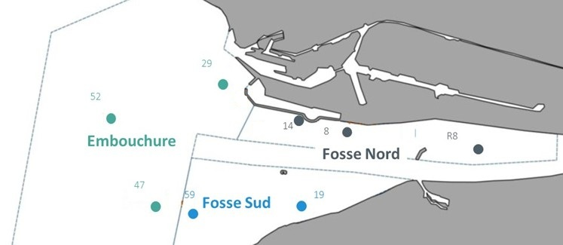

Figure 1 - Mapping of sole sampling areas and benthic sampling sites in the CHOPIN project.

### Prey

Benthic macrofauna sampling was conducted using a grab. Only certain collected species were selected for chemical analyses because they (1) are known to be part of the diet of juvenile soles (G1 and G2) in the Seine estuary, as previously described based on stomach content analyses (Tous-Rius, 2009), and (2) were available in sufficient quantities for contaminant analysis. As a result, among the targeted species, 16 benthic prey species representing three different taxa (bivalves, annelids, and crustaceans) were collected in June and October 2017 in the Seine estuary.

### Sole juveniles

The data used for chemical analysis were obtained from G0 sole sampling campaigns conducted by trawling in 2017. Additionally, stomach content analyses of G0 soles were performed using data from the CHOPIN and CAPES projects (combined datasets, the study area and sampling periods were consistent across both projects).

## Chemical analysis

### Organohalogenated families’ presentation

#### Polychlorinated biphenyls (PCBs)

Polychlorinated biphenyls (PCBs) are emblematic legacy pollutants, having been among the first twelve substances listed under the Stockholm Convention on Persistent Organic Pollutants (POPs) in 2001. Despite being banned for nearly three decades, PCBs remain an environmental concern due to their high toxicity, extreme persistence, and poor biodegradability. Their strong lipophilicity also contributes to significant bioaccumulation in aquatic organisms (Mackay and Fraser, 2000; Deribe *et al.*, 2011).

To mitigate these risks, the European Union has established regulatory thresholds for PCB concentrations in wild marine fish. Since 2006, the levels of the 12 dioxine-like PCB congeners have been subject to an Environmental Quality Standard (EQS), assessed in combination with dioxins and other dioxine-like compounds (Directive 2013/39/EU, 2013). More recently, French legislation has established environmental assessment criterion (EAC) based on concentrations of the seven indicator PCBs in bivalves. These thresholds, expressed in ng/g lipid, are as follows: 67 for CB 28, 108 for CB 52, 121 for CB 101, 25 for CB 118, 317 for CB 138, 1585 for CB 153 and 469 for CB 180 (legifrance.gouv, 2023).

#### Per- and polyfluoroalkyl substances (PFAS)

Most compounds within the broad family of per- and polyfluoroalkyl substances (PFAS) are extremely persistent in the environment and have demonstrated the potential to bioaccumulate and, in some cases, biomagnify through food webs (Martin *et al.*, 2003). Industrial production of PFAS began in the 1950s, reaching over 3 million tonnes by the year 2000, due to their widespread use in range of applications including fluoropolymer synthesis, water- and oil-repellent textile treatments, firefighting foams, lubricants, coatings, and food packaging materials (Buck *et al.*, 2011; Wang *et al.*, 2014; Evich *et al.*, 2022).

In the early 2000s, perfluorooctane sulfonate (PFOS) was recognized as a globally ubiquitous contaminant, with widespread detection in wildlife (Giesy and Kannan, 2001) and human populations (Kannan *et al.*, 2004), alongside increasing evidence of its toxicity (Renner, 2001). Since then, numerous studies have focused on understanding the environmental sources, pathways, and fate of PFAS (Ahrens and Bundschuh, 2014; Kelly *et al.*, 2024), revealing contamination hotspots in areas downstream of or near industrial facilities producing or using these substances (Moody *et al.*, 2002; Xie *et al.*, 2013; Munoz *et al.*, 2015).

In recognition of its persistence, toxicity, and widespread distribution, PFOS was added to Annex B (restriction) of the Stockholm Convention and designated as a priority substance under the European Water Framework Directive, which set an EQS of 9.1 ng/g wet weight in wild fish (Directive 2013/39/EU, 2013). Additionally, perfluorooctanoic acid (PFOA) and perfluorohexane sulfonic acid (PFHxS) have been included in Annex A (elimination) of the Stockholm convention, requiring the cessation of their production and use. This classification extends not only to the substances themselves but also to their salts, polymers, and any precursor compounds capable of degrading into them (e.g., 8:2 diPAP for PFOA).

### Screened compounds

Chemical acronyms, full names and CAS of the studied chemicals are listed in Table 1.

Table 1 – Chemical acronyms, full names and CAS Common Chemistry numbers along with their family and group. (* selected chemicals in this study).

|  | Group | Acronym | Name | CAS number | Detection % in prey | Detection % in sole |
| --- | --- | --- | --- | --- | --- | --- |
| PFAS | PFCA | PFPeA | Perfluoropentanoic acid | 2706-90-3 | 16 | **53** |
|  | PFHxA | Perfluorohexanoic acid | 307-24-4 | 9 | 0 |
|  | PFHpA | Perfluoroheptanoic acid | 375-85-9 | 13 | 13 |
|  | *PFOA | Perfluorooctanoic acid | 335-67-1 | **20** | **27** |
|  | *PFNA | Perfluorononanoic acid | 375-95-1 | **91** | **100** |
|  | *PFDA | Perfluorodecanoic acid | 335-76-2 | **64** | **93** |
|  | *PFUnDA | Perfluoroundecanoic acid | 2058-94-8 | **69** | **27** |
|  | *PFDoDA | Perfluorododecanoic acid | 307-55-1 | **98** | **100** |
|  | *PFTrDA | Perfluorotridecanoic acid | 72629-94-8 | **62** | **87** |
|  | *PFTeDA | Perfluorotetradecanoic acid | 376-06-7 | **53** | **40** |
| PFSA | PFBS | Perfluorobutanesulfonic acid | 375-73-5 | 0 | 0 |
|  | PFHxS | Perfluorohexanesulfonic acid | 355-46-4 | 11 | 13 |
|  | PFHpS | Perfluoroheptanesulfonic acid | 375-92-8 | 0 | 0 |
|  | *L-PFOS | Perfluorooctanesulfonic acid | 1763-23-1 (L-) | **98** | **100** |
|  | *Br-PFOS | Perfluorooctanesulfonic acid | 1763-23-1 (Br-) | **27** | **87** |
|  | PFDS | Perfluorodecanesulfonic acid | 355-77-3 | 2 | 0 |
| FOSA | *FOSA | Perfluorooctane sulfonamide | 754-91-6 | **91** | **73** |
| N-Alkyle FOSAA | FOSAA | Perfluorooctane sulfonamidoacetic acid | 2806-24-8 | 0 | 0 |
| MeFOSAA | N-methylperfluorooctane sulfonamidoacetic acid | 2355-31-9 | 16 | **27** |
| *EtFOSAA | N-ethylperfluorooctane sulfonamidoacetic acid | 2991-50-6 | **60** | **73** |
| FTS | 4:2-FTSA | 4:2-fluorotelomer sulfonic acid | 27619-93-8 | 0 | 0 |
|  | 6:2-FTSA | 6:2- fluorotelomer sulfonic acid | 27619-94-9 | **93** | 13 |
|  | *8:2-FTSA | 8:2- fluorotelomer sulfonic acid | 27619-96-1 | **71** | 40 |
|  | 10:2-FTSA | 10:2- fluorotelomer sulfonic acid | 108026-35-3 | 42 | 0 |
| diPAP | 6:2-diPAP | 6:2- fluorotelomer phosphat diester | 57677-95-9 | 2 | 0 |
|  | 8:2-diPAP | 8:2- fluorotelomer phosphat diester | 678-41-1 | 7 | 0 |
| PCB | Tri-CB | *CB 28 | 2',4,4'-trichlorobiphenyl | 7012-37-5 | **100** | **100** |
|  | *CB 31 | 2,4’,5-trichlorobiphenyl | 16606-02-3 | **100** | **100** |
| Tetra-CB | *CB 44 | 2,2’3,3’-tetrachlorobiphenyl | 41464-39-5 | **100** | **100** |
|  | *CB 49 | 2,2’4,5’- tetrachlorobiphenyl | 41464-40-8 | **100** | **100** |
|  | *CB 52 | 2,2',5,5'-tetrachlorobiphenyl | 35693-99-3 | **100** | **100** |
| Penta-CB | *CB 101 | 2,4,5,2',5'-pentachlorobiphenyl | 37680-73-2 | **100** | **100** |
|  | *CB 105 | 2,3,3’,4,4’-pentachlorobiphenyl | 32598-14-4 | **100** | **100** |
|  | *CB 110 | 2,3,3’,4’,6-pentachlorobiphenyl | 38380-03-9 | **100** | **100** |
|  | *CB 118 | 2',3,4,4',5'-pentachlorobiphenyl | 31508-00-6 | **100** | **100** |
| Hexa-CB | *CB 128 | 2,2’,3,3’,4,4’-hexachlorobiphenyl | 38380-07-3 | **100** | **100** |
|  | *CB 132 | 2,2’,3,3’,4,6’-hexachlorobiphenyl | 38380-05-1 | **100** | **100** |
|  | *CB 138 | 2,2',3,4,4',5'-hexachlorobiphenyl | 35065-28-2 | **100** | **100** |
|  | *CB 149 | 2,2’,3,4’,5’,6-hexachlorobiphenyl | 38380-04-0 | **100** | **100** |
|  | *CB 153 | 2,2',4,4',5,5'-hexachloro-1,1'-Biphenyl | 35065-27-1 | **100** | **100** |
|  | *CB 156 | 2,3,3’,4,4’,5-hexachlorobiphenyl | 38380-08-4 | **100** | **100** |
| Hepta-CB | *CB 170 | 2,2’,3,3’,4,4’,5 heptachlorobiphenyl | 35065-30-6 | **100** | **100** |
|  | *CB 180 | 2,2',3,4,4',5,5'-heptachlorobiphenyl | 35065-29-3 | **100** | **100** |
|  | *CB 187 | 2,2’,3,4’,5,5’,6-heptachlorobiphenyl | 52663-68-0 | **100** | **100** |
|  | *CB 194 | 2,2’,3,3’,4,4’,5,5’-octachlorobiphenyl | 35694-08-7 | **100** | **100** |

### Samples preparation and analysis protocoles

All samples were processed as pooled individuals to obtain the minimum mass required for chemical analysis and to enhance analytical sensitivity (Schäfer *et al.*, 2015). Sole specimens were grouped in batches ranging from 30 to 93 individuals per sample. Prey species were pooled in variable numbers depending on the species and individual size.

The experimental analysis of PFASs followed the methodology described by (Munoz et al., 2017), and PCB quantification followed the protocol outlined in (Gallien, 2021).

* LOQ vs blancs utilisés dans la procédure QA/QC ? « total number of blanks and the number of samples processed per batch with a blank are also important details to report.” “Investigators often choose to express Method Detection Limits (MDLs) as the mean concentration in field or laboratory blanks plus two or three times the SD. For contaminants not detected in field or laboratory blanks, the limit of quantification (LOQ) must be reported.”
* Methods with low recovery (e.g., less than 30%) should be treated with suspicion and considered for exclusion from further analysis. (Fremlin, Elliott and Gobas, 2025).
* Details of the chemical standards, reagents, and analytical methods, such as retention times and mass spectrum, used to identify the chemical substance in the sample need to be clearly reported (Fremlin, Elliott and Gobas, 2025).

The lipid content of biota samples was determined using XXX

Stable isotope ratios δ13C and δ15N was determined using XXX

# Dataset description

## Diet composition

|  |  |  |  |
| --- | --- | --- | --- |
| **Taxon** | **Class** | **Scientific name** | **diet_portion** |
| Annelida | Annelida sp. | Annelida sp. | 0,65 |
| Annelida | Polychaeta errantia | Alitta succinea | 0,03 |
| Annelida | Polychaeta errantia | Aphroditidae | 0,03 |
| Annelida | Polychaeta errantia | Aphroditiformia | 0,059 |
| Annelida | Polychaeta errantia | Eunereis longissima | 0,03 |
| Annelida | Polychaeta errantia | Glycera sp | 0,03 |
| Annelida | Polychaeta errantia | Hediste diversicolor | 0,915 |
| Annelida | Polychaeta errantia | Nephtys kersivalensis | 0,059 |
| Annelida | Polychaeta errantia | Nephtys sp | 1,329 |
| Annelida | Polychaeta errantia | Nereididae | 1,092 |
| Annelida | Polychaeta errantia | Pholoe inornata | 0,03 |
| Annelida | Polychaeta errantia | Phyllodocidae | 0,384 |
| Annelida | Polychaeta errantia | Polynoidae | 0,207 |
| Annelida | Polychaeta sedentaria | Ampharete lindstroemi | 0,089 |
| Annelida | Polychaeta sedentaria | Ampharetidae | 0,177 |
| Annelida | Polychaeta sedentaria | Arenicola marina | 0,03 |
| Annelida | Polychaeta sedentaria | Boccardiella ligerica | 0,354 |
| Annelida | Polychaeta sedentaria | Lagis koreni | 0,531 |
| Annelida | Polychaeta sedentaria | Lanice conchilega | 0,177 |
| Annelida | Polychaeta sedentaria | Magelona sp | 0,03 |
| Annelida | Polychaeta sedentaria | Melinna palmata | 0,177 |
| Annelida | Polychaeta sedentaria | Owenia fusiformis | 0,443 |
| Annelida | Polychaeta sedentaria | Polydora ciliata | 24,033 |
| Annelida | Polychaeta sedentaria | Polydorinae | 0,03 |
| Annelida | Polychaeta sedentaria | Pseudopolydora pulchra | 0,089 |
| Annelida | Polychaeta sedentaria | Pygospio elegans | 0,266 |
| Annelida | Polychaeta sedentaria | Sabellaria spinulosa | 0,03 |
| Annelida | Polychaeta sedentaria | Sabellidae | 0,03 |
| Annelida | Polychaeta sedentaria | Spionidae | 1,447 |
| Annelida | Polychaeta sedentaria | Streblospio benedicti | 0,03 |
| Arthropoda | Arachnida | Acari | 0,03 |
| Arthropoda | Arachnida | Halacaridae | 0,148 |
| Arthropoda | Hexanauplia | Copepoda | 0,148 |
| Arthropoda | Hexanauplia | Harpacticoida | 31,355 |
| Arthropoda | Hexanauplia | Sessilia | 0,59 |
| Arthropoda | Hexanauplia | Sessilia_larva | 0,03 |
| Arthropoda | Hexanauplia | eurytemora affinis | 0,059 |
| Arthropoda | Malacostraca | Ampelisca sp | 0,03 |
| Arthropoda | Malacostraca | Amphipoda | 0,266 |
| Arthropoda | Malacostraca | Arthropoda | 0,65 |
| Arthropoda | Malacostraca | Bathyporeia sp | 0,03 |
| Arthropoda | Malacostraca | Brachyura | 0,03 |
| Arthropoda | Malacostraca | Carcinus maenas | 0,03 |
| Arthropoda | Malacostraca | Caridea | 0,03 |
| Arthropoda | Malacostraca | Corophiidae | 0,03 |
| Arthropoda | Malacostraca | Corophium volutator | 11,456 |
| Arthropoda | Malacostraca | Crangon crangon | 1,594 |
| Arthropoda | Malacostraca | Crangonidae | 0,118 |
| Arthropoda | Malacostraca | Cumacea | 0,03 |
| Arthropoda | Malacostraca | Cyathura carinata | 0,502 |
| Arthropoda | Malacostraca | Decapoda | 0,03 |
| Arthropoda | Malacostraca | Diastylis bradyi | 1,033 |
| Arthropoda | Malacostraca | Diastylis sp | 0,59 |
| Arthropoda | Malacostraca | Diogenes pugilator | 0,03 |
| Arthropoda | Malacostraca | Ericthonius punctatus | 0,03 |
| Arthropoda | Malacostraca | Gammarus sp | 0,059 |
| Arthropoda | Malacostraca | Gastrosaccus spinifer | 0,118 |
| Arthropoda | Malacostraca | Gnathiidae | 0,03 |
| Arthropoda | Malacostraca | Leucothoe incisa | 0,03 |
| Arthropoda | Malacostraca | Liocarcinus sp | 0,03 |
| Arthropoda | Malacostraca | Melita hergensis | 0,03 |
| Arthropoda | Malacostraca | Monocorophium insidiosum | 0,03 |
| Arthropoda | Malacostraca | Mysidae | 0,03 |
| Arthropoda | Malacostraca | Nototropis falcatus | 0,03 |
| Arthropoda | Malacostraca | Pariambus typicus | 0,148 |
| Arthropoda | Malacostraca | Perioculodes longimanus | 0,03 |
| Arthropoda | Malacostraca | Photis longicaudata | 0,059 |
| Arthropoda | Malacostraca | Pontocrates altamarinus | 0,089 |
| Arthropoda | Malacostraca | Pontocrates sp | 0,03 |
| Arthropoda | Malacostraca | Portunidae | 0,03 |
| Arthropoda | Malacostraca | Pseudocuma (Pseudocuma) longicorne | 0,059 |
| Arthropoda | Malacostraca | Pseudocumatidae | 0,03 |
| Arthropoda | Malacostraca | Stenothoe marina | 0,03 |
| Arthropoda | Maxillopoda | Balanidae | 0,059 |
| Arthropoda | Ostracoda | Ostracoda | 1,27 |
| Mollusca | Bivalvia | Abra alba | 0,59 |
| Mollusca | Bivalvia | Bivalvia | 11,515 |
| Mollusca | Bivalvia | Bivalvia_larve | 0,266 |
| Mollusca | Bivalvia | Cardiidae | 0,236 |
| Mollusca | Bivalvia | Cerastoderma edule | 1,506 |
| Mollusca | Bivalvia | Kurtiella bidentata | 0,472 |
| Mollusca | Bivalvia | Limecola balthica | 0,059 |
| Mollusca | Bivalvia | Mactridae | 0,531 |
| Mollusca | Bivalvia | Mya sp | 0,148 |
| Mollusca | Bivalvia | Nucula nitidosa | 0,03 |
| Mollusca | Bivalvia | Nucula sp | 0,03 |
| Mollusca | Bivalvia | Pharidae | 0,148 |
| Mollusca | Bivalvia | Phaxas pellucidus | 0,148 |
| Mollusca | Bivalvia | Spisula subtruncata | 0,059 |
| Mollusca | Bivalvia | Veneridae | 0,354 |
| Mollusca | Gastropoda | Gastropoda | 0,03 |

## Total contamination levels by family

Detailed results by contaminant family, taxonomic group, and feeding mode—including median, minimum, and maximum values in ng/g dw, ng/g ww, and ng/g lw—are presented in Table 2.

Table 2 – Statistical summary of the sum of concentrations by main chemical of families (CB153 and L-PFOS) in sole, prey, diet, taxon and feeding mode expressed in ng/g dw, ng/g ww, and ng/g lw. Values are based on uncensored data: LOQ/2 for PFAS.

|  |  |  |  |  |  |  |  |  |  |  |  |
| --- | --- | --- | --- | --- | --- | --- | --- | --- | --- | --- | --- |
|  |  |  | Sum in ng/gdw | | | Sum in ng/gww | | | Sum in ng/glw | | |
|  |  |  | median | min | max | median | min | max | median | min | max |
| CB153 | Sole | 16 | 106,1 | 57,63 | 216,73 | 23,96 | 13,02 | 52,01 | 2667,06 | 1623,45 | 4227,06 |
| Prey | 44 | 49,17 | 6,52 | 308,55 | 6,69 | 1,21 | 41,04 | 2427,55 | 145,21 | 13873,71 |
| Diet | 44 |  |  |  |  |  |  | 1325,40 | 1093,49 | 1715,92 |
| Bivalves | 24 | 64,69 | 8,51 | 308,55 | 6,79 | 1,98 | 41,04 | 2799,35 | 1135,09 | 13873,71 |
| Crustaceans | 7 | 10,82 | 6,52 | 171,6 | 2,15 | 1,21 | 16,82 | 422,88 | 145,21 | 6021,22 |
| Polychaetes | 13 | 38,86 | 14,54 | 93,42 | 7,49 | 3,17 | 12,43 | 2007,96 | 238,36 | 6998,01 |
| Suspensivores | 14 | 52,36 | 8,51 | 89,1 | 6,08 | 1,98 | 17,2 | 2645,96 | 238,36 | 3810,74 |
| Deposivores | 18 | 59,96 | 18,4 | 308,55 | 7,49 | 3,94 | 41,04 | 2596,49 | 1187,31 | 13873,71 |
| Omnivores | 28 | 73,27 | 6,52 | 216,73 | 14,84 | 1,21 | 52,01 | 2493,69 | 145,21 | 6998,01 |
| L-PFOS | Soles | 15 | 10,59 | 2,42 | 35,74 | 2,32 | 0,56 | 7,72 |  |  |  |
| Prey | 45 | 3,8 | 0,36 | 25,28 | 0,53 | 0,08 | 4,55 |  |  |  |
| Diet | 45 | 6.74 | 4.63 | 9.72 |  |  |  |  |  |  |
| Bivalves | 22 | 2,11 | 0,89 | 6,76 | 0,27 | 0,1 | 1,3 |  |  |  |
| Crustaceans | 7 | 4,58 | 2,45 | 7,86 | 0,95 | 0,39 | 1,68 |  |  |  |
| Polychaetes | 16 | 12,37 | 0,36 | 25,28 | 2,56 | 0,08 | 4,55 |  |  |  |
| Suspensivores | 14 | 1,73 | 0,36 | 6,76 | 0,3 | 0,08 | 1,3 |  |  |  |
| Deposivores | 19 | 3,8 | 0,89 | 21,15 | 0,51 | 0,1 | 4,55 |  |  |  |
| Omnivores | 27 | 9,36 | 2,42 | 35,74 | 2,17 | 0,45 | 7,72 |  |  |  |

Among soles, PCBs are by far the most predominant contaminant family, with a median total concentration of 444.83 ng/g dw, compared to 18.45 ng/g dw for PFASs (uncensored data: LOQ/2 substitution for PFAS). This hierarchy is also observed in prey species, although PCB levels are lower (217.14 ng/g dw) and PFAS levels remain comparable (10.67 ng/g dw) to those from sole group.

The effects of taxonomic group and feeding mode on total concentrations were assessed using ng/g dw for PFAS and ng/g lw for PCB. For all contaminant families, the taxon effect was significant (Kruskal-Wallis test, p-value < 0.05). For PCBs, a significant difference was found only between bivalves and crustaceans (Dunn's test, p-value < 0.05). For PFAS, bivalves were significantly less contaminated than other taxa (Dunn's test, p-value < 0.05). A significant effect of feeding mode was observed for PFAS (Kruskal-Wallis test, p-value < 0.05). For PFAS, suspension feeders showed significantly lower levels than other feeding modes (Dunn's test, p-value < 0.05).

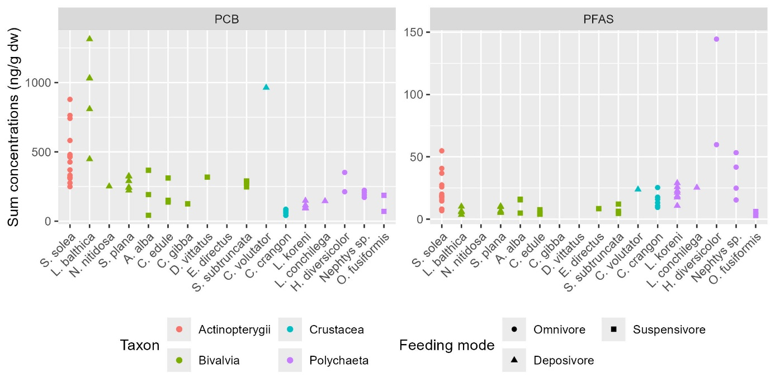

Figure 3 - Sum of contaminant families in each species (ng/g dw). Colors indicate taxonomic groups, and shapes represent feeding modes.

## Lipid contents and relationship with total contamination

Lipid levels range from 0.75 to 7.0% of dry weight (Figure 2). Median values are lowest in polychaetes (median = 1.5%). The highest levels are observed in sole (4.0%), while bivalves (2.3%) and crustaceans (2.9%) show intermediate values.

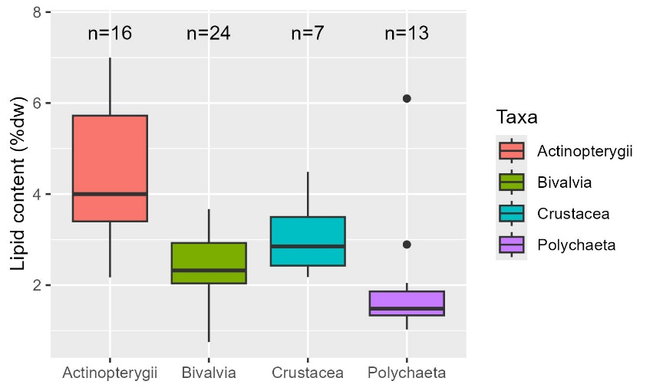

Figure 4 – Boxplots of lipid content (% dry weight) by taxon. Whiskers indicate the 5th–95th percentiles; boxes represent the 25th–75th percentiles; the line indicates the median; dots show outliers.

Relationships between lipid content and total contamination in PCB is represented by species in Figure 5. There is a significant positive correlation between lipid content and PCB contamination levels (Spearman's test: p-value = 5×10⁻⁴, ρ = 0.43). However, some species appear to deviate from this general trend. For example, *Crangon crangon* shows highly variable lipid levels without a corresponding increase in PCB contamination. Conversely, *Limecola balthica* exhibits relatively stable lipid content despite a wide range of PCB concentrations.

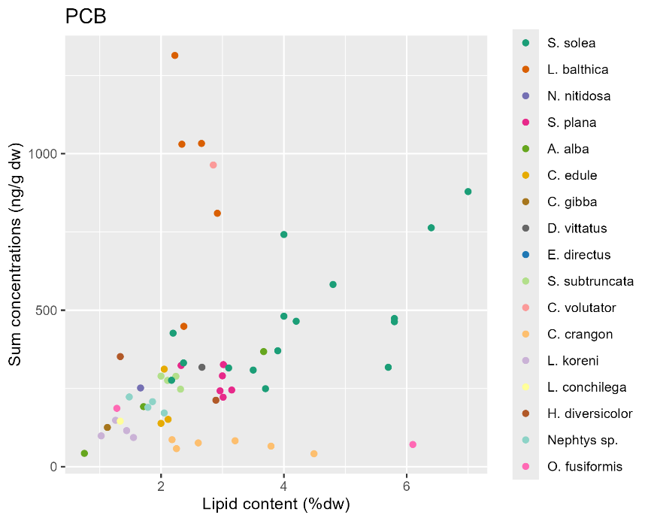

Figure 5 – Relationships between lipid content and total contamination in PCB.

## Physico-chemical properties and average contamination profiles

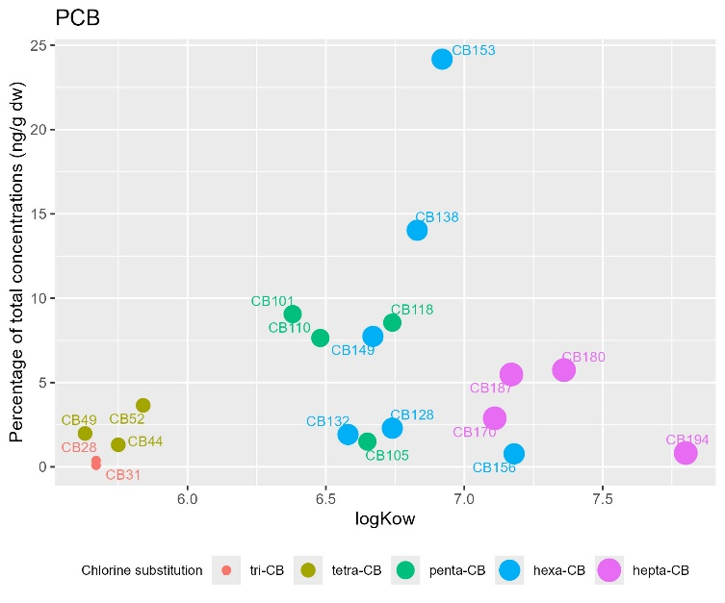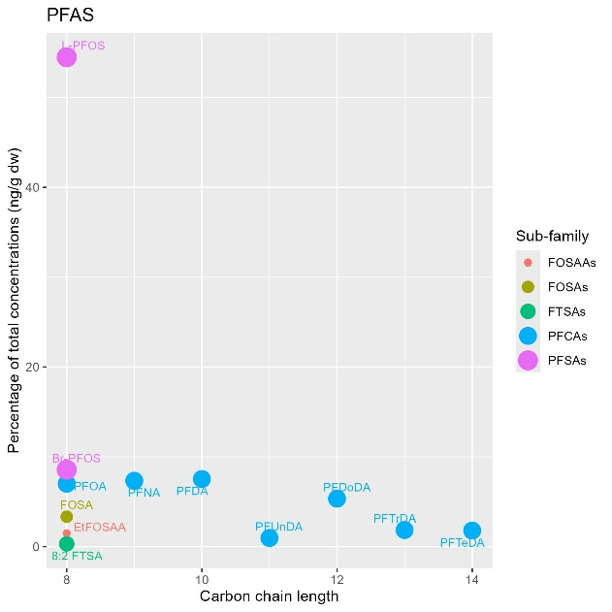

# BMFs estimates for PCBs

## Predator-prey BMF details by PCB congener

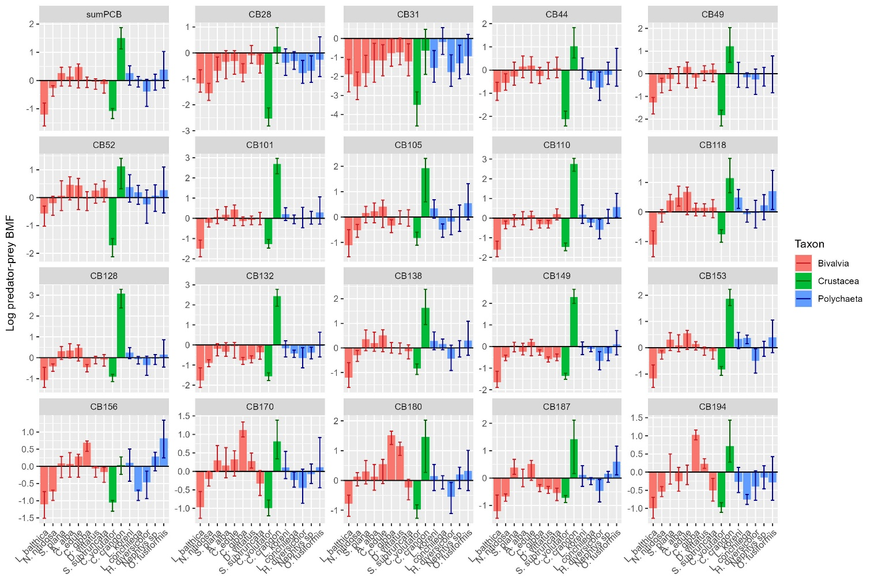

Figure 6 - Relationship between species and log-transformed minimum, median, and maximum BMF estimates under the BMFPP scenario, applied to both the sum and individual PCB congeners. Species taxa are represented by different colors. Values above zero indicate biomagnification.

## Isotopic signatures, trophic levels and TL-BMFs

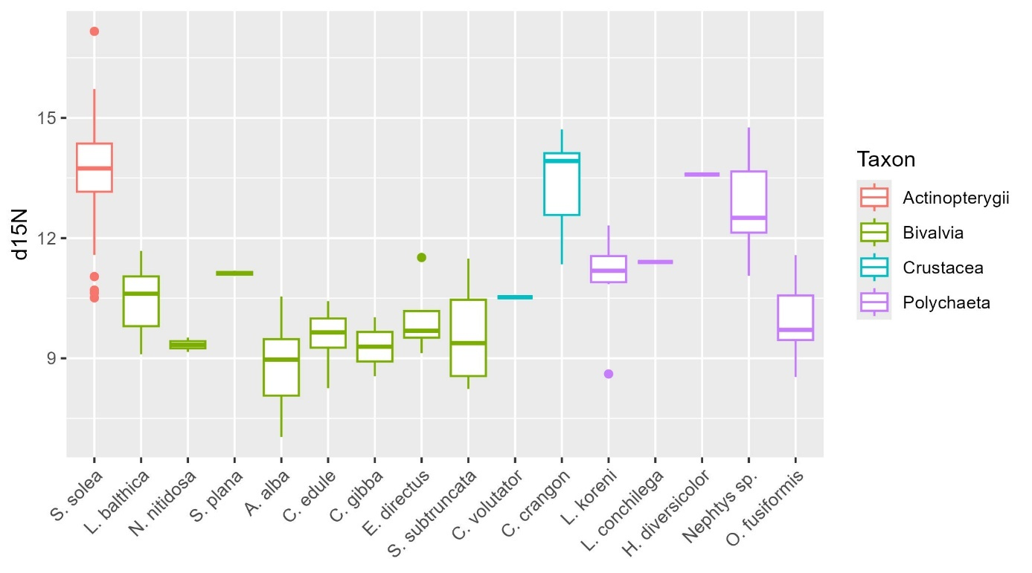

Figure 7 – isotopic signatures of each species, colored by taxonomic group.

Table 3 – Median and trophic positions used in the TL-BMF scenarios along with BMF estimates for CB153 (median [min-max]). *Donax vittatus* could’nt have been measured.

|  |  |  |  |
| --- | --- | --- | --- |
| *Group* | Median | TL | TL-BMF |
| *S. solea* | 13.70 | 3.97 | - |
| *Prey* | 10.50 | 3.03 | - |
| *Annelids* | 12.00 | 3.46 | - |
| *Arthropods* | 13.80 | 4.00 | - |
| *Mollusks* | 9.73 | 2.79 | - |
| *Diet* | 12.58 | 3.63 | 7.78 [1.9-17.95] |
| *L. balthica* | 10.61 | 3.05 | 0,28 [0.19-0.49] |
| *N. nitidosa* | 9.34 | 2.68 | 0,85 [0.71-0.91] |
| *S. plana* | 11.12 | 3.20 | 1,51 [0.87-2.11] |
| *A. alba* | 8.97 | 2.57 | 1,07 [0.90-1.42] |
| *C. edule* | 9.65 | 2.77 | 1,58 [0.95-1.74] |
| *C. gibba* | 9.29 | 2.66 | 1,11 [0.94-1.19] |
| *D. vittatus* | NA | NA | NA |
| *S. subtruncata* | 9.38 | 2.69 | 0,89 [0.71-0.99] |
| *C. volutator* | 10.53 | 3.03 | 0,42 [0.33-0.47] |
| *C. crangon* | 13.92 | 4.03 | 0.00 [0.00-0.00] |
| *L. koreni* | 11.19 | 3.22 | 1,57 [0.97-2.17] |
| *L. conchilega* | 11.40 | 3.28 | 1,74 [1.26-1.99] |
| *H. diversicolor* | 13.59 | 3.93 | 0.00 [0.00-0.44] |
| *Nephtys sp.* | 12.51 | 3.61 | 1,14 [0.40-1.96] |
| *O. fusiformis* | 9.71 | 2.79 | 1,40 [0.85-2.44] |

## Predator-prey trophic level–normalized BMF

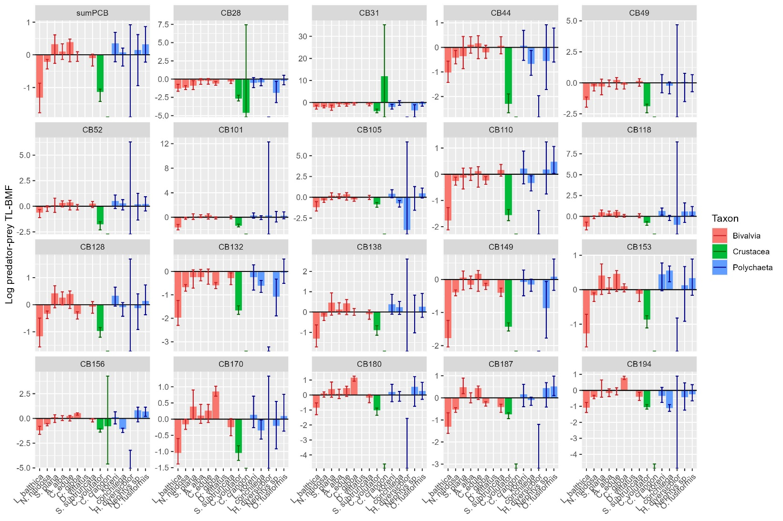

Figure 8 - Relationship between species and log-transformed minimum, median, and maximum BMF estimates under the TL-BMFPP scenario, applied to both the sum and individual PCB congeners. Species taxa are represented by different colors. Values above zero indicate biomagnification.

## BMF comparisons for PCBs

Table 4 – Summary statistics (median [min-max]) of BMF estimates for PCBs for each computation method.

|  |  |  |  |  |
| --- | --- | --- | --- | --- |
| PCB | BMF species | BMF diet | TL-BMF species | TL-BMF diet |
| sumPCB | 1.05 [0.77-1.15] | 1.72 [1.07-2.41] | 1.05 [0.71-1.31] | 4.94 [1.23-13.22] |
| CB28 | 0.63 [0.37-0.93] | 0.72 [0.38-1.53] | 0.48 [0.36-0.77] | 0.38 [0.06-3.45] |
| CB31 | 0.3 [0.12-0.72] | 0.31 [0.11-0.93] | 0.26 [0.14-0.4] | 0.03 [0-0.81] |
| CB44 | 0.81 [0.54-1.4] | 1.34 [0.69-2.44] | 0.68 [0.46-1.31] | 2.35 [0.34-13.73] |
| CB49 | 0.98 [0.54-1.32] | 1.42 [0.73-2.52] | 0.82 [0.43-1.29] | 2.81 [0.4-15.01] |
| CB52 | 1.21 [0.63-1.63] | 1.77 [0.78-2.66] | 1.15 [0.62-1.74] | 5.33 [0.49-17.58] |
| CB101 | 1.02 [0.73-1.41] | 2.05 [1.26-2.94] | 1.06 [0.72-1.4] | 8.18 [1.99-23.7] |
| CB105 | 0.99 [0.66-1.34] | 1.98 [0.81-3.02] | 0.88 [0.58-1.37] | 7.38 [0.55-25.52] |
| CB110 | 0.89 [0.65-1.19] | 1.8 [1.15-3.07] | 0.83 [0.59-1.1] | 5.59 [1.5-26.81] |
| CB118 | 1.16 [0.87-1.52] | 1.82 [1.09-2.89] | 1.12 [0.8-1.62] | 5.8 [1.3-22.53] |
| CB128 | 0.95 [0.72-1.16] | 2.08 [1.28-2.95] | 0.9 [0.62-1.31] | 8.62 [2.06-23.86] |
| CB132 | 0.68 [0.5-0.89] | 1.31 [0.86-2.16] | 0.54 [0.44-0.7] | 2.2 [0.63-9.63] |
| CB138 | 1.03 [0.79-1.35] | 1.75 [1.08-2.98] | 1.01 [0.74-1.64] | 5.17 [1.24-24.56] |
| CB149 | 0.77 [0.65-0.98] | 1.52 [1-2.19] | 0.75 [0.61-0.92] | 3.39 [1-10.03] |
| CB153 | 1.1 [0.83-1.28] | 2.01 [1.24-2.68] | 1.09 [0.78-1.3] | 7.78 [1.9-17.95] |
| CB156 | 1.04 [0.72-1.32] | 1.07 [0.6-1.35] | 0.97 [0.68-1.16] | 1.22 [0.22-2.39] |
| CB170 | 1.11 [0.72-1.64] | 1.35 [0.77-2.22] | 0.83 [0.64-1.58] | 2.43 [0.46-10.41] |
| CB180 | 1.16 [0.75-1.71] | 1.76 [0.73-2.77] | 1.1 [0.65-1.36] | 5.27 [0.39-19.83] |
| CB187 | 0.93 [0.73-1.02] | 1.6 [0.68-2.53] | 0.84 [0.66-0.94] | 3.97 [0.33-15.23] |
| CB194 | 0.77 [0.57-1.14] | 1.08 [0.68-1.94] | 0.66 [0.5-1.14] | 1.24 [0.33-6.98] |

## BMF comparison for PFASs

|  |  |  |  |  |  |
| --- | --- | --- | --- | --- | --- |
| PFAS | censored | Half-LOQ | Log-norm | cenfit | ros |
| 8:2 FTSA | 1.21 [0.55-2.66] | 0.16 [0.08-2.77] | 0.15 [0.07-2.82] | NA [NA-NA] | 0.71 [0.22-2.65] |
| Br-PFOS | 1.53 [0.9-3.04] | 2.48 [1.03-6.8] | 2.54 [1.03-7.33] | NA [NA-NA] | 2.03 [0.91-5.81] |
| EtFOSAA | 0.68 [0.26-1.98] | 0.6 [0.15-1.64] | 0.6 [0.15-1.66] | NA [NA-NA] | 0.59 [0.2-1.56] |
| FOSA | 0.28 [0.13-0.51] | 0.2 [0.06-0.45] | 0.2 [0.06-0.45] | 0.2 [NA-0.5] | 0.2 [0.08-0.45] |
| L-PFOS | 1.56 [0.91-2.93] | 1.57 [0.92-2.97] | 1.57 [0.92-2.97] | 1.59 [0.85-3.23] | 1.57 [0.92-2.97] |
| PFDA | 1.4 [0.85-2.32] | 1.52 [0.84-4.34] | 1.52 [0.84-4.65] | NA [0.7-NA] | 1.5 [0.84-3.32] |
| PFDoDA | 1.4 [0.67-2.19] | 1.4 [0.68-2.24] | 1.4 [0.68-2.24] | 1.42 [0.61-2.6] | 1.4 [0.68-2.24] |
| PFNA | 1.99 [0.87-4.05] | 2.03 [1-4.31] | 2.03 [1-4.31] | 2.07 [1.07-5.24] | 2.03 [1-4.31] |
| PFTeDA | 1.01 [0.42-1.58] | 0.05 [0.03-25.05] | 0.05 [0.03-26.3] | NA [NA-NA] | 0.45 [0.15-2.37] |
| PFTrDA | 1.8 [1-2.43] | 2.28 [0.84-3.35] | 2.28 [0.84-3.35] | 2.32 [0.77-NA] | 2.28 [0.84-2.91] |
| PFUnDA | 1.36 [0.89-2.15] | 0.35 [0.23-1.49] | 0.35 [0.21-1.5] | NA [NA-NA] | 0.64 [0.24-1.69] |

# Discussion

## Niveaux et profiles de contamination

La comparaison avec d’autres études est souvent critiquée pour la grande variabilité entre études, dues aux différences dans les caractéristiques des écosystèmes, la biologie et l’écologie des organismes ainsi qu’aux variations de conception des études (Fremlin, Elliott and Gobas, 2025). Dans la mesure du possible, les comparaisons avec la littérature ont donc été faites sur des espèces identiques, en privilégiant les milieux estuariens du continent Européen.

### Niveaux généraux entre les familles

* Comparaison PCB et PFASs même zone + TMF Olifants River Basin, subtropical, South Africa (Verhaert *et al.*, 2017)

Les concentrations mesurées dans les juvéniles de *Solea solea* et leurs proies révèlent une prédominance des PCBs par rapport aux PFASs. Ces résultats sont cohérents avec des études antérieures menées en milieux estuariens où les PCBs restent les contaminants organohalogénés les plus abondants, notamment en raison de leur persistance et de leur historique d’usage intensif (GIP Seine-aval, 2024). La contamination en PFASs, bien que faible, est néanmoins préoccupante, car ces composés sont considérés comme des contaminants émergents ayant des propriétés de bioaccumulation encore mal comprises (Loi *et al.*, 2011, p. 201). Des recherches récentes ont mis en évidence la présence de PFAS dans les écosystèmes aquatiques, soulignant leur persistance et leur potentiel de bioaccumulation (Cara *et al.*, 2022).

L’abondance relative des contaminants au sein des proies suit des tendances qui pourraient être expliquées par leurs propriétés physico-chimiques. En effet, les bivalves ont montré une bioaccumulation plus marquée des HBCDDs, ce qui pourrait s’expliquer par leur mode de filtration favorisant l’adsorption de ces composés lipophiles (REF). Inversement, les polychètes et crustacés semblent moins affectés par l’accumulation des PCBs et PFASs, ce qui pourrait être lié à des différences de capacité de métabolisation (REF) ou de biodisponibilité des contaminants dans le sédiment (fonction de la conductivité de l’eau et clay content) (Van Ael *et al.*, 2012).

### Niveaux et profils pour les PCB

* Estuaire de la Gironde, France 2005 (Bodin *et al.*, 2014) et 2012 (Lauzent, 2018)
* Estuaire de Scheldt, Belgique (Van Ael *et al.*, 2012) (check : intro, results – reste : 2 derniers paragraphes discussion)
* Belgian north sea western Scheldt estuary (Voorspoels *et al.*, 2004)

Une corrélation au taux de lipides peu marquée

(Van Ael *et al.*, 2012, 2013) : “It is previously stated that the lipid content of an organism has an inﬂuence on the accumulation of pollutants (Gewurtz *et al.*, 2006; Deribe *et al.*, 2011) Dans notre étude, les concentrations en somme de PCB sont significativement (lm p-value = 0.007) mais faiblement corrélées (R²= 0.37) aux taux de lipides uniquement pour les soles.

Un profil classique avec cependant un CB180 plus faible

* Les profils de contamination en PCBs étaient similaires entre soles et benthos, comme observé dans le Scheldt estuary in Belgium (Van Ael *et al.*, 2012) et l’estuaire de la Gironde en France (Lauzent, 2018)
* Au sein des PCBs, les 2 composés majoritaires sont le CB153 et le CB138 avec une proportion de 24% et 14% dans les soles, ce qui est cohérent avec la littérature :
  + pour l’estuaire de la Gironde en 2014 en France (23% et 16%) (Bodin *et al.*, 2014)
  + pour l’estuaire de la Gironde en 2017 en France (37% et 23%) (Lauzent, 2018)
  + pour l’estuaire du Scheldt en Belgique (17% et 10%)(Van Ael *et al.*, 2012).
  + Le 3ème composé est le CB101 (8%) et non le CB180 (6%) qui était le plus abondant pour l’estuaire de la Gironde en 2017 en France (4% et 30%)(Lauzent, 2018). Cependant, les niveaux sont sensiblement identiques pour l’estuaire du Scheldt en Belgique (6.3% et 5.6%) (Van Ael *et al.*, 2012)

Pourquoi un CB180 faible ?

Des concentrations dans le benthos et les soles plus fortes que dans d’autres estuaires Européens

* Comparaison PCB poisson (European sea bass) en estuaires Européens (Schnitzler *et al.*, 2011) : « The Scheldt and the Seine are still among the most contaminated estuaries in Europe. Each region presented their speciﬁc contamination patterns reﬂecting different sources due to the input of the respective rivers.”

Compared to the results from other studies and regions, POP concentrations in biota from the present study were relatively high.

Benthos :

On retrouve le pattern Bivalves > Polychaete > Crustacés dans la littérature(Voorspoels *et al.*, 2004; Van Ael *et al.*, 2012; Lauzent, 2018)

* Bivalves are known for their ability to concentrate lipophilic substances. They exhibit a low bio-transformation capacity and as ﬁlter feeders, they achieve high ﬁltration rates and accumulate chemicals from water, as well as from particulate material (Dörr and Liebezeit, 2009).
* ces auteurs suggèrent que les plus faibles contaminations des crustacés viendraient d’une nature plus pélagique que les autres espèces, vivants plus au contact du sédiment (Oh, Hartnoll and Nash, 2001).

La comparaison de la contamination en PCB du benthos avec la littérature montre des niveaux similaires ou plus forts dans notre étude. Seule la comparaison avec les bristle worms et

la moule bleue (Mytilus edulis) montre des niveaux plus faibles mais, dans cette étude, ces niveaux étaient anormalement élevés en comparaison de la littérature.

|  |  |  |  |  |  |  |
| --- | --- | --- | --- | --- | --- | --- |
| Present study | ∑PCB ng/gww  Lipid % | Other studies | ∑PCB ng/gww  Lipid % | Zone | Ref | Comparaison  Contamination et lipides |
| Benthos | 30[8-175] | Benthos | 9[1-27] | Gironde 2012 | (Lauzent, 2018) | 4-5x plus fort |
| 53[3-1690] | Scheldt | (Van Ael *et al.*, 2012) | 1.8x plus faible (10x pour les max) |
| Crangon crangon | 13[8-26]  2.9%[2.2-4.5] | Crangon crangon | 3[1-5] | Gironde 2012 | (Lauzent, 2018) | 5x plus fort |
| Crangon crangon | 11[3-40]  0.7[0.5-0.9] % | Scheldt | (Van Ael *et al.*, 2012) | [] similaire vs taux de lipides 4x supérieurs |
| crevette blanche | 15[13-17] | Gironde 2012 | (Lauzent, 2018) | similaire |
| Polychaete | 32[15-49]  1.5%[1.0-6.1] | Nereis | 3.4[3.2-3.6] | Gironde 2012 | (Lauzent, 2018) | 10x plus fort |
| bristle worms | 53[12-106]  1.3[1.0 -1.6]% | Scheldt | (Van Ael *et al.*, 2012) | Niveau similaire mais max [] 2 fois plus faible VS *max % 4 fois plus forts* |
| Scrobicularia plana | 30[24-44] | Scrobicularia plana | 10[4-16] | Gironde 2012 | (Lauzent, 2018) | 3x plus fort |
| Bivalves | 30[10-175]  2.3%[0.8-3.7] | Huitre | 18[10-26] | Gironde 2012 | (Lauzent, 2018) | 1.7x plus fort (max 6.7x) |
| Mytilus edulis | 782[287-1690]  2.7[2.0-3.7] % | Scheldt | (Van Ael *et al.*, 2012) | [] 26x plus faible VS *% similaires* |

Des concentrations plus fortes dans nos G0 que dans les adultes de la littérature

Tableau 6 - (6 PCB indicateurs de l’ICES)

|  |  |  |  |  |  |  |
| --- | --- | --- | --- | --- | --- | --- |
| Present study | ∑PCB  %lipid | Other studies | ∑PCB  %lipid | Zone | Ref | Comparaison |
| 19 PCB | 101[55-211] ng/gww  4%[2-7] | 33 PCB | 39[9-213] ng/gww  0.7% [0.4-1.3] | Scheldt | (Van Ael *et al.*, 2012) | [] 3x plus fort  % 5-6 fois plus fort |
| Individu entier | 13 ng/gww | Gironde 2012 | (Lauzent, 2018) | [] 10x plus fort |
| filet | 513 ng/gww | [] 5x plus faible |
| 19 PCB | 445[250-879] ng/g dw  4%[2-7] | filet | 75 ng/gdw  3% | Gironde 2005 | (Bodin *et al.*, 2014) | [] 6x plus forte vs % similaires |
| foie | 1177 ng/gdw  26% | [] 2.5 fois plus faible mais % 6.5 fois plus faible |
| individu entier | 57[31-123] ng/gww |  | 17[4-97] ng/gww | Scheldt | (Van Ael *et al.*, 2012) | [] 4 fois plus forte |
| filet | 75 ng/gww | (European Commission, 2022) | | Plus élevé pour 4 poissons /!\ filet |
|  |  |  |  |  |  |  |

Les niveaux de contamination des soles apparaissent plus élevés en PCB dans notre étude en Seine, par rapport à d’autres estuaires européens : 3 à 4 fois plus élevés qu’en estuaire de Scheldt (Van Ael *et al.*, 2012), bien connu pour être l’un des plus contaminés en OHC en Europe depuis 40 ans ; 6 à 10 fois plus élevés qu’en estuaire de la Gironde (Bodin *et al.*, 2014; Lauzent, 2018). Cette contamination plus forte de la Seine a été communément considérée depuis les années 80 cependant l’étude de (Bodin *et al.*, 2014) mettait en évidence des contaminations du flet 2 à 5 fois plus faibles en Seine (1986-1988) qu’en Gironde (2005). Cette tendance ne semble donc pas être observée sur la sole mais cela pourrait également refléter un changement de niveau de contamination de la Seine depuis la fin des années 80.

Les **concentrations en poids frais dans les soles** (107[55-211 ng/gww pour 19 CB, =61[31-123] ng/gww pour les) sont:

et de la Gironde (=2100-7700ng/g dw)

Aussi, la valeur moyenne des sommes de PCBs de 465 ng/g dw de notre étude, est encadrée par les valeurs dans le muscle (75 ng/gdw) et dans le foie (1177 ng/gdw) en estuaire de la Gironde, ce qui est attendu étant donné les différences de taux de lipides entre ces tissus (muscle : 3%, foie : 26%) et l’individu entier dans notre étude (4[2-7]%). Cette concentration plus élevée dans le foie que dans le muscle est bien connue pour les HOC (Schäfer *et al.*, 2015). Toutefois, si on compare les concentrations en poids de lipides, la valeur moyenne de 11334 ng/g lw de notre étude est deux fois plus élevée que la contamination du foie en estuaire de la Gironde (5201 +/- 1922 ng/g lw) indiquant des niveaux de contamination plus élevés en estuaire de Seine une fois la différence de taux de lipides prise en compte. En effet, les taux de lipides varient en fonction du stade de vie et il est donc recommandé d’étudier les concentrations normalisées par les lipides.

Il convient de préciser que notre étude porte sur les G0, premiers stades de vie alors qu’en Seine et en Scheldt des adultes ont été mesurés (32.9 et 15.4 cm, respectivement). Cette différence de contamination entre les stades de vie et taille de poisson est bien connue et peut supplanter les effets spatio-temporels (Schäfer *et al.*, 2015). Elle a par exemple été observée chez les poissons pour les PFAS (Lescord *et al.*, 2015; Munoz *et al.*, 2017). De plus faibles concentrations chez les jeune adultes peut possiblement s’expliquer par une modification des taux métaboliques, un changement de régime alimentaire ou un phénomène de dilution par la croissance. Cette différence de contamination entre les stades de vie a été observée chez les poissons pour les PFAS (Lescord *et al.*, 2015; Munoz *et al.*, 2017).

The PCB family is by far the most predominant in soles, with an average total PCBs concentration of 465.20 ng/g dw, compared to 22.34 ng/g dw for PFASs. This hierarchy is also observed in prey; however, PCB levels are lower at 292.50 ng/g dw, PFAS levels are similar at 23.55 ng/g dw.

# Supplementary materials

## Chemical concentrations : for each compound

Tableau A2. Detailed results for each chemical in each type of concentrations are listed in the Supplementary Material.

|  |  |  |  |
| --- | --- | --- | --- |
|  | ng_gdw | ng_glw | ng_gww |
| ∑PCB | 465.2[249.17-878.82] | 11334.42[5571.08-19435.43] | 106.76[54.57-210.92] |
|  | - | - | 61.09[31.27-123.38] |
| CB153 | 111.82[57.63-216.73] | 2673.6[1623.45-4227.06] | 25.66[13.02-52.01] |
| ∑PFAS | 22.34[5.44-57.84] | - | 5.08[1.25-12.49] |
| L-PFOS | 12.36[2.42-35.74] | - | 2.8[0.56-7.72] |

Tableau 2 : Tests de Dunn (pairwise Kruskall Wallis) sur l’effet des modes trophiques sur les

|  |  |  |  |
| --- | --- | --- | --- |
| Comparison | PCB | PFAS | HBCDD |
| Carnivore - Suspensivore | 0,002815 | 0,01459 | 0,000798 |
| Carnivore - Deposivore | 0,721313 | 1 | 0,024007 |
| Carnivore - Omnivore | 3,82E-05 | 1 | 1 |
| Deposivore - Omnivore | 0,010263 | 0,266473 | 0,001767 |
| Deposivore - Suspensivore | 0,259803 | 0,157691 | 1 |
| Omnivore - Suspensivore | 1 | 0,000489 | 4,7E-05 |

Tableau A3



# Résultats : Trophic magnification transfers

Discussion

Méthode de calcul des TMF : Plus récemment encore, Ballutaud et al. (2019) ont développé une méthode originale, implémentée dans un cadre bayésien, afin de tenir compte de la propagation des incertitudes dans le calcul des TMF. Ce modèle, baptisé ESCROC, repose sur le principe des modèles de mélange isotopiques classiques : il postule que la signature chimique (contaminant ou isotope) d’un prédateur est la moyenne pondérée de la signature chimique de ses proies plus un facteur d’enrichissement. Dans le cas des isotopes, ce facteur est appelé facteur d’enrichissement isotopique ; dans le cas des contaminants, il correspond au TMF. Initialement, il était prévu d’utiliser ESCROC sur les données acquises dans ce projet. Malheureusement, malgré un important effort d’échantillonnage et d’acquisition de données, les contraintes du projet n’ont pas permis de construire un jeu de données regroupant (1) suffisamment de données isotopiques acquises sur les mêmes individus que pour les données de contamination pour (2) assez d’organismes le long de la chaîne trophique (3) depuis les consommateurs primaires jusqu’à différents prédateurs. Nous n’avons donc pas pu implémenter ESCROC sur nos données. Aussi, dans le cadre de ce CHOPIN, la méthode LMEC a été privilégiée.

De plus, selon les familles, les valeurs de TMF ne sont pas tout à fait convergentes avec les diagnostics établis au regard des BMF. Ainsi, quel que soit le mode de calcul du BMF, tous les congénères de PCB apparaissent bioamplifiés entre proies benthiques et soles G0 alors que seul le CB-153 ressort si l’on considère les TMF. Différentes hypothèses ont été avancées pour expliquer les différences entre BMF et TMF (ex : forte contamination de certains bivalves situés en bas de chaine trophique). Les approches sont plus cohérentes entre elles pour les PFAS. Pour ces derniers, tous les composés fréquemment détectés dans les soles apparaissent bioamplifiés au regard des valeurs de TMF et de BMF obtenues même si la conclusion est plus nuancée lorsque l’on tient compte du bol alimentaire dans le calcul du BMF.